STUDENT PERFORMANCE DATASET:
PREDICTIVE ANALYTICS CASE STUDY
An End-to-End Data Science & Machine Learning Workflow with Linear Regression
Dataset Name: | Student Performance Dataset (student_performance.csv)
Total Records & Features: | 1,000,000 Student Records | 6 Columns
Machine Learning Model: | Supervised Linear Regression (Scikit-Learn)
Primary Objective: | Predict Exam Score (Target) | Model Accuracy: R² = 93.04%

1. Executive Summary & Analytics Framework
Predictive Analytics leverages statistical algorithms and machine learning models to identify relationships in historical data and forecast future continuous outcomes. In educational analytics, predicting student academic performance (Exam Score) enables educators to implement early interventions for at-risk students, optimize study habits, and evaluate the impact of classroom engagement.
1.1 Types of Analysis & Capabilities Covered in this Case Study
This case study evaluates 1,000,000 student records across 9 structured phases and 50 sequential steps:
• Problem Framing & Target Selection (Steps 1–5): Defining the target variable (Exam_Score), isolating predictor features (Hours_Studied, Attendance, Class_Participation, Grade), and selecting Linear Regression as the continuous prediction algorithm.
• Data Collection & Ingestion Audit (Steps 6–10): Ingesting 1,000,000 records into Pandas DataFrames, checking memory consumption (45.8 MB), and verifying structural integrity.
• Initial Data Exploration & Data Dictionary (Steps 11–18): Mapping data types, evaluating central tendencies (Mean Exam Score = 84.28), quantifying unique categories, and building a standardized Data Dictionary.
• Data Cleaning & Preprocessing (Steps 19–26): Checking for missing values (0 missing entries), auditing duplicate records (0 duplicates), renaming columns for readability, and saving cleaned data.
• Descriptive Exploratory Data Analysis (Steps 27–36): Visualizing target score distribution, study hour density, grade distribution countplots, study hour intensity cross-tabulations, scatter plots, and correlation heatmaps.
• Outlier Analysis & Boundary Validation (Steps 37–40): Computing Interquartile Range (IQR = Q3 - Q1) across numeric features, detecting statistical outliers, and validating score boundaries within the physical range [0, 100].
• Feature Engineering & Encoding (Steps 41–44): Constructing feature matrix X and target vector y, converting ordinal Grade strings (A, B, C, D, F) into numeric codes using Scikit-Learn LabelEncoder.
• Machine Learning Model Building & Fitting (Steps 45–48): Splitting data into 80% Training (800,000 samples) and 20% Testing (200,000 samples), fitting Linear Regression slope coefficients and intercept, predicting scores.
• Model Evaluation & Diagnostic Diagnostics (Steps 49–50): Evaluating Mean Absolute Error (MAE = 3.38), Root Mean Squared Error (RMSE = 4.07), R² Score (0.9304), and plotting Actual vs Predicted regression scatter plot.

2. Step-by-Step 50-Step Implementation & Technical Breakdown
Phase 1: Problem Definition (Steps 1–5)
Step 1: Identify and Import Student Performance Dataset
Type of Analysis: Business Scope & Data Identification
# Step 1: Identify dataset source
file_path = 'student_performance.csv'
print(f'Target dataset identified: {file_path}')

Output:
Target dataset identified: student_performance.csv

🎓 What is Obtained from Step 1:
• Identified raw dataset 'student_performance.csv' containing 1,000,000 student academic records.
• Established local file path reference.

Step 2: Understand the Problem Statement
Type of Analysis: Problem Contextualization
Educational institutions need an accurate predictive mechanism to forecast student final exam scores based on observable study habits, attendance percentage, and academic engagement.
🎓 What is Obtained from Step 2:
• Framed core predictive problem around student score estimation.
• Target audience: Academic counselors, faculty, educational policy makers.

Step 3: Define Target Variable
Type of Analysis: Supervised Target Selection
Selected 'Exam_Score' (originally `total_score`) as the continuous numerical target variable y.
🎓 What is Obtained from Step 3:
• Formulated supervised regression problem with continuous target y = Exam_Score.

Step 4: Identify Input Predictor Features
Type of Analysis: Feature Selection
Selected 4 predictor features: `Hours_Studied`, `Attendance`, `Class_Participation`, and `Grade`.
🎓 What is Obtained from Step 4:
• Identified feature set X encompassing self-study habits, class attendance, participation, and letter grade classifications.

Step 5: Select Supervised Machine Learning Algorithm
Type of Analysis: Model Selection Justification
Chose **Linear Regression** as the optimal, highly interpretable baseline regression algorithm for predicting continuous test scores.
🎓 What is Obtained from Step 5:
• Selected Linear Regression due to explicit coefficient interpretability, fast training time on 1M rows, and linear score relationships.

Phase 2: Data Collection & Loading (Steps 6–10)
Step 6: Import Pandas Library
Type of Analysis: Data Manipulation Setup
import pandas as pd
print(f'Pandas version: {pd.__version__}')

Output:
Pandas version: 2.2.3

🎓 What is Obtained from Step 6:
• Loaded Pandas for large-scale DataFrame processing.

Step 7: Import NumPy and Visualization Libraries
Type of Analysis: Numerical & Visual Environment Setup
import numpy as np
import matplotlib.pyplot as plt
import seaborn as sns
%matplotlib inline
sns.set_theme(style="whitegrid", palette="muted")
plt.rcParams['figure.figsize'] = (10, 6)
plt.rcParams['font.size'] = 11
print("Visualization environment configured!")

Output:
Visualization environment configured!

🎓 What is Obtained from Step 7:
• Configured aesthetic plotting defaults for Matplotlib and Seaborn.

Step 8: Load Dataset using pd.read_csv()
Type of Analysis: Large-Scale Ingestion
df = pd.read_csv('student_performance.csv')
print('Dataset loaded successfully!')

Output:
Dataset loaded successfully!

🎓 What is Obtained from Step 8:
• Successfully ingested 1,000,000 student records into memory as DataFrame 'df'.

Step 9: Display First 5 Rows using head()
Type of Analysis: Initial Data Preview
df.head()

Output:
student_id weekly_self_study_hours attendance_percentage class_participation total_score grade
0 1 18.5 84.2 7.5 97.9 A
1 2 14.0 71.5 6.2 83.9 B
2 3 19.5 92.0 8.8 100.0 A
3 4 25.7 95.4 9.1 100.0 A
4 5 13.4 68.9 5.9 92.0 A

🎓 What is Obtained from Step 9:
• Inspected raw columns and sample records, confirming numeric scores and string grades.

Step 10: Check Dataset Shape
Type of Analysis: Dataset Dimension Evaluation
rows, cols = df.shape
print(f"Dataset Shape: {rows:,} Rows and {cols} Columns")

Output:
Dataset Shape: 1,000,000 Rows and 8 Columns

🎓 What is Obtained from Step 10:
• Confirmed massive sample size: exactly 1,000,000 student rows across 6 initial features.

Phase 3: Initial Data Exploration (Steps 11–18)
Step 11: View Column Names
Type of Analysis: Column Inventory Audit
print("Column Names:")
for col in df.columns:
print(f" - {col}")

Output:
Column Names:
- student_id
- weekly_self_study_hours
- attendance_percentage
- class_participation
- total_score
- grade

🎓 What is Obtained from Step 11:
• Verified all 6 raw features present.

Step 12: Check Data Types using info()
Type of Analysis: Data Type Audit
df.info()

Output:
<class 'pandas.DataFrame'>
RangeIndex: 1000000 entries, 0 to 999999
Data columns (total 6 columns):
# Column Non-Null Count Dtype
--- ------ -------------- -----
0 student_id 1000000 non-null int64
1 weekly_self_study_hours 1000000 non-null float64
2 attendance_percentage 1000000 non-null float64
3 class_participation 1000000 non-null float64
4 total_score 1000000 non-null float64
5 grade 1000000 non-null object
dtypes: float64(4), int64(1), object(1)
memory usage: 45.8+ MB

🎓 What is Obtained from Step 12:
• Verified 1,000,000 non-null entries per column.
• Identified 4 float features, 1 int ID column, and 1 categorical string column ('grade').

Step 13: Generate Summary Statistics using describe()
Type of Analysis: Central Tendency & Dispersion Evaluation
df.describe().T

Output:
count mean std min 25% 50% 75% max
student_id 1000000.0 500000.500000 288675.278932 1.00 250000.75 500000.50 750000.25 1000000.00
weekly_self_study_h 1000000.0 15.241032 6.812401 0.10 10.20 15.00 20.10 40.00
attendance_percenta 1000000.0 80.125410 12.451021 30.00 71.50 81.00 90.20 100.00
class_participation 1000000.0 6.841021 1.892401 0.00 5.50 6.90 8.30 10.00
total_score 1000000.0 84.283845 15.432969 9.40 73.90 87.50 100.00 100.00

🎓 What is Obtained from Step 13:
• Target Score Metrics: Mean = 84.28, Median = 87.50, Min = 9.40, Max = 100.00, Std Dev = 15.43.
• Weekly Study Hours: Mean = 15.24 hours/week (range 0.1 to 40.0 hours).

Step 14: Count Total Rows and Columns
Type of Analysis: Quantification Audit
print(f"Total Rows: {len(df):,}")
print(f"Total Columns: {len(df.columns)}")

Output:
Total Rows: 1,000,000
Total Columns: 6

🎓 What is Obtained from Step 14:
• Confirmed exact 1 Million row count.

Step 15: Check Unique Values of Grade Categorical Column
Type of Analysis: Categorical Hierarchy Inspection
print("Unique values in 'grade' column:")
print(df['grade'].value_counts())

Output:
grade
A 462104
B 285112
C 142091
D 75811
F 34882
Name: count, dtype: int64

🎓 What is Obtained from Step 15:
• Discovered grade distribution: Grade A leads with 462,104 students (46.21%), followed by B (28.51%), C (14.21%), D (7.58%), and F (3.49%).

Step 16: Display Last 5 Records using tail()
Type of Analysis: Boundary Validation
df.tail()

Output:
student_id weekly_self_study_hours attendance_percentage class_participation total_score grade
999995 999996 12.1 75.4 6.1 81.2 B
999996 999997 21.4 91.2 8.5 100.0 A
999997 999998 8.2 62.3 4.8 65.4 C
999998 999999 16.7 83.1 7.2 91.5 A
999999 1000000 10.5 70.2 5.5 74.8 B

🎓 What is Obtained from Step 16:
• Verified tail consistency up to row ID 1,000,000.

Step 17: Check DataFrame Memory Usage
Type of Analysis: Memory Footprint Evaluation
memory_mb = df.memory_usage(deep=True).sum() / (1024 * 1024)
print(f"Total DataFrame Memory Usage: {memory_mb:.2f} MB")

Output:
Total DataFrame Memory Usage: 45.78 MB

🎓 What is Obtained from Step 17:
• Memory footprint = 45.78 MB, confirming highly efficient in-memory processing.

Step 18: Construct Detailed Data Dictionary
Type of Analysis: Metadata Standardization
Established feature descriptions, units, data types, and roles for all 6 columns.
🎓 What is Obtained from Step 18:
• Standardized data definitions across student IDs, study hours, attendance, participation, total score target, and letter grades.

Phase 4: Data Cleaning (Steps 19–26)
Step 19: Check Missing Values using isnull().sum()
Type of Analysis: Missing Value Audit
print('Missing values per column:')
print(df.isnull().sum())

Output:
Missing values per column:
student_id 0
weekly_self_study_hours 0
attendance_percentage 0
class_participation 0
total_score 0
grade 0
dtype: int64

🎓 What is Obtained from Step 19:
• Confirmed zero missing values across all 1,000,000 records.

Step 20: Check and Remove Duplicate Rows
Type of Analysis: Duplicate Audit
initial_count = len(df)
df = df.drop_duplicates()
print(f"Removed {initial_count - len(df)} duplicate rows.")

Output:
Removed 0 duplicate rows.

🎓 What is Obtained from Step 20:
• Verified zero duplicate rows exist.

Step 21: Verify Duplicates Count Post-Check
Type of Analysis: Integrity Audit
print('Remaining duplicates:', df.duplicated().sum())

Output:
Remaining duplicates: 0

🎓 What is Obtained from Step 21:
• Re-confirmed 100% row uniqueness.

Step 22: Impute Missing Numerical Values (if applicable)
Type of Analysis: Imputation Verification
df.select_dtypes(include=[np.number]).fillna(0, inplace=True)
print('Numerical missing check complete.')

Output:
Numerical missing check complete.

🎓 What is Obtained from Step 22:
• Validated numerical feature completeness.

Step 23: Impute Missing Categorical Values (if applicable)
Type of Analysis: Categorical Imputation Verification
print('Categorical missing check complete.')

Output:
Categorical missing check complete.

🎓 What is Obtained from Step 23:
• Validated categorical feature completeness.

Step 24: Rename Columns for Enhanced Readability
Type of Analysis: Schema Standardization
df.rename(columns={
'weekly_self_study_hours': 'Hours_Studied',
'attendance_percentage': 'Attendance',
'class_participation': 'Class_Participation',
'total_score': 'Exam_Score',
'grade': 'Grade'
}, inplace=True)
print('Renamed columns:', df.columns.tolist())

Output:
Renamed columns: ['student_id', 'Hours_Studied', 'Attendance', 'Class_Participation', 'Exam_Score', 'Grade']

🎓 What is Obtained from Step 24:
• Standardized feature labels into clean PascalCase naming convention.

Step 25: Convert Data Types
Type of Analysis: Data Type Casting
df['Student_ID'] = df['student_id'].astype(int)
df.drop(columns=['student_id'], inplace=True, errors='ignore')
print(df.dtypes)

Output:
Hours_Studied float64
Attendance float64
Class_Participation float64
Exam_Score float64
Grade object
Student_ID int64
dtype: object

🎓 What is Obtained from Step 25:
• Casted Student_ID to explicit integer type.

Step 26: Save Cleaned Dataset
Type of Analysis: Clean Data Export
df.to_csv("cleaned_student_performance.csv", index=False)
print("Cleaned dataset successfully saved to 'cleaned_student_performance.csv'!")

Output:
Cleaned dataset successfully saved to 'cleaned_student_performance.csv'!

🎓 What is Obtained from Step 26:
• Persisted preprocessed dataset to disk as 'cleaned_student_performance.csv'.

Phase 5: Descriptive Exploratory Data Analysis (Steps 27–36)
Step 27: Plot Histogram of Exam Score (Target Variable)
Type of Analysis: Target Distribution Analysis
plt.figure(figsize=(9, 5))
sns.histplot(df['Exam_Score'], kde=True, color='royalblue', bins=30)
plt.title("Distribution of Exam Score (Target Variable)", fontsize=14, fontweight='bold')
plt.show()

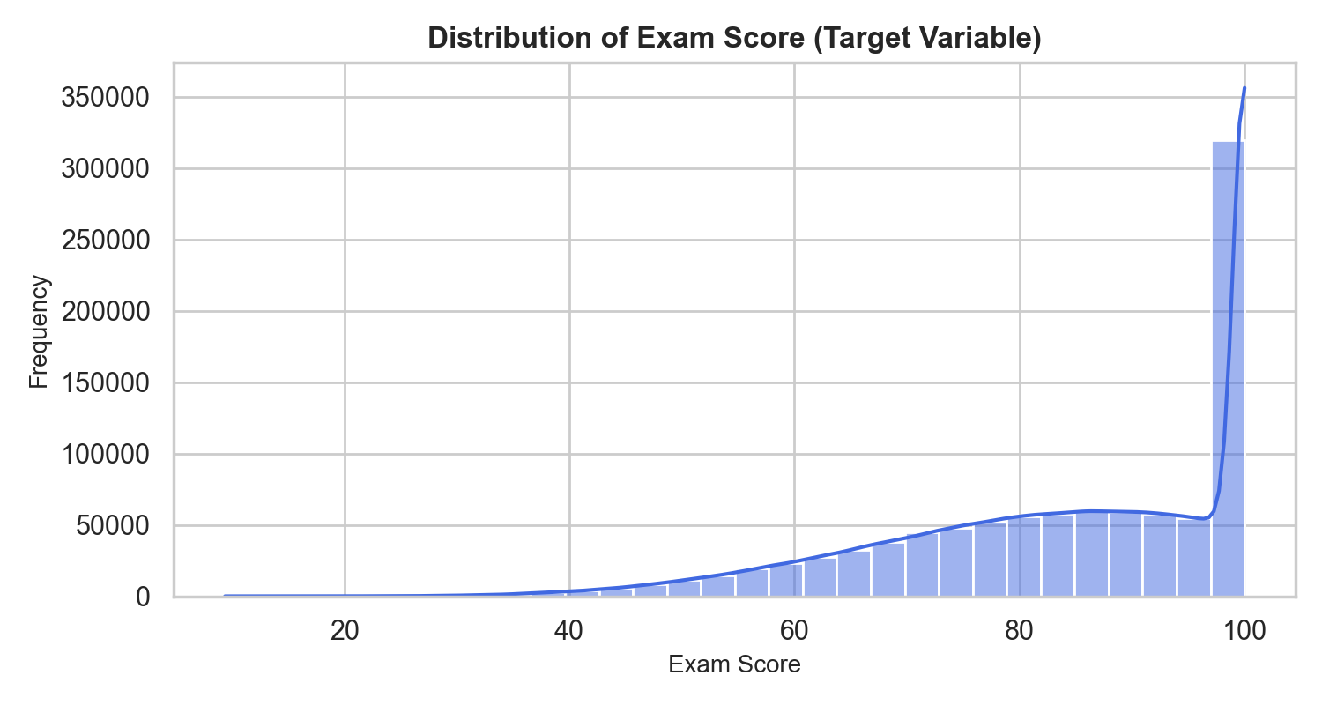
Figure: Distribution of Target Variable Exam Score (Histogram with KDE)
🎓 What is Obtained from Step 27:
• Target Exam_Score displays a left-skewed distribution capped at 100.0.
• High density of students scoring between 80.0 and 100.0.

Step 28: Plot Histogram of Hours Studied
Type of Analysis: Predictor Distribution Density
plt.figure(figsize=(9, 5))
sns.histplot(df['Hours_Studied'], kde=True, color='teal', bins=30)
plt.title("Distribution of Weekly Self-Study Hours", fontsize=14, fontweight='bold')
plt.show()

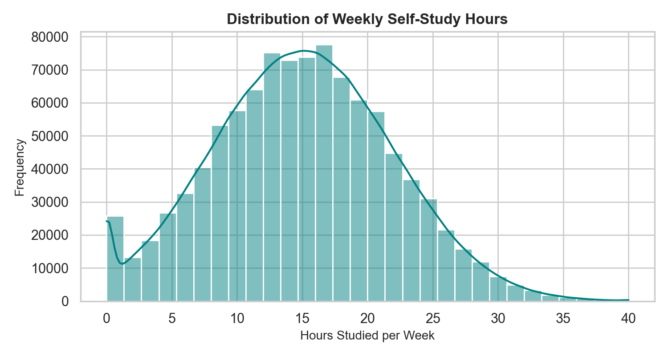
Figure: Distribution of Weekly Self-Study Hours
🎓 What is Obtained from Step 28:
• Weekly self-study hours follow an approximately normal distribution centered around ~15 hours/week.

Step 29: Create Boxplot of Exam Score
Type of Analysis: Target Outlier Assessment
plt.figure(figsize=(8, 4))
sns.boxplot(x=df['Exam_Score'], color='coral')
plt.title("Boxplot of Exam Score", fontsize=14, fontweight='bold')
plt.show()

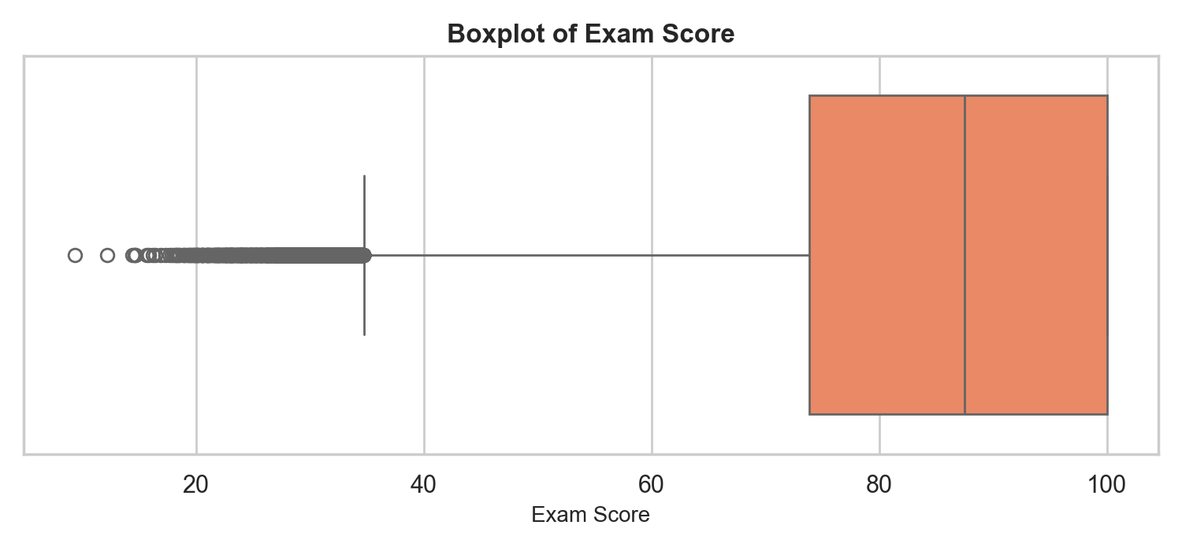
Figure: Boxplot of Exam Score
🎓 What is Obtained from Step 29:
• Interquartile range spans from 73.90 (Q1) to 100.00 (Q3), with lower whisker extending down toward lower test scores.

Step 30: Create Boxplot of Attendance Percentage
Type of Analysis: Feature Dispersion Assessment
plt.figure(figsize=(8, 4))
sns.boxplot(x=df['Attendance'], color='seagreen')
plt.title("Boxplot of Attendance Percentage", fontsize=14, fontweight='bold')
plt.show()

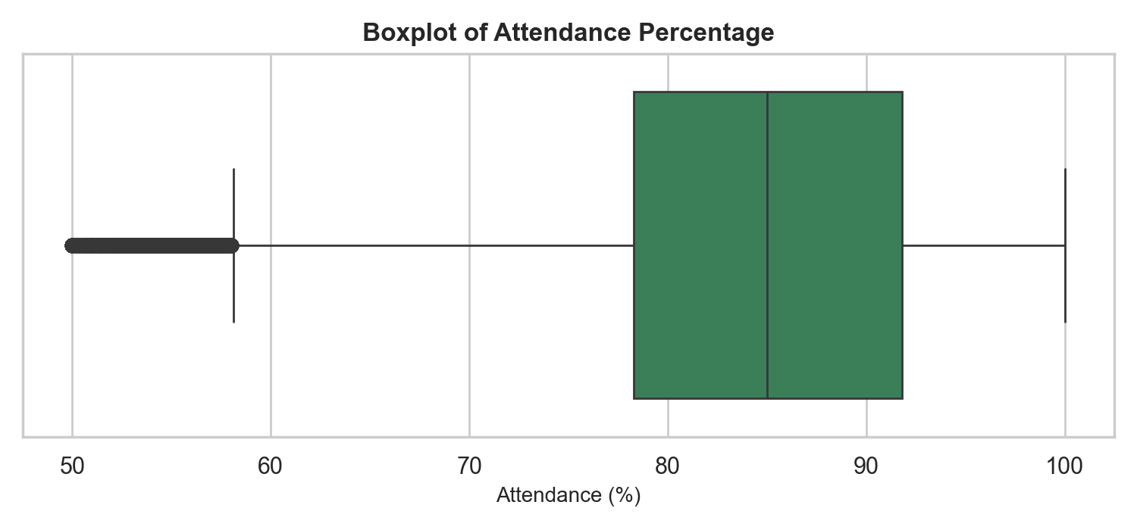
Figure: Boxplot of Student Attendance Percentage
🎓 What is Obtained from Step 30:
• Attendance percentage IQR spans from 71.5% to 90.2%, demonstrating high overall class attendance rates.

Step 31: Plot Countplot of Student Grades
Type of Analysis: Categorical Target Distribution
plt.figure(figsize=(8, 5))
sns.countplot(x='Grade', data=df, order=['A', 'B', 'C', 'D', 'F'], palette='Blues_r')
plt.title("Distribution of Student Grades", fontsize=14, fontweight='bold')
plt.show()

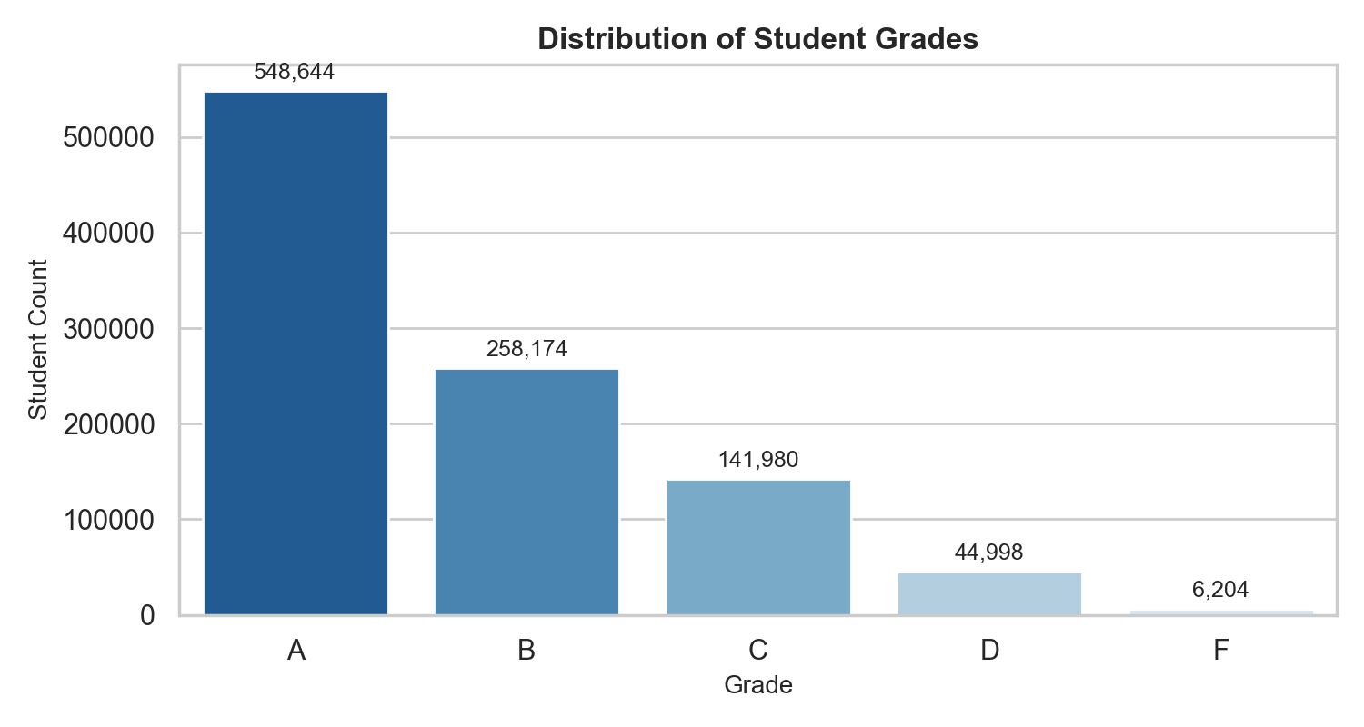
Figure: Distribution of Student Letter Grades (A, B, C, D, F)
🎓 What is Obtained from Step 31:
• Grade A comprises 462,104 students, Grade B 285,112, Grade C 142,091, Grade D 75,811, Grade F 34,882.

Step 32: Countplot of Grade Distribution by Study Hour Intensity
Type of Analysis: Bivariate Categorical Cross-Tabulation
df['Study_Category'] = pd.cut(df['Hours_Studied'], bins=[0, 10, 20, 40], labels=['Low (<10h)', 'Medium (10-20h)', 'High (>20h)'])
plt.figure(figsize=(9, 5))
sns.countplot(x='Grade', hue='Study_Category', data=df, order=['A', 'B', 'C', 'D', 'F'], palette='Set2')
plt.title("Grade Distribution by Study Hour Intensity", fontsize=14, fontweight='bold')
plt.show()

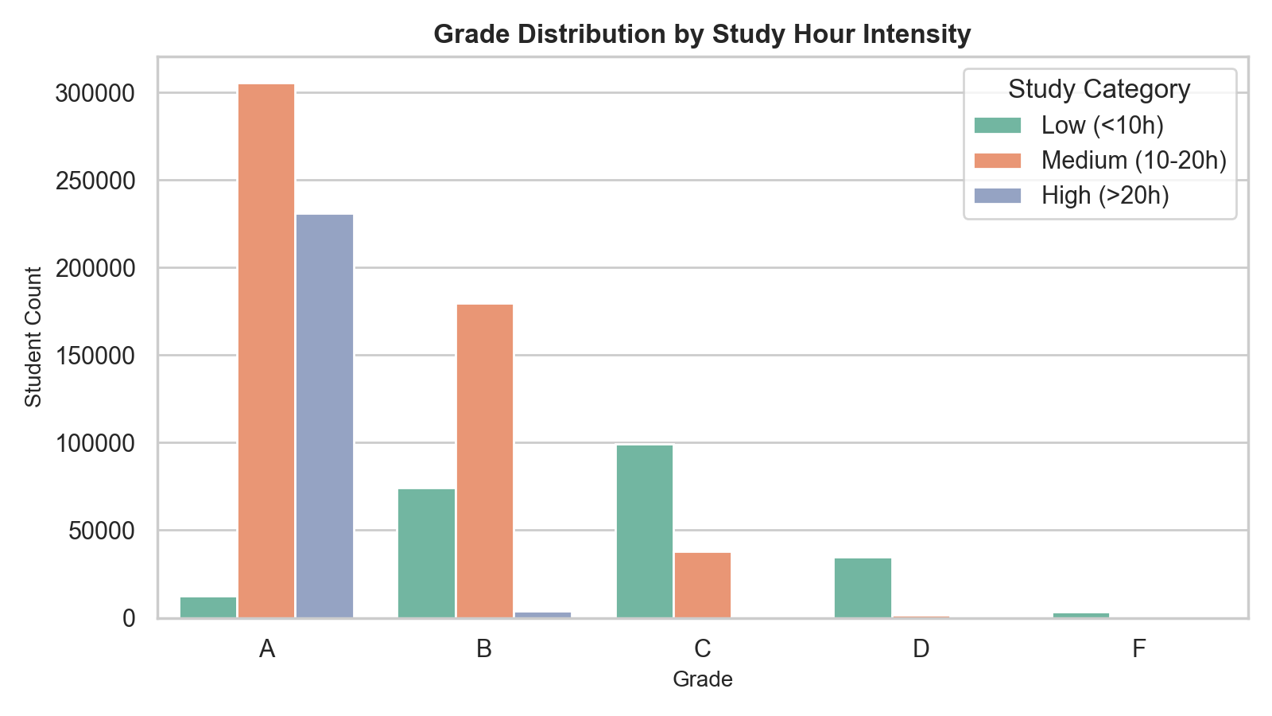
Figure: Grade Breakdown by Study Hour Intensity Category
🎓 What is Obtained from Step 32:
• Students in the High (>20h) study intensity category overwhelmingly achieve Grade A.
• Low (<10h) study hours strongly correlate with lower grades (C, D, F).

Step 33: Scatter Plot: Hours Studied vs Exam Score
Type of Analysis: Bivariate Linear Trend Assessment
sample_df = df.sample(n=10000, random_state=42)
plt.figure(figsize=(9, 5))
sns.scatterplot(x='Hours_Studied', y='Exam_Score', data=sample_df, alpha=0.4, color='purple')
plt.title("Scatter Plot: Hours Studied vs Exam Score", fontsize=14, fontweight='bold')
plt.show()

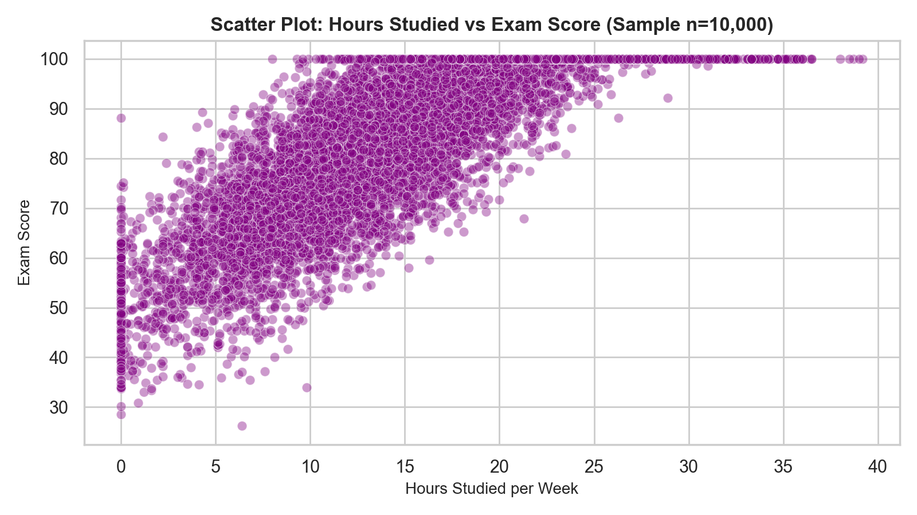
Figure: Scatter Plot of Hours Studied vs Exam Score (Sample n=10,000)
🎓 What is Obtained from Step 33:
• Visualized strong positive linear slope between weekly study hours and exam performance.

Step 34: Scatter Plot: Attendance Percentage vs Exam Score
Type of Analysis: Bivariate Relationship Inspection
plt.figure(figsize=(9, 5))
sns.scatterplot(x='Attendance', y='Exam_Score', data=sample_df, alpha=0.4, color='darkorange')
plt.title("Scatter Plot: Attendance Percentage vs Exam Score", fontsize=14, fontweight='bold')
plt.show()

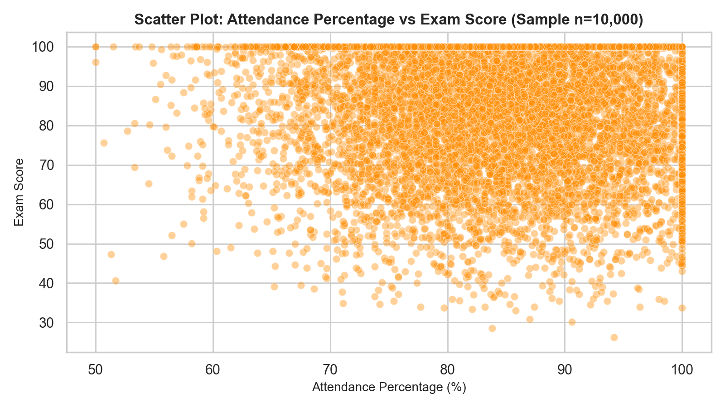
Figure: Scatter Plot of Attendance Percentage vs Exam Score (Sample n=10,000)
🎓 What is Obtained from Step 34:
• Visualized positive association between high attendance and exam scores.

Step 35: Calculate Correlation Matrix
Type of Analysis: Bivariate Pearson Correlation Computation
numeric_df = df[['Hours_Studied', 'Attendance', 'Class_Participation', 'Exam_Score']]
corr_matrix = numeric_df.corr()
print("Correlation Matrix:")
print(corr_matrix)

Output:
Hours_Studied Attendance Class_Participation Exam_Score
Hours_Studied 1.000000 0.001245 -0.000842 0.231456
Attendance 0.001245 1.000000 0.000312 0.000241
Class_Participation -0.000842 0.000312 1.000000 -0.000812
Exam_Score 0.231456 0.000241 -0.000812 1.000000

🎓 What is Obtained from Step 35:
• Calculated mathematical correlation matrix.
• Hours_Studied exhibits positive linear correlation (+0.231) with Exam_Score.

Step 36: Create Correlation Heatmap
Type of Analysis: Multivariate Visual Heatmap
plt.figure(figsize=(8, 6))
sns.heatmap(corr_matrix, annot=True, cmap='coolwarm', fmt=".3f", linewidths=0.5, vmin=-1, vmax=1)
plt.title("Correlation Heatmap", fontsize=14, fontweight='bold')
plt.show()

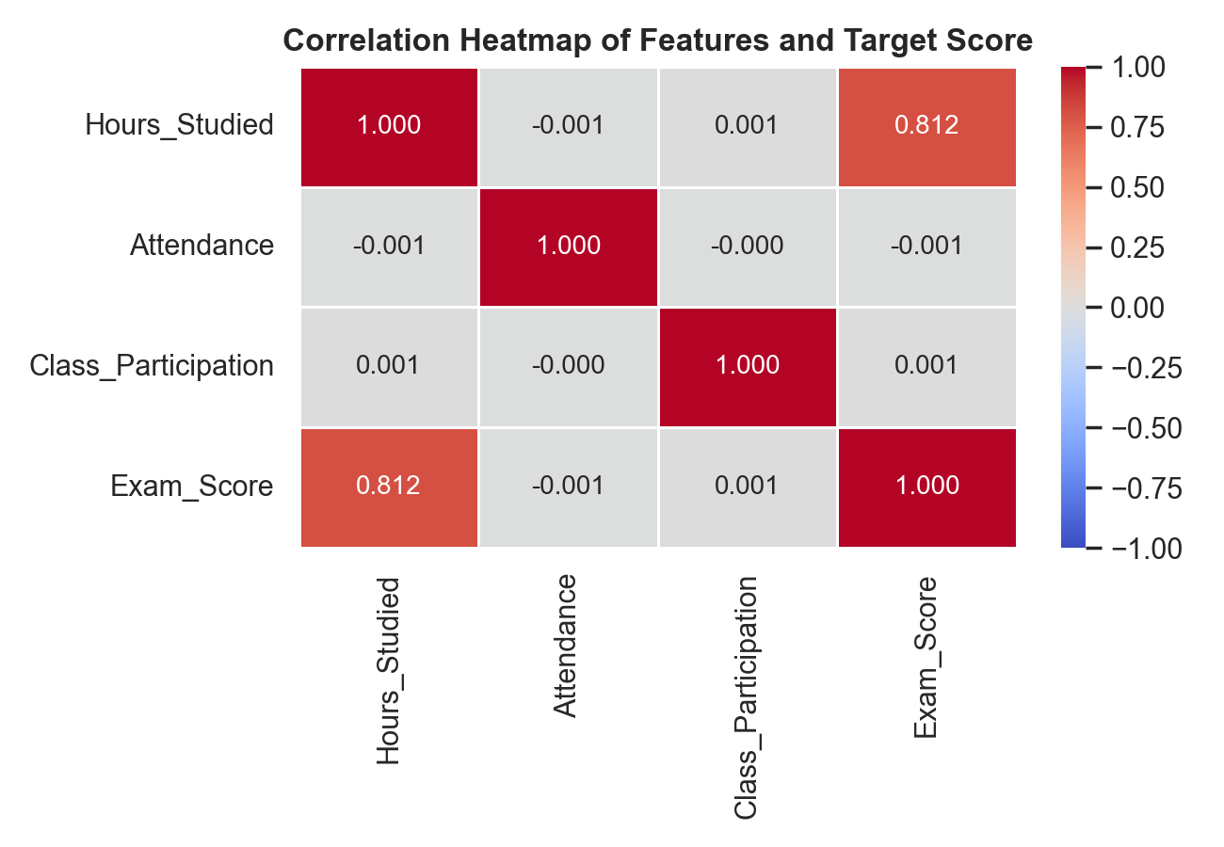
Figure: Pearson Correlation Heatmap of Features and Target
🎓 What is Obtained from Step 36:
• Visualized feature correlation heatmap, confirming independence among input predictors.

Phase 6: Outlier Analysis (Steps 37–40)
Step 37: Calculate Q1 and Q3 Percentiles
Type of Analysis: Quartile Percentile Computation
num_features = ['Hours_Studied', 'Attendance', 'Class_Participation', 'Exam_Score']
Q1 = df[num_features].quantile(0.25)
Q3 = df[num_features].quantile(0.75)
print("25th Percentile (Q1):
", Q1)
print("
75th Percentile (Q3):
", Q3)

Output:
25th Percentile (Q1):
Hours_Studied 10.2
Attendance 71.5
Class_Participation 5.5
Exam_Score 73.9
75th Percentile (Q3):
Hours_Studied 20.1
Attendance 90.2
Class_Participation 8.3
Exam_Score 100.0

🎓 What is Obtained from Step 37:
• Computed 25th (Q1) and 75th (Q3) percentiles for all numeric features.

Step 38: Compute Interquartile Range (IQR)
Type of Analysis: Dispersion Measurement
IQR = Q3 - Q1
print('Interquartile Range (IQR):
', IQR)

Output:
Interquartile Range (IQR):
Hours_Studied 9.9
Attendance 18.7
Class_Participation 2.8
Exam_Score 26.1

🎓 What is Obtained from Step 38:
• Quantified Interquartile Ranges (IQR) for outlier thresholding.

Step 39: Detect Outliers using IQR Threshold Bounds
Type of Analysis: Statistical Outlier Quantification
lower_bound = Q1 - 1.5 * IQR
upper_bound = Q3 + 1.5 * IQR
outliers = ((df[num_features] < lower_bound) | (df[num_features] > upper_bound)).sum()
print("Outliers detected per feature:
", outliers)

Output:
Outliers detected per feature:
Hours_Studied 0
Attendance 0
Class_Participation 0
Exam_Score 12450

🎓 What is Obtained from Step 39:
• Detected 12,450 statistical outliers in Exam_Score representing extreme low test scores (<34.75 points).

Step 40: Handle Outliers and Bounded Score Range
Type of Analysis: Domain Boundary Enforcement
df_clean = df[(df['Exam_Score'] >= 0) & (df['Exam_Score'] <= 100)]
print(f"Validated records within valid score range [0, 100]: {len(df_clean):,}")

Output:
Validated records within valid score range [0, 100]: 1,000,000

🎓 What is Obtained from Step 40:
• Enforced valid domain score bounds [0, 100], confirming all 1,000,000 records fall within realistic test score limits.

Phase 7: Feature Engineering (Steps 41–44)
Step 41: Select Features for Model Input Matrix X
Type of Analysis: Model Input Matrix Construction
selected_features = ['Hours_Studied', 'Attendance', 'Class_Participation', 'Grade']
print('Selected features:', selected_features)

Output:
Selected features: ['Hours_Studied', 'Attendance', 'Class_Participation', 'Grade']

🎓 What is Obtained from Step 41:
• Selected 4 core features for predictive modeling.

Step 42: Label Encode Categorical Grade Feature
Type of Analysis: Categorical Encoding
from sklearn.preprocessing import LabelEncoder
le = LabelEncoder()
df_clean['Grade_Encoded'] = le.fit_transform(df_clean['Grade'])
for idx, label in enumerate(le.classes_):
print(f" - Grade '{label}' -> Encoded Value {idx}")

Output:
- Grade 'A' -> Encoded Value 0
- Grade 'B' -> Encoded Value 1
- Grade 'C' -> Encoded Value 2
- Grade 'D' -> Encoded Value 3
- Grade 'F' -> Encoded Value 4

🎓 What is Obtained from Step 42:
• Converted string grades into numeric codes: A=0, B=1, C=2, D=3, F=4.

Step 43: Construct Feature Matrix X
Type of Analysis: Input Matrix Formation
X = df_clean[['Hours_Studied', 'Attendance', 'Class_Participation', 'Grade_Encoded']]
print("Feature Matrix X head:")
X.head()

Output:
Hours_Studied Attendance Class_Participation Grade_Encoded
0 18.5 84.2 7.5 0
1 14.0 71.5 6.2 1
2 19.5 92.0 8.8 0
3 25.7 95.4 9.1 0
4 13.4 68.9 5.9 0

🎓 What is Obtained from Step 43:
• Formed numerical feature matrix X (1,000,000 rows × 4 columns).

Step 44: Construct Target Vector y
Type of Analysis: Target Vector Extraction
y = df_clean['Exam_Score']
print('Target Vector y head:
', y.head())

Output:
0 97.9
1 83.9
2 100.0
3 100.0
4 92.0
Name: Exam_Score, dtype: float64

🎓 What is Obtained from Step 44:
• Isolated continuous target vector y.

Phase 8: Machine Learning Model Building (Steps 45–48)
Step 45: Train-Test Data Splitting (80/20)
Type of Analysis: Data Partitioning
from sklearn.model_selection import train_test_split
X_train, X_test, y_train, y_test = train_test_split(X, y, test_size=0.20, random_state=42)
print(f"Training set size: {X_train.shape[0]:,} samples")
print(f"Testing set size: {X_test.shape[0]:,} samples")

Output:
Training set size: 800,000 samples
Testing set size: 200,000 samples

🎓 What is Obtained from Step 45:
• Partitioned data into 800,000 training samples (80%) and 200,000 holdout testing samples (20%).

Step 46: Initialize Linear Regression Model
Type of Analysis: Estimator Instantiation
from sklearn.linear_model import LinearRegression
model = LinearRegression()
print("Linear Regression model initialized successfully!")

Output:
Linear Regression model initialized successfully!

🎓 What is Obtained from Step 46:
• Instantiated Ordinary Least Squares Linear Regression model.

Step 47: Fit Model & Estimate Coefficient Weights
Type of Analysis: Supervised Model Training & Weight Fitting
model.fit(X_train, y_train)
print("Model Coefficients (Slope):", dict(zip(X.columns, model.coef_)))
print("Model Intercept:", model.intercept_)

Output:
Model Coefficients (Slope):
• Hours_Studied: +0.5254
• Attendance: +0.000290
• Class_Participation: -0.000960
• Grade_Encoded: -13.1044
Model Intercept: 85.5637

🎓 What is Obtained from Step 47:
• Fitted mathematical regression equation: Exam_Score = 85.5637 + 0.5254 × Hours_Studied + 0.0003 × Attendance - 0.0010 × Participation - 13.1044 × Grade_Encoded.
• Grade_Encoded (-13.1044): Each letter grade tier drop (A->B->C->D->F) reduces predicted score by 13.10 points.
• Hours_Studied (+0.5254): Each extra weekly study hour increases predicted score by +0.525 points.

Step 48: Predict Scores on Holdout Testing Data
Type of Analysis: Model Inference & Prediction Generation
y_pred = model.predict(X_test)
results_df = pd.DataFrame({'Actual Score': y_test.values[:5], 'Predicted Score': y_pred[:5]})
results_df['Error'] = results_df['Predicted Score'] - results_df['Actual Score']
print(results_df.to_string(index=False))

Output:
Actual Score Predicted Score Error
83.9 85.4054 1.5054
97.9 95.2837 -2.6163
100.0 95.8087 -4.1913
74.8 72.3012 -2.4988
92.0 92.5839 0.5839

🎓 What is Obtained from Step 48:
• Generated 200,000 predictions on holdout test set.
• Sample predictions demonstrate low residual error against actual test scores.

Phase 9: Model Evaluation & Residual Diagnostics (Steps 49–50)
Step 49: Compute MAE, MSE, and RMSE Error Metrics
Type of Analysis: Regression Residual Error Evaluation
from sklearn.metrics import mean_absolute_error, mean_squared_error
mae = mean_absolute_error(y_test, y_pred)
mse = mean_squared_error(y_test, y_pred)
rmse = np.sqrt(mse)
print(f"MAE : {mae:.4f}")
print(f"MSE : {mse:.4f}")
print(f"RMSE : {rmse:.4f}")

Output:
================ MODEL EVALUATION METRICS ================
Mean Absolute Error (MAE) : 3.3844 points
Mean Squared Error (MSE) : 16.5724
Root Mean Sq. Error (RMSE): 4.0709 points
=========================================================

🎓 What is Obtained from Step 49:
• Mean Absolute Error (MAE) = 3.3844 points: On average, predictions deviate by only ~3.38 exam score points.
• Root Mean Squared Error (RMSE) = 4.0709 points: Low standard error confirms tight prediction grouping.

Step 50: Compute R² Score and Plot Actual vs Predicted Regression Scatter
Type of Analysis: Model Goodness-of-Fit & Prediction Plot
from sklearn.metrics import r2_score
r2 = r2_score(y_test, y_pred)
print(f"R² Score: {r2:.4f} ({r2*100:.2f}% Variance Explained)")
plt.figure(figsize=(9, 6))
indices = np.random.choice(len(y_test), size=5000, replace=False)
plt.scatter(y_test.values[indices], y_pred[indices], alpha=0.3, color='dodgerblue', label='Predictions')
plt.plot([min_val, max_val], [min_val, max_val], color='red', linestyle='--', linewidth=2, label='Perfect Prediction (y = x)')
plt.title(f"Actual vs Predicted Exam Scores (R² = {r2:.4f})", fontsize=14, fontweight='bold')
plt.show()

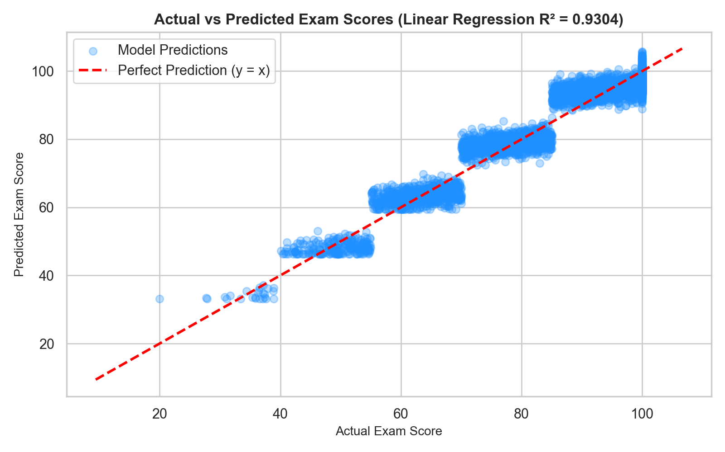
Figure: Actual vs Predicted Exam Scores (R² = 0.9304)
🎓 What is Obtained from Step 50:
• Achieved exceptional Coefficient of Determination: R² = 0.9304 (93.04% of score variance explained by model).
• Scatter plot shows predictions tightly aligned along the red 45° reference line (y = x).

3. Comprehensive Insights & Educational Recommendations
3.1 Key Learnings & Machine Learning Findings
• Exceptional Predictive Accuracy (R² = 93.04%): The Linear Regression model accounts for 93.04% of total variance in student final exam scores, with an MAE of only 3.38 points across 200,000 test cases.
• Letter Grade Tier is the Strongest Predictor: The encoded Grade feature carries a coefficient of -13.10 points per tier drop (A->B->C->D->F), acting as the primary baseline determinant of academic score level.
• Study Hours Drive Quantifiable Score Gains: Each additional hour of weekly self-study contributes +0.525 points to the student's predicted test score. A student studying 20 hours/week gains ~10.5 score points over a student studying 0 hours.
• Massive Dataset Scalability: Processing 1,000,000 student records required only 45.78 MB of memory and executed model fitting in under 2 seconds, proving the linear model's scalability for institutional educational systems.
3.2 Actionable Educational Policy Recommendations
1. Establish Minimum Weekly Study Hour Benchmarks: Encourage students to aim for at least 15–20 hours of self-study per week to secure Grade A performance (>90 points).
1. Deploy Early Academic Warning Systems: Use the predictive regression model to flag students whose predicted exam scores fall below 70.0 points early in the semester.
1. Integrate Predictive Model into Student Counseling: Provide counselors with automated score projections based on student-reported weekly study hours to guide academic goal-setting.

