**Qlick Sense**

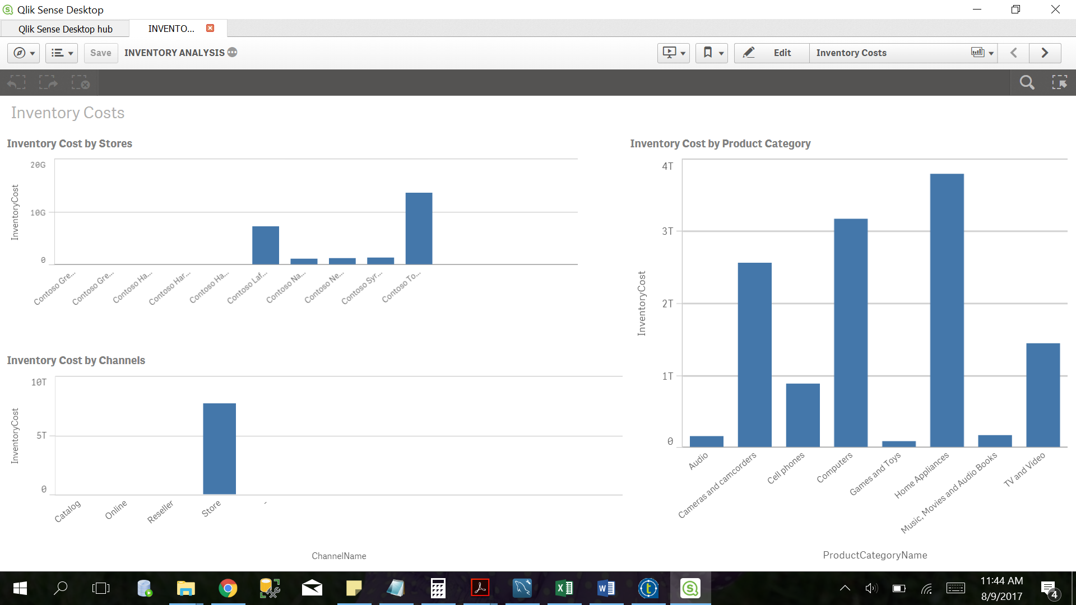

Figure 1: Inventory Costs by store, channel and product category

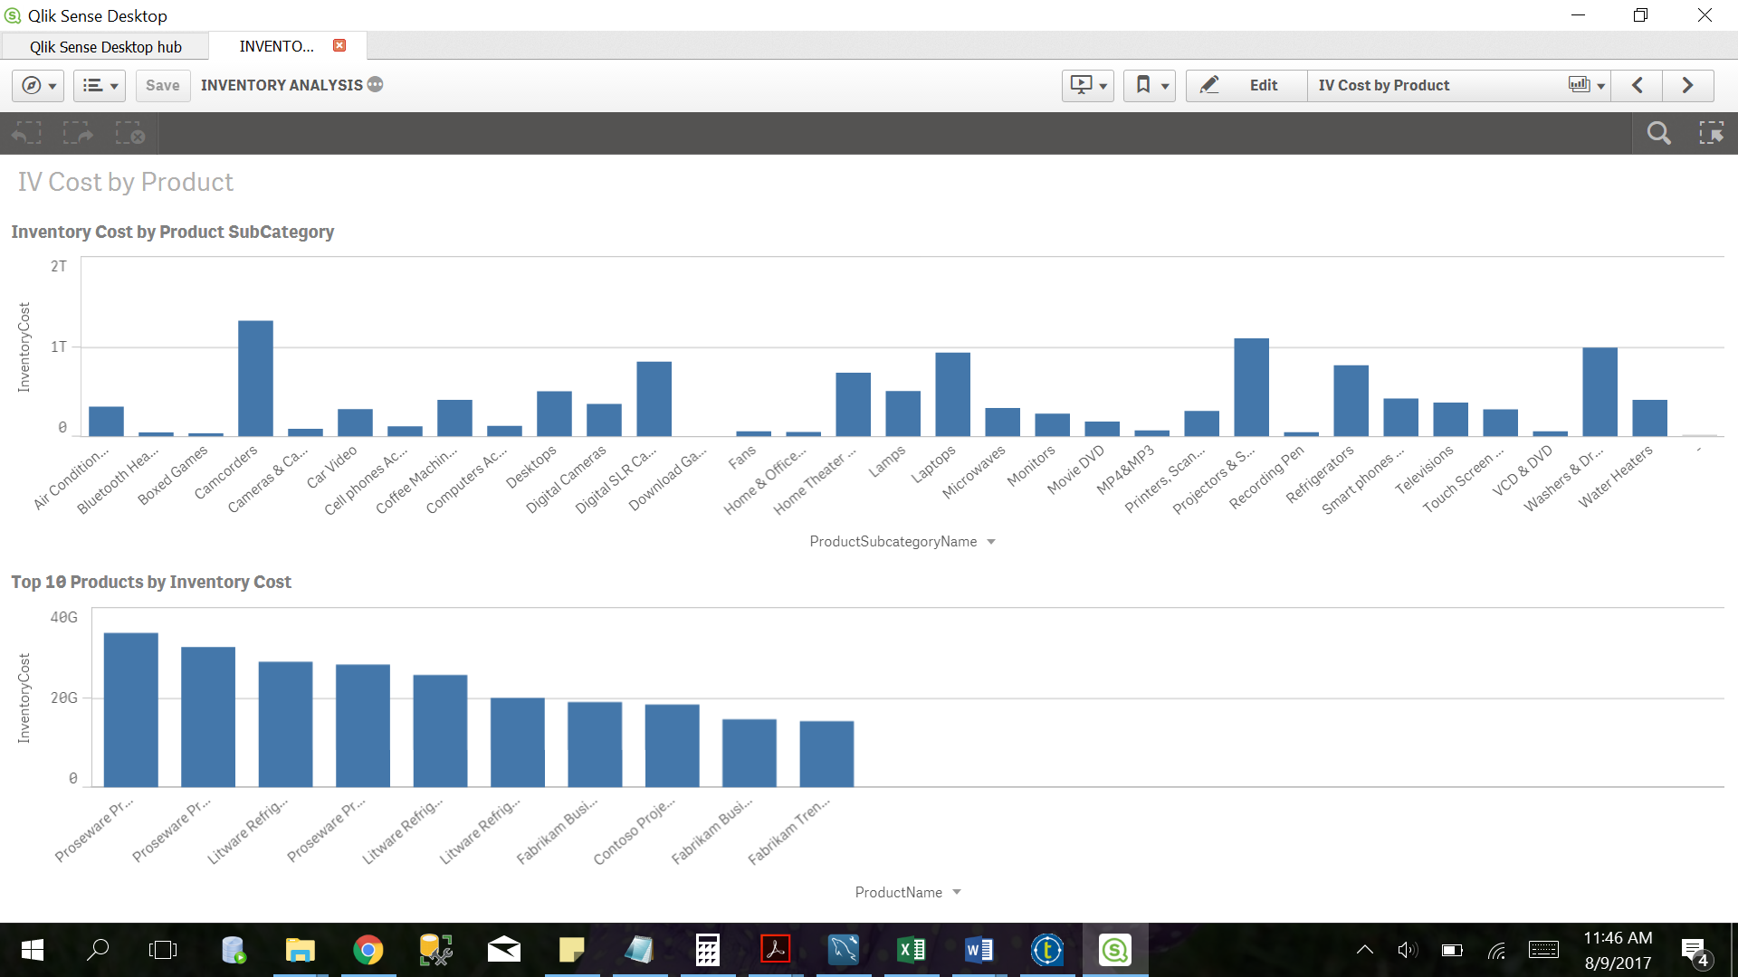

Figure 2: Inventory analysis by product subcategory

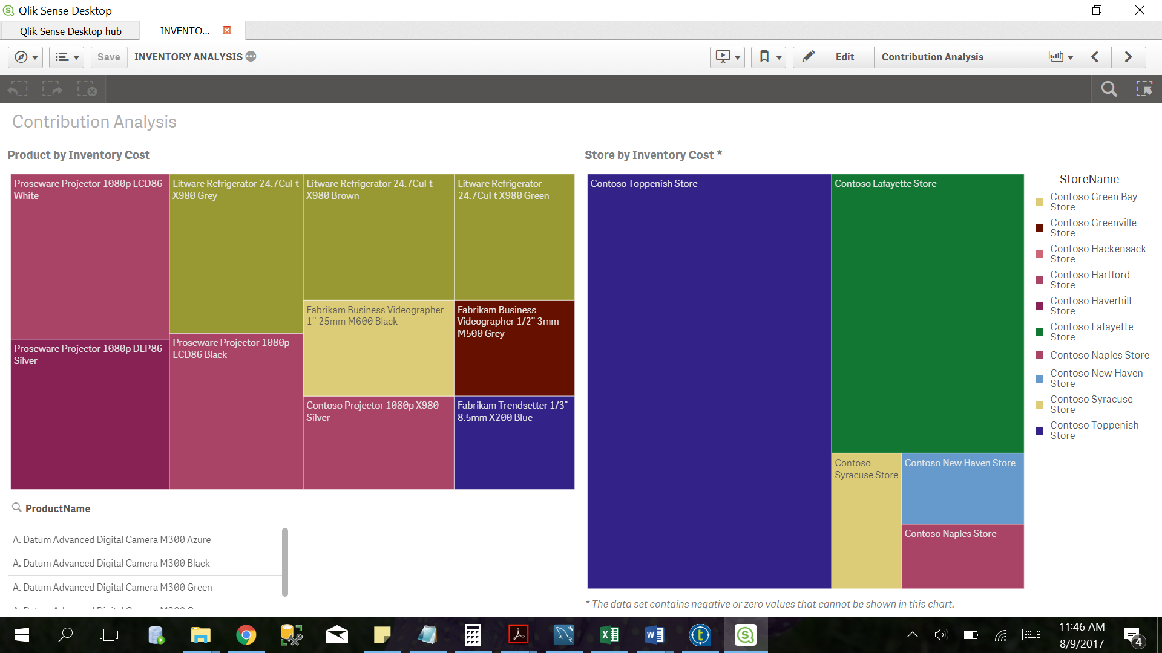

Figure 3: Contribution Analysis by inventory cost

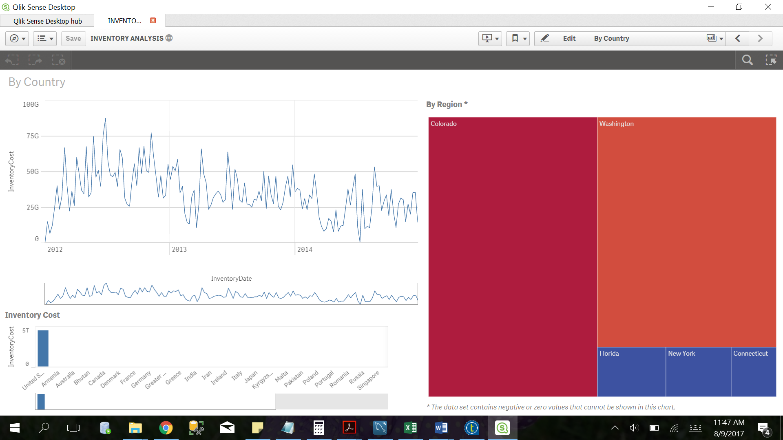

Figure 4: Inventory Analysis by country and region

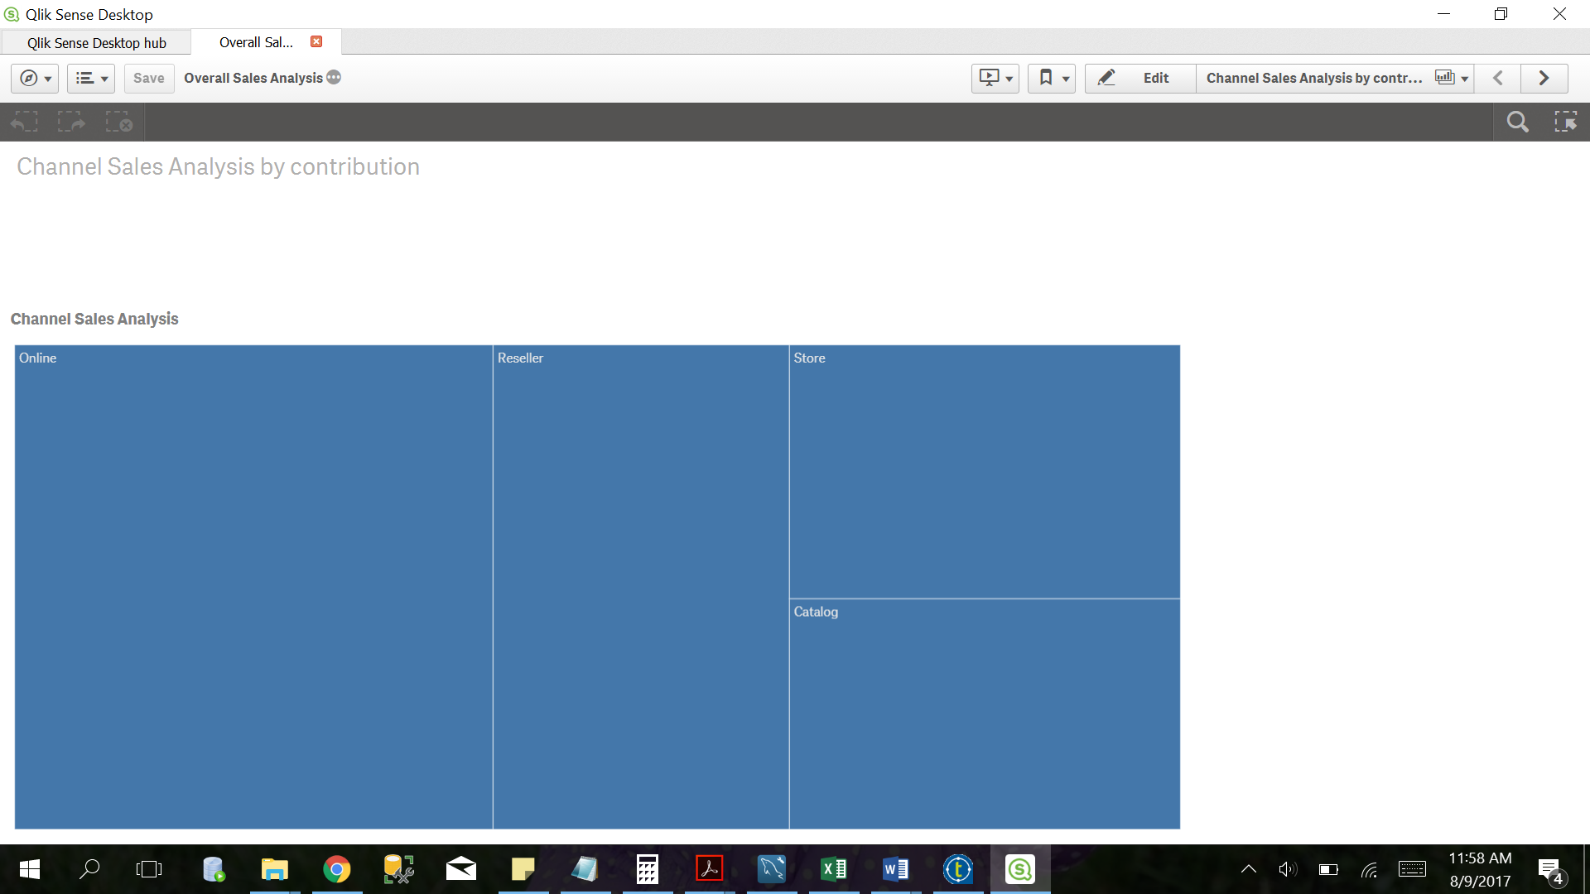

Figure 5: Sales Analysis by contribution

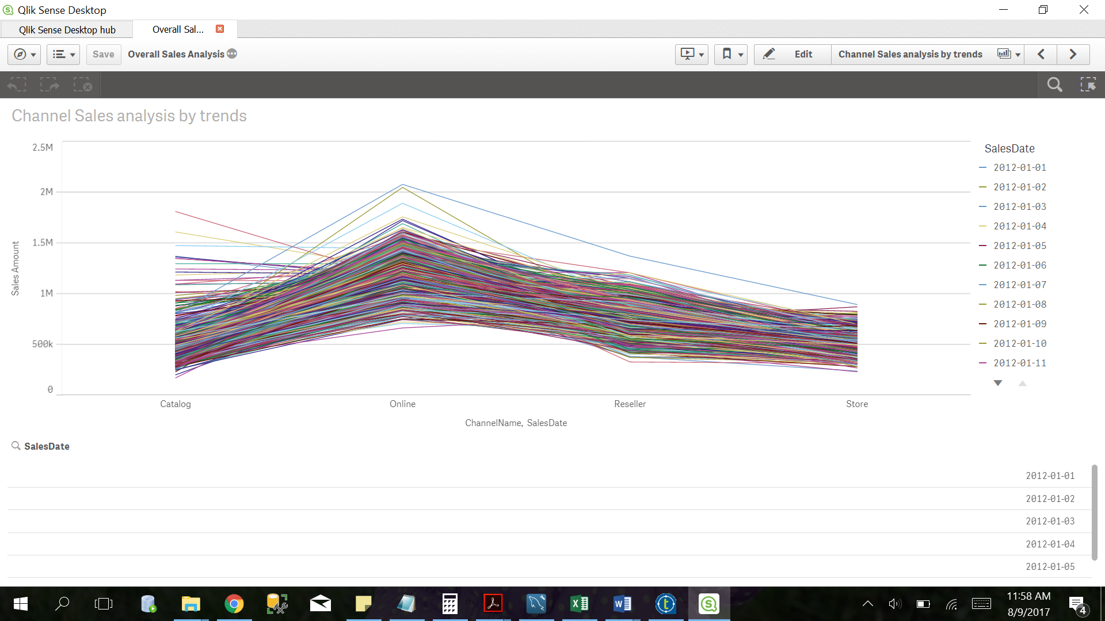

Figure 6: Sales Analysis by trends

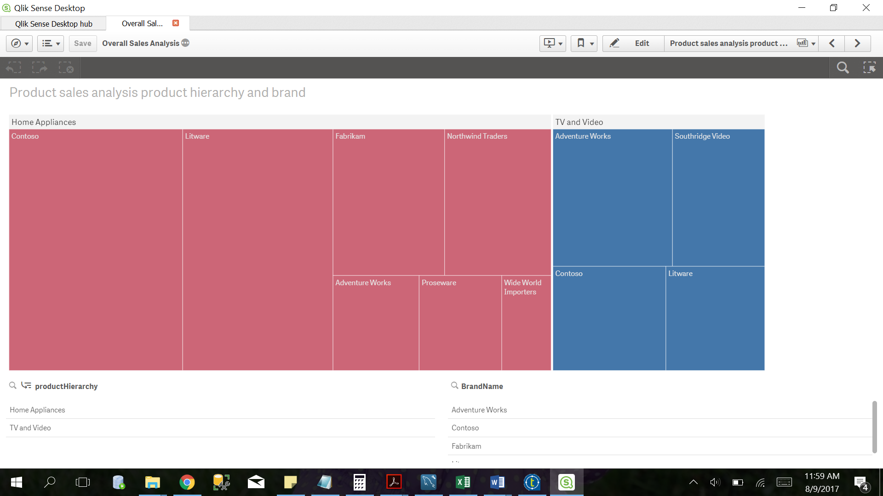

Figure 7: Sales analysis by product hierarchy and brand

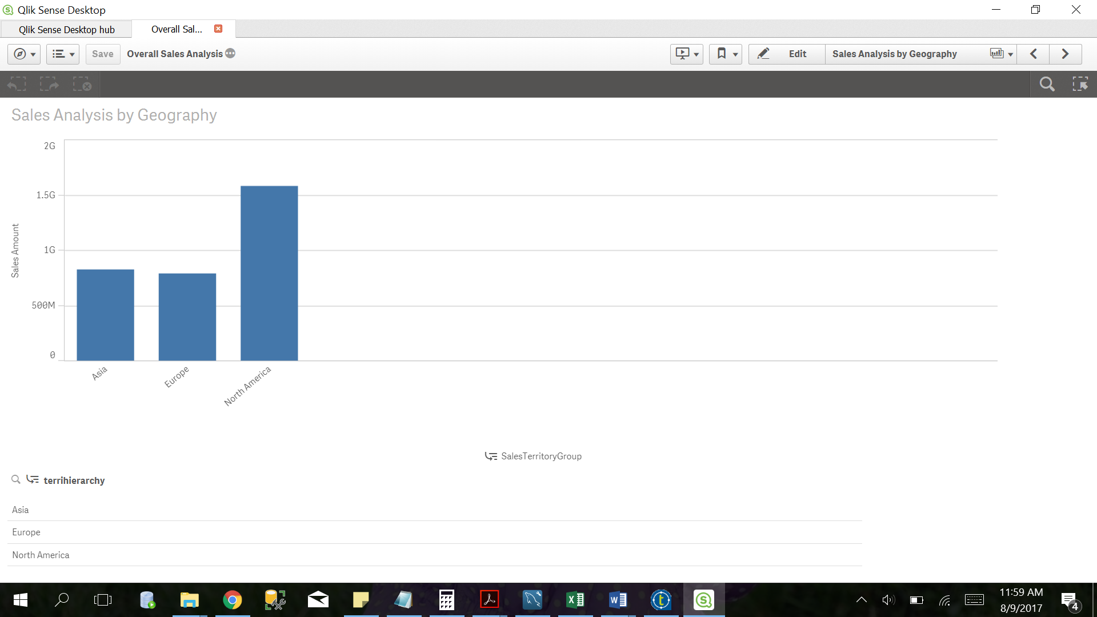

Figure 8: Sales Analysis by geography

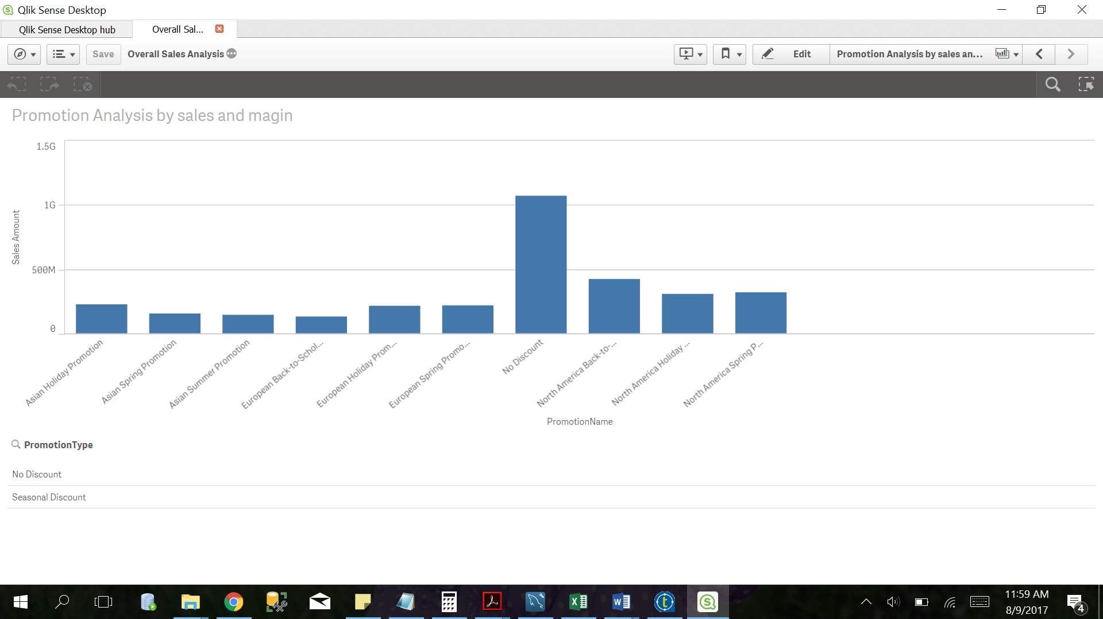

Figure 9: Promotion Analysis by sales and margin

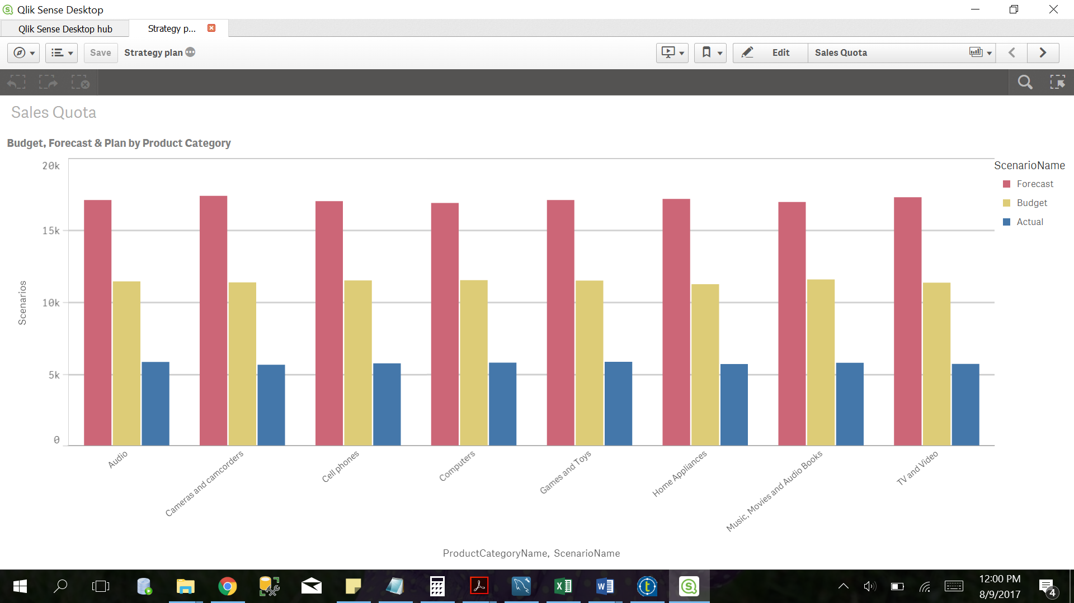

Figure 10: Strategy Plan analysis by product category

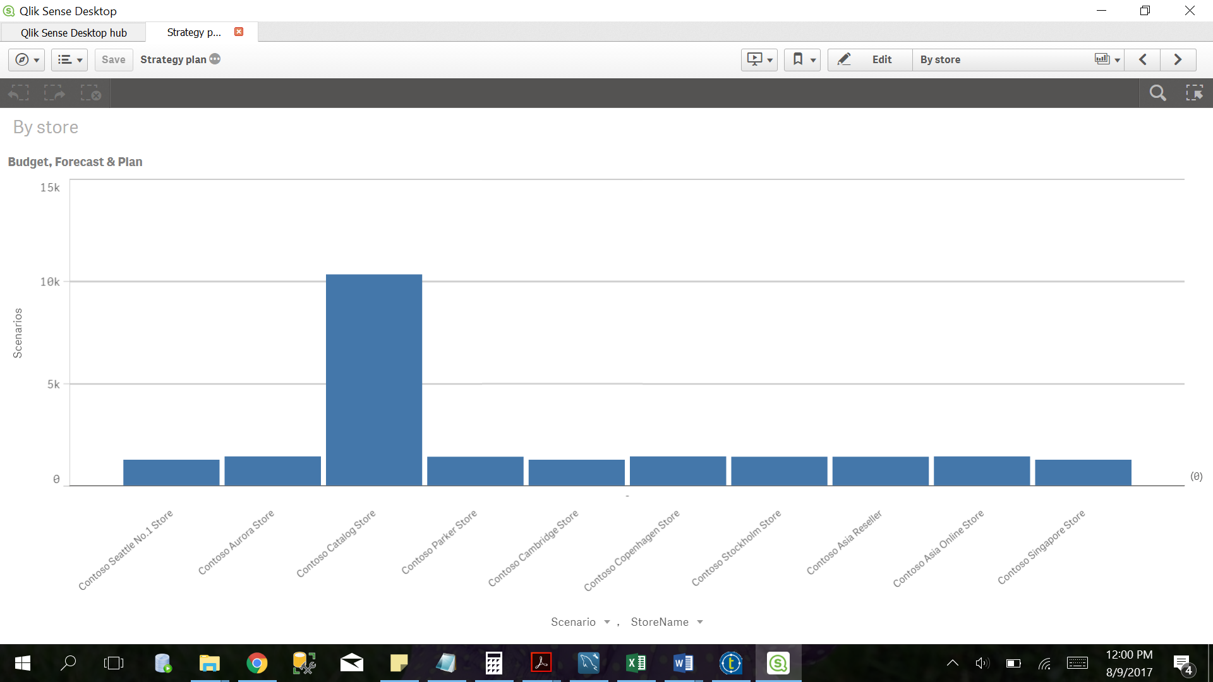

Figure 11: Strategy Analysis by store

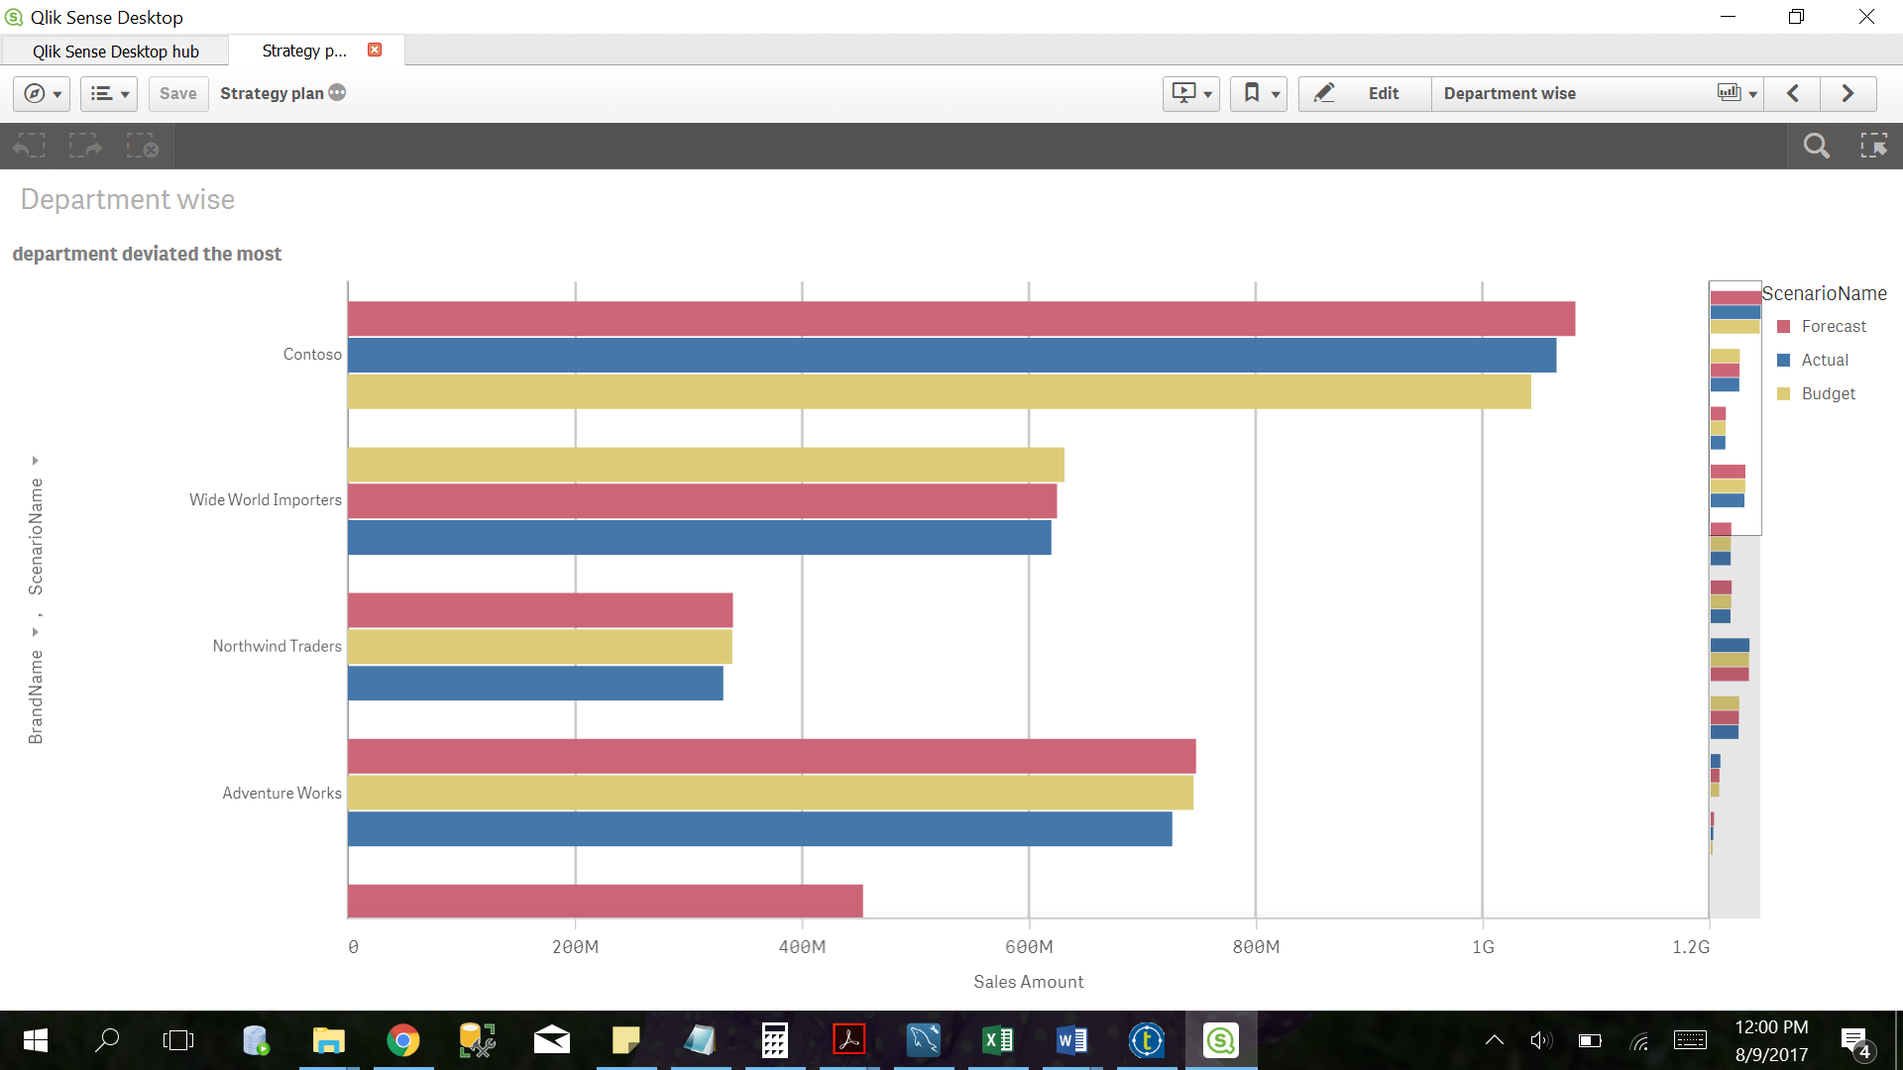

Figure 12: Strategy Analysis by department

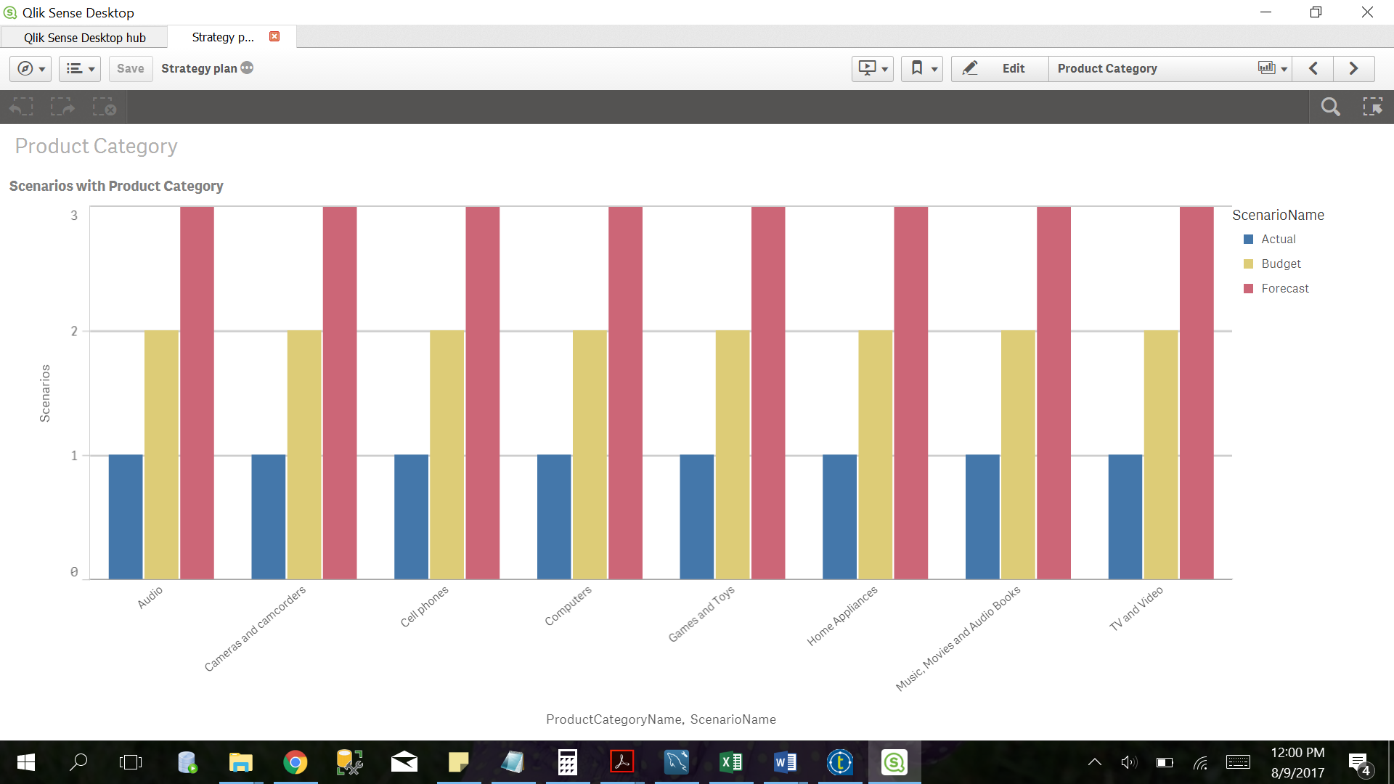

Figure 13: Strategy Analysis by scenarios

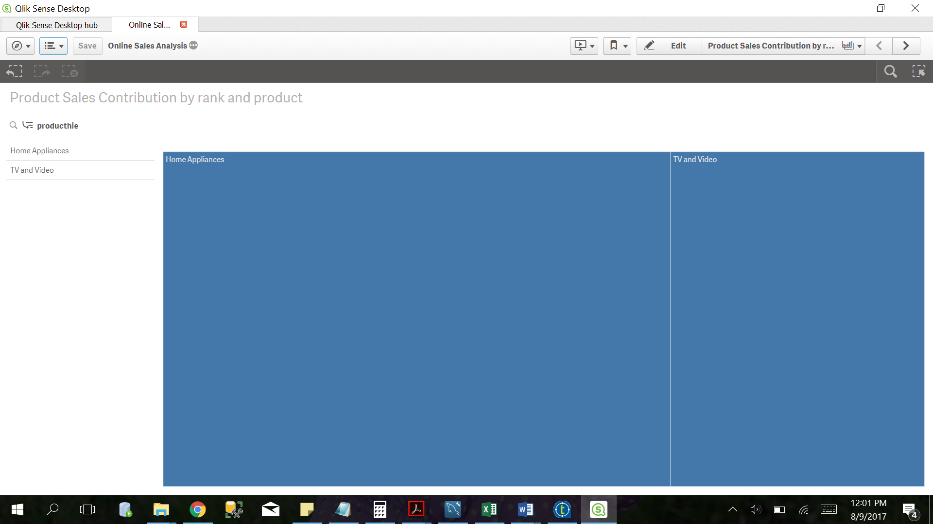

Figure 14: Online Sales Analysis by rank

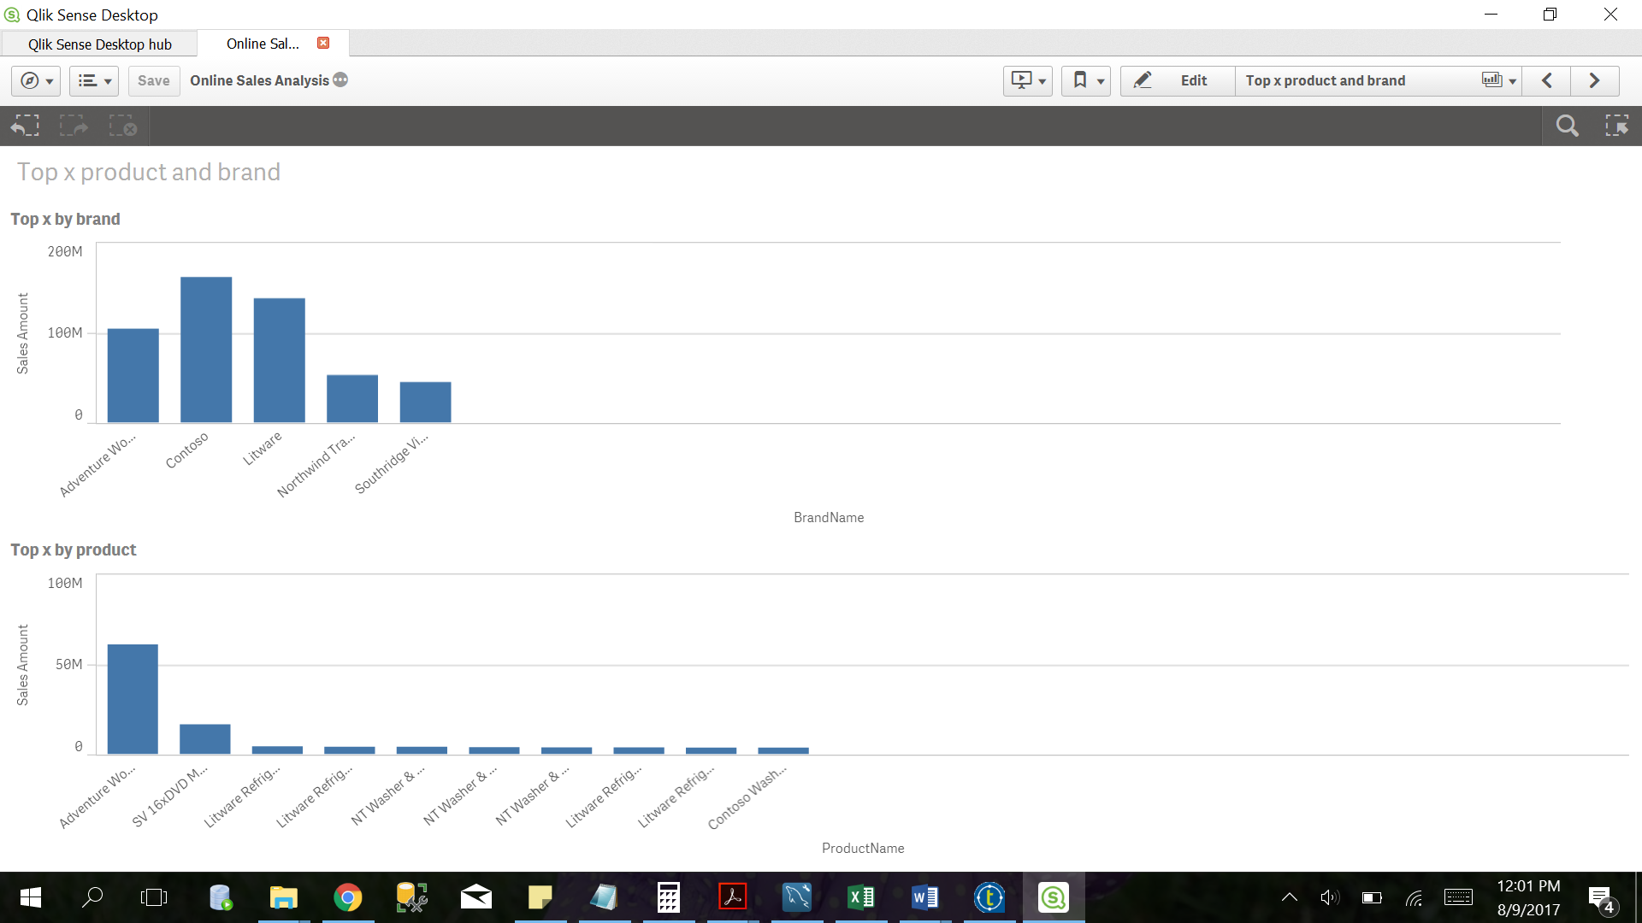

Figure 15: Online Analysis by product

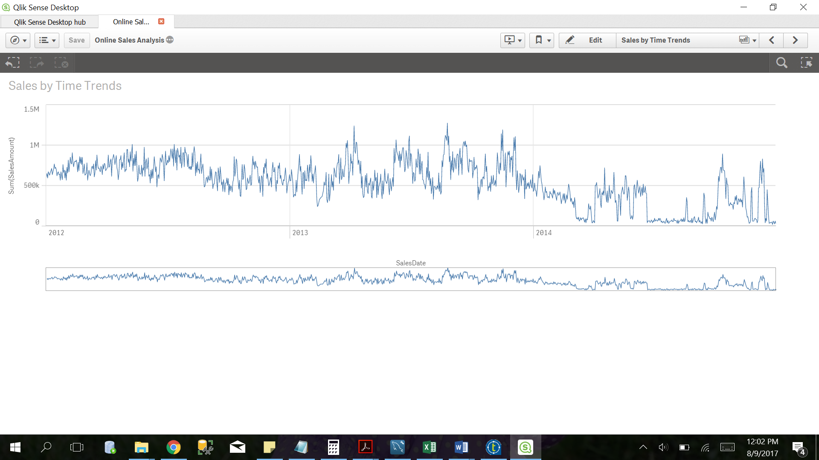

Figure 16: Online Sales Analysis by time trends

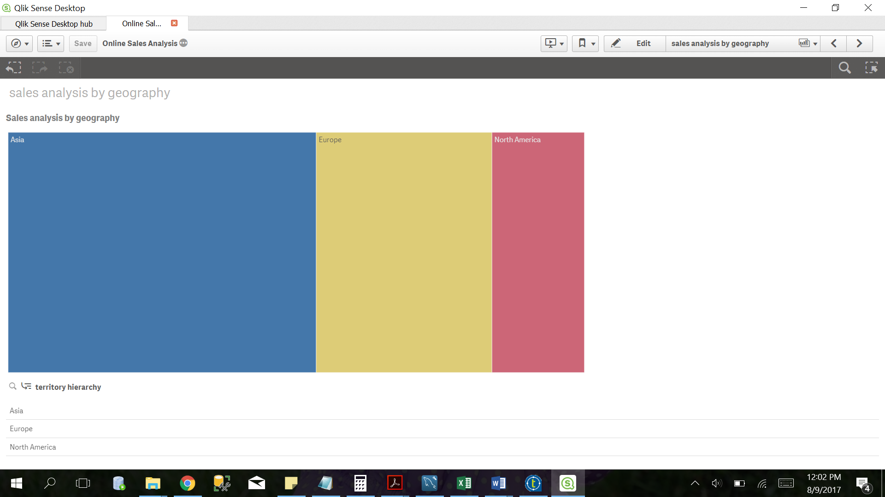

Figure 17: Online Sales Analysis by geography

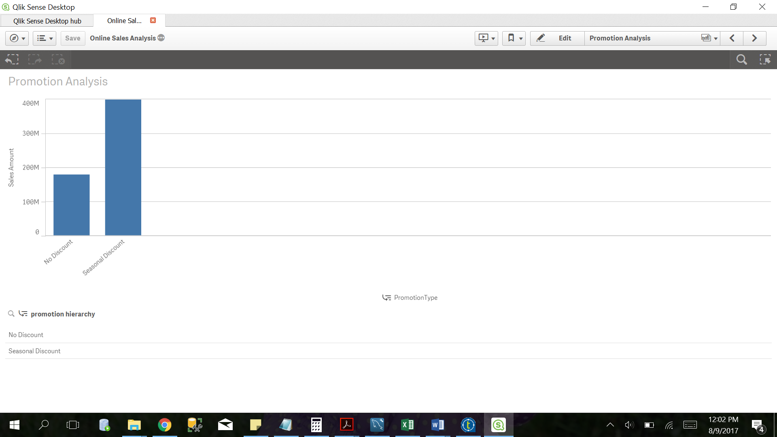

Figure 18: Promotion Analysis by discount