Que 1

%DSB-FC

clear all;

close all;

fs = 1000;

t = 0:1/fs:1;

fm = 4;

m = cos(2\*pi\*fm\*t);

figure(1);

plot(t,m);

xlabel('Time');

ylabel('Amplitude');

title(['Cosine Message Wave fm = ',num2str(fm),'Hz']);

%Spectrum of Message Signal

%Absolute frequency on X-axis vs. Magnitude on Y-axis

N = length(m);

M = fftshift(fft(m,N));

f = fs\*[-N/2:N/2-1]/N;

figure(2);

plot(f,abs(M));

xlabel('Absolute frequency');

ylabel('DFT values');

title('Spectrum of Message Signal');

%Carrier Signal Generation

fc = 50;

A = 1;

c = A\*cos(2\*pi\*fc\*t);

figure(3);

plot(t,c);

xlabel('Time');

ylabel('Amplitude');

title(['Cosine Carrier wave fc=',num2str(fc),'Hz']);

%Spectrum of the Carrier Signal

%Absloute frequency on X-axis vs. Magnitude on Y-axis

C = fftshift(fft(c,N));

figure(4);

plot(f,abs(C));

xlabel('Absolute Frequency');

ylabel('DFT Values');

title('Spectrum of Carrier Signal');

%DSB-FC

x = m.\*c + c;

figure(5);

plot(t,x);

xlabel('Time');

ylabel('Amplitude');

X = fftshift(fft(x,N));

figure(6);

plot(f,abs(X));

xlabel('Aboslute Frequency');

ylabel('DFT Values');

title('Spectrum of DSB-FC Signal');

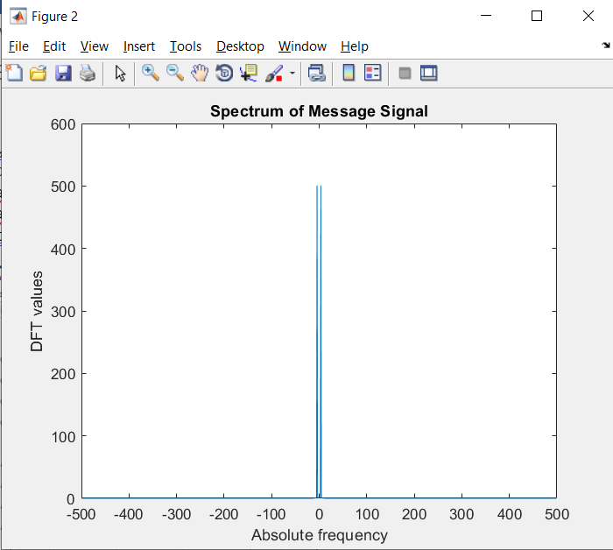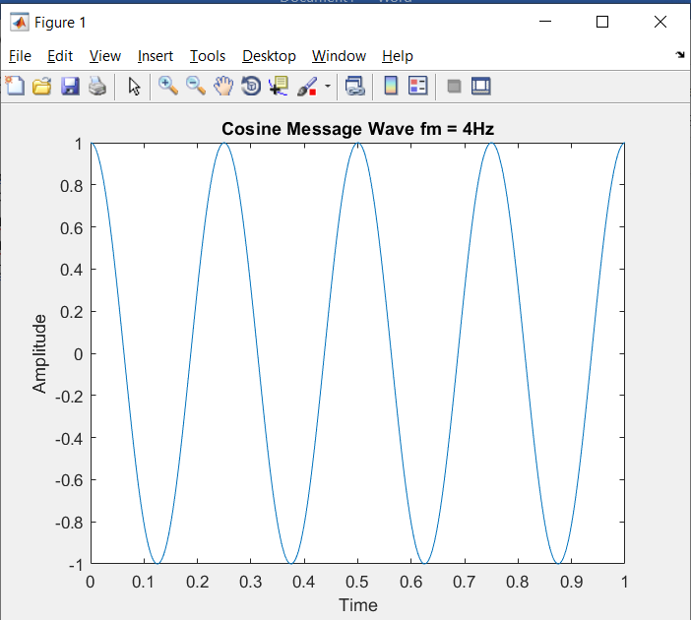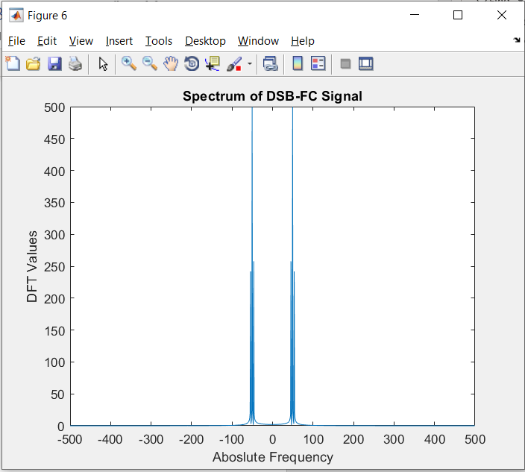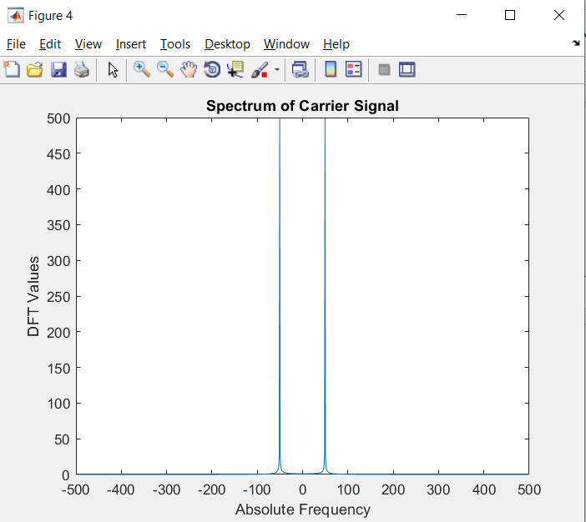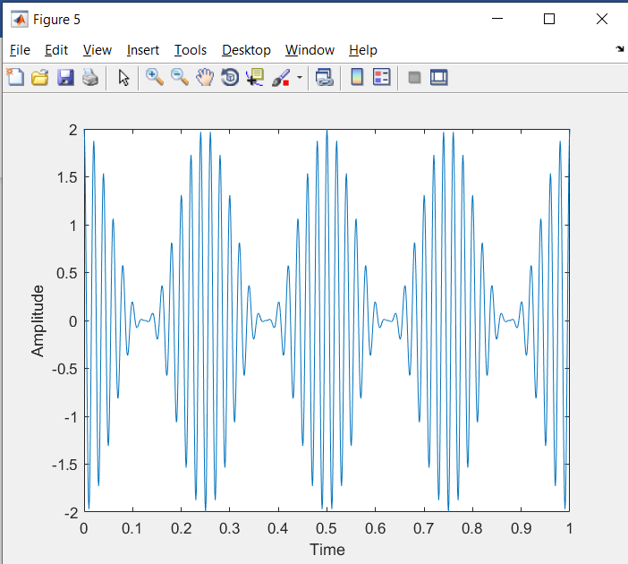

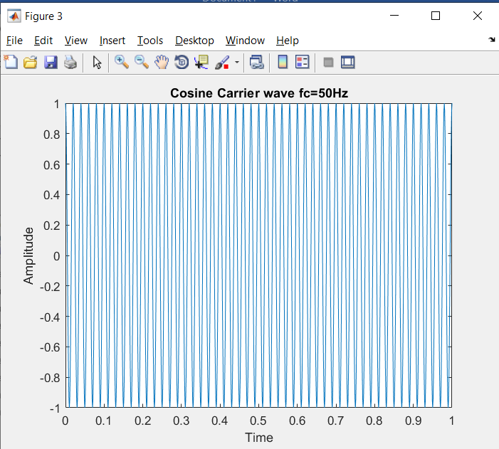

Que 2

clc;

close all;

clear all;

a=1;

fc=5;

t=0:0.001:1;

c=a\*sin(2\*pi\*fc\*t);

subplot(3,1,1);

plot(t,c)

y = awgn(c,30,'measured');

subplot(3,1,2);

plot(t,y + c);

