**BRACT’s**

**Vishwakarma Institute of Technology, Pune-37**

**Department of Electronics Engineering**

**Course Project Report for Electronic Circuits**

-Guided by M.E.Rane Sir

**Course Project Name:** **Water Level Indicator**

**Class:**SY **Division:** A

**Semester:**1 **Academic Year:**2019-20

***Student Details:***

|  |  |  |
| --- | --- | --- |
| Name | GR.NO. | Roll No. |
| Kunal Gaikwad | 11810864 | 37 |
| Ruturaj Deshmukh | 11810243 | 31 |

**Project description:**

Today water is one of the precious resources. In this tutorial I am going show how we can make a very simple water level indicator which not only shows the current water level in water tank but also helps to save water from overflowing while filling it. 

The circuit is based on logic NOT and logic AND gate. For these we have used 2 7404 IC which contains 6 NOT gates and 2 7408 IC which contains 4 AND gates. Using eight wires at different height of tank the circuit can sense 8 different level of water. Here the wires work as sensor. The sensor at the bottom is connected to the ground of the circuit. Rest sensors otr leds are connected to the input of four NOT gates. These NOT gate inputs are pulled high by 1MΩ resistance. The output of these NOT gates are connected with AND gates as per below circuit diagram. The output of the AND gates are connected with LEDs via 222Ω resistance.

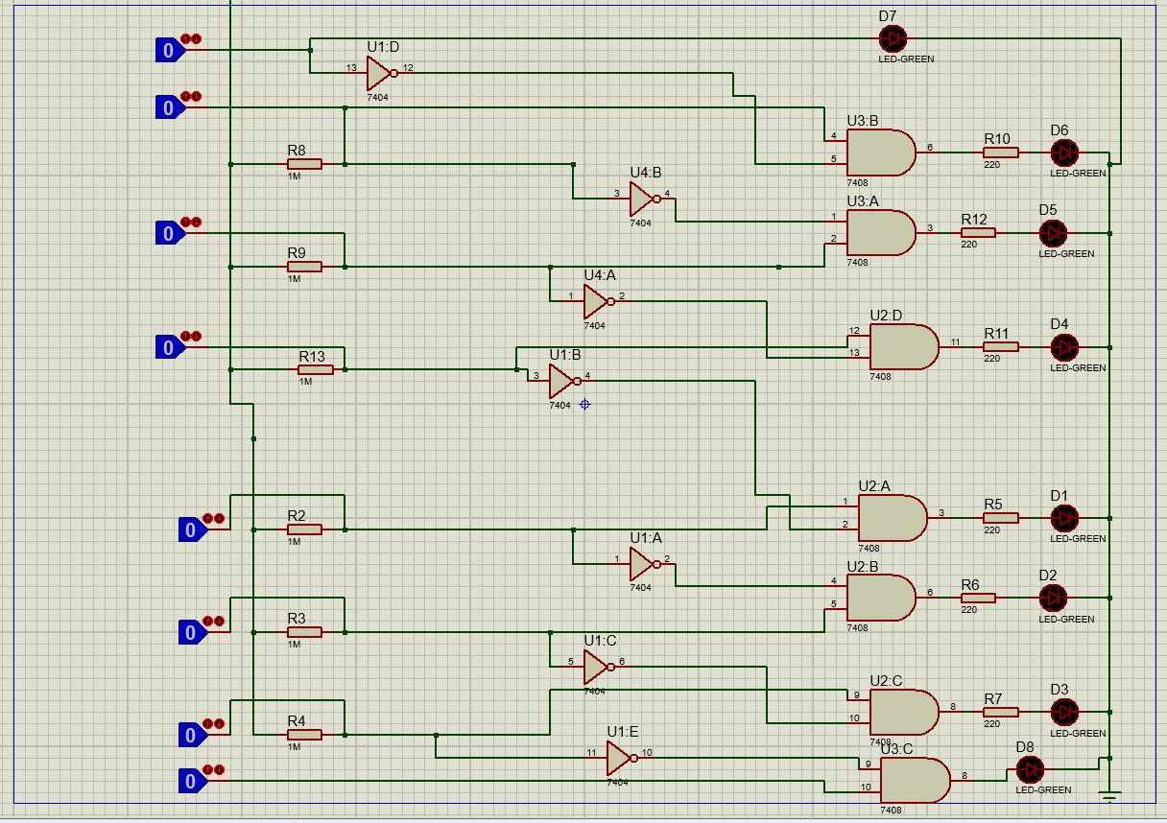

So, the circuit not only capable of cautioning a person that the water tank has been filled up to certain level, but also indicates that the water level has fallen below the minimum detectable level. This circuit is important in appliances such as the water cooler where there is a danger of motor-burnout when there is no water in the radiator used up also it can be used in fuel level indication.

**List of components**

* 7404 IC (NOT Gate)
* 7408 IC (AND Gate)
* 1MΩ Resistance
* 222Ω Resistance
* LED (Red, Yellow, Green)
* Buzzer
* 7805 IC(Votage Regulator)

**Observations:**

We observe that whenever the water reaches the specific level the level is indicated by the three different colours of led and when he water reaches the top level ,alarm is given by buzzer ensure that water doesn’t overflow.Circuitory is based on input and output to the gates used in the 7401 and 7404 Integrated circuits and can be used widely.

**Conclusion:**

This project will be very useful in rural Areas where people are unable to buy expensive tools or materials due to financial conditions and it will also help to save the water due to overflow which is the need of today’s world.

**References:**

* WikiPedia
* You Tube