**Tiny Particles, Big Impact:**

**Nanoformulated Tobramycin for Cystic Fibrosis**

INTRODUCTION-

Cystic fibrosis is an autosomal recessive, monogenetic disorder caused by mutations in the cystic fibrosis transmembrane conductance regulator (CFTR) gene. It is characterized by the buildup of thick, sticky mucus in the lungs and other organs, leading to frequent respiratory infections and inflammation. Chronic bacterial infections, especially with *Pseudomonas aeruginosa*, are a major cause of lung damage and morbidity in CF patients

Tobramycin is a potent aminoglycoside antibiotic commonly used in the treatment of severe bacterial infections, particularly those caused by Gram-negative bacteria. It works by inhibiting bacterial protein synthesis, leading to cell death. Given its effectiveness against *Pseudomonas aeruginosa*, a common pathogen in patients with cystic fibrosis, tobramycin has become a cornerstone in managing pulmonary infections associated with this condition. Tobramycin, administered either via intravenous or inhaled routes, has demonstrated significant efficacy in reducing bacterial load, improving lung function, and enhancing the quality of life in CF patients.

Tobramycin binds to the 16s ribosomal RNA component of the bacterial 30s ribosomal unit, inhibiting the initiation step of translation. By binding to the A-site, tobramycin induces mistranslation and causes transfer RNA to misread the codon, thus causing incorrect delivery of aminoacyl units. Incorrectly synthesized proteins build up inside the cell, disrupting the cell membrane and various cellular processes; this mechanism of action designates tobramycin as a bactericidal agent.

EXISTING FORMULATIONS-

The development and widespread use of chronic suppressive aerosolized antibacterial therapies, in particular **Tobramycin Inhalation Solution (TIS)**, in CF has contributed to reduced lung function decline and improved survival. However, the requirement for the aerosolization of these agents through nebulizers has been associated with increased treatment burden, reduced quality of life and remain a barrier to broader uptake.

**Tobramycin Inhalation Powder (TIP)** has been developed by Novartis with the express purpose of delivering the same benefits as TIS in a time-effective manner. In clinical studies, TIP has been shown to be safe, result in equivalent or superior reductions in *P. aeruginosa* sputum density and produce similar improvements in pulmonary function. TIP offers significant advantages in time saving, portability and convenience over traditional nebulized TIS with comparable clinical outcomes for individuals with CF.

Inhaled antibiotic [tobramycin](https://www.sciencedirect.com/topics/pharmacology-toxicology-and-pharmaceutical-science/tobramycin) (TIP) for the treatment of [Pseudomonas aeruginosa](https://www.sciencedirect.com/topics/immunology-and-microbiology/pseudomonas-aeruginosa) pulmonary infections are associated with the increase in life expectancy seen in [cystic fibrosis](https://www.sciencedirect.com/topics/pharmacology-toxicology-and-pharmaceutical-science/cystic-fibrosis) patients over recent years. The efficacy of free drug administration in CF patients is not high enough to achieve therapeutics levels at the site of infection due to its rapid clearance and poor mucus penetration. These drawbacks could be overcome by nanotechnology. Encapsulation of antibiotics into nanocarriers has attracted considerable interest to improve the therapeutic index of antimicrobials. Moreover, many cystic fibrosis patients present an accumulation of dehydrated and thicker mucus within the airways causing respiratory problems, therefore, it is important for therapeutic agents to penetrate into this mucus in order to distribute the drug and maximize its antibacterial effect. Nano-antibiotic represents a promising strategy to overcome the mucus barrier, increase local drug concentrations and to prolong the drug retention in the lung as other authors have also previously reported, **Tobramycin-loaded lipid** **nanocarriers (Tb-NLCs)** was created.

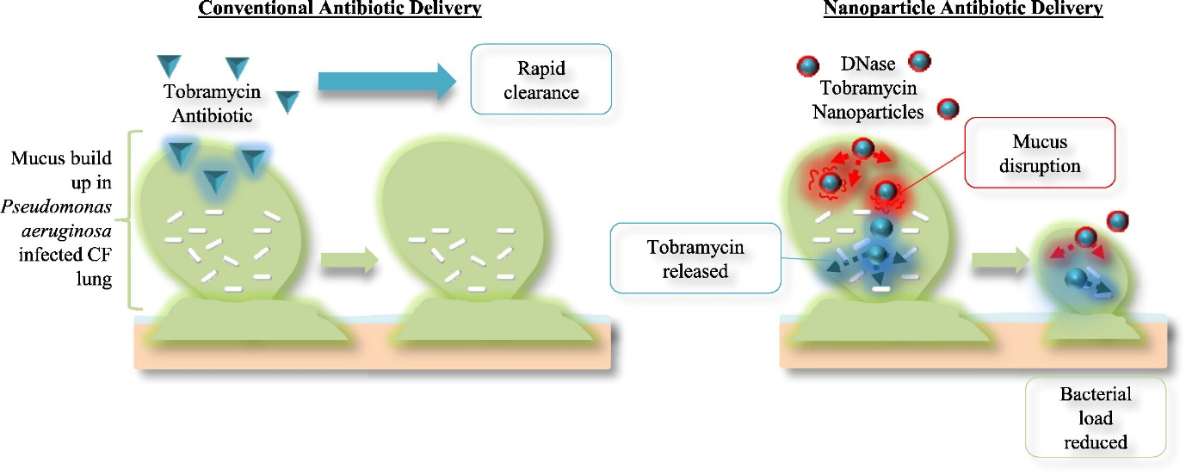

Certain lipid nanocarriers or their degradation products might cause toxicity or an immune response, particularly when administered in high doses or repeatedly. Therefore**, Poly(lactic-co-glycolic acid) (PLGA) Nanoparticles loaded with Tobramycin** can improve stability, prevent aggregation, and reduce clearance by the reticuloendothelial system (RES). Bioadhesive polymers can improve the effectiveness of a therapy by increasing the residence time of the formulation in the lungs. The NPs were coated with low molecular weight chitosan to enhance the mucoadhesiveness of PLGA-NPs. Overall it reduces immune recognition and enhances drug delivery to target tissues.

**Nano into micro formulations (NiMs)** of tobramycin for the treatment of *Pseudomonas aeruginosa* airway infections in CF were produced by spray drying a solution containing polymers or sugars and a nanometric polyanion-tobramcyin complex (PTC), able to facilitate the drug diffusion through the mucus secretion, achieving, at the same time, a sustained tobramycin delivery.