BCSE497J Project-I

A ZERO TRUST-DRIVEN FRAMEWORK FOR MITIGATING ACCESS CONTROL MISCONFIGURATIONS IN MULTI-CLOUD ENVIRONMENTS

22BCI0040 | VISHAL GOWDA V
22bci0258 | HARSHAD R K REDDY

Under the Supervision of

RAGHUL J
Assistant Professor
School of Computer Science and Engineering (SCOPE)

B.Tech.
in
Computer Science and Engineering
with specialization in information security

School of Computer Science and Engineering



September 2025

TABLE OF CONTENTS

Sl.No | Contents | Page No.
 | Abstract | 1
1. | INTRODUCTION | 2
 | 1.1 Background | 2
 | 1.2 Motivations | 2
2. | LITERATURE REVIEW
 | 2.1 Literature Review | 3-4
 | 2.2 Architecture diagram | 5
 | 2.3 Research gap mitigations | 6
 | 2.4 Hardware software specifications | 7-8
3. | MODULE WISE SPLIT-UP
 | 3.1 All madules explained | 8-9
 | 3.2 Gantt chat | 10
 | 3.3 Mod 1 | 11-15
 | 3.4 Mod 2 | 15-20
 | 3.5 Future scope | 21

A Zero Trust-Driven Framework for Mitigating Access Control Misconfigurations in Multi-Cloud Environments
Vishal Gowda V, Harshad K Reddy
Vellore Institute of Technology, Vellore, India

ABSTRACT

Even with the widespread adoption of cloud computing, maintaining ro- bust and scalable security across dynamic, heterogeneous, and multi-cloud infrastructures remains an open challenge. Access control misconfigura- tions—such as overly permissive IAM policies, unsecured storage buckets, and lateral privilege escalations—continue to be a primary cause of enter- prise data breaches. Existing mechanisms lack real-time responsiveness and context-awareness to effectively handle these threats. This paper proposes a Zero Trust-driven framework that integrates Infrastructure-as-Code (IaC) auditing, continuous monitoring of runtime configurations, and automatic policy remediation to secure cloud-native environments. Leveraging tools such as AWS CloudTrail, Config, and policy scanners, the proposed archi- tecture enforces least-privilege access dynamically. A base paper from IEEE Access guides the formulation of this strategy, which is further validated through case analysis and misconfiguration simulations. Results demonstrate improved access governance without compromising usability or performance.

Keywords:Cloud Security, Access Control, IAM Misconfiguration, Zero Trust Architecture, AWS CloudTrail, Infrastructure as Code.

1. INTRODUCTION

Cloud computing has revolutionized modern IT infrastructure by offering on-demand, scalable, and flexible services. However, with the increasing adoption of multi-cloud and hybrid architectures, managing secure access across distributed platforms has become more complex. Access control mis- configurations—such as unintentional public access, excessive permissions, and outdated role definitions—are cited in nearly 90% of cloud security breaches. Current security practices often fail to adapt dynamically to work- load changes or audit ephemeral resources like containers and serverless functions.
This paper introduces a context-aware, Zero Trust-aligned approach to mitigate these issues. By combining infrastructure template scanning, real- time policy auditing, and automated remediation, our framework addresses the limitations in visibility, compliance, and control. Section 2 outlines the
literature survey of high-quality studies. Section 3 presents the proposed architecture, while Sections 4 and 5 cover evaluation and conclusions respectively

2. LITERATURE SURVEY
Recent studies (2020 and beyond) have focused heavily on mitigating cloud access misconfigurations using dynamic access control, Zero Trust, and Infrastructure-as-Code scanning. This section summarizes high-impact research from leading journals like IEEE, Elsevier, and Springer.
- Base Paper:
Federated Zero Trust Architecture using Artificial Intelligence
Proposes a federated model for Zero Trust enhanced with AI, enabling adaptive decision-making and stronger authentication across distributed environments.
🔗 Link
- Cloud Service Misconfigurations: Emerging Threats, Enterprise Data Breaches and Solutions – IEEE
Explores common misconfigurations in cloud services and highlights how they lead to enterprise breaches, along with mitigation strategies.
🔗 Link
- Unified Framework for Securing Cloud-Native Storage: Detecting and Mitigating Multi-Cloud Bucket Misconfigurations
Introduces a unified approach to secure multi-cloud storage buckets, preventing data leaks caused by misconfigured access policies.
🔗 Link
- A Comprehensive Study on Misconfiguration-SAAS Security Threat
Reviews SaaS-based misconfiguration issues, emphasizing the risks they pose to enterprise data protection.
🔗 Link
- An Optimized Role-Based Access Control Using Trust Mechanism in E-Health Cloud Environment
Proposes a trust-enhanced RBAC system to improve data security and privacy in healthcare cloud environments.
🔗 Link
- Cloud Data Leakage, Security, Privacy Issues and Challenges
Analyzes risks of cloud data leakage, focusing on insecure APIs, misconfigured storage, and weak privacy safeguards.
🔗 Link
- Secure Data Deduplication With Dynamic Access Control for Mobile Cloud Storage
Presents a secure deduplication method that embeds dynamic access control to protect mobile cloud storage systems.
🔗 Link
- Role of Artificial Intelligence and Machine Learning in Enhancing Cloud Security
Explores AI/ML techniques for detecting anomalies, preventing misconfigurations, and automating access control decisions.
🔗 Link
- A Systematic Review on Blockchain-Based Access Control Systems in Cloud Environment
Reviews blockchain-based access control models that provide tamper-resistance and decentralized authorization.
🔗 Link
- Zero-Trust Based Dynamic Access Control for Cloud Computing
Proposes a Zero Trust-driven adaptive model to dynamically adjust access policies in cloud infrastructures.
🔗 Link
- Cloud Native Network Security Architecture Strategy under Zero Trust Scenario
Suggests a Zero Trust-aligned security framework to strengthen network security in cloud-native systems.
🔗 Link
Security Issues in Multi-Cloud: A Systematic Literature Review
Provides a comprehensive review of security challenges in multi-cloud environments, including identity sprawl, policy conflicts, and compliance issues.
🔗 Link
- A Secure and Verifiable Access Control Scheme for Big Data Storage in Clouds
Proposes a verifiable scheme that ensures secure access control for large-scale cloud storage while maintaining integrity and confidentiality.
🔗 Link
- Dual Access Control for Cloud-Based Data Storage and Sharing
Introduces a dual-layer access control model to balance flexible data sharing with strict confidentiality enforcement in cloud systems.
🔗 Link
- Implementing Dynamic Confidential Computing for Continuous Cloud Security Posture Monitoring
Suggests a Zero Trust-based confidential computing model to continuously monitor and mitigate security threats across cloud environments.
🔗 Link

2.2 ARCHITECTURE DIAGRAM

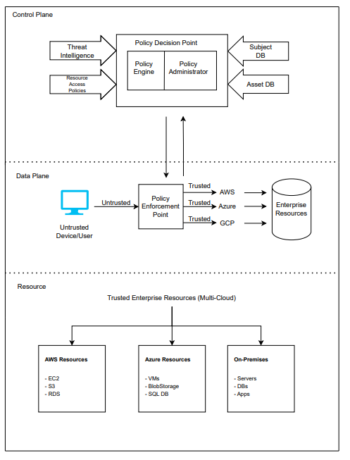

2.3 RESEARCH GAP MITIGATION:

- Lack of Real-Time Responsiveness: Existing mechanisms detect misconfigurations only after the fact through periodic audits and static scans. A Zero Trust-driven framework can continuously monitor runtime configurations instead of just static templates.
- Limited Context-Awareness: Many IAM and access control tools do not dynamically adapt to changing contexts such as workload variations or ephemeral resources like containers and serverless functions. Integrating context-aware policy enforcement allows dynamic re-evaluation of access in multi-cloud environments.
- Absence of Automatic Remediation: Most systems detect misconfigurations but require manual remediation, which is slow and prone to errors. Automatic policy remediation mechanisms can fix overly permissive policies or unsecured buckets without human intervention.
- Fragmented Multi-Cloud Security: Cloud providers (AWS, Azure, GCP) offer separate monitoring tools, lacking a unified mechanism for handling misconfigurations across multi-cloud setups. A unified Zero Trust framework can operate across heterogeneous multi-cloud infrastructures.
- Weak Integration of Zero Trust in Misconfiguration Mitigation: Although Zero Trust is widely discussed, few implementations focus on access control misconfigurations like IAM over-permissioning and lateral privilege escalation. A Zero Trust-driven model can specifically prevent and mitigate these threats.
- Lack of IaC-Aware Security: Infrastructure-as-Code tools (Terraform, CloudFormation) are major sources of misconfigurations, but many solutions do not integrate IaC auditing into security frameworks. Embedding IaC auditing with runtime monitoring in a single security loop enables proactive prevention.

2.4 HARDWARE AND SOFTWARE SPECIFICATIONS

1. Hardware Specifications
To implement and test the proposed framework, moderate hardware is sufficient since most workloads are simulated via cloud services and containers.
- Processor (CPU): Intel i5/i7 or AMD Ryzen 5/7, ≥ 2.5 GHz
- Memory (RAM): Minimum 8 GB (16 GB recommended for multi-cloud simulations and Docker/Kubernetes workloads)
- Storage: 256–512 GB SSD (required for storing logs, IaC templates, and monitoring data)
- Network: Stable broadband connection ≥ 20 Mbps for interaction with AWS, Azure APIs.
- GPU: Not mandatory.

2. Software Specifications
Operating System: Windows 10 or 11.

Programming Languages and Tools:
- Python: Policy Decision Point (PDP), monitoring scripts, automation
- FastAPI / Flask: Implementation of PDP APIs
- Terraform / AWS CloudFormation: Infrastructure-as-Code for misconfiguration simulation.
- Docker + Kubernetes: Containerized workloads and enforcement point simulation

Cloud Platforms:
- Amazon Web Services (AWS): CloudTrail, Config, IAM, S3
- Microsoft Azure: RBAC, Monitor, Blob Storage
- Google Cloud Platform (GCP): IAM, Cloud Logging, Cloud Storage

Zero Trust and Policy Tools:
- Open Policy Agent (OPA): Policy decision engine
- OPA Gatekeeper: Kubernetes-based policy enforcement
- Cloud Custodian: Multi-cloud governance and policy automation
- Checkov / Terraform Compliance: IaC misconfiguration scanning

Monitoring and Logging Tools:
- AWS CloudTrail / Azure Monitor / GCP Logging → Cloud-native logging
- Prometheus + Grafana → Centralized log analysis and visualization
- Splunk (Community Edition) → Security Information and Event Management (SIEM)

3.1 MODULE WISE SPLIT-UP OF PROJECT IMPLEMENTATION:

1. Identity and Access Management (IAM) Monitoring Module
- Objective: Detect overly permissive policies, unsecured storage, and privilege escalations.
- Tasks:
  - Continuously scan IAM roles, users, and policies across AWS, Azure, and GCP.
  - Identify violations such as *:* permissions, unused credentials, and public access.
- Tools/Tech: AWS IAM Analyzer, Azure AD, GCP IAM.

2. Infrastructure-as-Code (IaC) Auditing Module
- Objective: Prevent misconfigurations at the deployment stage.
- Tasks:
  - Scan Terraform/CloudFormation templates before deployment.
  - Enforce compliance with least privilege and Zero Trust rules.
- Tools/Tech: Terraform Compliance, Checkov, OPA policies.

3. Policy Decision Point (PDP) Module
- Objective: Act as the “brain” of Zero Trust access control.
- Tasks:
  - Evaluate access requests against security policies.
  - Integrate threat intelligence and context (time, device, location).
- Tools/Tech: Open Policy Agent (OPA), Python (FastAPI/Flask) for PDP APIs.

4. Policy Enforcement Point (PEP) Module
- Objective: Enforce PDP decisions before allowing access.
- Tasks:
  - Intercept user/resource access requests.
  - Allow/Deny based on PDP evaluation.
- Tools/Tech: Envoy Proxy, API Gateway (Kong, AWS API Gateway), Kubernetes Admission Controllers.

5. Misconfiguration Detection & Remediation Module
- Objective: Continuously detect and fix misconfigurations.
- Tasks:
  - Compare deployed configurations with security baselines.
  - Trigger auto-remediation workflows for misconfigured IAM/storage policies.
- Tools/Tech: AWS Config, Azure Policy, GCP Config Validator, Cloud Custodian.

6. Continuous Monitoring & Logging Module
- Objective: Provide visibility and feedback loops.
- Tasks:
  - Collect logs from CloudTrail, Azure Monitor, GCP Logging.
  - Aggregate and analyze in centralized SIEM/dashboard.
  - Feed findings into PDP for adaptive policies.
- Tools/Tech: ELK Stack, Prometheus + Grafana, Wazuh/Splunk.

7. Multi-Cloud Resource Layer
- Objective: Represent the actual enterprise resources protected by Zero Trust.
- Components:
  - AWS Resources: EC2, S3, RDS
  - Azure Resources: VMs, Blob Storage, SQL DB
  - GCP Resources: Compute Engine, Cloud Storage, BigQuery
  - On-Premises: Servers, databases, enterprise apps

3.2 GANTT CHART AND TIMELINES:

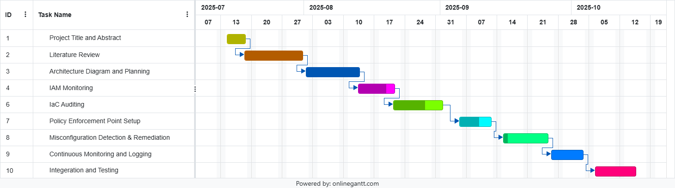

3.3 IAM MONITORING MODULE IMPLEMENTATION DOCUMENTATION

Step 1: Create an AWS Account.

Step 2: Create a test IAM User in AWS for monitoring purpose and assign policies such as SecurityAudit. Also, add a policy which gives suspiciously excess permissions such as IAM FullAccess. This is done to simulate a condition where our program is triggered.

Step 3: Install AWS CLI for Windows and configure credentials such as AWS Access Key, Secret Access Key, and default region and output format.
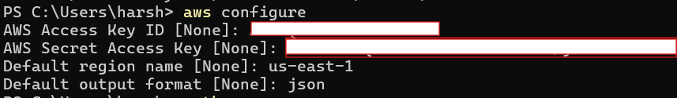

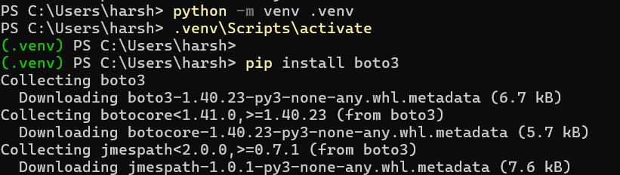
Step 4: Install Python and boto3 (AWS SDK for Python).

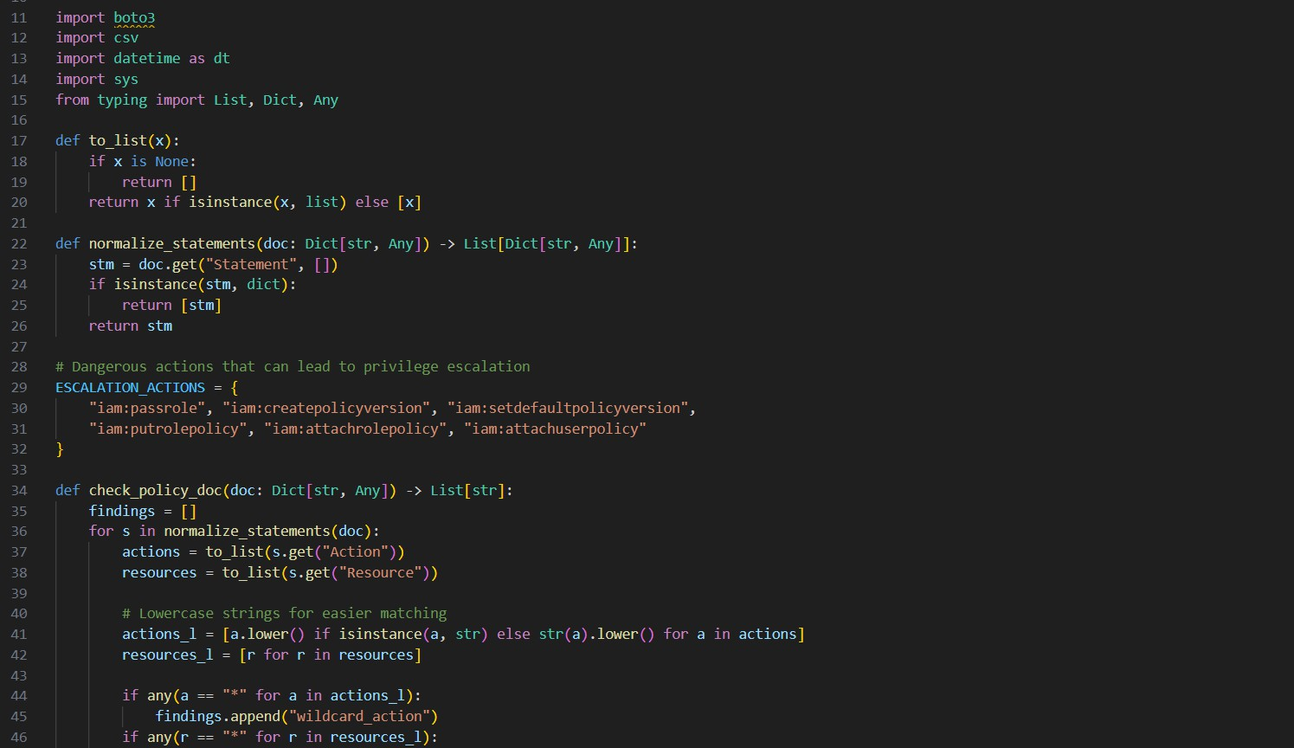
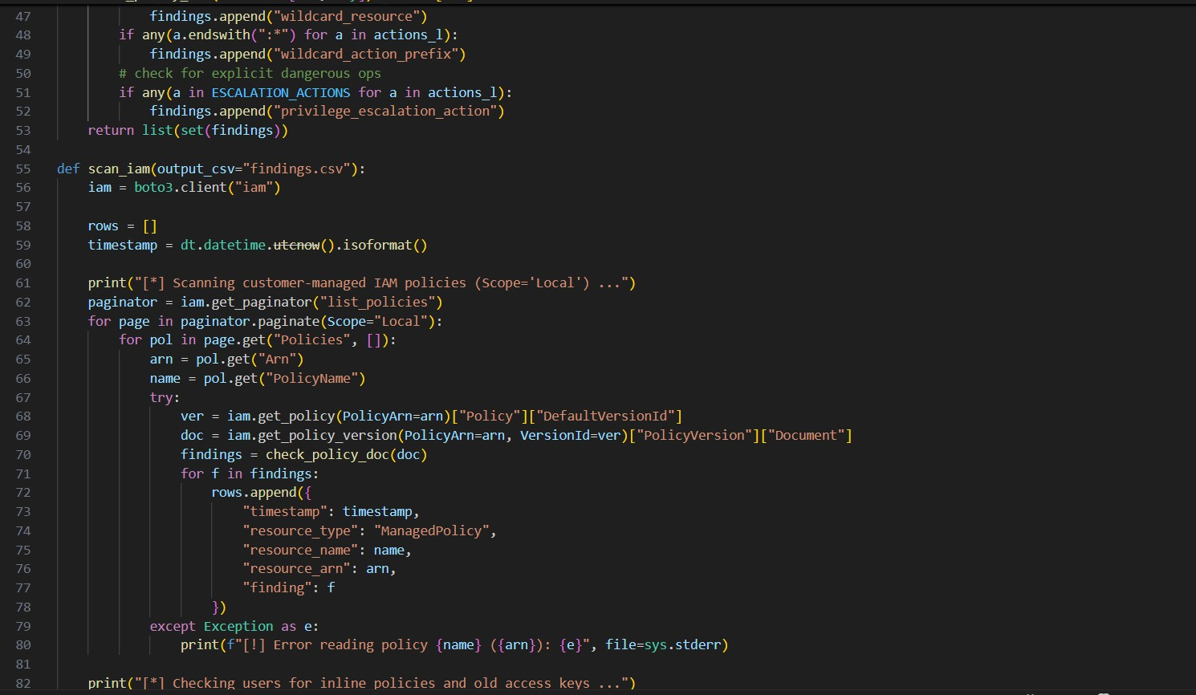
Step 5: Create a file named iam_monitor.py and write the following code:

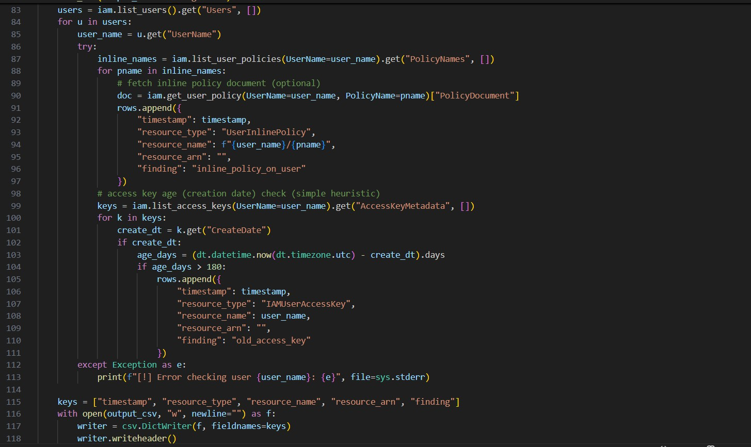

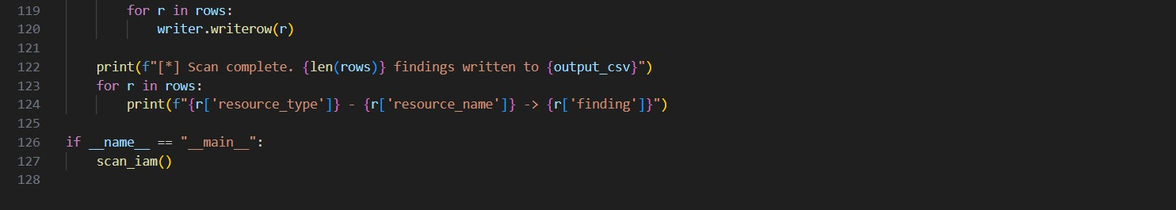
Step 6: Use AWS CLI to create a customer-managed policy with wildcards so the script flags as possible IAM least privilege violation.
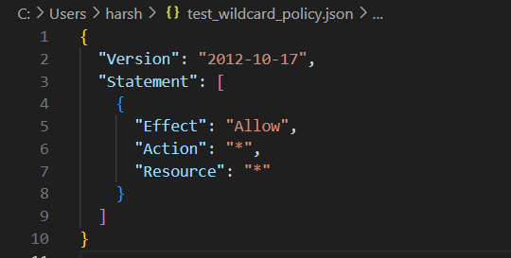
Step 7: This command creates a dangerously permissive IAM policy named TestWildcardPolicy, so that your monitoring tool has something to detect and report.
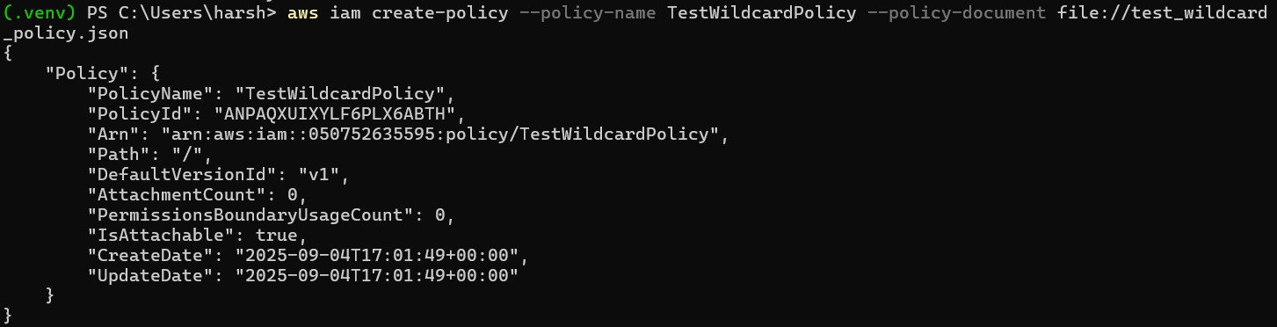

Step 8: Run the script and it will flag for bad policies write its findings to findings.csv
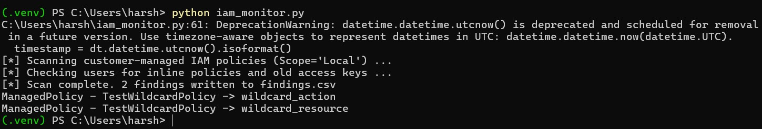

- ManagedPolicy - TestWildcardPolicy -> wildcard_action
→ Your script detected that the policy allows Action: "*" (all actions).
- ManagedPolicy - TestWildcardPolicy -> wildcard_resource
→ It also flagged that the policy applies to Resource: "*", meaning it grants access to any resource.
- 2 findings written to findings.csv
→ The script stored the results in a CSV file, which you can open in Excel, Notepad, or import into dashboards (e.g. Grafana) for visualization.

Findings.csv will document the following information regarding the policy creation.

This module can be extended in future for functionalities such as:
Privilege escalation patterns (e.g., iam:PassRole, sts:AssumeRole, iam:CreatePolicyVersion).
Over-permissive S3 bucket policies (public Principal: "*") → check via s3.get_bucket_policy.
Unused IAM users/roles → flag accounts with no login or API activity for X days.
MFA enforcement → detect IAM users without MFA enabled.
Inactive access keys → disable or flag keys unused for > 90 days.
Root account usage → alert if root account used (best practice: avoid).

3.4 Infrastructure as Code (IaC) Implementation

What this module will do:
- Load Terraform files (.tf) before they are deployed.
- Detect simple misconfigurations like:
Action = "*" or Resource = "*" in IAM policy blocks. Public S3 buckets (acl = "public-read" or public = true).
Security group with wide-open ingress (0.0.0.0/0).
- Save findings to a CSV/print them on screen.

Steps to reproduce implementation:
Step 1: Install a parser library for HCL (Terraform Language). HCL is a language used to describe infrastructure resources in machine friendly and human-readable format.
Terraform is an open-source IaC tool that uses HCL to define, provision and manage infrastructure resources such as cloud infrastructure in AWS using configuration files. (In short, a CLI for defining resources in cloud instead of clicking buttons).
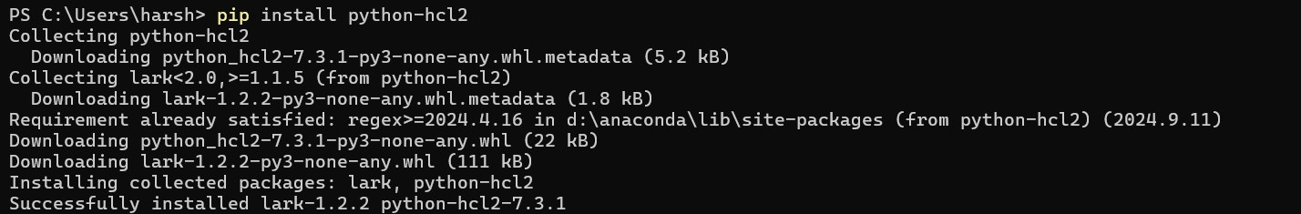

Step 2: Write the python code for the scanner which detects and prevents insecure policies before deployment
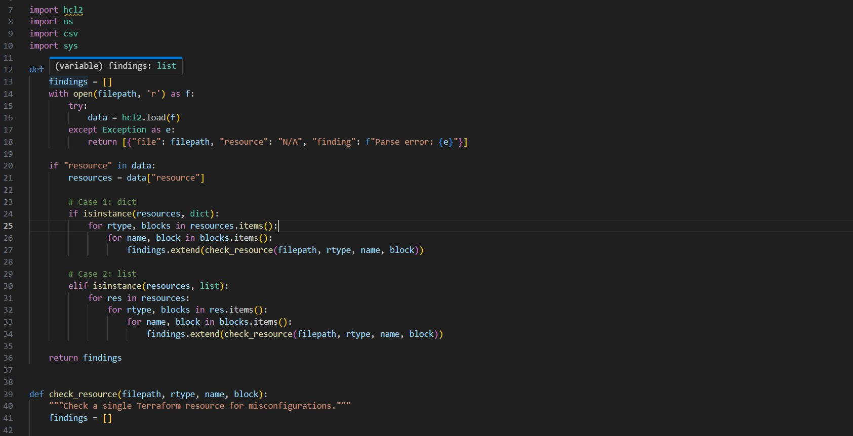
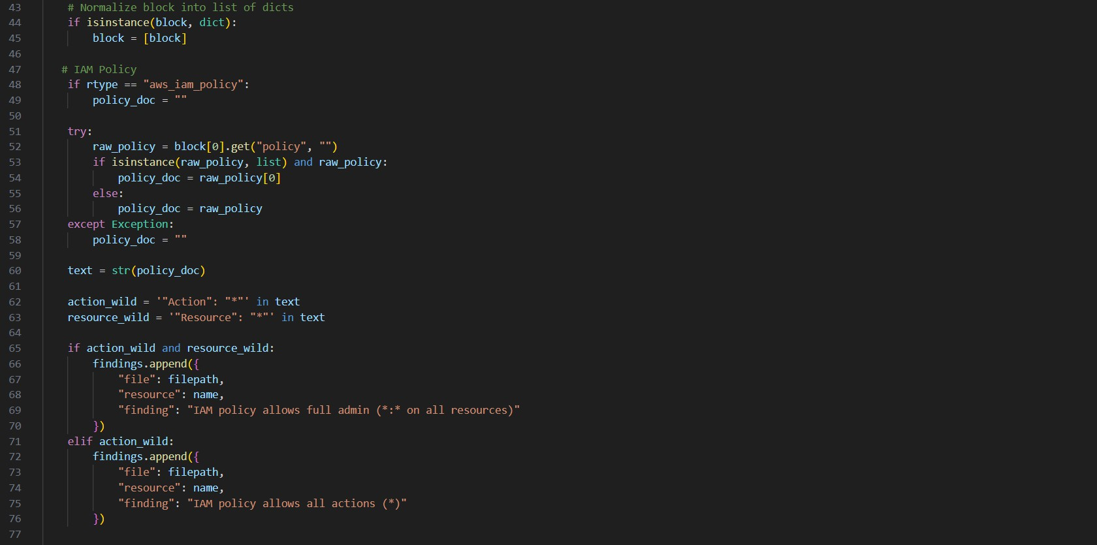
Lets name the file iac_monitor.py:

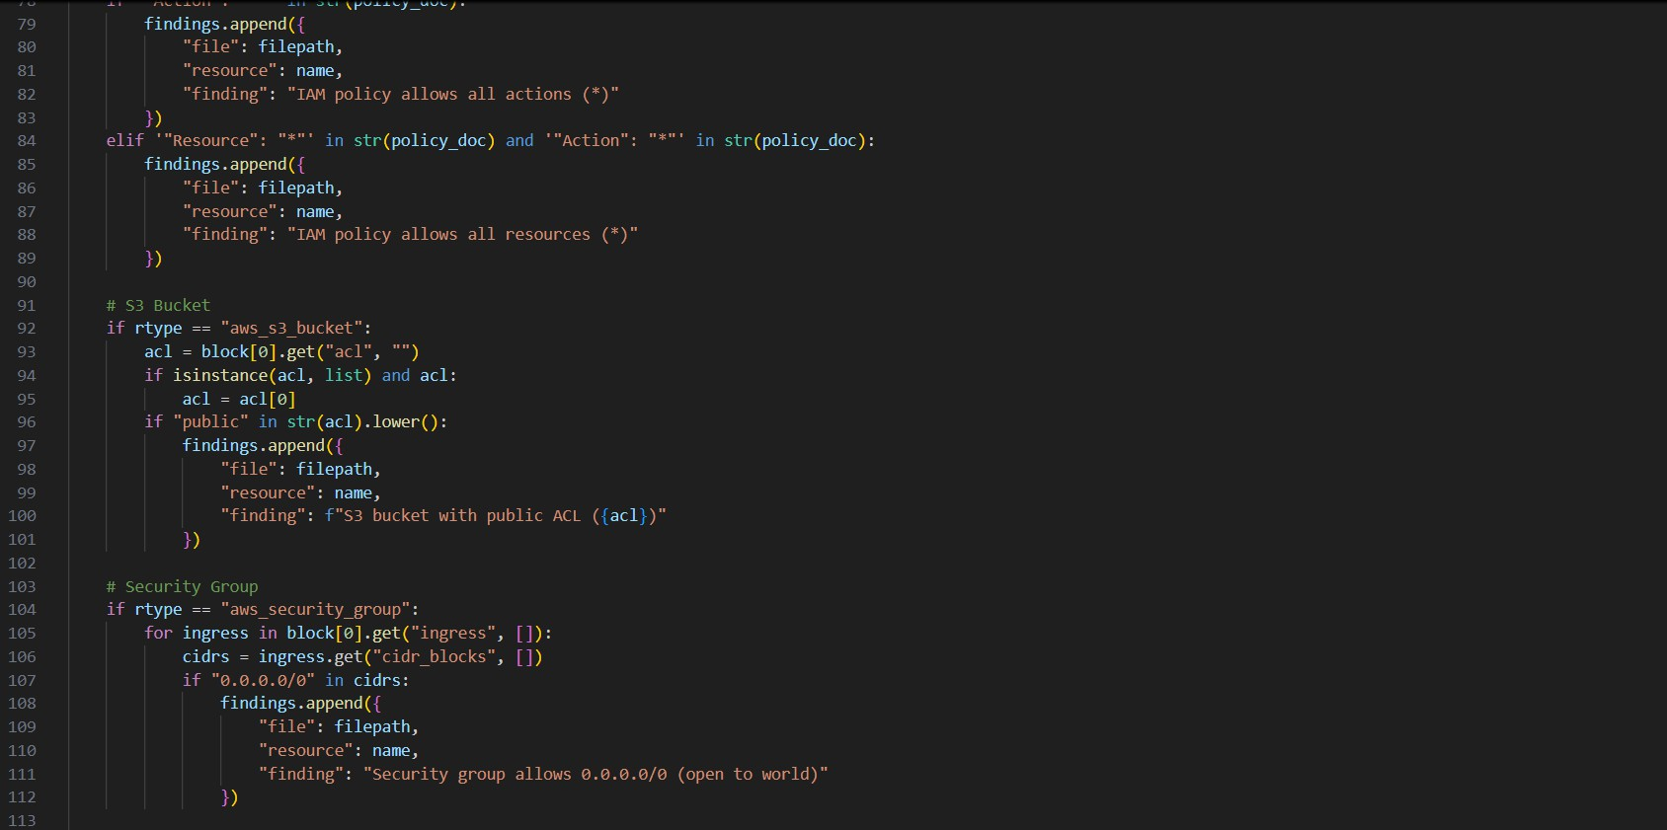

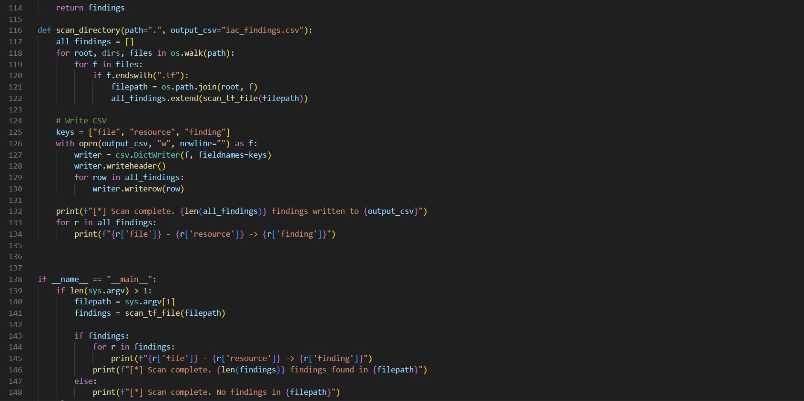

Step 3: We will create three Terraform files to check the scanner’s efficiency and ability to identify misconfigurations.

bad.tf:

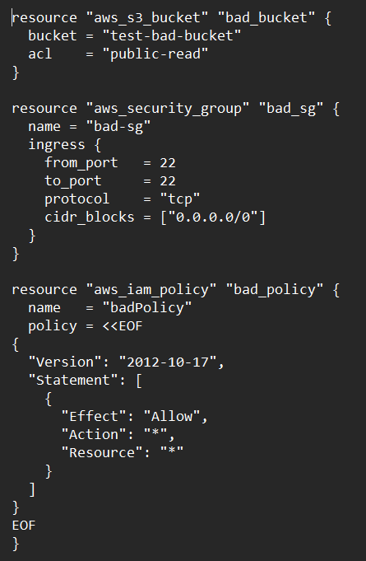

good.tf
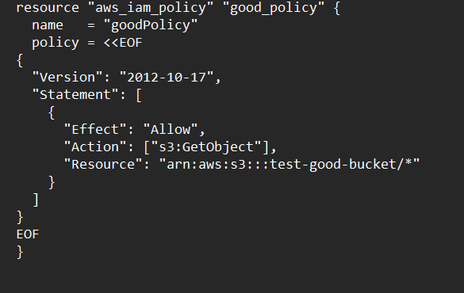

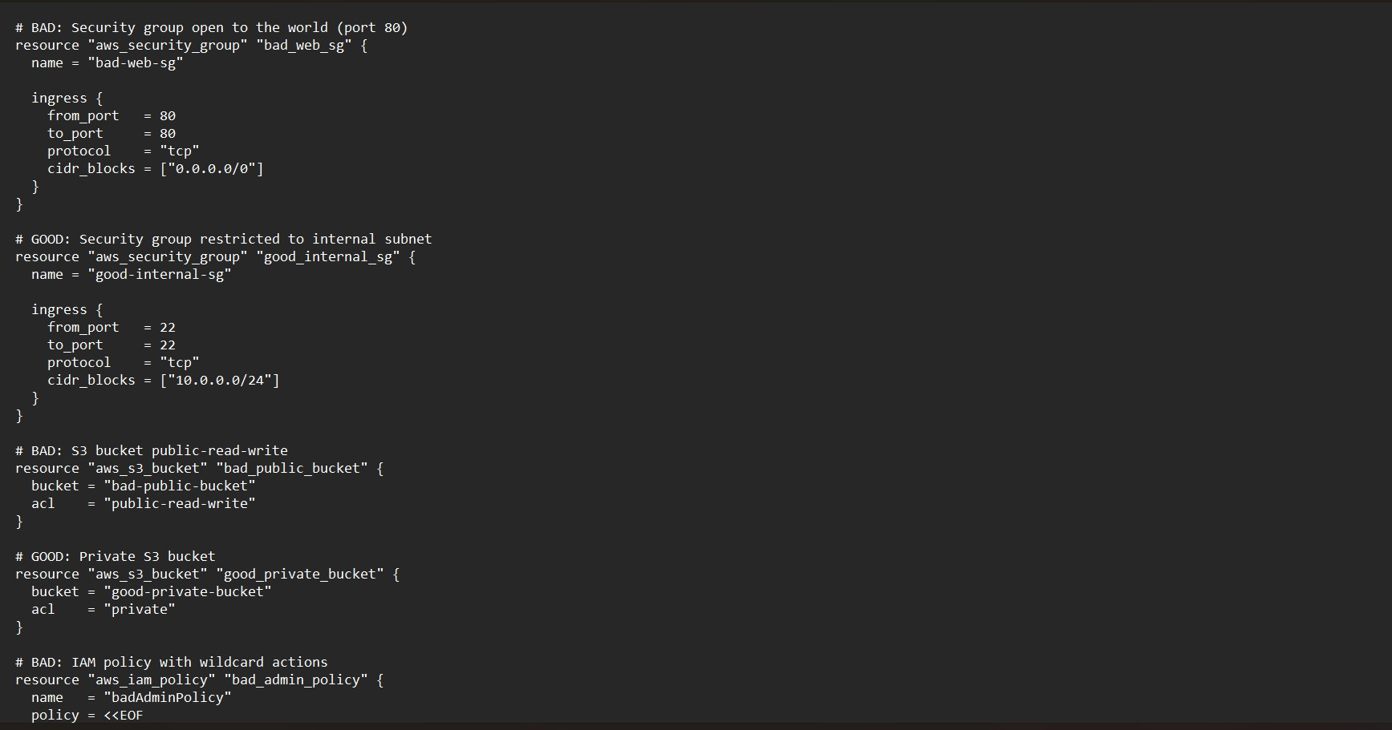
mix.tf

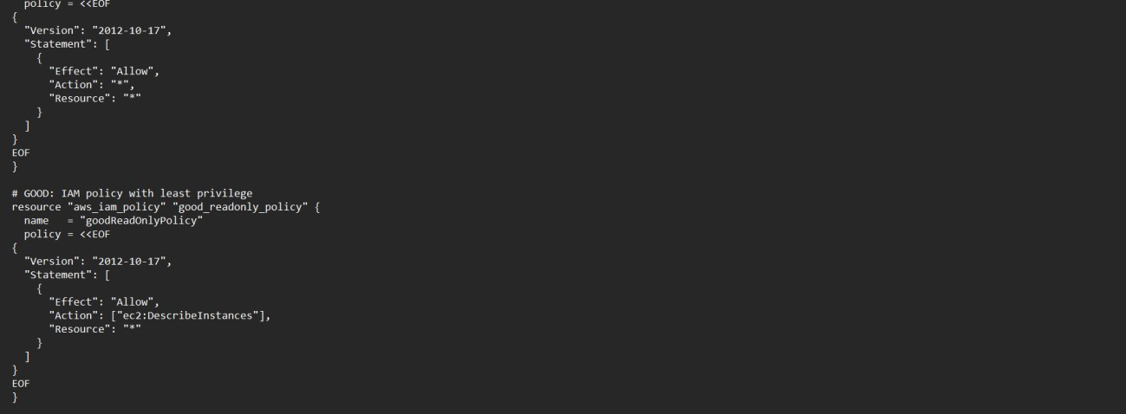

Step 4: Run the scanner against these .tf files and we can see the findings and vulnerabilities detected in the infrastructure of the resource.

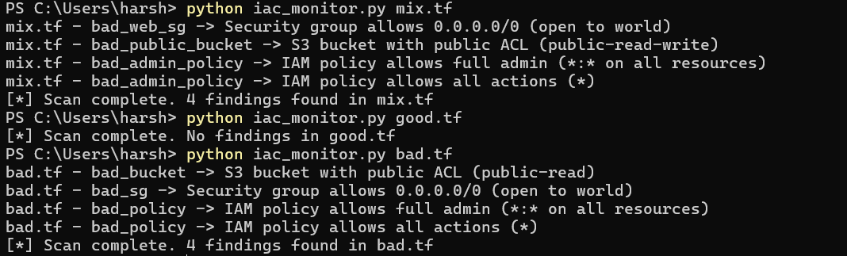

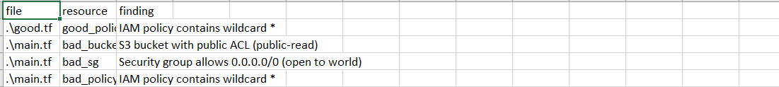
Step 5: The findings are documented in the iac_findings.csv file which can be used to analyze and visualize (using Grafana)

3.5 Future Scope:
Multi-Cloud Expansion: (Azure, GCP etc).
Severity-Based Risk Scoring: High, Medium, Low.
Continuous Monitoring: Deploy as a Lambda function to automatically run on a schedule.
Visualization & Reporting: Dashboards using AWS QuickSight, Grafana.

