CSE- 511

COMPUTING LAB I
ADBMS

I semester M.Tech(CSE)

2014

Prepared By | (Dr. Dinesh Acharya U)
Approved By | (HOD)

Dept of Computer Science & Engineering

Objectives:

- Experiments covering the study of relational database features
- Experiments covering the study of object-Based database features
- Experiments covering study of OLAP and XML

Outline:

- Design of Relational Database (1 Week)
- SQL (1 Week)
- PL/SQL(1 Week)
- Object-Based Databases (2 Weeks)
- OLAP(2 Weeks)
- XML(1 Week)

1. Design of Relational Data Base

[Refer ppt slides in Tutorial Week1]
1.1 Consider the following set of requirements for a university database that is used to keep track of students' transcripts:

(a) The university keeps track of each student's name, student number, social security number, current address and phone, permanent address and phone, birthdate, sex, class (freshman, sophomore, ..., graduate), major department, minor department (if any), and degree program (B.A., B.S., ..., Ph.D.). Some user applications need to refer to the city, state, and zip of the student's permanent address, and to the student's last name. Both social security number and student number have unique values for each student.

(b) Each department is described by a name, department code, office number, office phone, and college. Both name and code have unique values for each department.

(c) Each course has a course name, description, course number, number of semester hours, level, and offering department. The value of course number is unique for each course.

(d) Each section has an instructor, semester, year, course, and section number. The section number distinguishes different sections of the same course that are taught during the same semester/year; its values are 1, 2, 3, ...; up to the number of sections taught during each semester.

(e) A grade report has a student, section, letter grade, and numeric grade (0, 1, 2, 3, 4 for F, D, C, B, A, respectively).

Design an ER diagram. Specify key attributes of each entity type and structural constraints on each relationship type. Note any unspecified requirements, and make appropriate assumptions to make the specification complete.

1.2 Convert the ER diagram of exercise 1.1 into a relational schema

Assignment Day 2
1.3. Convert the following ER model of Hospital database into a relational schema
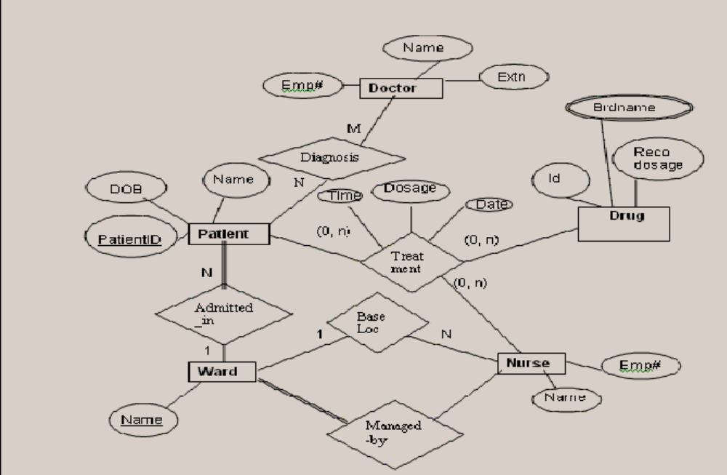

1.4 Consider the universal relation R={A,B,C,D,E,F,G,H,I,J} and the set of functional dependencies G = A,B -> C; B,D->E,F; A,D->G,H; A->I; H->J}. What is the key for R? Decompose R into 2NF and then 3NF relations.

1.5 Normalize the given table to 2NF and 3 NF
Details:
HappyHome supermarket deals with groceries, household items, stationary products and gift items. They have announced a summer mela where, for every customer who holds a membership with HappyHome, any three items can be taken for free. The total price of the three items should be equal to or below rs.1000. They record details of these free products given to their member customers in a table as below:
{ Invoice#, Membership#, Cust name, Address, Item1, Qty, Amt, Item2, Qty, Amt,
Item 3. Qty, Amt }

1.6 Consider the following relation for published books:

BOOK (Book_title, Authorname, Book_type, Listprice, Author_affil, Publisher)
Author_affil referes to the affiliation of the author. Suppose the following dependencies exist:
Book_title -> Publisher, Book_type
Book_type -> Listprice
Author_name -> Author-affil

(a) What normal form is the relation in? Explain your answer.
(b) Apply normalization until you cannot decompose the relations further. State the reasons behind each decomposition.

2. SQL

2.1 Overview of Sql* Plus commands and DDL
[Refer Tutorial Week2/2a]

2.2 Write the SQL commands to create a database schema for the following relational schema:

CUSTOMER (CUST_ID, CUST_NAME, ANNUAL_REVENUE, CUST_TYPE)
CUST_ID must be between 100 and 10,000
ANNUAL_REVENUE defaults to $20,000
CUST_TYPE must be manufacturer, wholesaler, or retailer
SHIPMENT (SHIPMENT_#, CUST_ID, WEIGHT, TRUCK_#, DESTINATION, SHIP_DATE)
Foreign Key: CUST_ID REFERENCES CUSTOMER, on deletion cascade
Foreign Key: TRUCK_# REFERENCES TRUCK, on deletion set to null
Foreign Key: DESTINATION REFERENCES CITY, on deletion set to null
WEIGHT must be under 1000 and defaults to 10
TRUCK (TRUCK_#, DRIVER_NAME)
CITY (CITY_NAME, POPULATION)
[Refer Tutorial Week 3 for the data set]

2.3 Perform the following queries:

1. What are the names of customers who have sent packages (shipments) to Sioux City?
2. To what destinations have companies with revenue less than $1 million sent packages?
3. What are the names and populations of cities that have received shipments weighing
over 100 pounds?
4. Who are the customers having over $5 million in annual revenue who have sent
shipments weighing less than 1 pound?
5. Who are the customers having over $5 million in annual revenue who have sent
shipments weighing less than 1 pound or have sent a shipment to San Francisco?
6. Who are the drivers who have delivered shipments for customers with annual revenue
over $20 million to cities with populations over 1 million?
7. List the cities that have received shipments from customers having over $15 million in
annual revenue.
8. List the names of drivers who have delivered shipments weighing over 100 pounds.
9. List the name and annual revenue of customers who have sent shipments weighing
over 100 pounds. 10. List the name and annual revenue of customers whose shipments
have been delivered by truck driver Jensen.
11. List customers who had shipments delivered by every truck. ( use NOT EXISTS)
12. List cities that have received shipments from every customer. ( use NOT EXISTS)
13. List drivers who have delivered shipments to every city. (use NOT EXISTS)
14. Customers who are manufacturers or have sent a package to St. Louis.
15. Cities of population over 1 million which have received a 100-pound package From
customer 311.
16. Trucks driven by Jake Stinson which have never delivered a shipment to Denver.
17. Customers with annual revenue over $10 million which have sent packages under 1
pound to cities with population less than 10,000.
18. Create views for each of the following:
a. Customers with annual revenue under $1 million.
b. Customers with annual revenue between $1 million and $5 million.
c. Customers with annual revenue over $5 million.
19. Use these views to answer the following queries:
a. Which drivers have taken shipments to Los Angeles for customers with
revenue over $5 million?
b. What are the populations of cities which have received shipments from
customers with revenue between $1 million and $5 million?
c. Which drivers have taken shipments to cities for customers with revenue
under $1 million, and what are the populations of those cities?

3. PL/SQL

[Refer Tutorial Week 3]
- Write a PL/SQL procedure that accepts a single positive number as input, and prints out the factorial of that number.
- Handle the division-by-zero exception in the invert function which computes inverse of the given number
- Handle no-data-found exception in a simple procedure, balance( CName IN VARCHAR2, Balance OUT NUMBER) that prints the balance for a specified customer from the simple banking database.
- Give a procedure on banking database to include too-many-rows exception.
- Write a “safe” withdrawal procedure, withdrawal( AccNo IN VARCHAR2, Amount IN NUMBER) on Account table. Check for sufficient balance and update the balance. Use an exception to handle the case of attempting to overdraw an account
- Write a procedure, transfer(giveAccNo IN VARCHAR2, receiveAccNor IN VARCHAR2,amount IN NUMBER) to transfer money from one person's account to another. Check for the transfer amount being negative and check whether the giver has sufficient funds to allow the transfer.
- Create a package by including few procedures / functions defined above and demonstrate the usage of the same.
- Give a procedure RichPoor(Amount Numbers), that iterates through the Accounts Table and classifies customers as being either "rich" or "poor" (our definition of rich is anyone who has more than Rs.2000 in an account). Use Cursor.
- Write a procedure called BranchList that produces, for each branch, a list of customers and the total amount of money held in accounts in that branch. The procedure should produce the output in the following format:
  - Branch Name & Address
  - Customer List
  - Total Deposits
- Write a procedure called CloseBranch that takes two arguments (the branch to be closed and the branch to take over the accounts) and transfers all accounts and loans at the closing branch to the new branch and removes the closing branch. If the destination branch does not yet exist, assume that it is a newly-opened branch and add it to the Branch table, with a message to remind the user to supply an address for the new branch. Use parameterized cursors.
- Write a single Trigger with multiple triggering events (inserting /updating / deleting). For eg., display the type of operation whenever it is applied on the Accounts table of the simple Bank Database.
- Write a trigger to implement the following:
Whenever a withdrawal / deposit operation is applied on the simple bank
database, insert the row effected, before updation, of Accounts table into
Old_Accounts(attributes are same as that of Accounts + Updation_date) along
with the System Date.
- Include the Payments(loan_number, payment_number, payment_date,
payment_amount). table into Bank Database of Lab1. Write a trigger to update
the corresponding row in the loan table, whenever a customer does the loan
payment.

4. Object-Based Database

[Refer Tutorial Week 4]
Object Types and Object Relational Tables:
- Create an object type “person” that contains name and phone number. Create an object table “person_table” for this type. Insert five rows into this table using both the methods(relational and object relational) of insertion.

- Create a type "job" with four columns: "jobtitle", "job_ID", "salary_amount" and "years_of_experience". Create an object table "job_table" for this type. Insert 5 rows into this table.

- Try different select statements on both tables, such as
"SELECT * FROM ...",
"SELECT name FROM ...",
"SELECT p.name FROM ...",
"SELECT VALUE(p) FROM ..."

Object Type as User Defined Types:
- Create an object type "address" that contains street name, number, flat number, city, postal code, and country in a manner so that street name, number and flat number are closely related(use user defined data type) and country is separate from all the other attributes.

- Drop "person" and "person_table". Create a type "person" which contains first name, middle initial, last name, phone (business, home, mobile) and address (from exercise 4). Make sure that first name, middle initial, last name are closely related and that the phone numbers are closely related to each other.Create an object table "person_table" that corresponds to "person".
Insert five rows of data into "person". (Note: you'll have to use the object-relational form of insertion).

Inheritance:
- Create a type "employee" under "person" that has an additional attribute "emp_ID" of type INT. Create it as NOT FINAL. Create a corresponding employee_table and insert 3 rows into it.
- Alter both the employee_table and the job_table (from exercise 2) so that they have primary keys.

References / REFs:
- Create the employment table using REFs insert 3 rows into it.

- What does "Select * from employment" show?
Print the complete information from table "employment" in two formats:
First, print it in a way that it shows all types and all data. (E.g EMPLOYEE
(NAME ('Mary', NULL, 'Edwards'), ....) You can do this by dereferencing
(DEREF) the two columns of employment.
Second, print it in a way so that it only shows the data, not the types.

- Using the employment table, print the names of all employees whose salary is larger than 20000. Print the jobtitles of all employees who live in Edinburgh. (Note that in contrast to relational databases you do not need a join to do this!)

- Create an object type "project" with columns: "project_id", "project_leader", "project_title" where "project_leader" is a REF to person. Create a corresponding object table "project_table". Alter the table so that project_id is a primary key. Insert 3 rows into "project_table".

- Create a table "project_membership" with two columns "project_id" and "member" so that the project IDs are references to projects but can only be filled with data from project_table. The members are references to person and can only be filled with data from employee_table. Insert 3 rows into this table. Select all rows from this table using dereferencing of the two columns.

5. Object-Based Database….

[Refer Tutorial Week 5]
Member Methods:
- Create TYPE job2, which contains the same columns as the type job(exercise 2 from last week’s exercises), but also include a method "evaluate_qualification" to print "too bad" for all jobs that have less than 2 years of experience, "OK" for 2 years of experience and "great" for more than two years of experience.

- Add a second method to the type declaration of job2. This method is called salary_fraction. It takes a real number N as an argument and returns the salary divided by N. For example, if N is 12, it returns the monthly salary.

- Create an object table for job2 and insert three rows.
Write an SQL statement that selects evaluate_qualification and monthly salaries for all rows of the table.
Write an SQL statement that selects all columns for rows which have an 'OK' value for evaluate_qualification and a half-yearly salary of more than 10000.

- Alter the person type from last week's exercises(exercise no. 5) so that it has a print_name method. This method prints the lastname, a comma, a space, the firstname, a space and then the middle initial(Use PL/SQL string concatenation operator is ||).

- Alter the person type from last week's exercises so that it has a method that counts how many categories of phone numbers a person has. The categories are "home phone", "business phone", "mobile phone". Thus the result must be between 0 and 3. (Note: NULL can be used within PL/SQL in the same way as in SQL.)

Map Methods:
- Create a map method for "person" so that objects of type person are ordered by lastname, firstname, middle initial.

Collection Types:
- Create a type phone_code that has area_code and local_number as attributes. Create a type phone_numbers as a table of phone_code. Create a table company3 that has the attributes name and phone, where phone is of type phone_numbers.
name | phone
'abc'
  area_code | localnumber
  '0131' | '243-4758'
  '0131' | '485-2534'
Insert several rows into company3. Note that in contrast to the insert statement for company2, you now have one more level "phone_code" which must be used when constructing the values.

- Use the table company3 from the previous exercises.
Write SQL statements for the following:
Select all phone numbers which belong to a given company name.
Select all companies which have a certain area_code.
Select all local numbers.

6 &7. OLAP
[Refer Tutorial Week 6_7]

Implement the following multidimensional star schema:
Fact Table:
Sales(pid: integer, timeid integer, locid integer,sales real)
Dimension Tables:
Locations(locid integer, city: string, state: string,country: string);
Products(pid integer,pname string, category string, price: real);
Times(timeid integer, date: string, week: integer, month: integer, quarter: integer, year:
integer, holiday: boolean)

Consider the instance of Sales relation
- Show the result of pivoting the relation on pid and timeid
- Write a collection of sql queries to obtain the same result as in the previous part
- Show the result of pivoting the relation on pid and locid
Consider the Cross-tabulation on Sales by year and state
- Show the result of roll-up on locid
- Write a collection of sql queries to obtain the same result as in the previous part
- Show the result of roll-up on locid followed by drill-down on pid
- Show the result of roll-up on pid followed by drill-down on timeid
Consider the Locations, Products, and Sales relations
- Find the percentage change in the total monthly sales for each location
- Find the percentage change in the total monthly sales for each product
- Find the average daily sales over the preceding 30 days for each product
- For each week, find the maximum moving average of sales over the preceding four weeks
- Find the rank of products based on total sales in sorted order
- Find the top five products ranked by total sales
- Find the rank of products by total sales within each location
- Find the top three locations ranked by cumulative sales, for every month over the past year
- Rank all products by total sales over the past year, and for each location find the difference in total sales relative to the location behind it.

8. XML

[Refer Tutorial Week 8]
- Consider a mail order database in which employees take orders for parts from
customers.
The data requirements are summarized as follows:
- The mail order company has employees identified by a unique employee number, their first and last names, and a zip code where they are located.
- Customers of the company are uniquely identified by a customer number. In
addition, their first and last names and a zip code where they are located are
recorded.
- The parts being sold by the company are identified by a unique part number. In addirion, a part name, their price, and quantity in stock are recorded.
- Orders placed by customers are taken by employees and are given a unique order number. Each order may contain certain quantities of one or more parts and their received date as well as a shipped date is recorded.
- Create a XML representation of the data (you should invent your own data
instances).
- Write a DTD / XML Schema specification for the XML document
constructed in part a.
- Write expressions in XQuery to answer following queries:
- Retrieve the names of parts that cost less than $20.00.
- Retrieve the names and cities of employees who have taken orders for parts costing more than $50.00
- Retrieve the pairs of customer number values of customers who live in the same zip code.
- Retrieve the names of customers who have ordered parts only from employees living in the city of Wichita.
- Retrieve the names of customers who have ordered all parts costing less than $20.00.
- Retrieve the names of customers who have not placed a single order.
- Retrieve the names of customers who have placed exactly two orders.
- Design a relational schema to publish this data.

- Consider the grade book database in which instructors within an academic department maintain scores/points obtained by individual students in their classes. The data requirements are summarized as follows:
- Students are identified by a unique student id, their first and last names, and an email address.
- The instructor teaches certain courses each term. The courses are uniquely
identified by a course number, a section number, and the term in which they are taught. The instructor also assigns grade cutoffs (example 90, 80, 70, and 60) for letter grades A, B, C, D, and F for each course he or she teaches.
- Students are enrolled in courses taught by the instructor. Each course being taught by the instructor has a number of grading components (such as mid-term, final exam, project, etc.). Each grading component has a maximum number of points (such as 100 or 50) and a weight (such as 20% or 10%). The weights of all the grading components of a course usually add up to 100.Finally, the instructor records the points earned by each student in each of thegrading components in each of the courses. For example, student with id=1234 earns 84 points for the grading component mid-term for the course CSc 2310 section 2 in the fall 2005 term. The mid-term grading component may have been defined to have a maximum of 100 points and a weight of 20% of the course grade.
a. Create a XML representation of the data described (you should invent your
own data instances).
b. Write a XML Schema / DTD specification for the XML document constructed in
part a.
c. Write expressions in XQuery to answer the following queries:
- Retrieve the names of students enrolled in the ‘Automata’ class in the term of Fall 1996.
- Retrieve the SID values of students who have enrolled in CSc226 as well as CSc227.
- Retrieve the SID values of students who have enrolled in CSc226 or CSc227.
- Retrieve the names of students who have not enrolled in any class.
- Retrieve the names of students who have enrolled in all courses in the catalog table.
d. Design a relational schema to publish this

Scheme of Evaluation
Lab carries total of 100 marks and its distribution is given below.

Periodic Evaluation( Week 1 – 8): 48 Marks [4 * 12(Report: 6; Execution:6)]
VIVA: 12 Marks
Lab Test : 40 Marks
------------
Total: 100 Marks
------------

Reference:
[1] Silberschatz, Korth and Sudarshan, “Database System Concepts, Sixth
Edition, McGraw Hill, NY
[2] Ivan Bayross, “SQl, PL/SQL” BPB Publications 3rd Revised Edition
[3] John Adolph Palinski,”Oracle SQL and PL/SQL Handbook”, 2003
Pearson Education

