 | Pimpri Chinchwad Education Trust’s  Pimpri Chinchwad College of Engineering  An Autonomous Institute  (Permanently affiliated to Savitribai Phule Pune University) | SET - I/II/III
 |  | SEMESTER - I
Summative Assessment
Fourth Year B. Tech. (Computer Engineering)
Computer Vision
[BCE7518]
(Regulation:2020)
Odd Semester (2024-25)
Total No. of Questions-4 Total No. of Printed Pages-2
[Time:2 Hours] [Max. Marks: 60]
PRN

Instructions:
IMP: Verify that you have received a question paper with correct course, code, branch etc.
i. All questions are compulsory.
ii. Assume suitable data wherever necessary.
iii. Neat labelled diagrams must be drawn wherever necessary.
iv. Figure to right indicates full marks.
v. Use of a non-programmable calculator is allowed.

Q. 1: Solve the Following
Q. No. | Question | CO | Marks
A | How Texture of in Images, can be used as feature, eloborate with suitable application. | CO1 | 5
B | Elaborate at least two applications of computer vision in various domains. | CO1 | 4
C | Apply a probabilistic model to estimate the likelihood of different shapes in an image. How does this help in recognizing objects with uncertain boundaries? | CO1 | 6

Q. 2: Solve the Following
Q. No. | Question | CO | Marks
A | Given the data in the table, reduce the dimension from 2 to 1 using the Principle Component Analysis algorithm.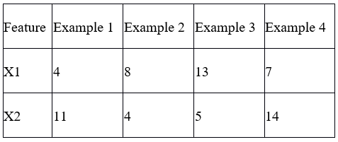 | CO2 | 8
B | Elaborate on challenges that are associated with image filtering, such as noise reduction and detail preservation? | CO2 | 3
C | Justify the use of SIFT with respect to any Image Processing Application? | CO2 | 2
D | Compare a low-pass filter and a high-pass filter. | CO2 | 2

Q. 3: Solve the Following
Q. No. | Question | CO | Marks
A | Why do we prefer Convolutional Neural networks (CNN) over Artificial Neural networks (ANN) for image data as input? | CO3 | 4
B | Consider Cancer detection use case and elaborate the concept of convolutional neural networks (CNNs) with neat diagrams also enlist the advantages of CNN in image processing in detail. | CO3 | 7
C | Illustrate the problems associated with the Convolution operation and how can one resolve them? | CO3 | 4

Q. 4: Solve the Following
Q. No. | Question | CO | Marks
A | Implement a Hough Transform-based line detector. Evaluate its performance on synthetic and real-world images. | CO4 | 6
B | Apply object detection on medical image analysis to detect brain tumors. | CO4 | 5
C | Elaborate region-based convolutional neural networks (R-CNN)? How do they differ from traditional CNNs? | CO4 | 4

*** End of Paper ***

