Invoice Tracker
User Manual
All Channels (HQ)
For: HQ users and Admins
Version 1.0 · November 2026

Contents
1. About this guide 3
2. Signing in 3
2.1 First-time setup 3
2.2 Sign in 3
2.3 Forgot password 4
3. Finding your way around 4
4. Dashboard (Invoice Tracking) 4
4.1 Summary cards 5
4.2 Charts 5
5. Search and track an invoice 5
5.1 Invoice details 6
5.2 Export to Excel 7
6. Processing Channels 7
7. Supplier Visibility 7
8. Vendor Status Reports 8
9. Logs / History 9
10. Inquiry Desk (supplier queries) 9
11. Supplier Management 10
11.1 Review an access request 11
11.2 Add or manage a supplier 11
12. Settings (Admin) 11
12.1 Integration Settings 11
12.2 User Management 12
12.3 Roles & Permissions 12
12.4 Audit Logs 13
13. Notifications, Profile and Logout 13
14. Invoice status meanings 13
15. Roles and what they can do (default) 14
16. Common messages and what to do 14

1. About this guide
Invoice Tracker shows where every supplier invoice is, from upload to payment. This guide is for head-office (HQ) users and Admins who track invoices across all channels: Msetu / SRM and PO Portal.
Note: What you see in the menu depends on your role (Invoice Team L1, L2, L3 or Admin). If a menu item in this guide is missing for you, your role does not include it. Ask an Admin if you need it.

2. Signing in

2.1 First-time setup
An Admin creates your account. You then receive a Welcome email that lists your role, your portal and your Inquiry Desk access.
- Open the email and click Set Your Password. The link works for a limited time only.
- Choose a password of at least 8 characters, confirm it and save.
- Sign in as described below.

2.2 Sign in
- Open the Invoice Tracker sign-in page.
- Click Internal Team.
- In Portal / Team, select All channels (HQ).
- Enter your Email ID and Password.
- Keep Remember me on this device ticked only on your own computer.
- Click Continue. Your dashboard opens.
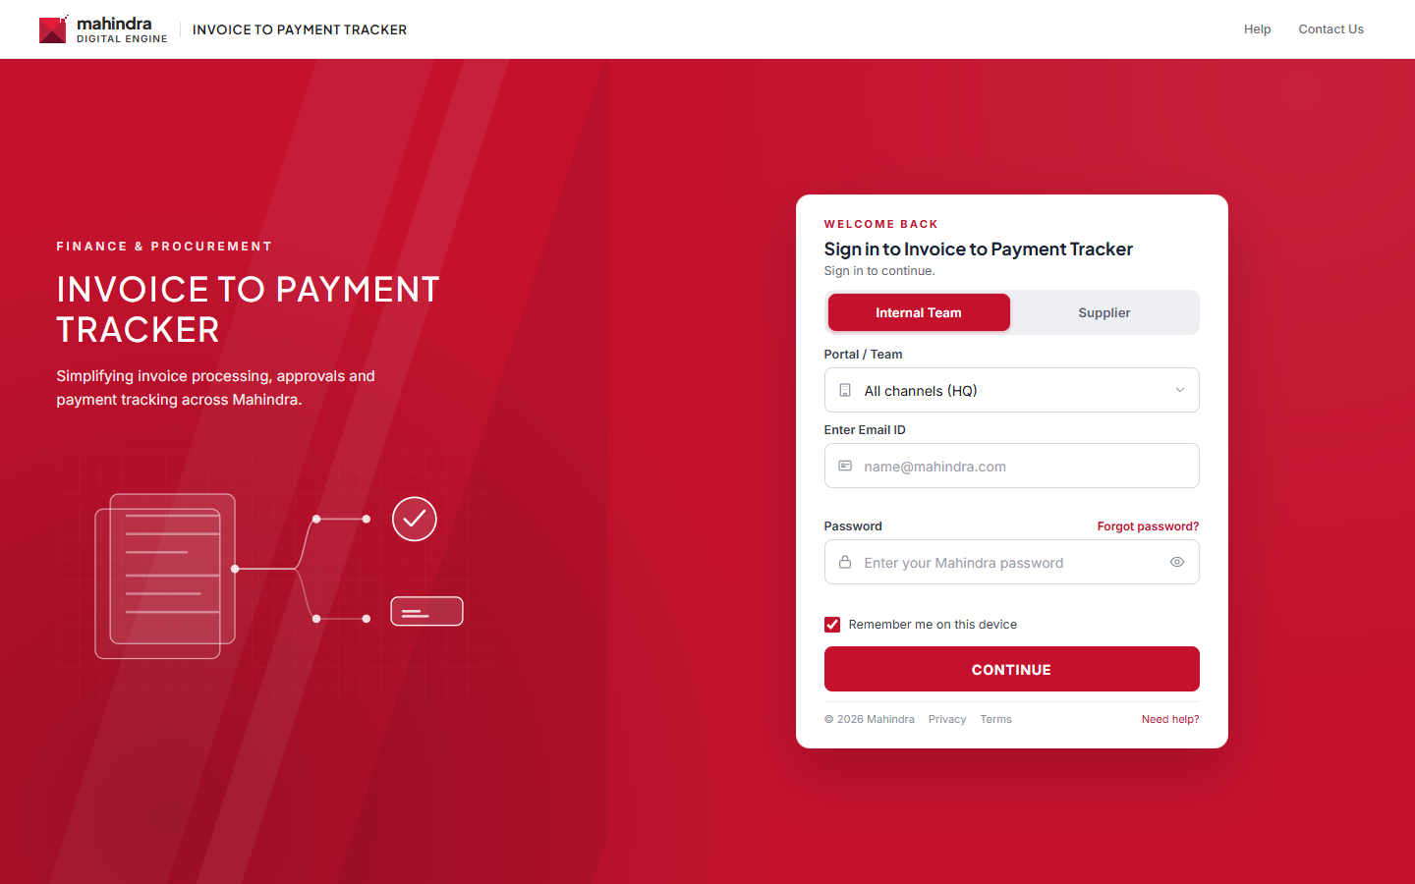
Figure 1: Sign-in page: Internal Team
Note: Admins can sign in to any portal. Other users can only open the portal assigned to them.

2.3 Forgot password
- On the sign-in page click Forgot password?
- Enter your Sign-in email and click Send reset email.
- Open the email and click the link.
- Enter a new password (at least 8 characters) twice and save. Then sign in again.

3. Finding your way around
Area | What it does
Left menu | Invoice Tracking, Search Invoice(s), Processing Channels (Msetu / SRM, PO Portal), Supplier Visibility, Inquiry Desk, Notifications, then Reports & admin: Vendor Status Reports, Logs / History, Settings, Profile, Logout.
FY filter (top bar) | Choose the financial year, or All Years. All pages use this choice.
Channel (top bar) | Choose All Channels or one channel.
Vendor Code (top bar) | Show only one supplier's invoices. Type to search the list.
Bell icon | Your latest notifications. The red number shows unread ones.
☰ (menu) icon | Collapse or expand the left menu.
Back link (under the top bar) | Returns to the page you came from.

4. Dashboard (Invoice Tracking)
The dashboard is the first page after sign-in. It gives a quick picture of all invoices for the selected year, channel and vendor code.
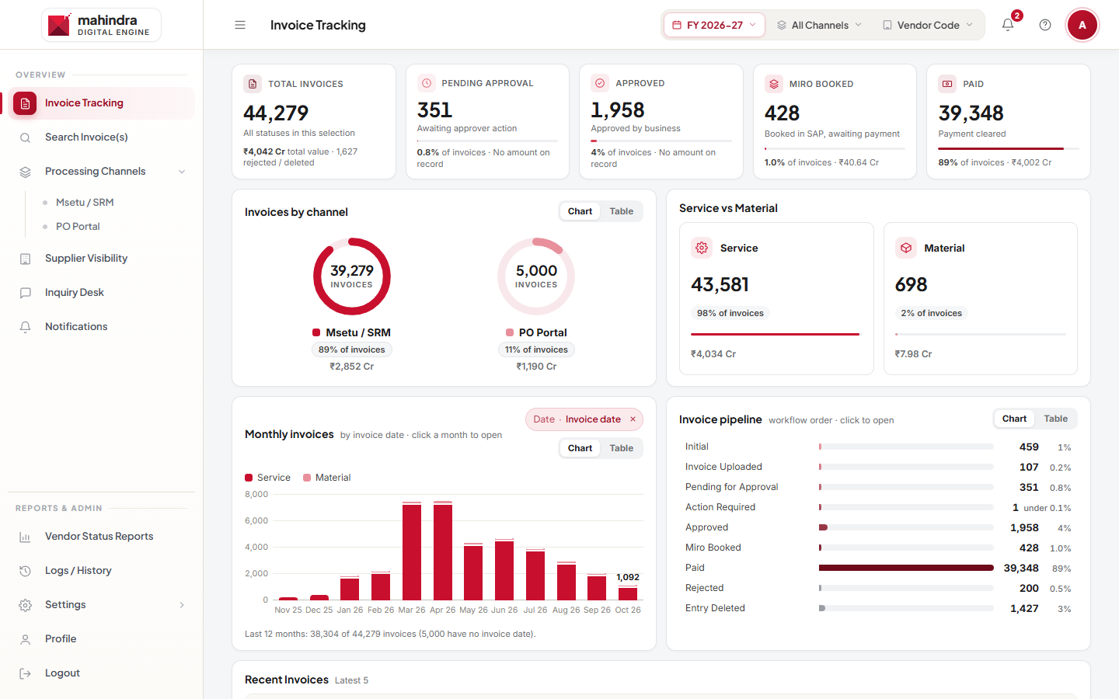
Figure 2: Invoice Tracking dashboard

4.1 Summary cards
Card | Meaning
Total Invoices | All invoices in your selection, with total value and the number rejected or deleted.
Pending Approval | Waiting for the approver to act.
Approved | Approved by the business.
Miro Booked | Booked in SAP, waiting for payment.
Paid | Payment cleared.
Each card also shows its share of all invoices (for example "0.8% of invoices") and the amount, when an amount is on record.

4.2 Charts
- Invoices by channel: invoice count and value per channel. Switch between Chart and Table.
- Service vs Material: how many invoices are for services and how many for material.
- Monthly invoices: invoices per month for the last 12 months. Use the Date chip to change which date is counted (for example invoice date or payment due date). Click a month to open those invoices.
- Invoice pipeline: how many invoices sit at each status, in workflow order. Click a status to open those invoices.
- Recent Invoices: the latest 5 invoices.
Tip: Clicking a card, month or status opens Search Invoice(s) with that filter. This needs the "Search invoices" permission.

5. Search and track an invoice
- Click Search Invoice(s) in the left menu.
- Type in the search box: invoice number, PO number, status, date or amount. To search several fields at once, separate them with commas in this order: invoice, PO, item, UTR.
- Narrow the list with the chips: Status, Product, Date (Invoice, Upload, Approval, MIRO booking, Payment Due or UTR clearing date) and a date range.
- Click an invoice number (or the eye icon) to open its details.
- Click Clear to remove all filters, or All dates to remove the date range.
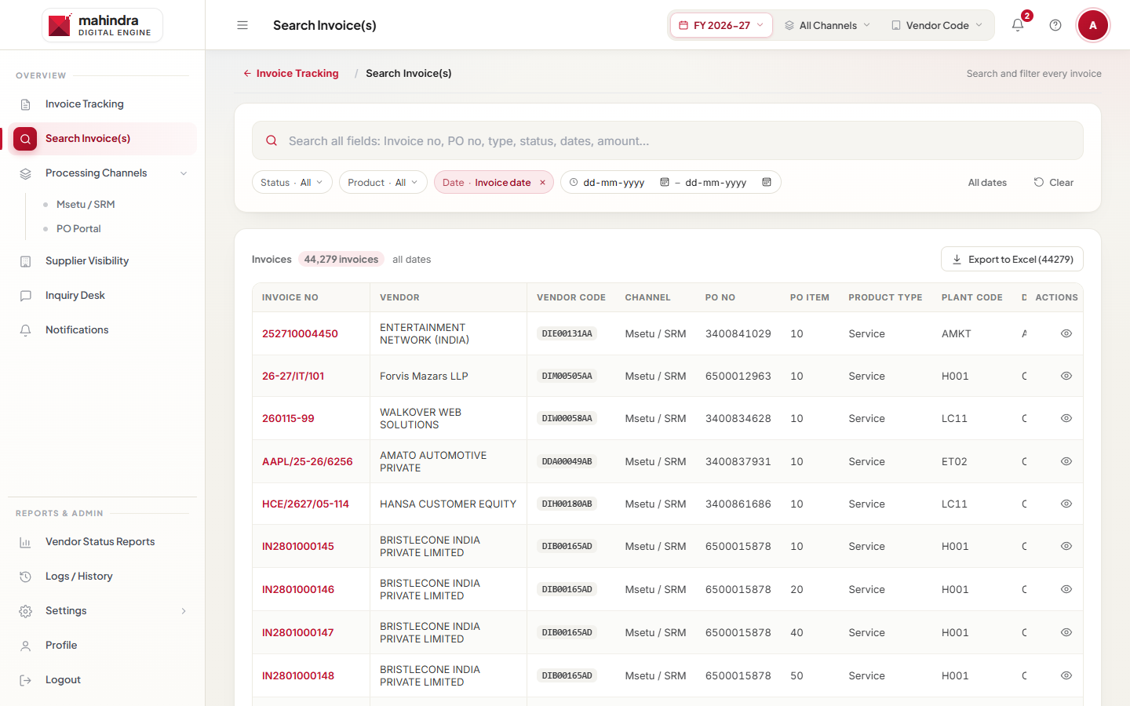
Figure 3: Search Invoice(s)

5.1 Invoice details
The details window shows:
- Status and channel, with a short "Why this channel" explanation.
- Currently Handled By: the approver and accounts person (or "Not assigned").
- Invoice Progress: Initial → Invoice Uploaded → Pending for Approval → Approved → Miro Booked → Paid. The current step says "In progress".
- Status & payment: current status and UTR number. "Not yet visible" means the payment reference has not arrived yet.
- Dates: Invoice Date, Upload Date, Payment Due Date and Payment Date.
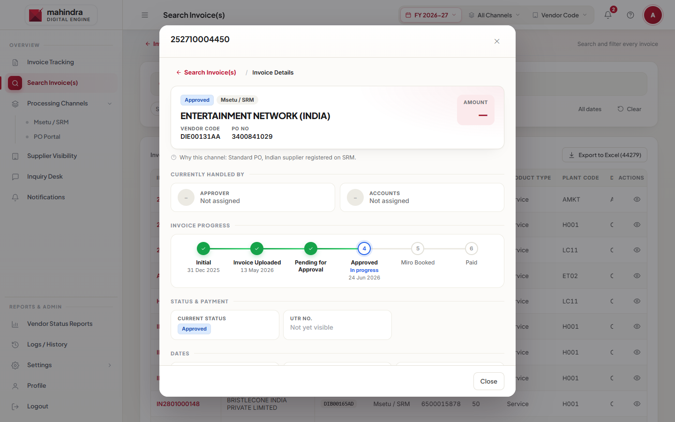
Figure 4: Invoice details

5.2 Export to Excel
Click Export to Excel (N) above the table to download the invoices that match your filters. Tick rows first to export only those (Export Selected to Excel). The button only appears if your role has the "Export data" permission.

6. Processing Channels
Under Processing Channels open Msetu / SRM or PO Portal to see that channel's own invoice register (with channel-specific columns and filters) and its History tab. These pages work the same way as described in the PO Portal and Msetu / SRM manuals.

7. Supplier Visibility
- Click Supplier Visibility.
- Pick a supplier by Supplier Name, PAN or Vendor Code.
- See the supplier's Total Invoices, Paid, Open Queries and Total Invoice Amount, and their invoice list as the supplier sees it.
- Use the status and date filters. The Filtered Invoice Amount shows the total of the filtered list.
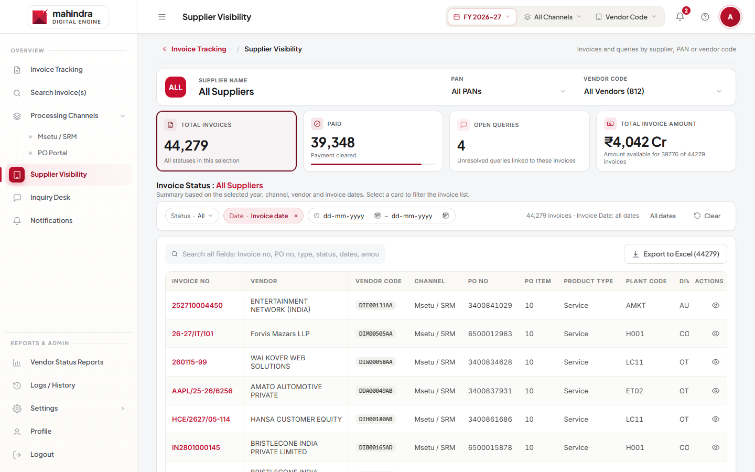
Figure 5: Supplier Visibility

8. Vendor Status Reports
Shows completed invoices (payment confirmed, UTR available). Cards: Completed Invoices, Suppliers Covered, Paid Value, Top Supplier. Search the list, tick rows if needed and click Export to Excel.
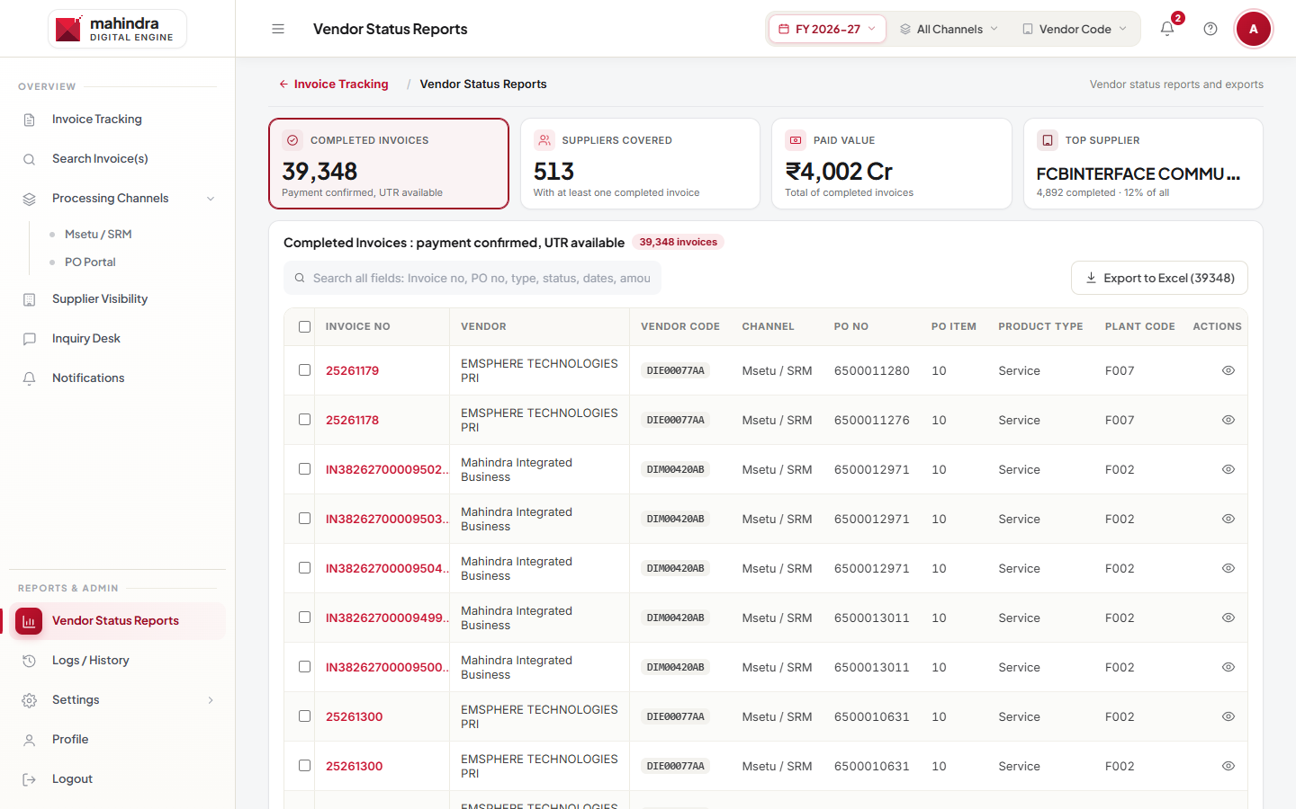
Figure 6: Vendor Status Reports

9. Logs / History
A combined history of invoice, payment and query events. Search by invoice, vendor, PO or details; filter by type (Invoice, Payment, Query) and date; click Export (N) to download. Columns: Date, Invoice No, Vendor Code, PO No, Type, Event, Performed By, Details.
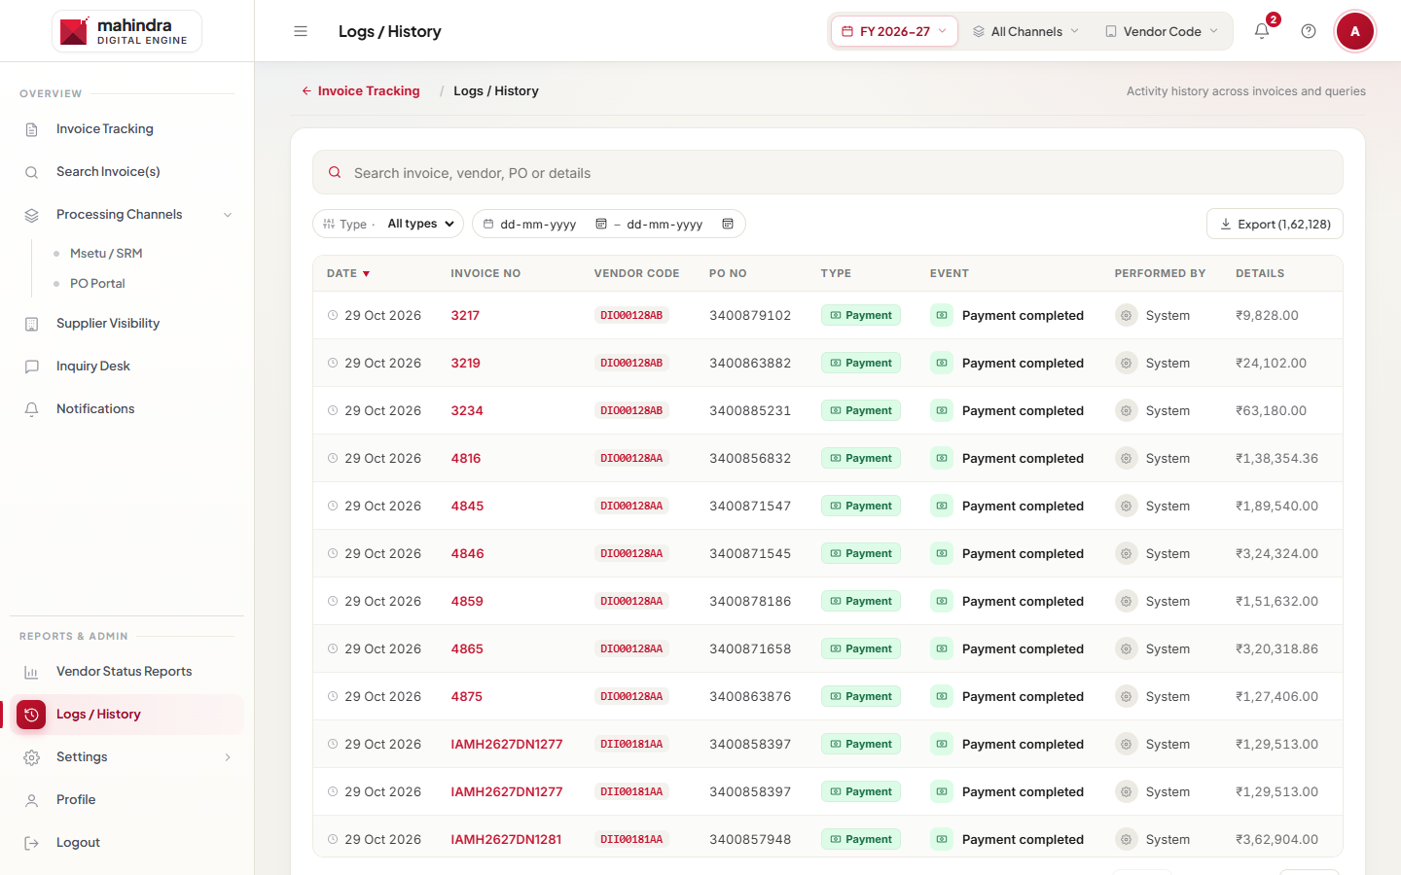
Figure 7: Logs / History

10. Inquiry Desk (supplier queries)
Suppliers raise queries about their invoices. They come to the Inquiry Desk of the invoice's channel. You only see this menu if you have an Inquiry Desk role: Admin, Channel Lead or Assignee.
- Click Inquiry Desk. The cards show Open, In Progress, SLA Breached and Resolved / Closed queries. Click a card to filter.
- Search by query number, invoice, vendor, subject or owner. Filter with All categories. Switch between List and Board view.
- Click a query to open it.
- Write in the reply box. Choose Public reply (the supplier sees it) or Internal note (only the Mahindra team sees it). Attach a file if needed and click Send.
- Use Assign to give the query to a team member.
- When the issue is solved, click Resolve and add a resolution note. The supplier can then close it or reopen it.
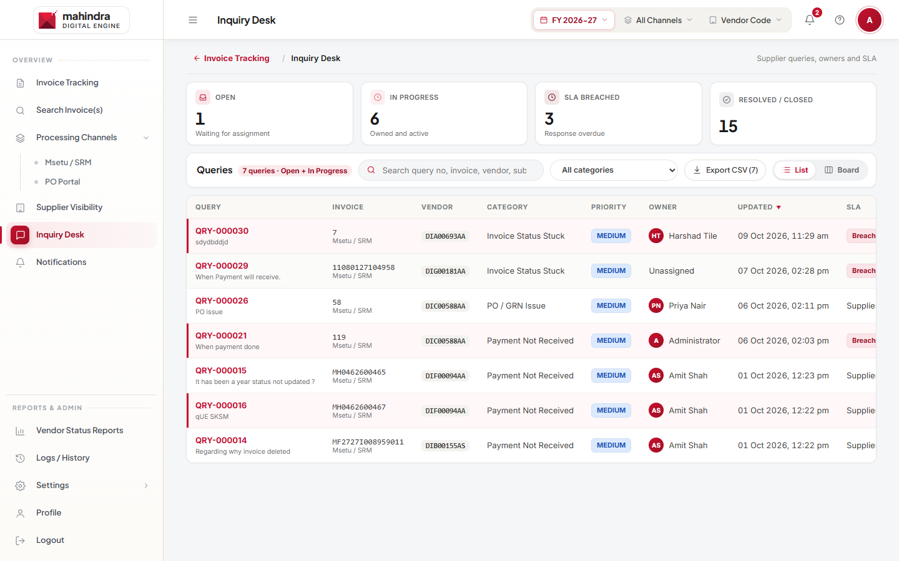
Figure 8: Inquiry Desk
Note: Channel Leads see and assign all queries in their channel. Assignees see and answer the queries assigned to them.

11. Supplier Management
Settings › Supplier Management lets you give suppliers access to the portal. You need the "Manage suppliers" permission.
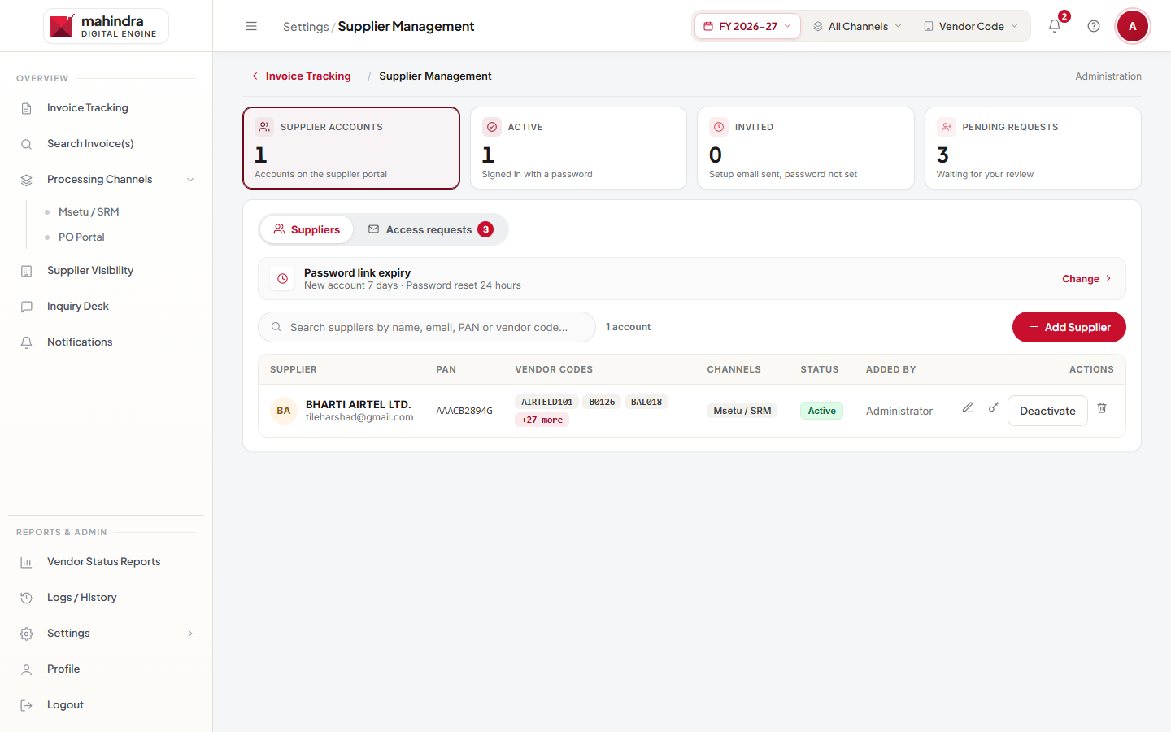
Figure 9: Supplier Management

11.1 Review an access request
A supplier can ask for an account from the sign-in page, or ask to add or remove vendor codes from their profile. You get a notification.
- Open the Access requests tab. Requests waiting for you show Pending.
- Click Review. Check Match with invoice data: each vendor code shows Found or Not found, with the supplier name and PAN in our data.
- Tick the vendor codes to give.
- Click Approve & send setup email (new account) or Apply change (code change). The supplier receives an email.
- To refuse, click Reject…, pick a reason (for example "Details don't match our records"), add a note and click Reject and email supplier.
Note: Admins can change any code. If another team has already approved the request, you see "Already approved by … Use Edit supplier to add your codes."

11.2 Add or manage a supplier
- Add Supplier: search the supplier name, PAN or vendor code, enter their email, tick the vendor codes and click Create supplier. A setup email is sent.
- Row icons: Edit supplier details, Send setup email, Send password reset email, Delete supplier.
- Activate / Deactivate turns a supplier's sign-in on or off.

12. Settings (Admin)

12.1 Integration Settings
Shows the health of data connections. Under Portal Availability an Admin can switch each portal on or off (Msetu / SRM, PO Portal, MFOX Portal). A switched-off portal cannot be used for sign-in.
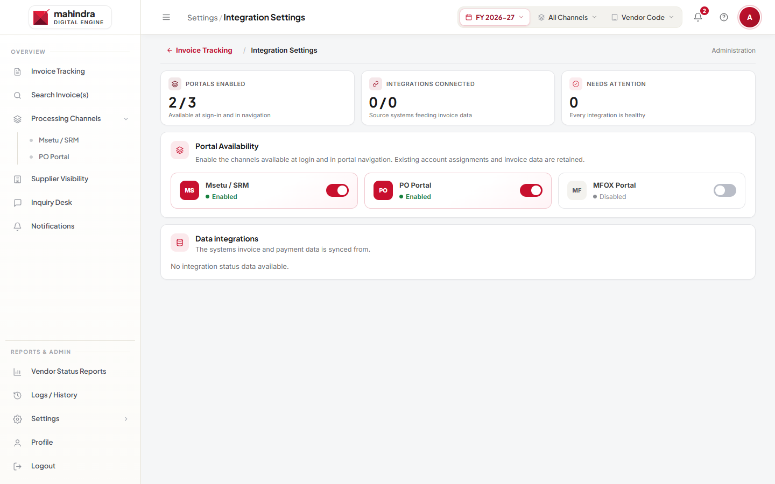
Figure 10: Integration Settings

12.2 User Management
- Click Add User. Enter Full Name and Email, choose the Application Role, the Ticket Role (Inquiry Desk access) and the Authorized Channel.
- Click Create User & Generate Link. The user receives a Welcome email with a Set Your Password link.
- Use the row icons to Edit user (including Active / Inactive status), Send account setup or password reset email, or Remove User.
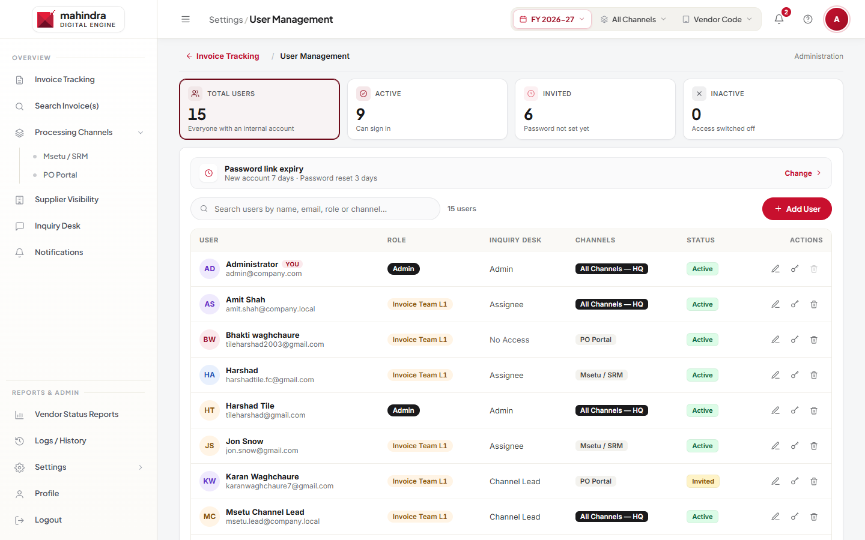
Figure 11: User Management

12.3 Roles & Permissions
A table of roles and permissions. Tick or untick a box to allow or remove a permission. Use New role to create a role and Edit roles to rename or delete one (users of a deleted role are moved to another role you choose).
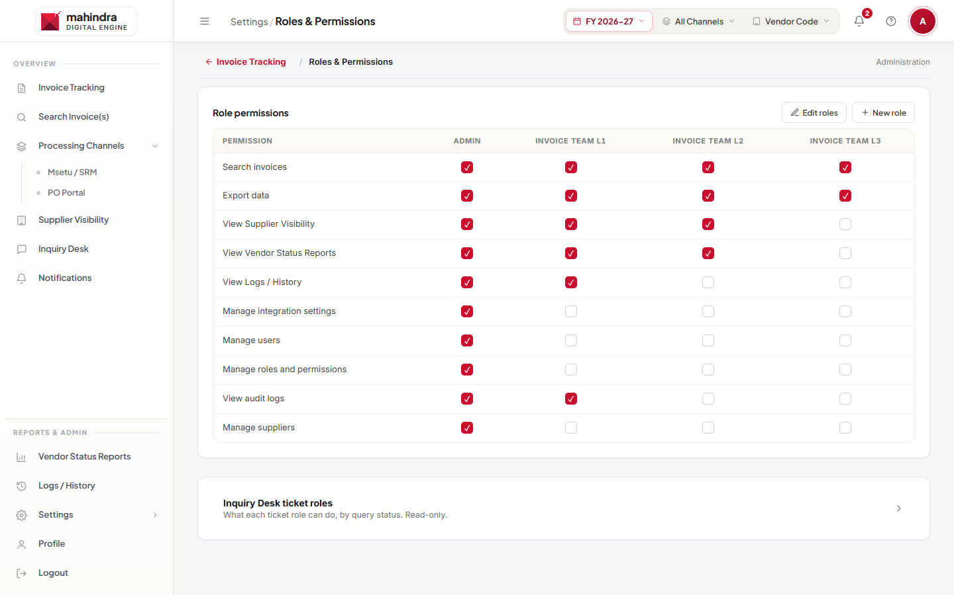
Figure 12: Roles & Permissions

12.4 Audit Logs
A record of sign-ins, failed sign-ins and changes made in the app, with search and event-type filters.

13. Notifications, Profile and Logout
- Notifications: updates on queries and supplier requests. Click Mark all read to clear the count. Use All / Unread and the search box.
- Profile: your name, email, role and portal access.
- Logout: click Logout and confirm Log Out. Always log out on a shared computer.

14. Invoice status meanings
Status | What it means
Initial | Invoice recorded; not yet uploaded.
Push to PO Portal | Passed from Msetu / SRM to PO Portal for processing.
Invoice Uploaded | Invoice uploaded by the supplier.
Pending for Approval | Waiting for the approver.
Action Required | The approver has asked for more information.
Level Approved | Approved at one level; more approvals pending.
Approved | Approved by the business.
Miro Booked | Booked in SAP (MIRO); waiting for payment.
Paid | Payment cleared; UTR number available.
Rejected | Rejected; the rejection reason is shown with the invoice.
Entry Deleted / Deleted | Removed from processing.

15. Roles and what they can do (default)
Role | Default access
Invoice Team L1 | Dashboard, Search invoices, Export data.
Invoice Team L2 | L1 + Manage suppliers, Vendor Status Reports, Logs / History.
Invoice Team L3 | L2 + Audit logs, Supplier Visibility.
Admin | Everything, including Settings (integrations, users, roles).
Admins can change these permissions in Settings › Roles & Permissions, so your access may differ.
Reports, Logs / History, Supplier Visibility and the other Settings pages are available only when signed in to All channels (HQ).

16. Common messages and what to do
Message | What to do
Invalid email or password. | Check your email and password. Use Forgot password? if needed.
This account hasn't been activated yet… | Use the Set Your Password link from your Welcome email, or ask an Admin for a new one.
This account has been deactivated. Contact an administrator. | Ask an Admin to activate your account.
This account can only sign in to its assigned portal. | Choose your own portal in Portal / Team.
This portal is currently disabled. Contact your administrator. | The portal has been switched off by an Admin.
This reset link is invalid or has expired. Request a new one. | Use Forgot password? again and use the newest email.
Unable to load portal options. Refresh the page to try again. | Refresh the page. If it continues, contact support.
No invoices match | Clear a filter or widen the date range. Check the FY and Vendor Code filters in the top bar.
UTR "Not yet visible" | The payment reference has not arrived yet. Check again later.

Need help? Use Contact Us at the top of the sign-in page to email the helpdesk.

