Invoice Tracker
User Manual
Vendor View (Supplier Portal)
For: Suppliers / vendors
Version 1.0 · November 2026

Contents
1. About this guide 3
2. Getting an account 3
2.1 Request an account 3
2.2 Set your password 3
3. Signing in 3
3.1 Forgot password 4
4. Finding your way around 4
5. Dashboard 5
6. My Invoices 5
6.1 Invoice details 6
7. Raising a query 7
7.1 Following up 7
8. Logs, Notifications and Profile 8
8.1 Add or remove vendor codes 8
9. Invoice status meanings 9
10. Common messages and what to do 9

1. About this guide
The Mahindra Invoice Tracker supplier portal lets you see the status of your invoices, when you will be paid, and the payment reference (UTR). You can also raise a query about an invoice. This guide explains every step.

2. Getting an account

2.1 Request an account
- Open the sign-in page. Under "New supplier, or no account yet?" click Request an account.
- Enter your Company name and your Email. This email will be your sign-in. Each account needs its own email.
- Enter your PAN (10 characters, like ABCDE1234F).
- Enter your Vendor codes. Separate several codes with a comma or space.
- Add a Note only if you are unsure about something (optional).
- Click Submit request. A "Request submitted" message confirms it and you also receive an email.
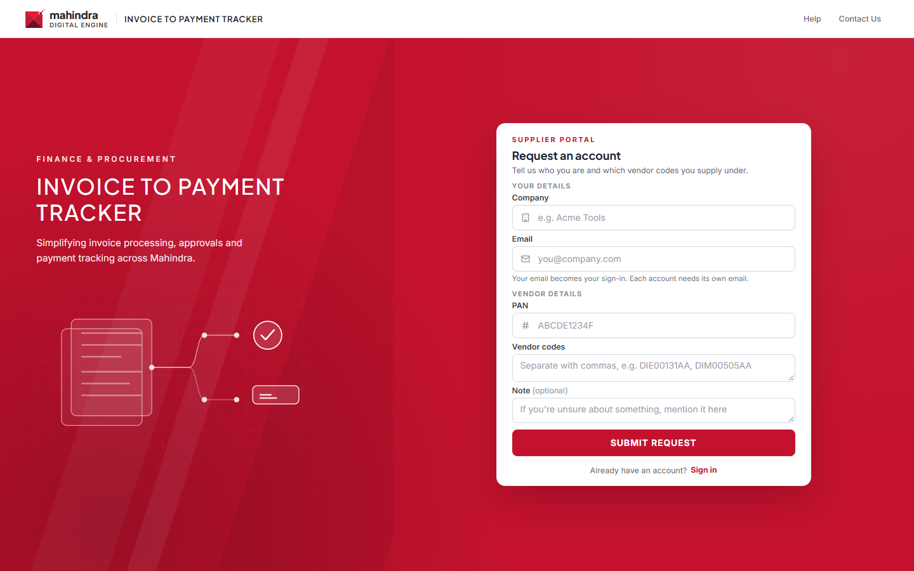
Figure 1: Request an account
The Mahindra team reviews your request. If it is approved you receive an email with a link to set your password. If it is rejected the email tells you why.

2.2 Set your password
- Open the email and click the link. The link works for a limited time.
- Confirm your Email, enter a New password (at least 8 characters) and Confirm password.
- Click Set password and continue. You are taken to the sign-in page.

3. Signing in
- Open the sign-in page. Supplier is selected.
- Enter your Email and Password.
- Keep Remember me on this device ticked only on your own computer.
- Click Continue. Your dashboard opens.
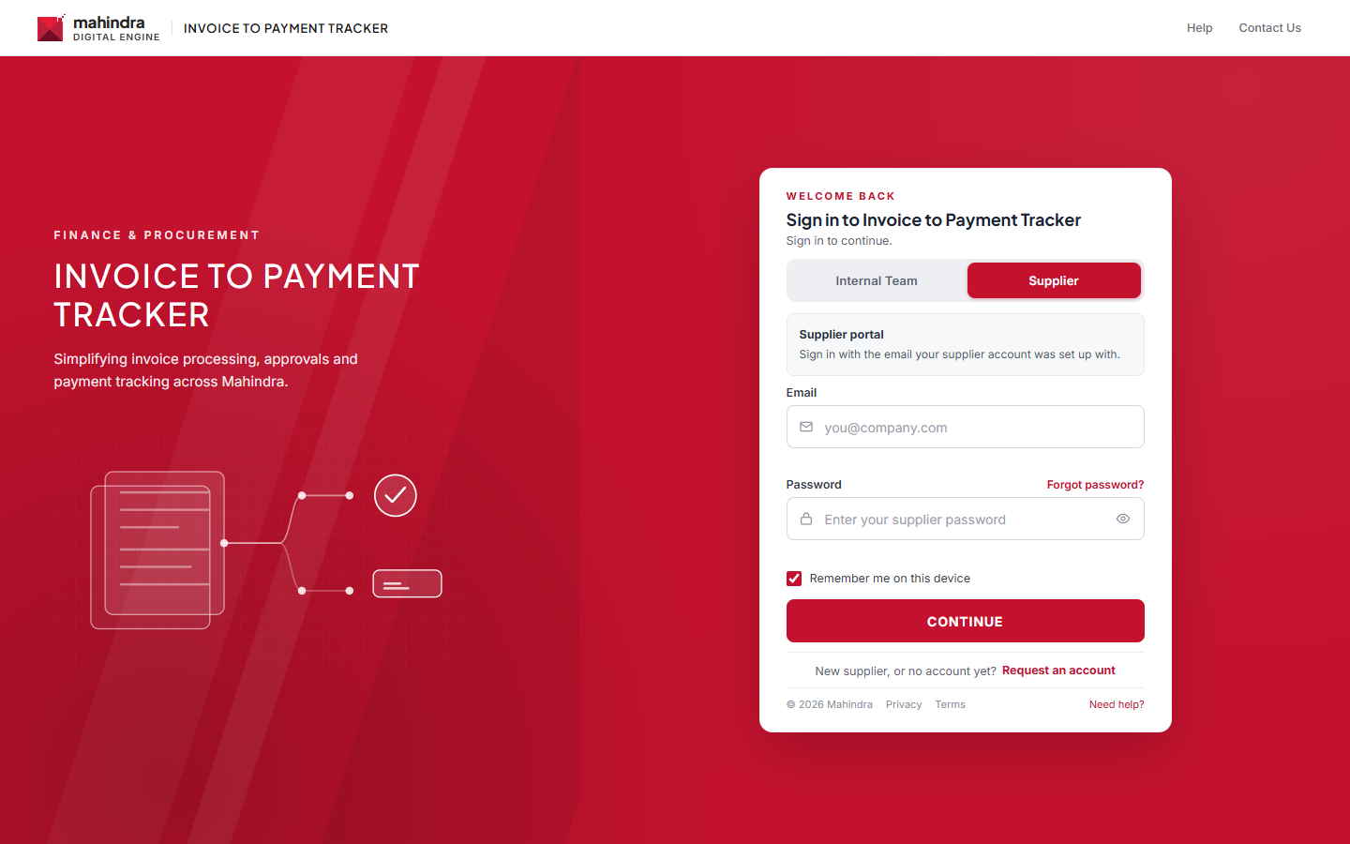
Figure 2: Supplier sign-in
Note: After 5 wrong passwords your account is locked for 15 minutes.

3.1 Forgot password
- Click Forgot password? on the sign-in page.
- Enter your Sign-in email and click Send reset email.
- Open the email, click the link and choose a new password.

4. Finding your way around
Area | What it does
Left menu | Dashboard, My Invoices, Logs, My Queries, Notifications, My Profile, Logout.
FY filter (top bar) | Choose the financial year.
Vendor code list (top bar) | Show one vendor code, or All vendor codes.
Bell icon | Your latest notifications.

5. Dashboard
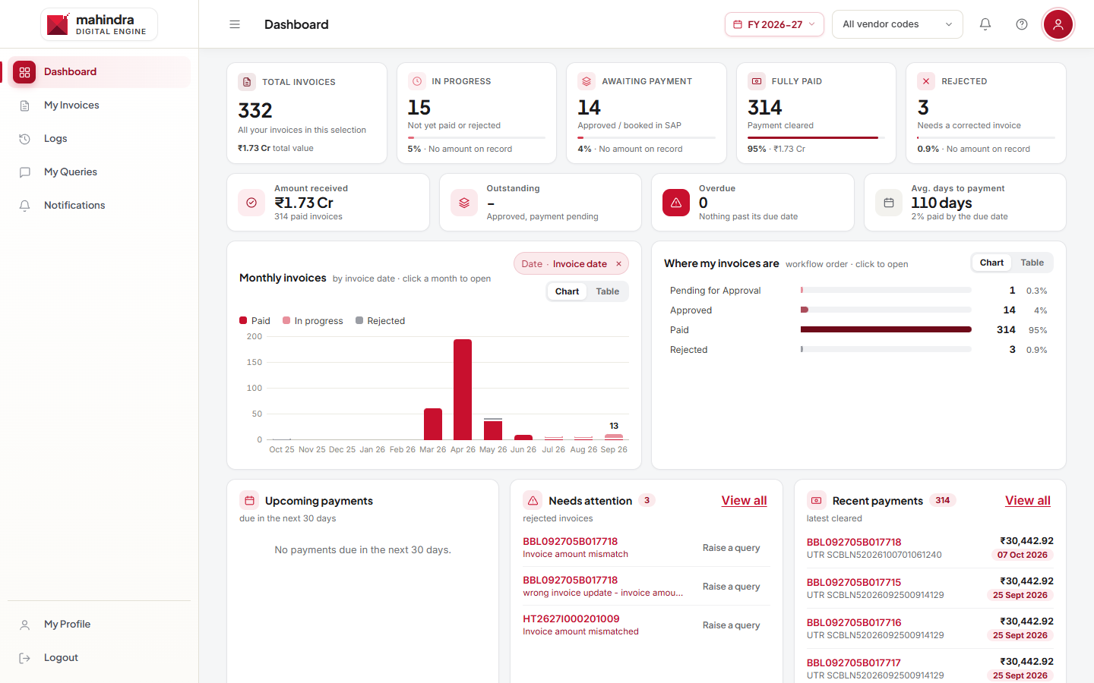
Figure 3: Supplier dashboard
Card | Meaning
Total Invoices | All your invoices in this selection.
In Progress | Not yet paid or rejected.
Awaiting Payment | Approved or booked in SAP; payment pending.
Fully Paid | Payment cleared.
Rejected | Needs a corrected invoice.

- Amount received, Outstanding, Overdue and Avg. days to payment show your money position.
- Monthly invoices and Where my invoices are charts: click a month or status to see those invoices.
- Upcoming payments (next 30 days), Needs attention (rejected invoices, with Raise a query), Recent payments (with UTR) and My Queries.
- Click any card to open My Invoices filtered to that group.

6. My Invoices
- Click My Invoices.
- Use the Status filter, the Date chip and the date range, or type in the search box.
- Click an invoice number to see its progress.
- Click Export to Excel (N) to download the list.
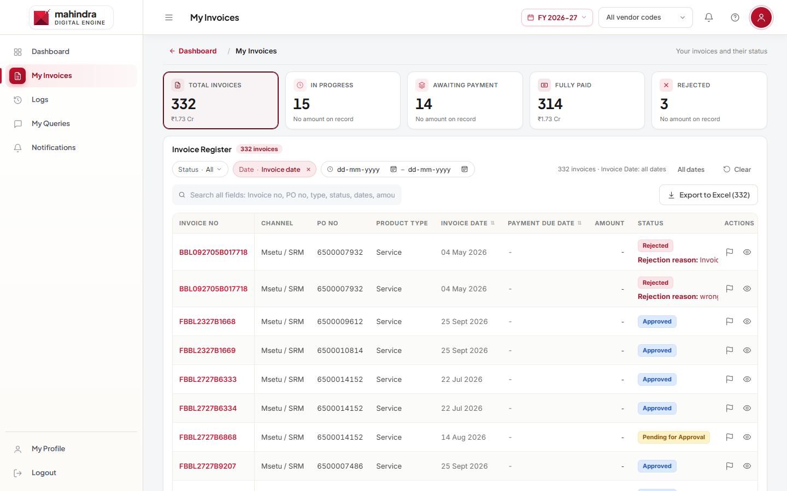
Figure 4: My Invoices

6.1 Invoice details
The invoice page shows the Invoice Progress (Initial → Invoice Uploaded → Pending for Approval → Approved → Miro Booked → Paid), the payment due date, payment date and UTR No. If the invoice was rejected, the rejection reason is shown. Click View Full Detail for all fields.
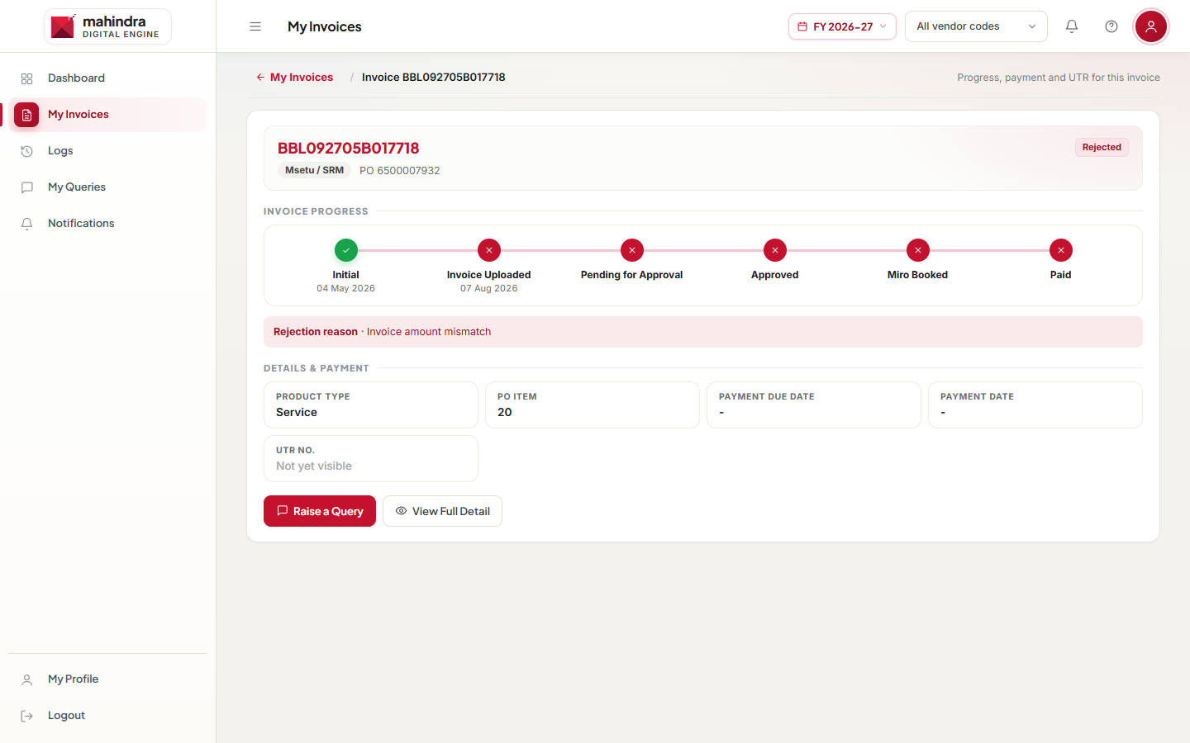
Figure 5: Invoice details

7. Raising a query
- Open the invoice and click Raise a Query (or the flag icon in the invoice list).
- Choose the Topic (for example Payment Not Received, Amount Mismatch, Invoice Rejected) and the Priority (Low, Medium, High).
- Write a Subject and Details. Attach a file if needed (5 MB maximum).
- Click Submit Query. The query goes to the Mahindra team of that invoice's channel.
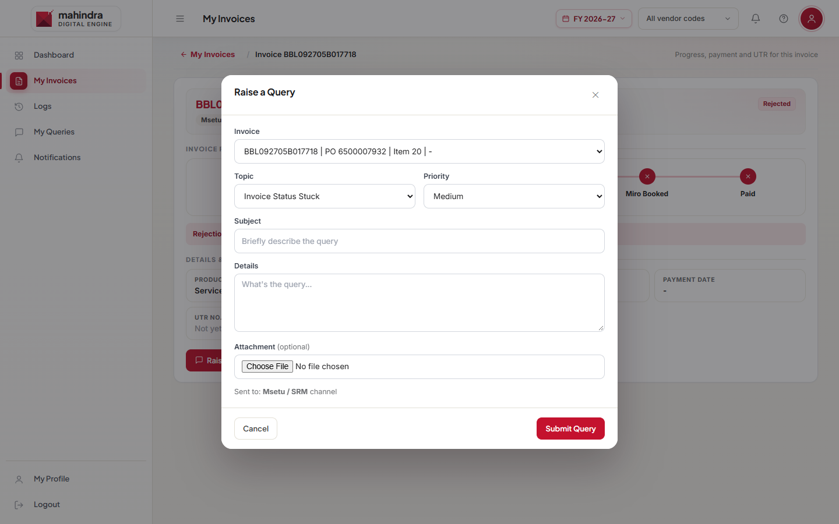
Figure 6: Raise a query

7.1 Following up
- My Queries shows Open (waiting for the Mahindra team), In Progress and Resolved / Closed queries.
- Open a query to read the replies. Write in Write a reply and click Send while it is open or in progress.
- When the team resolves it, click Close if you are satisfied, or Reopen and give a reason.
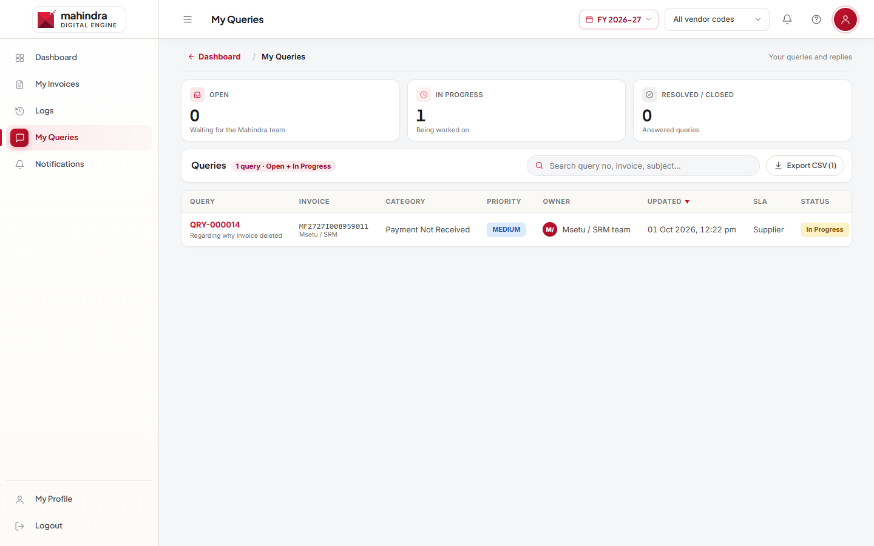
Figure 7: My Queries

8. Logs, Notifications and Profile
- Logs: a timeline of invoice events, payments and query updates. Filter by type and search; export to CSV.
- Notifications: updates on your queries. Click Mark all read to clear them.
- My Profile: your sign-in email, PAN and vendor codes.

8.1 Add or remove vendor codes
- Go to My Profile › Vendor code access and click Request a change.
- Enter Vendor codes to add and/or tick Vendor codes to remove.
- Write a Note explaining why (required) and click Send request.
- The status shows Waiting for review, then Approved or Rejected. You can send a new request once the current one is reviewed.
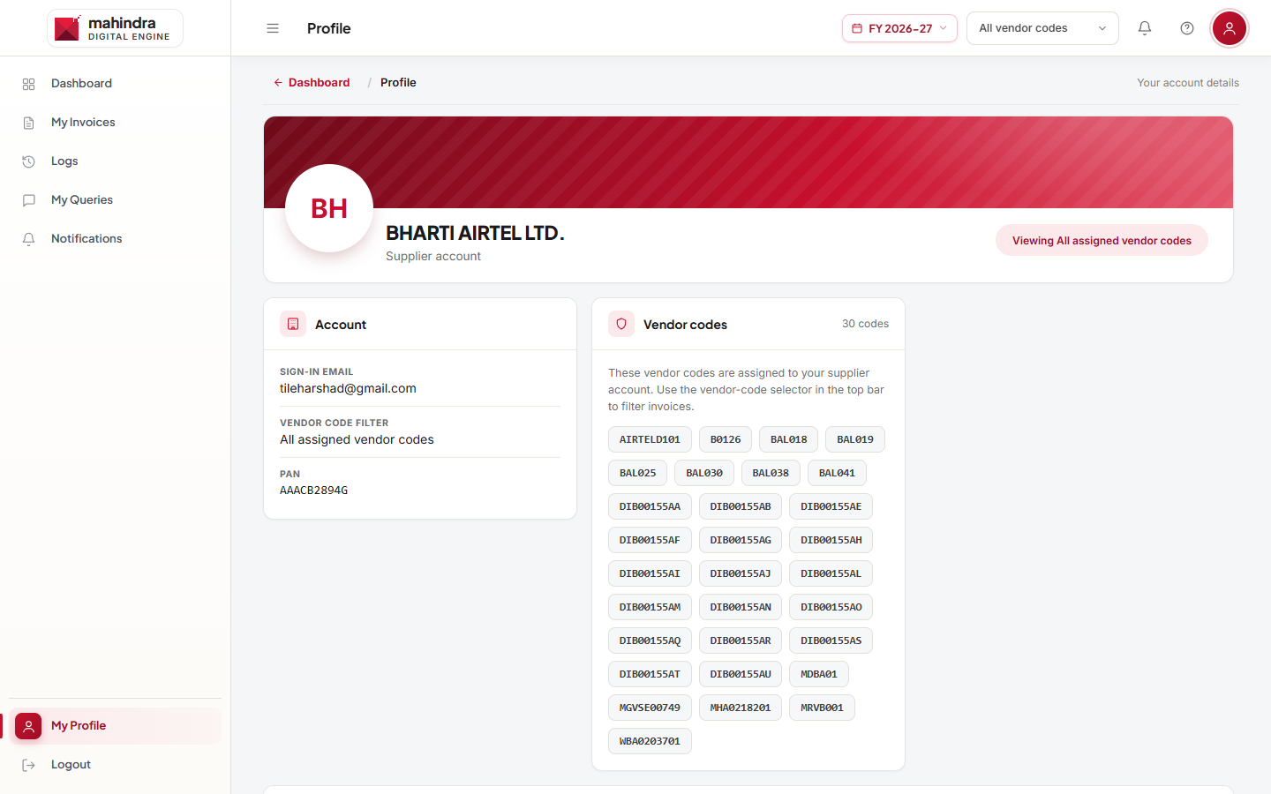
Figure 8: My Profile

9. Invoice status meanings
Status | What it means
Initial | Invoice recorded; not yet uploaded.
Invoice Uploaded | Your invoice has been received.
Pending for Approval | Waiting for Mahindra approval.
Action Required | Mahindra needs more information; raise a query if you are unsure what is needed.
Approved | Approved; moving to accounts.
Miro Booked | Booked in SAP; payment will follow.
Paid | Payment made; see the UTR number.
Rejected | Rejected; see the reason and send a corrected invoice.

10. Common messages and what to do
Message | What to do
Email or password is incorrect, or the account is inactive. | Check your email and password. Use Forgot password? If it still fails, your account may be inactive; contact the Mahindra team.
This link is invalid or has expired. Ask the team for a new one. | The setup or reset link is used or too old. Use Forgot password?, or ask the team for a new setup email.
That email doesn't match this link. | Enter the email address the link was sent to.
This email already has a supplier account. Sign in, or use Forgot password. | Sign in with that email instead of requesting a new account.
A request from this email is already waiting for review. | Wait for the review email.
PAN must be 10 characters like ABCDE1234F. | Check your PAN.
Too many requests. Please try again a little later. | Wait a while before trying again.
This portal is currently disabled. Contact your administrator. | Contact the Mahindra team.
Attachment must be 5 MB or smaller. | Attach a smaller file.
UTR "Not yet visible" | Payment reference not available yet. Check again later.

Need help? Use Contact Us at the top of the sign-in page to email the helpdesk.

