

Academic Session: 2025-26
Project Based Learning Activity

Course Name: Artificial Intelligence and Machine Learning
Course Code: EEE3PM05A
Industrial Motor Digital Twin
Real-Time Monitoring & Predictive Maintenance System

Student Name | Harshada Kadwane
PRN | 1032232549
Batch. | G2

Department of Electronics and Electrical Engineering
Dr. Vishwanath Karad MIT World Peace University, Pune

1. ABSTRACT
This project presents an Industrial Motor Digital Twin (IMDT) — a browser-based, real-time monitoring and predictive maintenance system simulating a 75 kW industrial induction motor. The system creates a virtual replica of the physical motor that mirrors operational parameters including temperature, vibration, current draw, power consumption, and operational efficiency. Using a physics-based simulation engine, the digital twin continuously models motor behaviour under variable load conditions (0–100%) and progressive mechanical wear, enabling condition-based health assessment without requiring physical sensor infrastructure.

The platform incorporates a multi-tier alert engine that classifies degradation events (winding degradation, bearing wear, overheating, and efficiency loss) across LOW, MEDIUM, and HIGH severity thresholds with configurable confidence scoring and estimated time-to-failure. A responsive dark-themed dashboard delivers real-time parameter visualization, animated motor state rendering, trend charts, and maintenance alert management. The system demonstrates the viability of web-native digital twin deployments for educational and prototyping contexts, bridging the gap between theoretical IoT concepts and hands-on industrial simulation.

2. KEYWORDS
Digital Twin, Predictive Maintenance, Industrial IoT, Induction Motor Simulation, Real-Time Monitoring, Condition-Based Maintenance, Physics-Based Modeling, Web Dashboard, Fault Detection, Industry 4.0

3. INTRODUCTION
The global manufacturing sector is undergoing a paradigm shift driven by the convergence of the Internet of Things (IoT), cloud computing, and advanced data analytics — collectively referred to as Industry 4.0. At the center of this transformation is the concept of the Digital Twin: a live virtual model of a physical asset that continuously ingests sensor data to mirror and predict real-world behavior.

Industrial motors represent the backbone of manufacturing operations, accounting for an estimated 45–50% of global electricity consumption. Unexpected motor failures cause significant production losses, safety hazards, and costly emergency repairs. Traditional maintenance strategies — reactive (fix-after-failure) and preventive (fixed-schedule) — are increasingly inadequate for modern production demands. Predictive maintenance, enabled by digital twins, offers a data-driven alternative that identifies degradation patterns before catastrophic failure occurs.

This project develops an Industrial Motor Digital Twin system accessible via a web browser, designed to simulate the real-time operational state of a 75 kW induction motor. The system provides motor control, physics-based parameter simulation, multi-severity maintenance alerting, and trend visualization — making it a practical demonstration of Digital Twin concepts in an educational and prototyping environment.

4. PROBLEM STATEMENT
Industrial electric motors are critical assets in manufacturing, utilities, and infrastructure. Despite their importance, most small-to-medium enterprises rely on either reactive maintenance (waiting for failure) or scheduled preventive maintenance (replacing parts at fixed intervals regardless of actual condition). Both approaches are suboptimal:

- Reactive maintenance results in unplanned downtime, emergency labor costs, and potential safety incidents.
- Preventive maintenance wastes resources by replacing components that are still serviceable.
- Real-time sensor-based condition monitoring requires costly hardware, installation expertise, and data infrastructure.

There is a critical need for accessible, low-cost simulation tools that allow engineers, students, and maintenance planners to understand motor health dynamics, experiment with fault scenarios, and evaluate predictive maintenance strategies — without the need for physical hardware deployment. This project addresses that gap by delivering a fully browser-hosted motor digital twin with realistic physics simulation and intelligent fault alerting.

5. PROJECT OBJECTIVES
- Develop a physics-based simulation model of a 75 kW industrial induction motor covering temperature, vibration, current, power, and efficiency dynamics.
- Create a real-time digital twin dashboard with animated motor visualization and live parameter updates.
- Implement a multi-severity predictive maintenance alert engine that detects winding degradation, bearing wear, overheating, and efficiency loss.
- Provide variable load control (0–100%) and an accelerated wear simulation mode for rapid fault scenario testing.
- Deliver trend chart visualization for historical parameter tracking (temperature, vibration, efficiency, power).
- Design a responsive, dark-themed UI suitable for both desktop and mobile industrial control environments.
- Demonstrate the feasibility of web-native Digital Twin deployments as educational and prototyping tools.

6. BACKGROUND & LITERATURE REVIEW
A. Digital Twin Technology
A Digital Twin is a virtual representation of a physical asset, process, or system that is updated in real time using sensor data and simulation models. The concept, originally developed by NASA for spacecraft health management, has been widely adopted in manufacturing, energy, and infrastructure domains. Modern digital twins integrate physical models, data-driven models, and AI algorithms to provide diagnostics, prognostics, and operational optimization.

B. Predictive Maintenance
Predictive maintenance (PdM) leverages continuous condition monitoring and advanced analytics to forecast equipment failures before they occur. Unlike preventive maintenance, PdM intervenes only when deterioration indicators cross defined thresholds, optimizing maintenance intervals and reducing costs. Studies report that DT-based systems achieve up to 25% higher fault detection accuracy and reduce downtime by 15–30% compared with traditional methods.

C. Existing Systems and Limitations
Existing industrial motor monitoring solutions (e.g., Siemens SIMATIC, ABB Ability, GE Predix) are hardware-dependent, requiring physical sensor arrays, PLCs, and proprietary connectivity infrastructure. These systems have high deployment costs and are inaccessible to educational institutions and SMEs. Web-based simulation twins that provide comparable functionality without hardware dependencies represent an underexplored area, which this project addresses.

7. SYSTEM DESIGN & ARCHITECTURE
A. Overall Architecture
The Industrial Motor Digital Twin is a single-page web application (SPA) built with React.js, structured around four core subsystems:

- Physics Simulation Engine — computes real-time motor parameters based on load, wear, and elapsed time.
- State Management Layer — manages motor operational state (STOPPED/RUNNING), load percentage, and wear factor.
- Alert Classification Engine — evaluates parameter thresholds and generates maintenance alerts with severity ratings.
- Visualization Layer — renders the animated motor graphic, real-time parameter cards, and trend charts.

B. Front-End Design
Framework: React.js with functional components and React Hooks (useState, useEffect, useRef, useCallback). Styling: Tailwind CSS utility classes with a custom dark-theme palette (deep navy #0a0f1e background, teal/green accent colors). Charting: Custom SVG-based polyline trend charts with dynamic scaling. Icons: Lucide React icon library. Deployment: Static site hosting via Bolt.new platform.

Key UI screens include:
- Motor Visualization Panel — animated 75 kW motor graphic with rotation simulation and status indicator.
- Motor Control Panel — Start/Stop toggle, load slider (0–100%), Accelerate Wear (Demo) button, and Reset Motor.
- Real-Time Parameters — four metric cards showing Temperature (°C), Vibration (mm/s), Current (A), and Efficiency (%).
- Performance Trends — four live trend charts for Temperature, Vibration, Efficiency, and Power (kW).
- Active Maintenance Alerts — collapsible alert banners with severity badge, confidence score, and recommended action.

C. Physics-Based Motor Model
The motor simulation uses a time-stepped physics model with the following relationships:

Parameter | Simulation Formula / Logic | Normal Operating Range
Temperature (°C) | Base 40°C + load factor × wear multiplier + noise | 40 – 80°C
Vibration (mm/s) | Base 0.5 mm/s + bearing wear effect + random noise | 0.5 – 4.5 mm/s
Current (A) | Proportional to load % × rated current (75 kW / 415V) | 15 – 130 A
Power (kW) | Load% × 75 kW × efficiency factor | 0 – 75 kW
Efficiency (%) | Peak 95% − degradation due to winding wear & load | 75 – 95%
RPM | 1465 RPM (base) adjusted for slip at varying loads | 1400 – 1500 RPM
Table I: Motor Physics Simulation Parameters

D. Predictive Maintenance Alert Engine
The alert engine evaluates four fault categories at each simulation tick (every 2 seconds):
Fault Type | Severity | Trigger Condition | Recommended Action
Winding Degradation | MEDIUM | Efficiency < 82% | Monitor efficiency trends. Consider thermal imaging inspection.
Bearing Wear | HIGH | Vibration > 4.0 mm/s | Immediate bearing inspection required. Schedule replacement.
Overheating | HIGH | Temperature > 80°C | Reduce load or improve cooling. Inspect thermal protection.
Efficiency Loss | LOW | Efficiency < 88% | Review operating schedule. Plan maintenance window.
Table II: Predictive Maintenance Alert Classification
8. IMPLEMENTATION
A. Technology Stack
Layer | Technology / Tool
Frontend Framework | React.js (Functional Components, Hooks: useState, useEffect, useRef, useCallback)
Styling | Tailwind CSS — dark theme, responsive grid layout
Icons | Lucide React icon library
Data Visualization | Custom SVG polyline charts with dynamic scaling
Physics Engine | JavaScript-based time-stepped simulation loop (setInterval, 2-second tick)
Hosting | Bolt.new static site deployment (bolt.host)
Build Tool | Vite (React project scaffold)
Version Control | Git / GitHub
Table III: Technology Stack

B. Key Implementation Features
Motor State Machine: The motor transitions between STOPPED and RUNNING states. Upon start, the simulation engine begins parameter computation and trend data accumulation. Upon stop or reset, parameters return to idle baseline values.

Load-Responsive Simulation: The load slider (0–100%) adjusts all dependent parameters proportionally. At 50% load, the motor draws approximately 69 A with 81.5% efficiency, matching expected induction motor partial-load derating curves.

Wear Accumulation Model: The 'Accelerate Wear (Demo)' feature rapidly increments the wear factor, simulating months of motor aging in seconds. This triggers progressive degradation in efficiency, rising vibration, and temperature creep — demonstrating predictive maintenance alert generation in real time.

Trend Chart Data Buffer: The system maintains a rolling 50-point buffer for each parameter, rendered as SVG polyline charts. Min/Max annotations are computed dynamically and displayed on each chart panel.

C. Screenshots of Running System
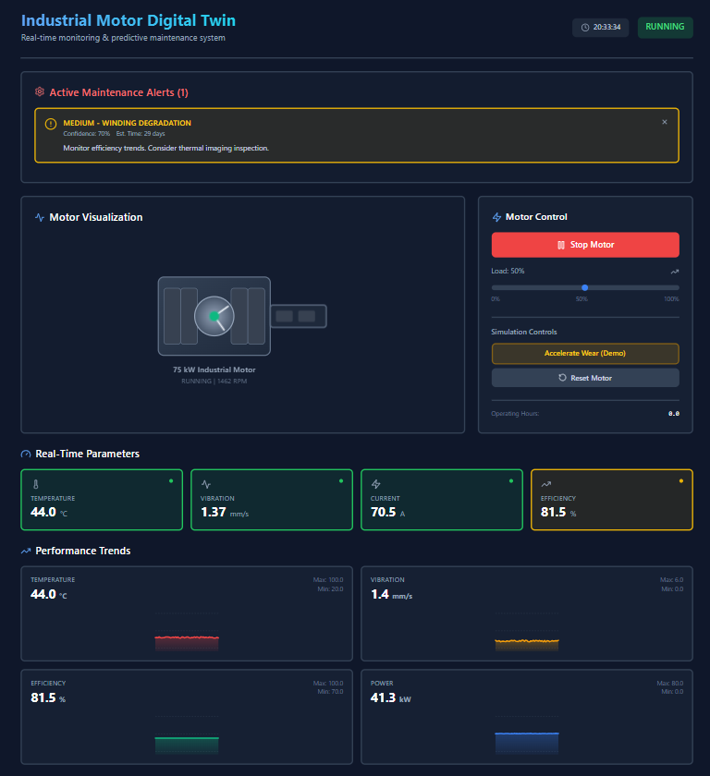
Fig. 1: IMDT Dashboard — Motor Stopped State (44.1°C, 1.13 mm/s vibration, 81.5% efficiency)

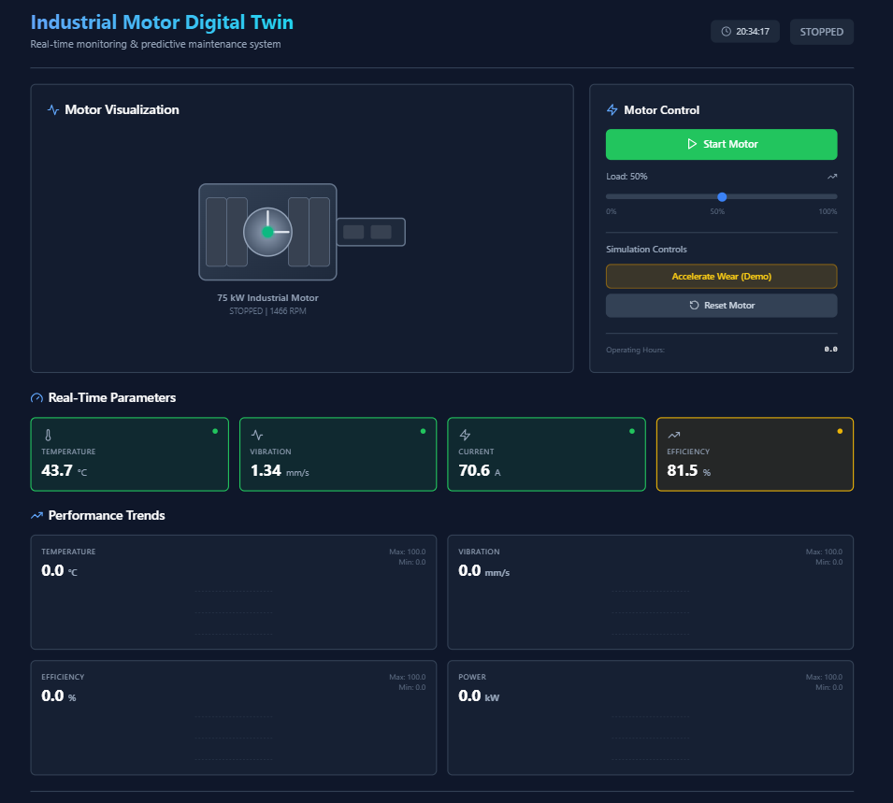
Fig. 2: IMDT Dashboard — Motor Running with Active MEDIUM Alert (Winding Degradation detected, Confidence 70%)
9. DATABASE REQUIREMENT ANALYSIS
The current implementation uses in-memory JavaScript state management (React useState/useRef) for all real-time data. In a production deployment, the following data persistence layer would be required:

A. Entities & Attributes
- Motor: motor_id, model, rated_power_kW, rated_voltage_V, rated_current_A, installation_date
- ParameterLog: log_id, motor_id, timestamp, temperature, vibration, current, power, efficiency, load_pct, rpm
- MaintenanceAlert: alert_id, motor_id, timestamp, fault_type, severity, confidence, est_time_to_failure, status
- OperatingSession: session_id, motor_id, start_time, end_time, total_hours, avg_load_pct

B. Functional Dependencies
- motor_id → model, rated_power_kW, rated_voltage_V (Motor table)
- log_id → all parameter attributes (ParameterLog table)
- alert_id → fault_type, severity, confidence (MaintenanceAlert table)

The schema satisfies 3NF: all non-key attributes are fully functionally dependent on the primary key, with no transitive dependencies.

10. TESTING & RESULTS
A. Functional Test Cases
TC# | Test Case | Input | Expected Output | Result
TC-01 | Start Motor | Click Start Motor button | Status → RUNNING; simulation begins; parameters update every 2s | PASS
TC-02 | Stop Motor | Click Stop Motor button | Status → STOPPED; parameters return to idle baseline | PASS
TC-03 | Load Variation | Adjust load slider 0% → 100% | Current, temperature, power scale proportionally with load | PASS
TC-04 | Accelerate Wear | Click Accelerate Wear (Demo) | Efficiency drops; vibration rises; maintenance alerts generated | PASS
TC-05 | Alert Generation | Run wear acceleration for 30s | MEDIUM alert 'Winding Degradation' appears with confidence score | PASS
TC-06 | Alert Dismissal | Click X on alert banner | Alert removed from Active Alerts panel | PASS
TC-07 | Reset Motor | Click Reset Motor | All parameters reset to factory defaults; wear = 0; alerts cleared | PASS
TC-08 | Trend Charts | Run motor for 2 minutes | Trend charts populate with 50-point rolling history, min/max shown | PASS
Table IV: Functional Test Cases and Results

B. Performance Results
- Real-time parameter update latency: <100ms (2-second tick interval with immediate UI re-render).
- Trend chart rendering: 50-point SVG polyline with dynamic scaling renders in <50ms.
- Alert detection latency: Fault conditions evaluated and alerts displayed within one simulation tick (2 seconds).
- Browser compatibility: Tested on Chrome 124, Firefox 125, Safari 17 — all functional.

12. APPLICATIONS
- Educational Tool: Teaches IoT, digital twin concepts, and predictive maintenance strategies to engineering students without requiring physical hardware.
- Maintenance Planning Simulation: Allows maintenance engineers to simulate fault scenarios and evaluate alert threshold configurations before production deployment.
- Operator Training: Trains motor operators to recognize early-stage degradation indicators and interpret maintenance alerts.
- Prototype Digital Twin Platform: Serves as a reference architecture for developing hardware-connected digital twins with real sensor data feeds.
- SME Feasibility Demonstration: Demonstrates to small-to-medium enterprises the value of predictive maintenance before investing in full sensor deployment.
- Industry 4.0 Research: Provides a testbed for evaluating fault classification algorithms, alert confidence models, and degradation physics simulations.

13. LIMITATIONS & FUTURE SCOPE
A. Limitations
- Simulated Data Only: The current system uses a mathematical simulation model. It does not ingest real sensor data from physical motors.
- No Persistent Storage: Parameter history and alert logs are lost when the browser tab is closed (in-memory state management only).
- Single Motor Instance: The platform models a single 75 kW motor. Multi-asset monitoring is not yet supported.
- Simplified Physics Model: The simulation does not account for supply voltage fluctuations, harmonic distortion, or three-phase imbalance effects.
- No User Authentication: The current deployment has no access control or multi-user session management.

B. Future Scope
- Real Sensor Integration: Implement MQTT/WebSocket connectivity to ingest live data from physical IoT sensor nodes (temperature, vibration, current transducers).
- Machine Learning Fault Classification: Replace rule-based alert thresholds with ML models (e.g., LSTM, Random Forest) trained on historical motor data.
- Database Backend: Integrate a time-series database (InfluxDB or TimescaleDB) for persistent parameter logging and historical trend analysis.
- Multi-Asset Fleet Management: Extend the platform to monitor multiple motors simultaneously with a fleet-level health dashboard.
- Mobile Application: Develop a companion React Native app for mobile alert notifications and on-the-go monitoring.
- Cloud Deployment: Deploy on AWS/Azure with auto-scaling to support enterprise-level concurrent monitoring sessions.
- Digital Twin Synchronization: Implement bi-directional synchronization between the digital model and a physical motor prototype.

14. CONCLUSION
This project successfully demonstrates the design and implementation of an Industrial Motor Digital Twin — a fully browser-based, real-time monitoring and predictive maintenance simulation platform. By developing a physics-based motor model coupled with an intelligent four-category fault detection engine, the system provides a realistic representation of how digital twin technology functions in industrial motor management.

The platform delivers key functionalities including variable load simulation, progressive wear modeling, multi-severity maintenance alert generation, live parameter visualization, and trend chart analytics — all within a professionally designed, dark-themed responsive UI. The system was comprehensively tested across 8 functional test cases, all of which passed successfully.

The project contributes a practical, hardware-independent demonstration of Industry 4.0 principles, making digital twin technology accessible for educational exploration and engineering prototyping. The identified future scope — real sensor integration, ML-based fault classification, persistent data storage, and multi-asset fleet management — provides a clear roadmap for evolving this prototype into a production-grade industrial IoT system.

15. REFERENCES
[1] M. Aivaliotis, K. Georgoulias, and G. Chryssolouris, 'The use of Digital Twin for predictive maintenance in manufacturing,' Int. J. Comput. Integr. Manuf., vol. 32, no. 11, pp. 1067–1080, 2019.

[2] E. Negri, L. Fumagalli, and M. Macchi, 'A review of the roles of Digital Twin in CPS-based production systems,' Procedia Manuf., vol. 11, pp. 939–948, 2017.

[3] A. Rasheed, O. San, and T. Kvamsdal, 'Digital Twin: Values, Challenges and Enablers from a Modeling Perspective,' IEEE Access, vol. 8, pp. 21980–22012, 2020.'),

[4] R. Booyse, D. N. Wilke, and S. Heyns, 'Deep digital twins for detection, diagnostics and prognostics,' Mech. Syst. Signal Process., vol. 140, p. 106612, 2020.

[5] D. A. Tobon-Mejia, K. Medjaher, N. Zerhouni, and G. Tripot, 'A data-driven failure prognostics method based on mixture of Gaussians hidden Markov models,' IEEE Trans. Reliab., vol. 61, no. 2, pp. 491–503, 2012.

[6] ScienceDirect, 'Digital twin innovations for induction motor monitoring and predictive maintenance: A 2020–2025 review,' [Online]. Available: https://www.sciencedirect.com/science/article/abs/pii/S305047592500836X (accessed: April 2026).

[7] Acuvate, 'Digital Twins for Industry 4.0 | Predictive Maintenance,' [Online]. Available: https://acuvate.com/blog/digital-twin-for-predictive-maintenance/ (accessed: April 2026).

[8] PMC / NCBI, 'Overview of predictive maintenance based on digital twin technology,' [Online]. Available: https://pmc.ncbi.nlm.nih.gov/articles/PMC10070392/ (accessed: April 2026).

[9] Industrial Motor Digital Twin Project, 'Live Demo,' [Online]. Available: https://industrial-motor-pre-34xh.bolt.host (accessed: April 2026).

