JUnit 5 and Maven
Simple Java Learning Notes

1. What is Unit Testing?
A unit test is a small piece of code that tests a particular part of a program and checks whether it produces the expected result.
Analogy: Baking a cake
Imagine you bake a cake. Before selling it, you taste a slice and check whether it is sweet enough and baked properly. This is similar to unit testing: we test a small part of our code to check whether it works correctly.
Earlier, developers often tested programs manually by running the code and checking the output. Automated unit tests can be run with a command or a button, helping us quickly check whether the code still works after changes.

2. What is JUnit 5?
JUnit 5 is a Java testing framework that provides annotations, assertions, and tools for writing and running automated tests.
Example: If a calculator method adds two numbers, JUnit can verify that add(2, 3) returns 5.

3. The Three Steps of Unit Testing (AAA Pattern)
- Arrange – Set up the required objects and data.
- Act – Execute the method we want to test.
- Assert – Check whether the actual result matches the expected result.
// Arrange: Set things up
Calculator calc = new Calculator();
// Act: Perform the operation
int result = calc.add(2, 3);
// Assert: Check the expected result
assertEquals(5, result);
assertEquals(5, result) checks whether the expected value 5 matches the actual value in result. If they match, the assertion passes; otherwise, it fails.
JUnit 5 import: import static org.junit.jupiter.api.Assertions.assertEquals;

4. What is Maven?
Apache Maven is a build automation and dependency management tool used mainly for Java projects.
Maven helps with these tasks:
- Dependency management: Downloads libraries such as JUnit, Hibernate, Spring Boot, and database drivers.
- Compilation: Compiles Java source code.
- Testing: Runs automated tests through configured testing tools.
- Packaging: Creates a distributable JAR or WAR file.
Analogy: The chef and the manager
You are the chef (developer) who writes the recipe (Java code). The pom.xml file is like a shopping list that states what the project needs. Maven is the manager who gets the required ingredients and coordinates the build process. JUnit is like tasting the cake to check whether the result is correct.
Maven does not write Java code for you. It automates and manages much of the build process.
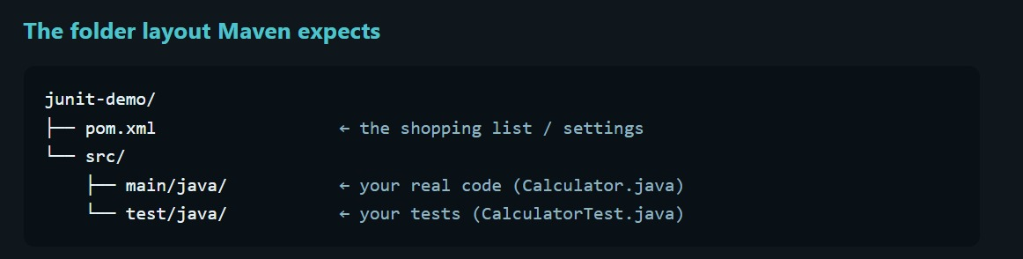

Maven syntax:
1.mvn -v :: Displays the Maven and Java versions.
2 mvn clean :: Deletes previously generated build files from the target folder.
3 mvn test:: Compiles and runs the project's automated tests.
4 mvn compile:: Compiles the main Java source code.

5. Steps of j unit testing::
DEVELOPERS/Emoployes
1) Design - Algorithm
2)write the code
3)write the test
4)run the test
Extension(3rd party)Customized
Vintage API
Jupiter API

PLATFORM
IDEs/Tools

What is a Test Engine: A Test Engine is responsible for discovering and executing tests belonging to a particular testing framework:For example, the JUnit Jupiter Test Engine discovers and runs JUnit Jupiter tests.

Junit jupitor : it is the new programming model : @Test, @BeforeEdge, assertions. Also contains the engine that runs Jupiter tests. It is used by the developers whilw writing the test.

J unit Vintage API: A compatibility unit that old j unit 3 and 4 tests on the new platform, it is used by old projects that haven’t yet migrated.
Ex: The platform is a building,projector system and ticket counter, it can show u any movie – Jupitoer is todays modern movie the only one u can write . vintage is a an old movie that runs on same projects . the building dosent care as long as the matching engine(player) exist.
Junit Engine (Jupiter/Vintage)Scans for the @Test Methods
Mvn test: runs all the test files inside the current folder

Runs LifeCycle: BeforeAll,BeforeEach,test,AfterEach
Maven Surefie Plugin

Results back to maven/Vs code Red or Green -> Buils Fail/Success
Junit Platform Launcher(Finds the right Engine)

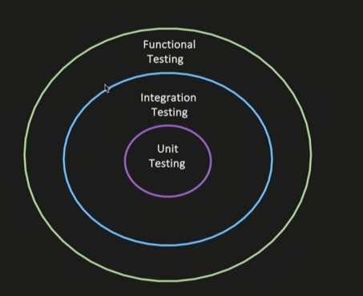

TYPES OF TESTING:::
1) Unit Testing : testing of a individual unit or method
2)Integration testing: to check if system behaves properly if wired together
3)Functional testing : to

INTEGRATION TESTING :
1)useCase 1: service -> repository -> database
- to invoke as method in service layer
- verify that the dependency integration works correctly
-your test can assert that data was persistent properly into the database
-validate that the msg is successfully published

FUNCTIONAL TESTING: End to End testing of a feature or a business functionality, verifying if it works as expected
1

