**Subquery**

A **subquery in SQL** is simply a **query inside another query**.  
It’s also called a **nested query** or **inner query**

**Syntax**

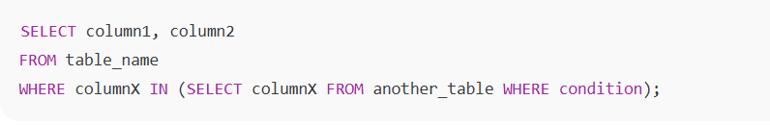

Types of Subqueries:

**1. Scalar Subquery**

* Returns **only one value** (one row, one column).
* Can be used in the SELECT, WHERE, or HAVING clause.

Example:

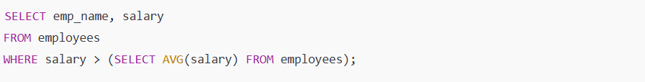

Here, (SELECT AVG(salary) FROM employees) returns **a single value** → average salary.

**2. Row Subquery**

* Returns **a single row with multiple columns**.

Example:

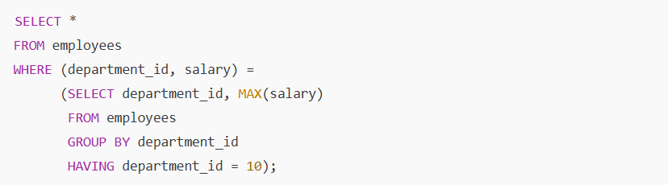

Here, the subquery returns **one row with two values** (department_id and max salary).

**3. Table Subquery (Multi-row / Multi-column)**

* Returns **multiple rows and columns**.
* Often used with IN, EXISTS, or in FROM clause as a derived table.

Example:

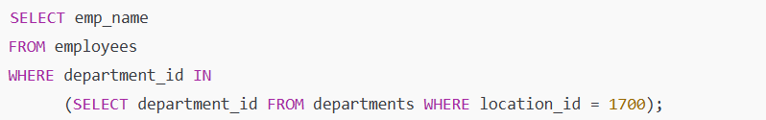

Here, the subquery returns a **list of department IDs** → used with IN.

**4. Correlated Subquery**

* Runs **for each row** of the outer query.
* References a column from the outer query.
* Slower but powerful.

Example:

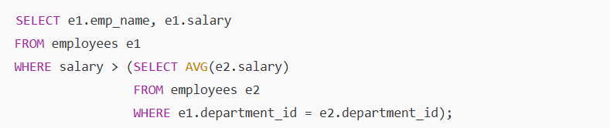

Here, the inner query runs for **each department of the outer row**.

**5. Nested Subquery**

* A subquery inside another subquery.
* Can be scalar, row, or table type.

Example:

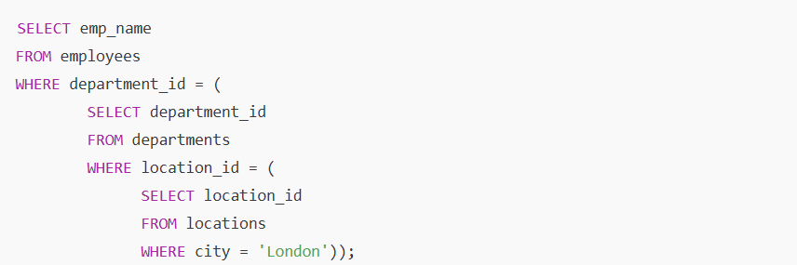

**Summary:**

* **Scalar Subquery** → 1 value
* **Row Subquery** → 1 row, multiple columns
* **Table Subquery** → Multiple rows/columns
* **Correlated Subquery** → Runs for each row of outer query
* **Nested Subquery** → Subquery inside subquery