**Assignment No :-**

**Step 1: Reformat your microSD card**

The first step to getting started with Raspberry Pi is to reformat the microSD card that you will use to download the operating system. Even brand new SD cards will have some extraneous files on them. Reformatting it will remove all files and completely clear the card.

1. Insert your **microSD card** into the USB card reader.

[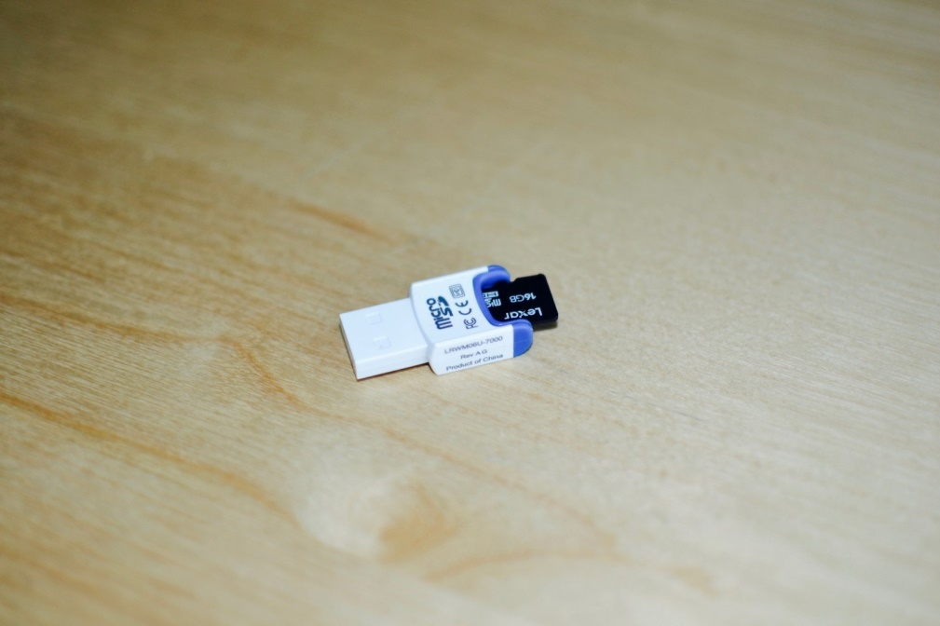](https://www.imore.com/sites/imore.com/files/styles/xlarge/public/field/image/2016/02/Raspberry-Pi-SD-card-reader-hero.jpg?itok=sYcI1Xpm)

1. Connect the **card reader** to your computer.
2. Download [SD Formatter 5.0](https://www.sdcard.org/downloads/formatter_4/).

[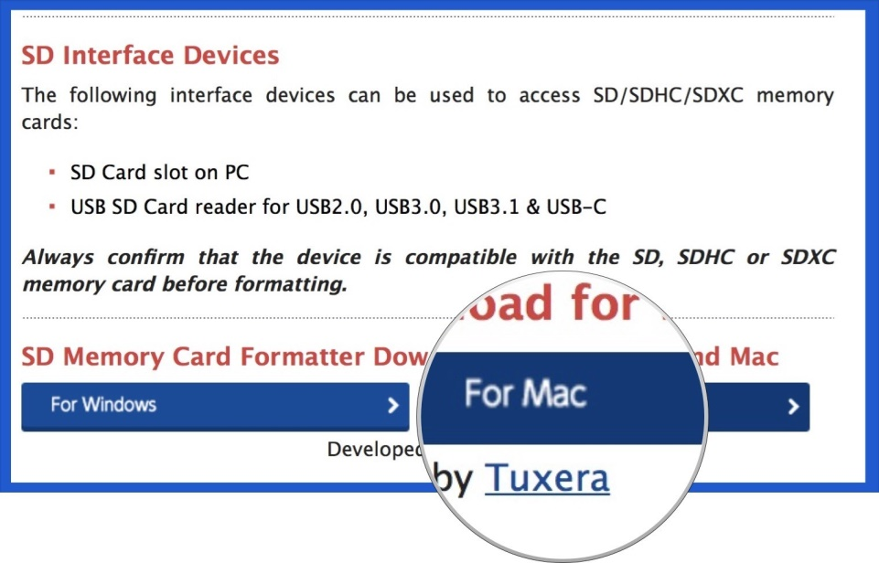](https://www.imore.com/sites/imore.com/files/styles/xlarge/public/field/image/2018/03/raspberry-pi-sd-formatter-download-mac-screenshot.jpg?itok=DvT3zBYP)

1. Double-click on **SDFormatter_5.00B.pkg** in your **downloads folder** in your **Dock** to install SD Formatter 5.0.

[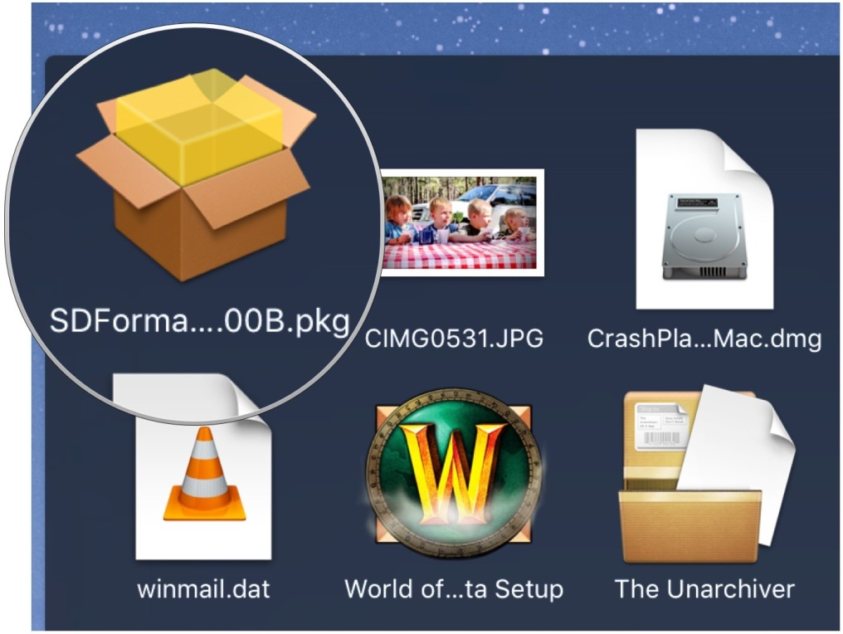](https://www.imore.com/sites/imore.com/files/styles/xlarge/public/field/image/2016/02/Raspberry-Pi-installing-SDFormatter-Mac-Screenshot.jpg?itok=d0yi1H63)

1. Follow the instructions in the installation window.
2. Click the **Launchpad** icon in your Dock. It looks like a silver rocket ship.

[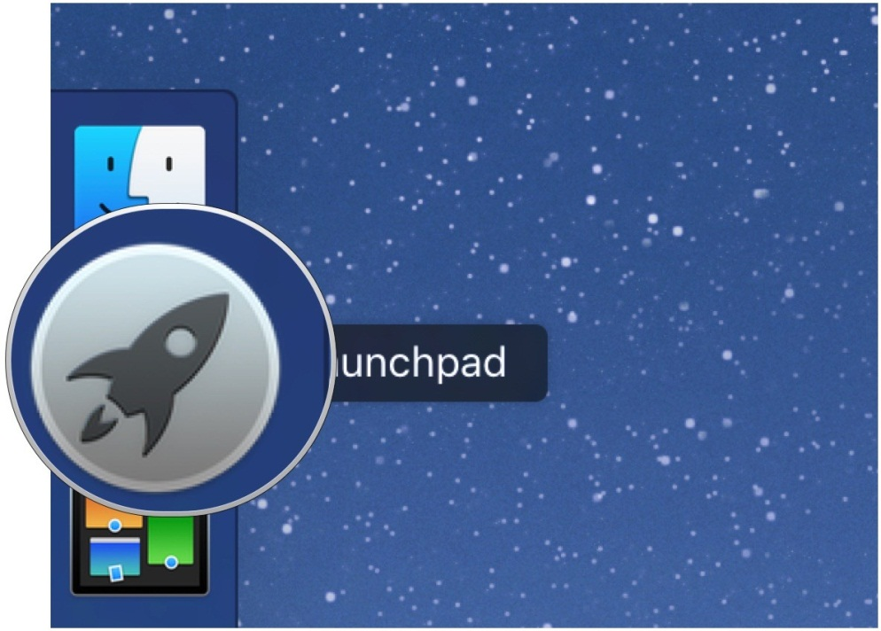](https://www.imore.com/sites/imore.com/files/styles/xlarge/public/field/image/2016/02/Launcpad-icon-Mac-screenshot.jpg?itok=SS-eESwR)

1. Find the **SD Formatter 5.0** app.
2. To move between Launchpad windows, click the **Next Page** icons at the bottom center of the screen, or swipe to the right or left with your trackpad or Magic Mouse.
3. Click on the **SD Formatter 5.0** app to open it. A formatting window will appear on your desktop.

[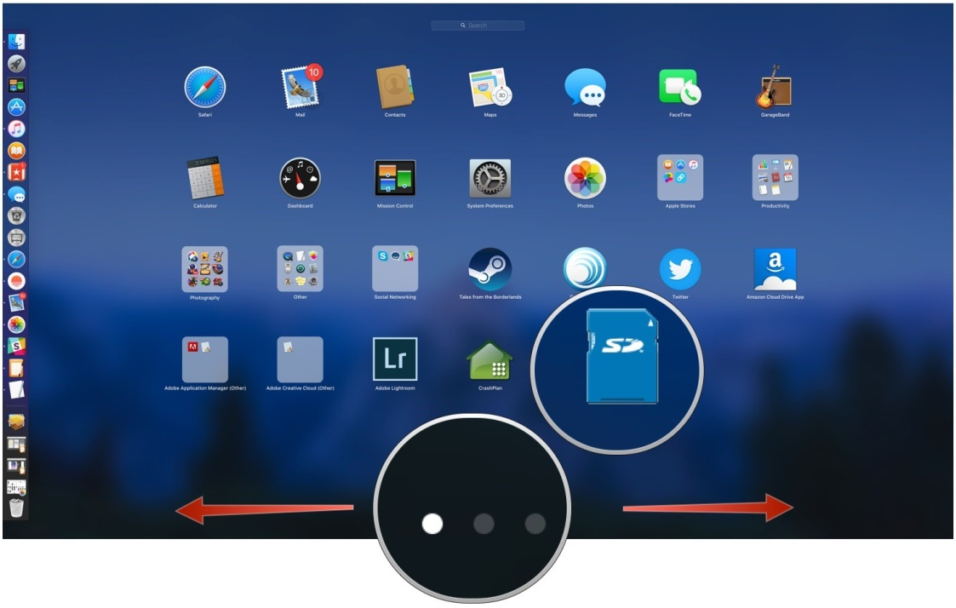](https://www.imore.com/sites/imore.com/files/styles/xlarge/public/field/image/2016/02/Apps-in-Launchpad-Mac-screenshot-02.jpg?itok=P1KUQ3EC)

1. Under **Select Card** select your microSD card from the dropdown menu.
2. Click **Format** in the bottom right corner.

[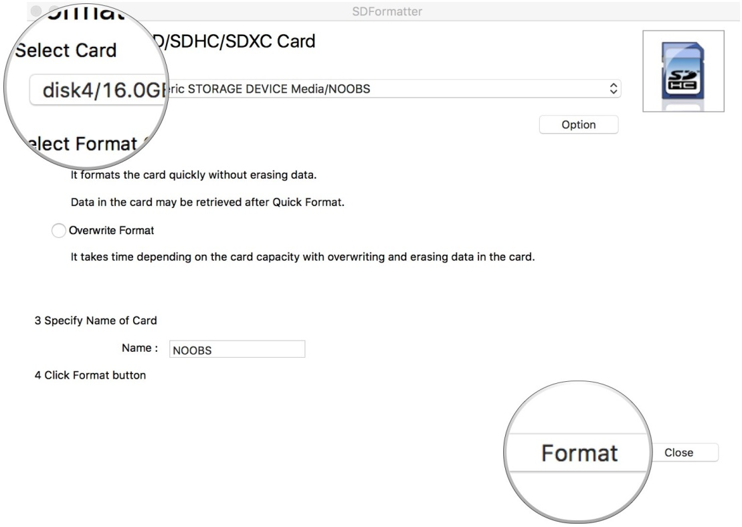](https://www.imore.com/sites/imore.com/files/styles/xlarge/public/field/image/2016/02/SD%20Formatter-setup-Mac-screenshot-02.jpg?itok=41353ltc)

When the reformat is complete, you will get a notification window. Select **OK** to close the window.

**Step 2: Download NOOBS onto the microSD card**

The next step is to get NOOBS onto the microSD card. Once it's loaded, you can plug it into your Raspberry Pi and configure the operating system. The microSD card should already be connected to your computer at this time.

1. Download the ZIP file of [NOOBS Version 2.4.5](https://www.raspberrypi.org/downloads/noobs/). It is a large file and will take a while to complete. You will want Raspbian, so do not download NOOBS Lite.

[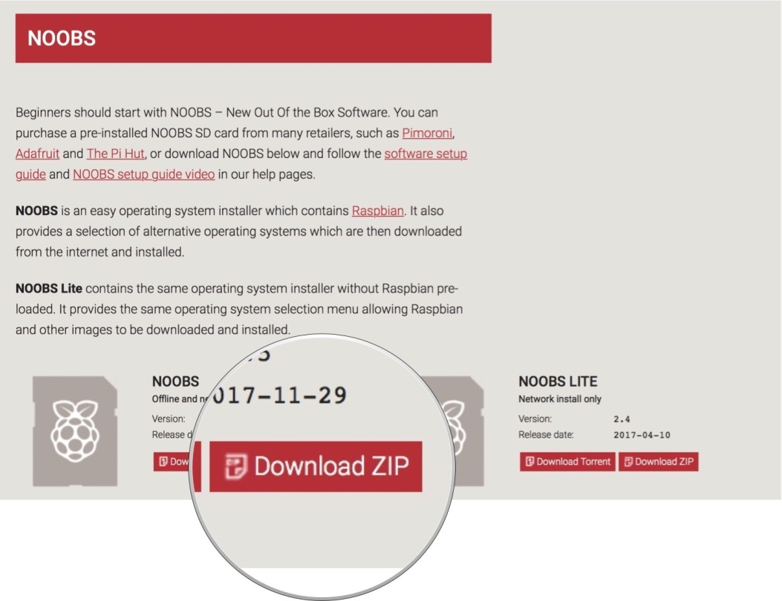](https://www.imore.com/sites/imore.com/files/styles/xlarge/public/field/image/2018/03/raspberry-pi-noobs-download-mac-screenshot.jpg?itok=Ll5nKnvw)

1. Double-click on the NOOBS file from the **Downloads folder** in your **Dock** to open it.

[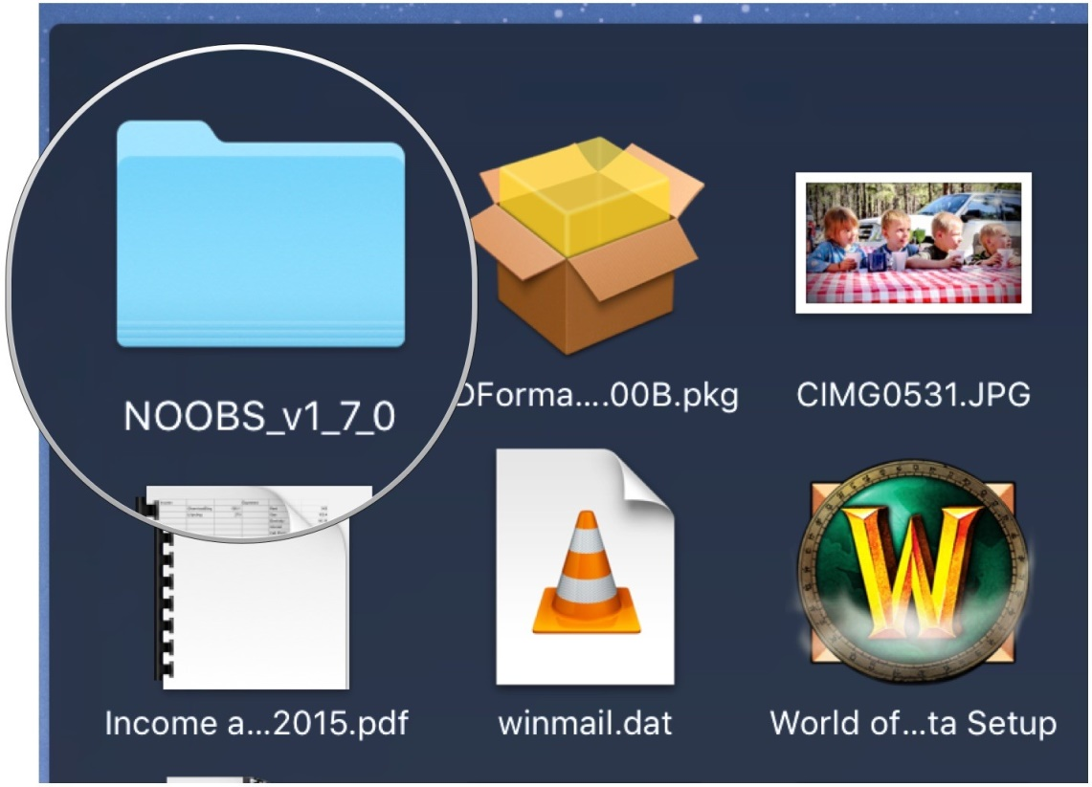](https://www.imore.com/sites/imore.com/files/styles/xlarge/public/field/image/2016/02/Raspberry-Pi-opening-NOOBS-file-Mac-screenshot.jpg?itok=WOnTJhGf)

1. Select the **first file** inside the NOOBS folder.
2. Scroll down and Shift + left-click on the **last file** in the NOOBS folder.
3. Drag and drop all selected NOOBS files into the **SD card icon** on your desktop. You don't have to open the SD card drive.

[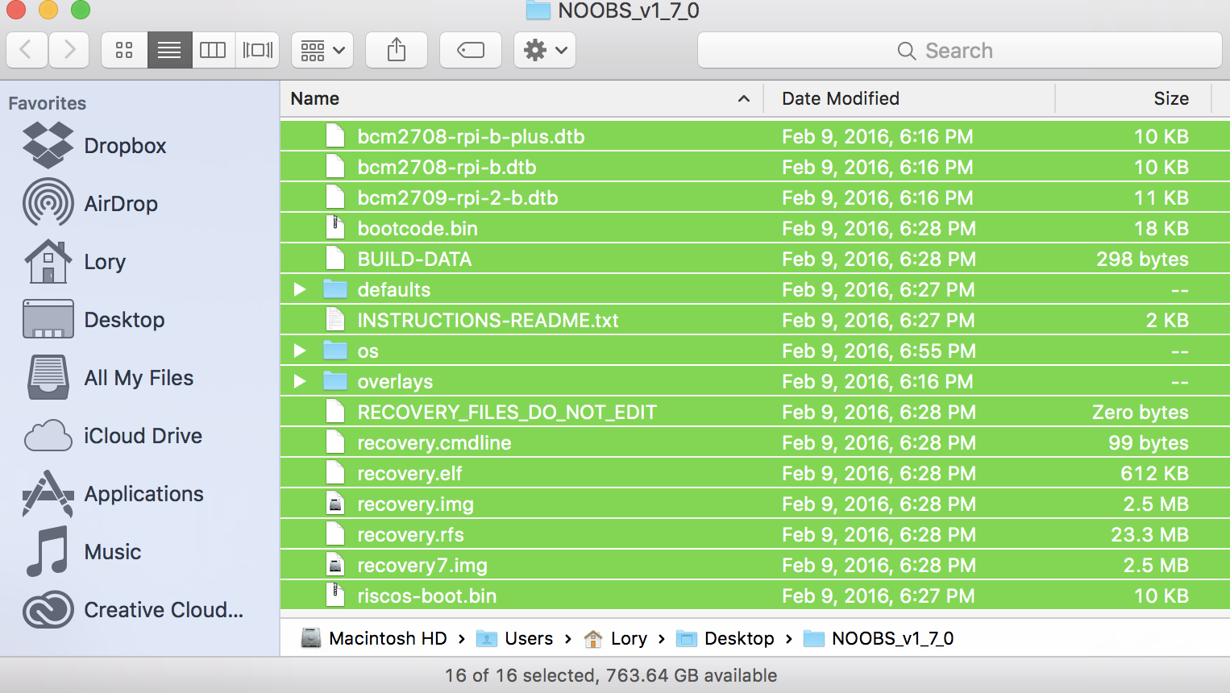](https://www.imore.com/sites/imore.com/files/styles/xlarge/public/field/image/2016/02/Drag-NOOB-files-to-SD-Card-Mac-screenshot.png?itok=9oVx6BOw)

1. Right-click on the **SD card icon**.
2. Select **"Eject [SD Card Name]"**.

[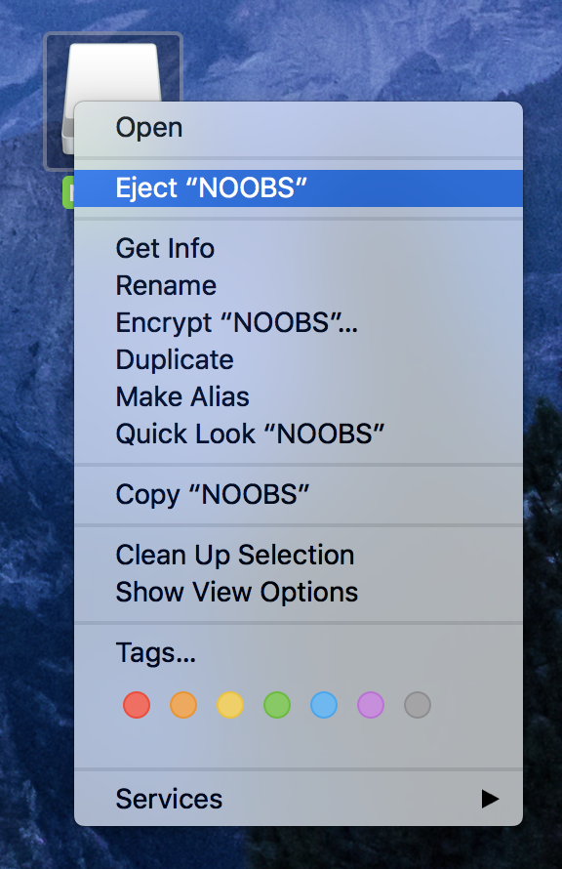](https://www.imore.com/sites/imore.com/files/styles/xlarge/public/field/image/2016/02/SDFormatter-eject.png?itok=fVFWbKx6)

1. Remove the card reader from your computer.
2. Remove the microSD card from the card reader.

**Step 3: Set up your Raspberry Pi**

1. Insert the **microSD card** into the card slot on the underside of the Raspberry Pi.

[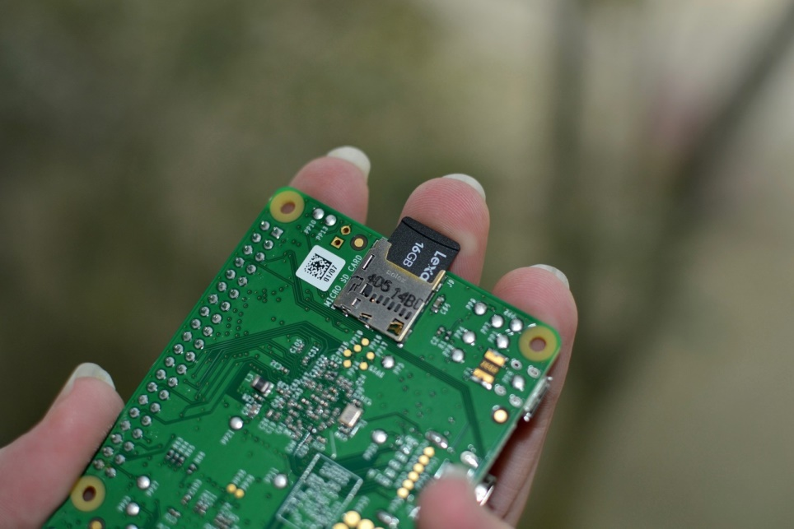](https://www.imore.com/sites/imore.com/files/styles/xlarge/public/field/image/2016/02/Raspberry-Pi-insert-micro-sd-into-slot-hero.jpg?itok=7rLpxYNa)

1. Plug the **USB keyboard** into one of the USB ports.
2. Plug the **USB mouse** into one of the USB ports

Alternatively, connect the **Bluetooth adapter** into one of the USB ports.

[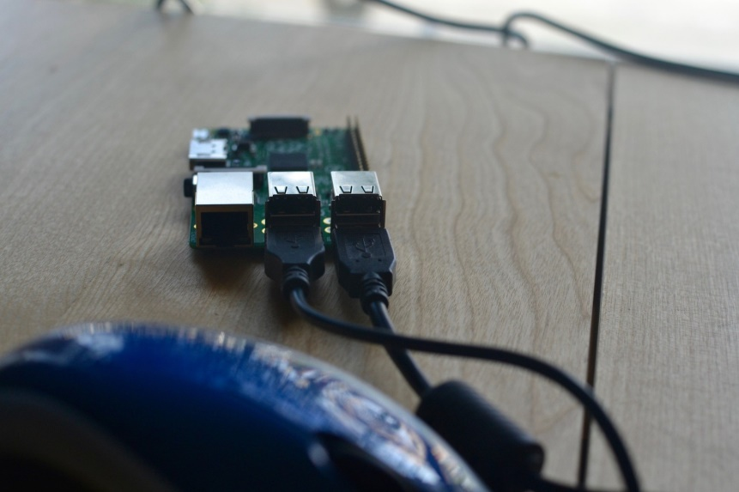](https://www.imore.com/sites/imore.com/files/styles/xlarge/public/field/image/2016/02/Raspberry-Pi-connect-keyboard-mouse-hero.jpg?itok=z0Cva_0A)

1. Turn on your **monitor or TV set** and make sure it is set to the proper input (e.g. HDMI 1 or Component)
2. Plug the **HDMI or video component cable** into the monitor or TV set.
3. Connect the other end of the cable into the Raspberry Pi.

[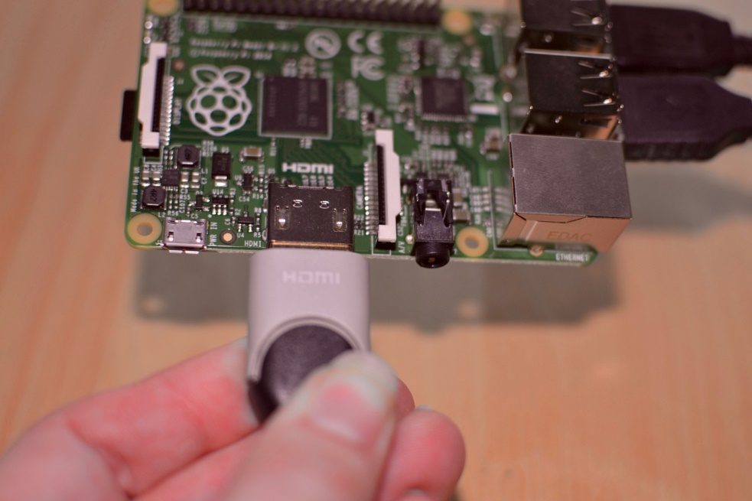](https://www.imore.com/sites/imore.com/files/styles/xlarge/public/field/image/2016/02/Raspberry-Pi-connect-HDMI-hero.jpg?itok=vuBfzxxO)

1. Connect an **ethernet cable** to your router if you plan to connect to the Internet.
2. Connect the other end of the cable to your Raspberry Pi.

Alternately, connect the **Wi-Fi adapter** to the Raspberry Pi.

[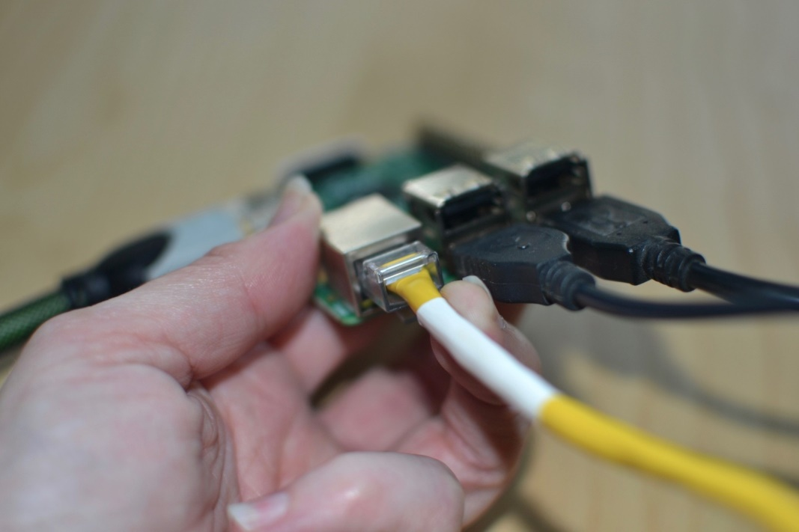](https://www.imore.com/sites/imore.com/files/styles/xlarge/public/field/image/2016/02/Raspberry-Pi-connect-ethernet-hero.jpg?itok=Png3LvtY)

1. Connect the **power supply** to the Raspberry Pi.
2. Plug the power supply into the **power outlet**. This will turn on and boot up Raspberry Pi. A power indicator light will begin to glow, letting you know that you are connected,

[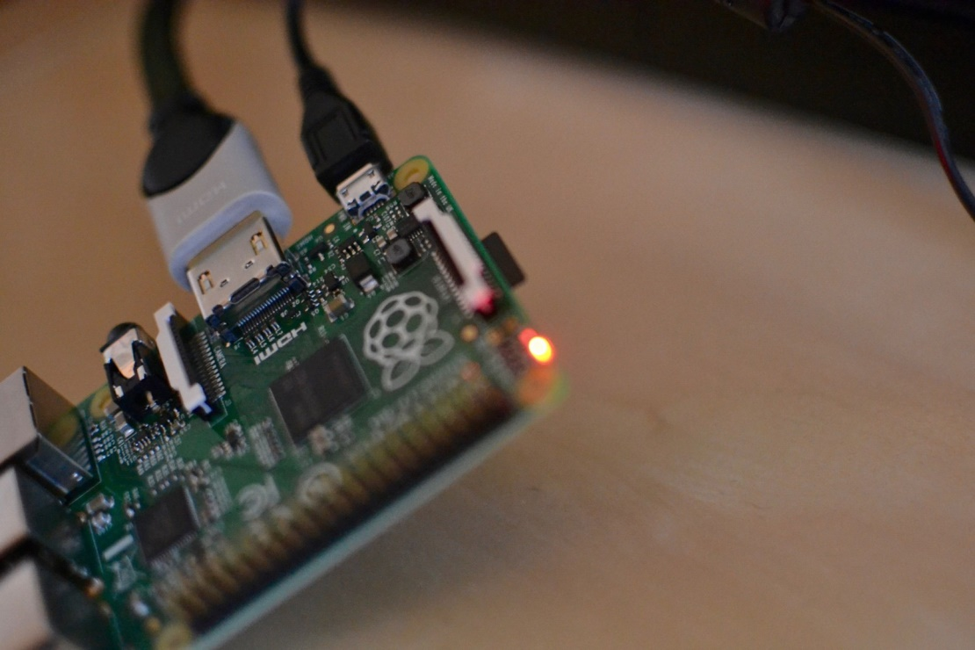](https://www.imore.com/sites/imore.com/files/styles/xlarge/public/field/image/2016/02/Raspberry-Pi-powered-up-hero.jpg?itok=214MSnbm)

**Step 4: Download the Raspbian operating system on the Raspberry Pi**

Beginners should start off using the Raspbian operating system. It is the easiest to use and there are hundreds of projects out there that use the Raspbian operating system. If you want to use a different operating system later on, you can reconfigure your Raspberry Pi then.

Once you have successfully followed the steps above, a start screen will appear on your monitor or TV.

1. Select **Raspbian**.
2. Click **Install**.

[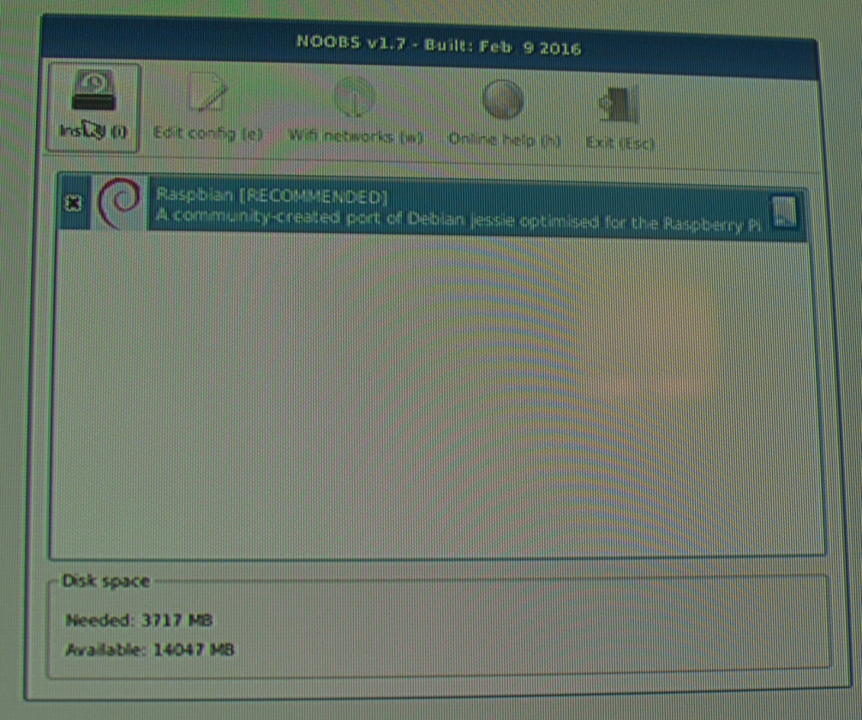](https://www.imore.com/sites/imore.com/files/styles/xlarge/public/field/image/2016/02/Raspberry-Pi-installing-Raspbian-monitor-hero-02.jpg?itok=9-BAjc7h)

1. When the warning window pops up. Click **Yes** to confirm. This is just letting you know that the microSD card will be overwritten with an uncompressed version of the Raspbian operating system.
2. Wait for the installation process to complete.

[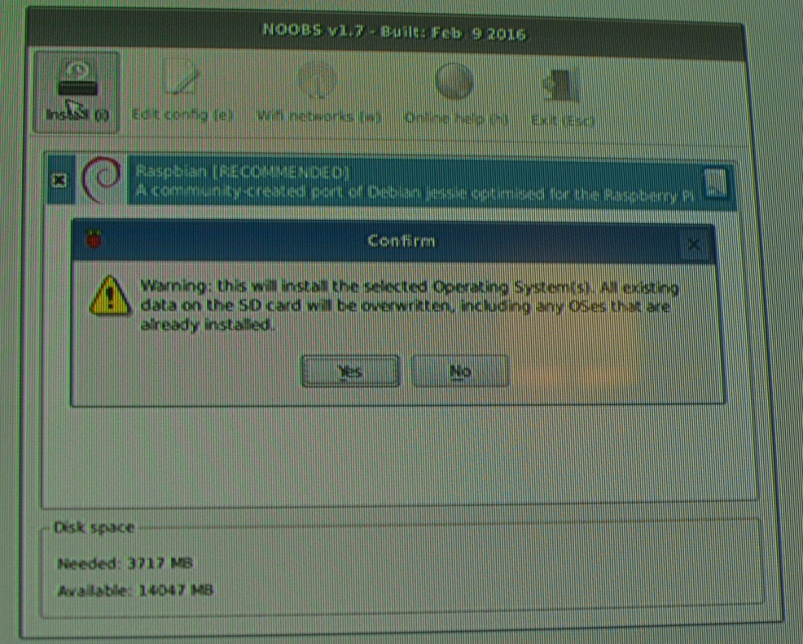](https://www.imore.com/sites/imore.com/files/styles/xlarge/public/field/image/2016/02/Raspberry-Pi-warning-monitor-hero-02.jpg?itok=FORw_9DS)

Once the installation process is finished, Raspbian will automatically begin to boot.

**Step 5: Configure your Raspberry Pi**

When Raspbian begins to load a bunch of lines of code will appear. This will continue until the boot process has completed. Then, the Raspbian Home screen will appear. You will need to configure your Raspberry Pi system in order to add your location, date, and time.

1. Click **Menu** in the upper left corner of the screen.

[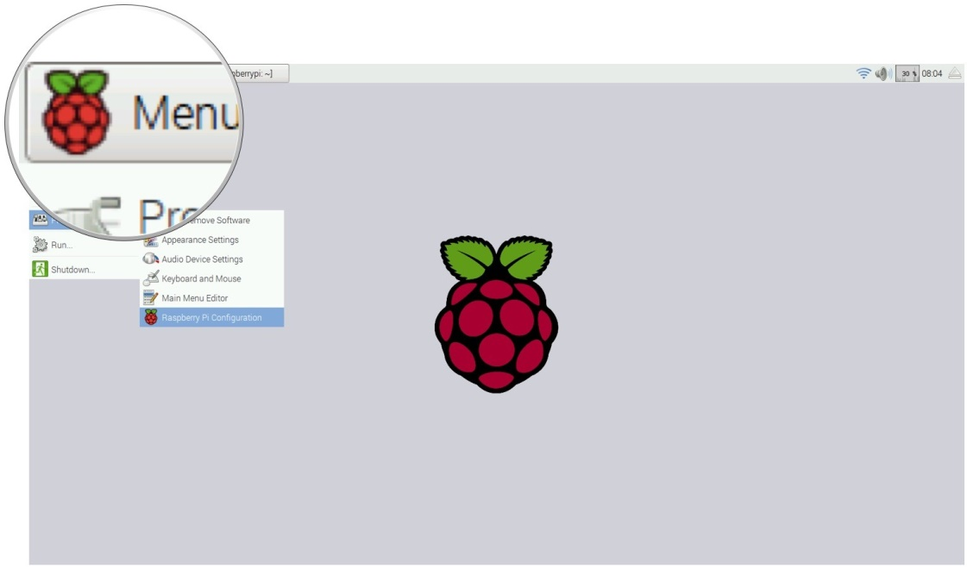](https://www.imore.com/sites/imore.com/files/styles/xlarge/public/field/image/2016/02/Raspberry-Pi-selecting-menu-monitor-screenshot.jpg?itok=snE0X59E)

1. Select **Preferences** in the dropdown menu.

[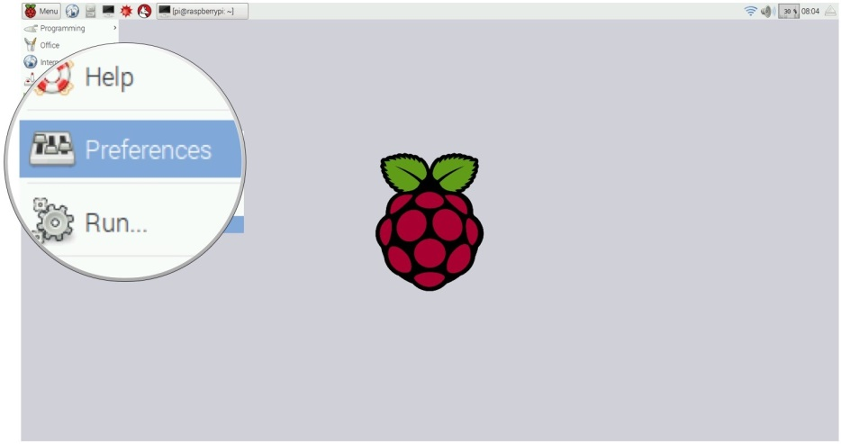](https://www.imore.com/sites/imore.com/files/styles/xlarge/public/field/image/2016/02/Raspberry-Pi-selecting-preferences.jpg?itok=wkSUrECp)

1. Select **Raspberry Pi Configuration** under Preferences.

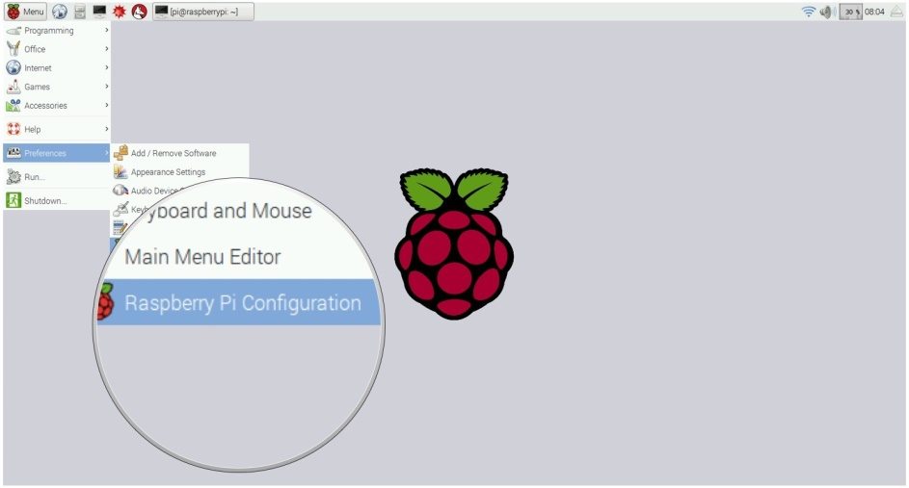

1. When the configuration window appears, click on the **Localisation** tab.
2. Click on **Set Locale…** to set your location.
3. Click on **Set timezone…** to set your local time.
4. Click on **Set Keyboard…** to set your keyboard language.

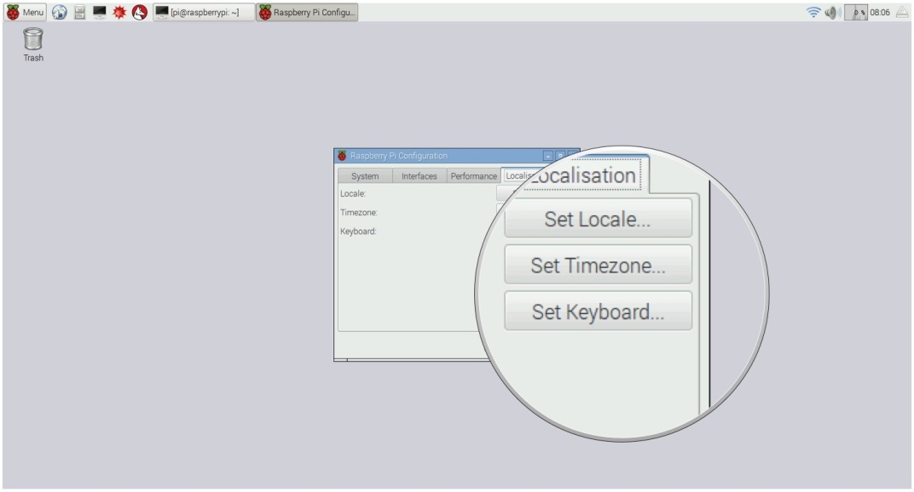

1. Reconfiguring your Raspberry Pi will require a reboot. When the reboot window appears, click **Yes** to continue.

[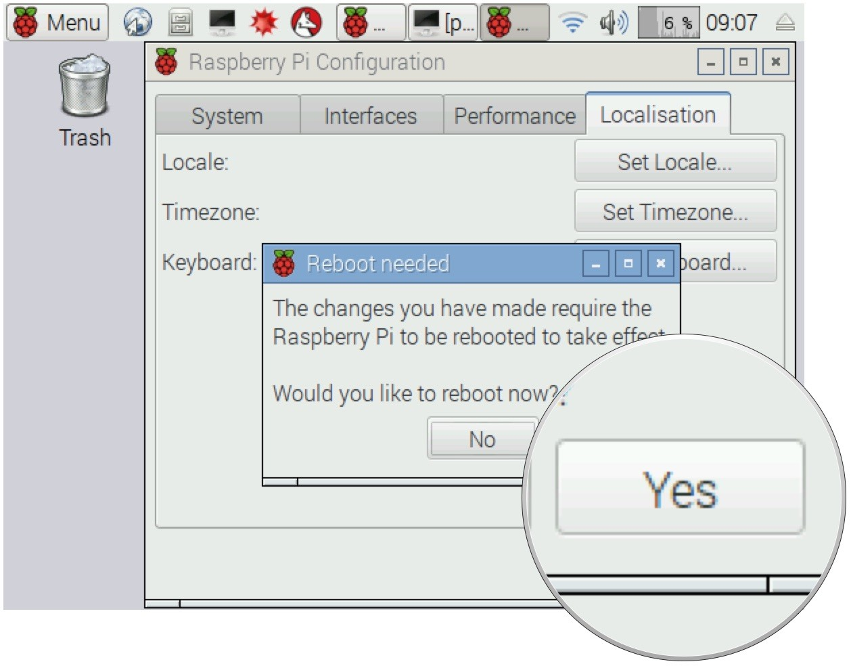](https://www.imore.com/sites/imore.com/files/styles/xlarge/public/field/image/2016/02/Raspberry-Pi-reboot-raspbian-monitor-screenshot-02.jpg?itok=haAbjsnM)

**Conclusion** :- In this way we have installed raspberry pi operating system .it has been done in five steps. From this we have come to know that raspberry pi operating system is more powerfull than arduino. We can connect to wifi also by using this os.