Setting up the ThingSpeak Account
- First of all, go to the following link and sign up to ThingSpeak. If you already have an account, then sign in.
https://thingspeak.com/

- After creating the account or logging in, you will be see a page like shown below. Click on new channel.
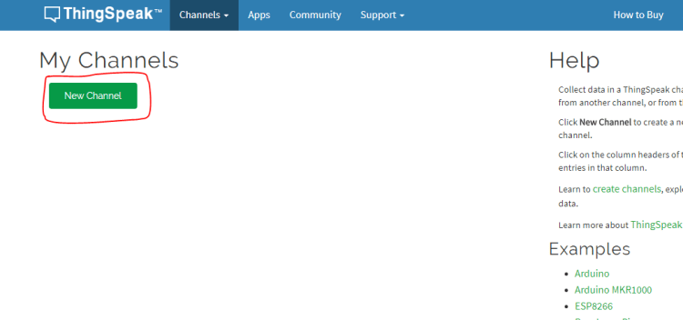
3.Now you will need to enter the information about the channel. Enter the information like shown below. Select two fields because we will be sending the data for the two fields from the raspberry pi. Leave the other information as it is and save the channel.

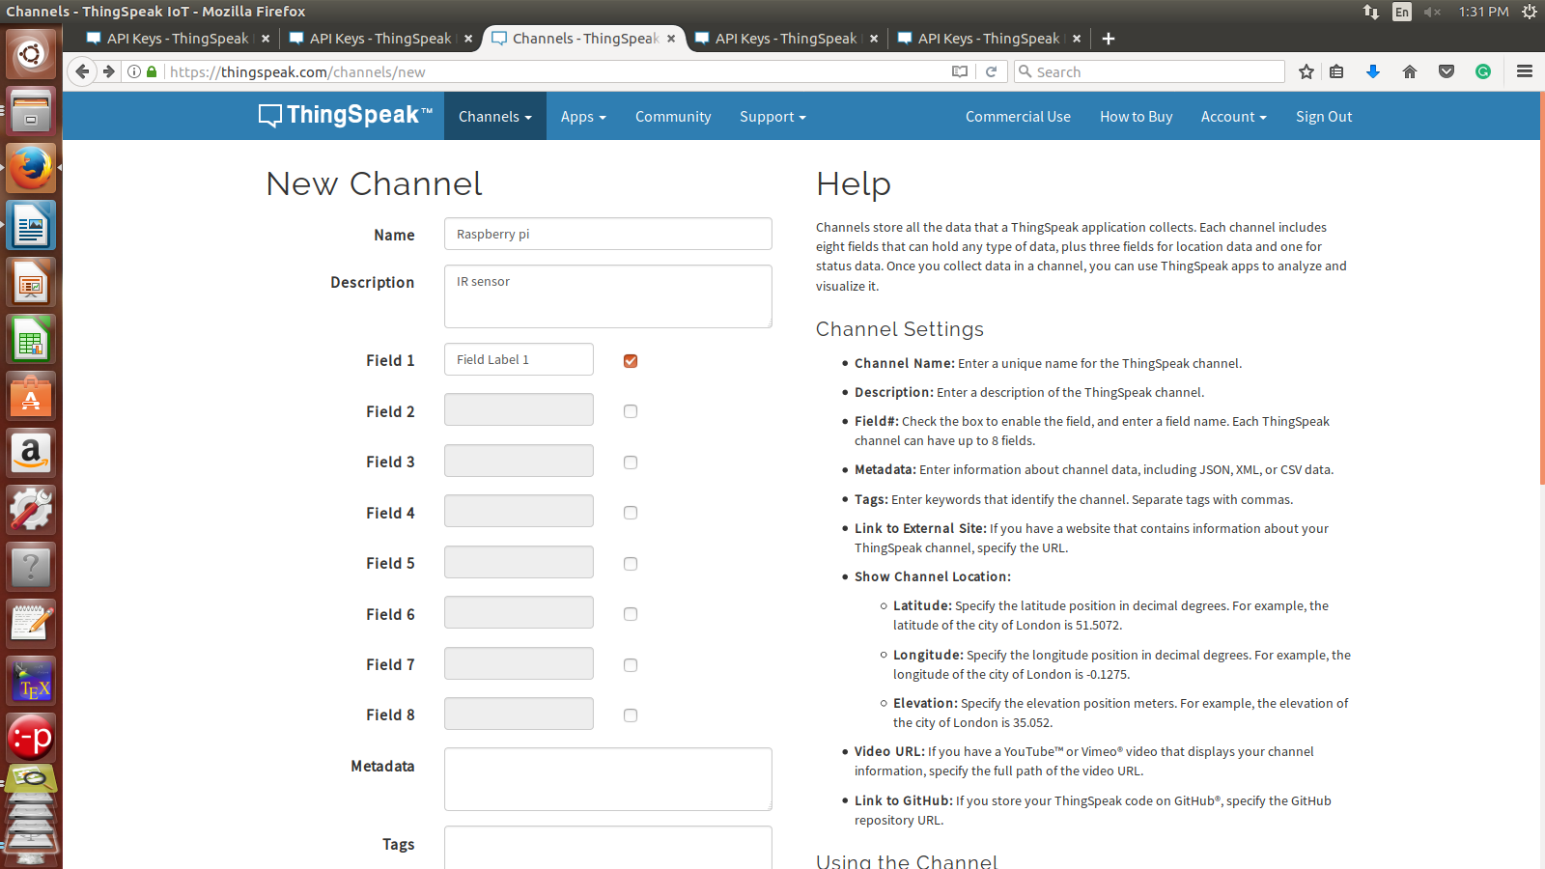
4.After saving the channel, you will see a page like shown below. From there, go to the API keys tab.
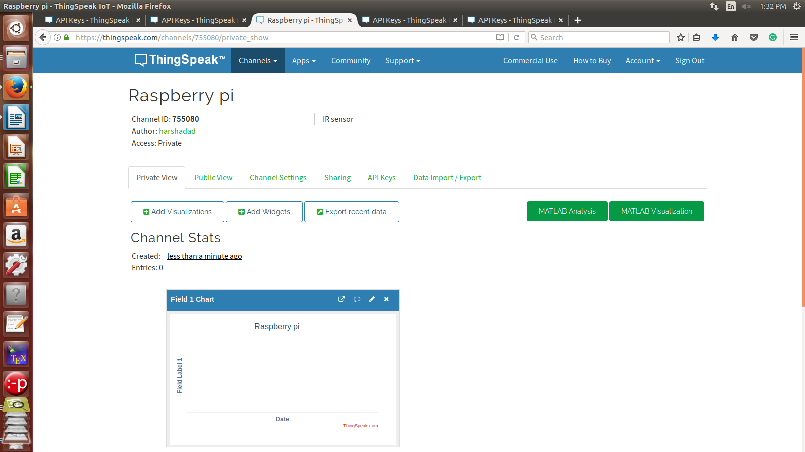
5.In the API keys tab, copy the write API key. This is the API key at which we will send the data from the Raspberry pi.
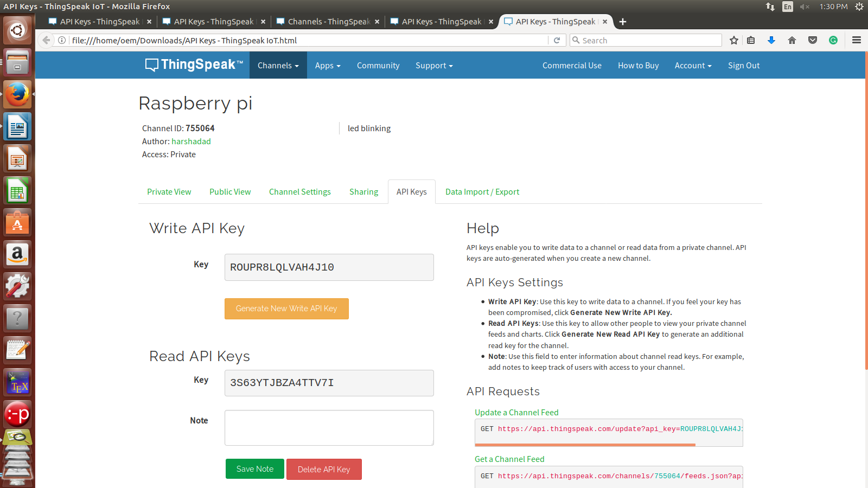

Circuit Diagram and Explanation
Make the connections of the DHT22 with the Raspberry pi as described below
DHT22 | Raspberry pi
VCC | 5v
Data pin | Connect to GPIO 23 and also connect to 5V through 10K resistor
GND | GND
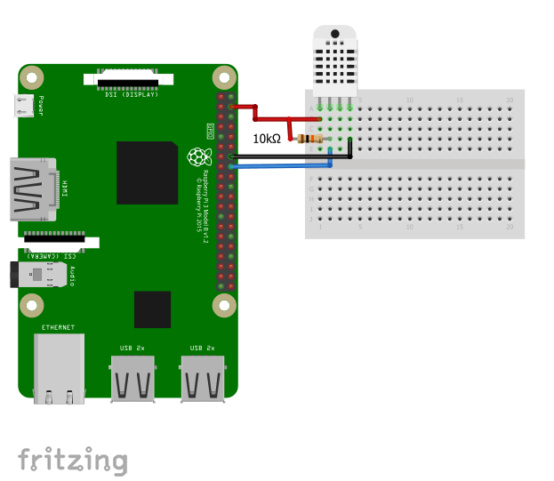

Installing the DHT22 Library
To install the library, Follow the below steps
- Enter the below command to clone the library
git clone https://github.com/adafruit/Adafruit_Python_DHT.git
- Then enter in to the installed directory using the below command
cd Adafruit_Python_DHT
- Now download the required modules using the below command
sudo apt-get install build-essential python-dev
- Then install the library using the below command
sudo python setup.py install

Raspberry pi Code
Enter the below code in your python script and run it.
import sys
import urllib2
from time import sleep
import Adafruit_DHT as dht

# Enter Your API key here
myAPI = '5QTYDNRHSJ5RESA5'
# URL where we will send the data, Don't change it
baseURL = 'https://api.thingspeak.com/update?api_key=%s' % myAPI

def DHT22_data():
# Reading from DHT22 and storing the temperature and humidity
humi, temp = dht.read_retry(dht.DHT22, 23)
return humi, temp

while True:
try:
humi, temp = DHT22_data()

# If Reading is valid
if isinstance(humi, float) and isinstance(temp, float):
# Formatting to two decimal places
humi = '%.2f' % humi
temp = '%.2f' % temp

# Sending the data to thingspeak
conn = urllib2.urlopen(baseURL + '&field1=%s&field2=%s' % (temp, humi))
print conn.read()
# Closing the connection
conn.close()

else:
print 'Error'

# DHT22 requires 2 seconds to give a reading, so make sure to add delay of above 2 seconds.
sleep(20)

except:
break
After running it, output looks like below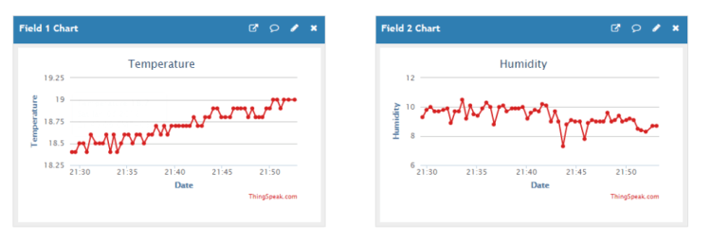
CONCLUSION:
After the study of this assignment we are familiar with the Thingspeak platform and how to send temperature and humidity data to thingspeak cloud .

