Laboratory Journal

**Name :- Vigneshmurali Iyer**

**Enrollment Number :- MITU22BTIT0098**

**Roll Number :- 2225048**

**SY – IT – CORE**

Design a Company Registration Form with CSS styles that includes all of the form tag's

features. Show the relevant Form output in a compatible browser.

Assignment

No-1

**Assignment No :- 1**

**Problem Statement :-** Food delivery Website

**Theory :-**

1. **HTML**

**What type of data need to collect from the user for registration form?**

|  |  |  |
| --- | --- | --- |
| **Sr. No.** | **Data need to collect from the user** | **HTML Tag** |
| 1 | First Name | <input type="text"> |
| 4 | Email Address | <input type="email"> |
| 5 | Phone Number | <input type="tel"> |
| 6 | Address | <textarea></textarea> |
| 7 | Gender | <input type="radio"> |
| 8 | Date of Birth | <input type="date"> |
| 10 | Username | <input type="text"> |

|  |  |  |
| --- | --- | --- |
| 11 | Password | <input type="password"> |
| 17 | Remember Me | <input type="checkbox"> |
| 18 | Submit Button | <input type="submit"> |

**Syntax of above HTML Tags :-**

* + First Name: <input type="text" id="firstname" placeholder="First Name">
  + Email Address: <input type="email" id="email" placeholder="Email">
  + Phone Number: <input type="tel" id="phone" placeholder="Phone Number">
  + Address: <textarea id="address" cols="18" rows="2" placeholder="Address"></textarea>
  + Gender: <input type="radio" name="gender" id="male">Male <input type="radio" name="gender" id="female">Female
  + Date of Birth: <input type="date" id="dob">
  + Username: <input type="text" id="username" placeholder="Username">
  + Password: <input type="password" id="password" placeholder="Password">
  + Terms And Conditions: <input type="checkbox" id="TAC">I agree to the Terms and Conditions
  + Submit Button: <input type="submit">

**What type of data need to collect from the user for login form?**

|  |  |  |
| --- | --- | --- |
| **Sr. No.** | **Data need to collect from the user** | **HTML Tag** |
| 1 | Enter Username | <input type="text"> |
| 2 | Enter Password | <input type="password"> |
| 3 | Login Button | <input type="submit"> |
| 4 | Registration Link | <a ></a> |

**Syntax of above HTML Tags :-**

* + Username : <input type="text" id="Username" placeholder="Username">
  + Password : <input type="password" id="Password" placeholder="Password">
  + Login : <input type="submit" value="Login">
  + Registration Link : <a href="Register.html">New Registration</a>

**index.html :-**

<!DOCTYPE html>

<html lang="en">

<head>

<meta charset="UTF-8">

<meta name="viewport" content="width=device-width, initial-scale=1.0">

<title>Sign In</title>

</head>

<body>

<h1>Welcome to Tomato</h1>

<img src="https://th.bing.com/th/id/OIP.zl2mf8r8CUzyDTDby5rgTgHaE8?w=292&h=195&c=7&r=0&o=5&pid=1.7" alt="logo food delivery">

<form action="homepage.html">

<label for="Username"> Username</label><br>

<input type="text" name="Username" placeholder="Username" required><br>

<label for="Password">Password</label> <br>

<input type="password" name="Password" placeholder="Password" required><br>

<label for="Remember-me">

<input type="checkbox" name="Remember-me" title="Remember-me"> Remember-me

</label> <br>

<label for="sign-up-form">

<a href="sign-up.html" target="_blank">New here? Click here to sign-up</a>

</label><br>

<input type="submit" value="Login"> <br>

</form>

</body>

</html>

**Sign-up.html**:

<!DOCTYPE html>

<html lang="en">

<head>

<meta charset="UTF-8">

<meta name="viewport" content="width=device-width, initial-scale=1.0">

<title>Sign-up</title>

</head>

<body>

<h1>Welcome to Tomato</h1>

<img src="https://th.bing.com/th/id/OIP.zl2mf8r8CUzyDTDby5rgTgHaE8?w=292&h=195&c=7&r=0&o=5&pid=1.7" alt="logo food delivery">

<p>Register Here</p>

<form action="homepage.html">

<label for="firstname">Enter Name :- </label>

<br>

<input type="text" id="firstname" placeholder="Name">

<br>

<br>

<input type="text" id="lastname" placeholder="Last Name">

<br>

<br>

<label for="email">Enter Email Address :- </label>

<br>

<input type="email" id="email" placeholder="Email">

<br>

<br>

<label for="phone">Enter Phone Number :- </label><br>

<input type="tel" id="phone" placeholder="Phone Number">

<br>

<br>

<label for="address">Enter Address :- </label>

<br>

<textarea id="address" cols="18" rows="2"></textarea>

<br>

<br>

<label for="gender">Select Gender :- </label>

<br><label for="gender">

<input type="radio" name="gender" id="male">Male

<input type="radio" name="gender" id="female">Female

</label>

<br>

<br>

<label for="dob">Enter Date of Birth</label>

<br>

<input type="date" id="dob">

<br>

<label for="Username">Username</label>

<br>

<input type="text" placeholder="Username">

<br><label for="password"> password </label>

<br>

<input type="password" name="password" placeholder="password">

<br>

<input type="submit" value="Create account" placeholder="register">

<br>

</form>

</body>

</html>

**Output :-index.html :-**

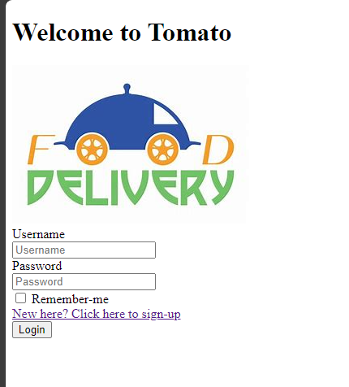

**Sign-up.html :-**

