Task 1: Define a model for ID verification system to ensure that the user is a student & from that institute where he/she applied for sign in on the platform.

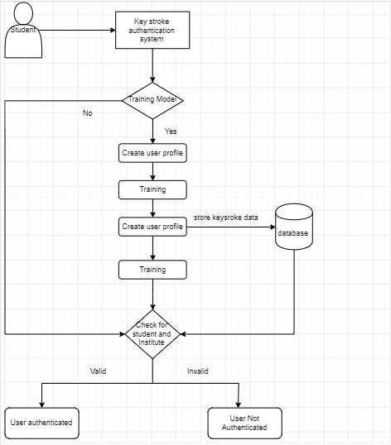

Keystroke dynamics or typing dynamics refers to the automated method of identifying or confirming the identity of an individual based on the manner and the rhythm of typing on a keyboard. **Keystroke dynamics** is a behavioral biometric.