**Pre-Requisite-**

* Eclipse, Java and maven should be installed
* WebDrivers executables(.exe files)

**Require Setup Configurations-**

* **Need to change Source directory path in pom.xml**

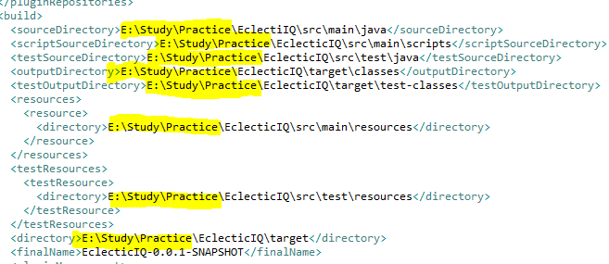

**(Due to some issue could not set path variables for source directory)**

* **Excel Path Configuration – Need to change Excel path**
* UtitlityClasses(Package)->CommonFunctions.java->getInputSheetData()

