📄 ASSIGNMENT 8 – DOCUMENTATION
Art & Craft Workshop Web Application

1. Objectives
- To design static web pages (Home, About, Contact, Events) using HTML & CSS.
- To make responsive layouts using Media Queries.
- To add JavaScript validation for an Event Registration Form.
- To create an Event List using JavaScript Arrays with search functionality.
- To store registration data into a database using Node.js + MySQL.
- To create an Admin Panel with Login, Add, Update, Delete event operations (UI only).
- To display Participant List from Static JSON data.
- To host the project locally and prepare documentation with screenshots.

2. Tools & Technologies Used
Frontend
- HTML5
- CSS3
- Media Queries
- JavaScript (Vanilla JS)
Backend
- Node.js
- Express.js
- MySQL Database
- MySQL Workbench
Additional Tools
- VS Code
- XAMPP / MySQL Server
- Browser (Chrome)

3. Project Module Overview
✔ Static Pages
- Home Page (Art & Craft theme)
- About Page
- Contact Page
- Event List Page
✔ JavaScript Modules
- Registration Form Validation
- Event Search Filtering
- JSON-based Participant Table
✔ Server + Database Module
- Node.js Server
- Save registration form data into MySQL
- Tested using browser
✔ Admin Panel
- Login (email + password)
- Add Event
- Update Event
- Delete Event
- Dashboard (UI only)

4. Code Snippets (Short & Important)

4.1 Registration Form Validation (JavaScript)
function validateForm() {
let name = document.getElementById("name").value.trim();
let email = document.getElementById("email").value.trim();
let mobile = document.getElementById("mobile").value.trim();

if (name === "") {
alert("Name cannot be empty");
return false;
}
if (!email.match(/^[a-zA-Z0-9._%+-]+@[a-z0-9.-]+\.[a-z]{2,}$/)) {
alert("Enter valid email");
return false;
}
if (!mobile.match(/^[0-9]{10}$/)) {
alert("Mobile must be 10 digits");
return false;
}
return true;
}

4.2 Event Search (JavaScript)
let events = ["Clay Modeling", "Origami Session", "Fabric Painting"];

function searchEvents() {
let keyword = document.getElementById("searchBox").value.toLowerCase();
let result = events.filter(e => e.toLowerCase().includes(keyword));
console.log(result);
}

4.3 Node.js Backend (Storing Registration Data)
app.post("/register", (req, res) => {
const { name, email, mobile, event } = req.body;

db.query("INSERT INTO registrations (name, email, mobile, event_name) VALUES (?, ?, ?, ?)",
[name, email, mobile, event],
(err, result) => {
if (err) throw err;
res.send("Registration stored in database!");
});
});

4.4 Admin – Add Event (JavaScript)
function addEvent() {
let name = document.getElementById("newEventName").value;
let date = document.getElementById("newEventDate").value;

events.push({ name, date });
loadEvents();
}

4.5 Participants JSON Table (JavaScript)
let participants = {
clay: [
{ name: "Aarav", email: "aarav@gmail.com", mobile: "9876543210" }
]
};

5. Screenshots
5.1 Home Page
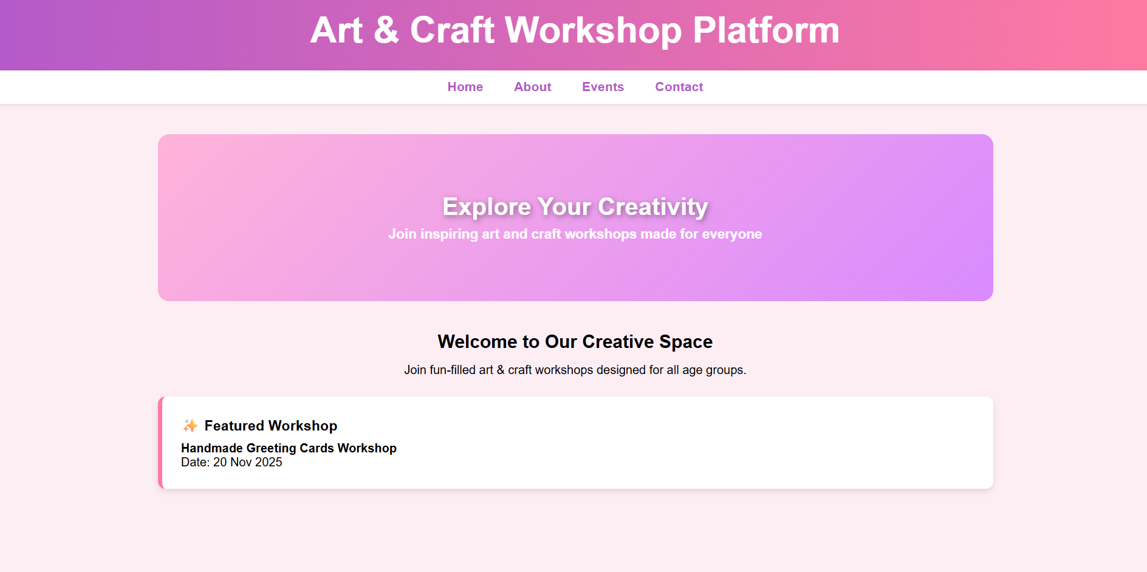

5.2 Registration Form
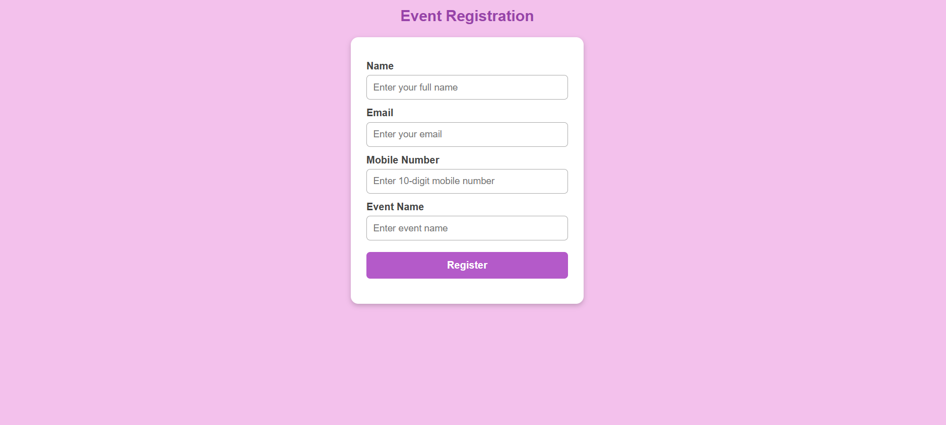
5.3 Event List Search
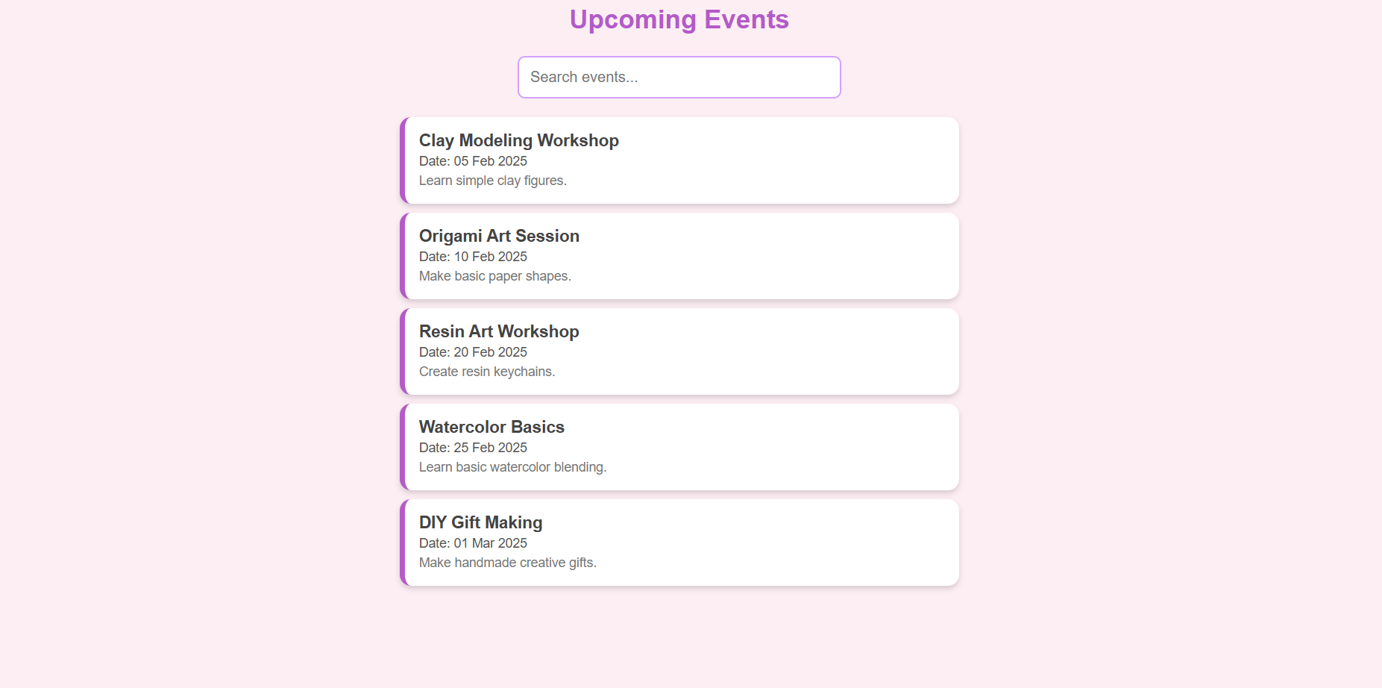

5.4 Admin Login Page
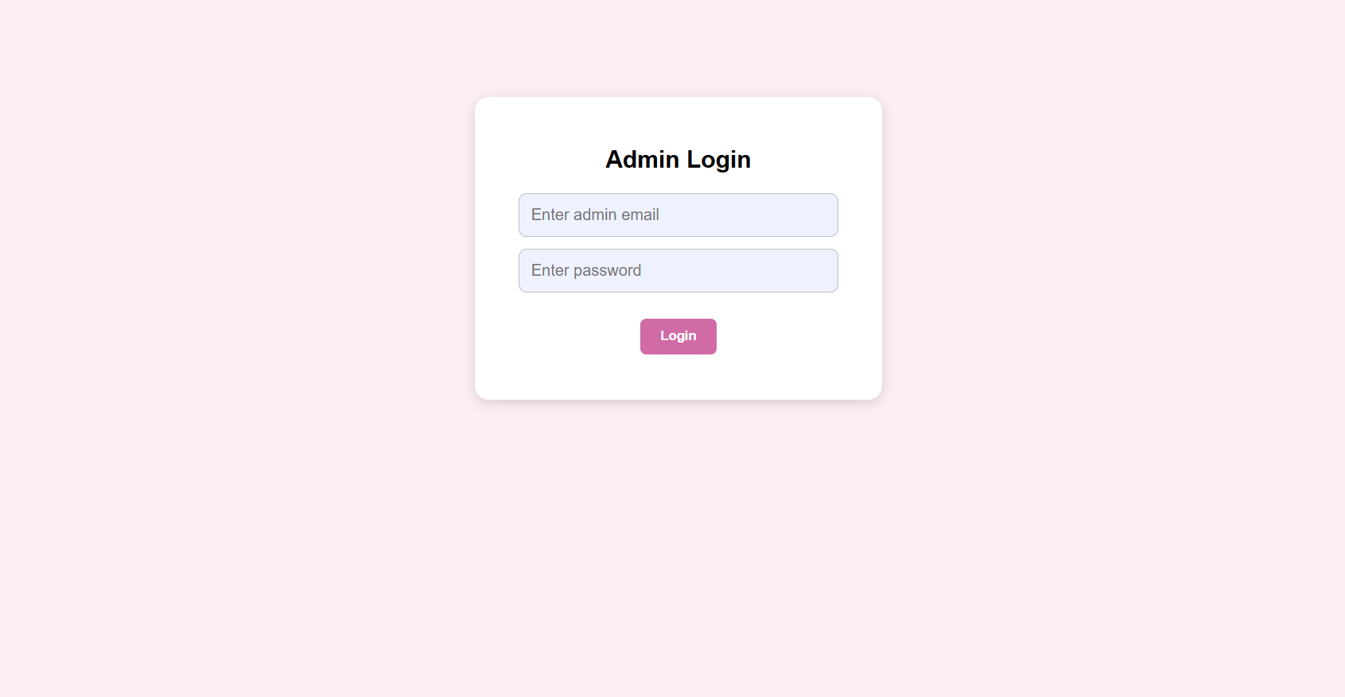
5.5 Admin Dashboard
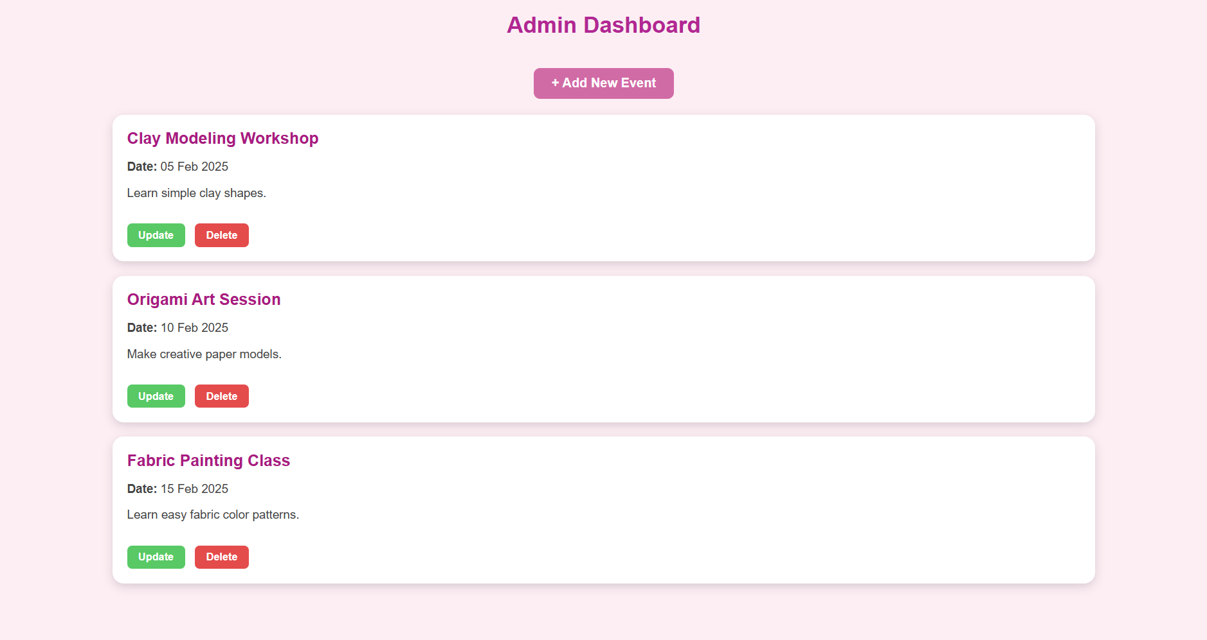

5.6 Participant List
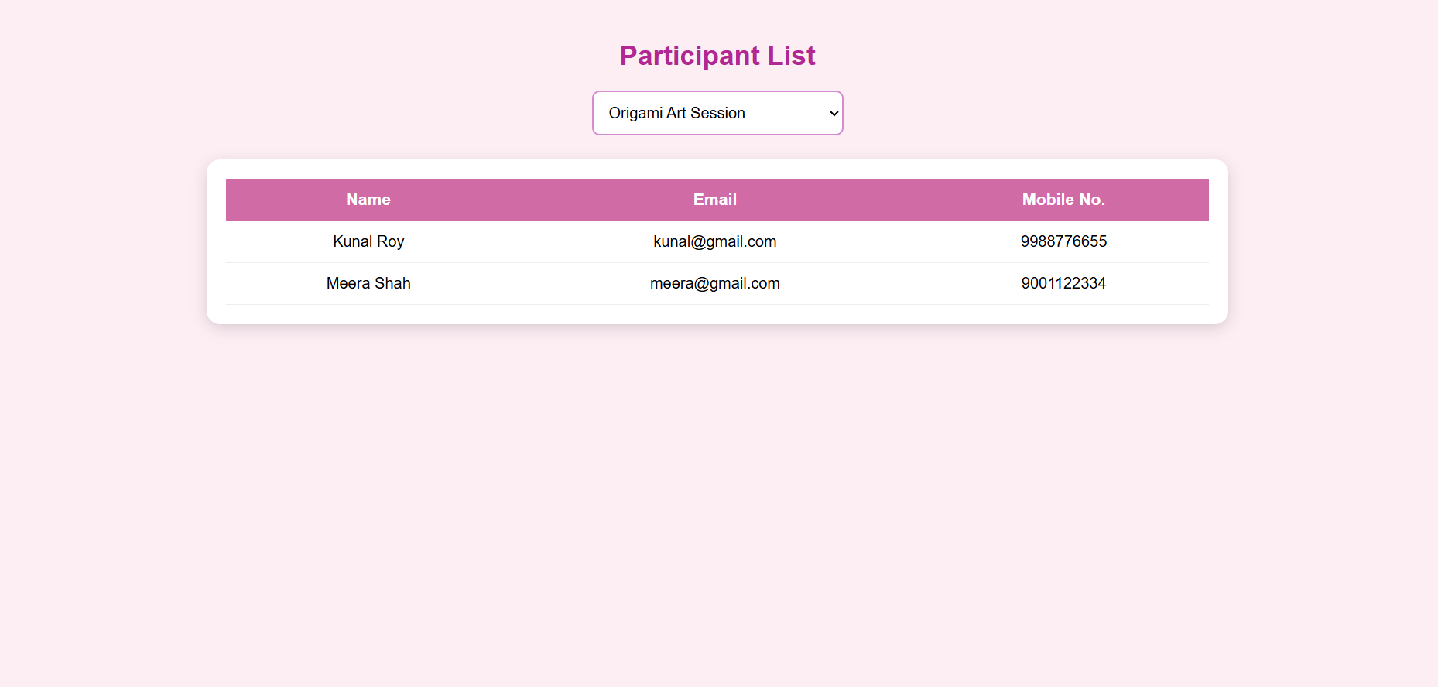
6. Conclusion
The Art & Craft Workshop Web Application successfully demonstrates:
- HTML & CSS webpage development
- Responsive design using media queries
- JavaScript-based form validation and search
- Backend development using Node.js and MySQL
- Admin Dashboard with Add, Update, Delete (UI)
- Participant table using JSON
- Modular project structure
This project meets all the requirements of LP2 Web Technology Assignments.

