

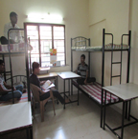

Rooms

The hostel rooms are spacious and well ventilated. Each room accommodates 2 to 4 students depending on the size of the room. Each student is provided with a bed, a mattress, a table, a chair, a cupboard or shelf, light, fan etc.



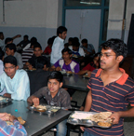

Mess

Each hostel has a spacious dining hall and kitchen. Students themselves are expected to wash their plates after meals and take care of cleanliness in the dining hall. The food is simple but nutritious.



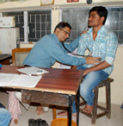

Medical Aid

Each hostel has a clinic where qualified doctors (most of whom are ex-students of Samiti) provide treatment for minor illnesses. Each student has to undergo a medical check up once in each a year.



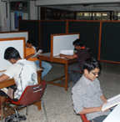

Library

Each hostel has a library of text books and literary books. Keeping in mind the high cost of text books, Samiti issues one set of text books to a group of 3 students free of charge for their use during their stay in the hostel. This saves considerable expense for them.   
Each hostel also has a reading room where students can study in comfort and peace during the day or night.   
Several prominent news papers and magazines are subscribed to for each hostel for use of the students.



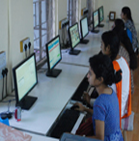

Computer Centre

Recognising the need for students to be computer literate if they have to face the world in the present times, Samiti has set up a computer centre in each hostel where students can learn and practice on computers. In fact, Samiti has made a rule that students who are not computer literate must acquire the skill within one year failing which their admission would not be renewed.



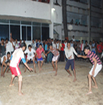

Sports