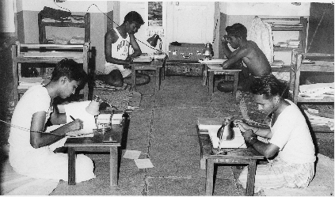

Students' Welfare Association (Popularly knows as 'Samiti') is a public charitable trust located in Pune, Maharashtra state, India. Registration No : E 219 under section 50 A (3) of the Public Trusts Act 1950.

Brief History

Pune is considered as the epicentre of education of Maharashtra and India. Because of a large number of private and government colleges and institutions offering courses in a wide variety of fields in Pune, a large number of students from all over India and foreign countries come to Pune for higher education. Students from economically weaker families from rural areas cannot afford the cost of living in a college or private hostel apart from the college fees and other educational expenses and many of them have to give up their plans for higher education which would improve the standard of living of their families.

Management

The affairs of SAMITI are managed by a Board of Trustees comprising eminent social workers and representatives of the Advisory Board, Karyakartas and primary members. The Board of Trustees is guided by an Advisory Board comprising heads of reputed colleges and educational institutions. The administration is conducted by employed staff and a group of dedicated Karyakartas organized in various sub-committees, under the leadership of the Managing Trustee.

Organizational Structure

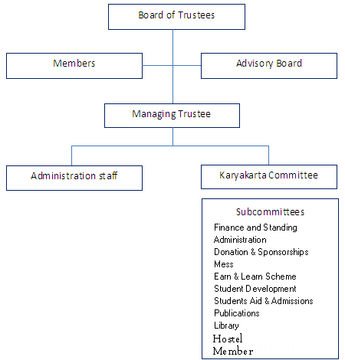

Board of Trustees: (2014-2017)