Activity 2: Jenkins CI/CD Pipeline with Terraform Infrastructure Provisioning
Nov 9, 2026 · @Harshada

1. Aim and objectives
Student: Harshada Gahininath Gujar · GitHub: Harshadagujar2005
This activity built a working CI/CD pipeline in Jenkins that pulls code from GitHub, builds and tests it, then validates, plans and applies a Terraform configuration that creates an AWS EC2 instance. The pipeline ran end to end and finished with Finished: SUCCESS, and the EC2 instance jenkins-terraform-demo was created in the Asia Pacific (Mumbai) region.
Objectives:
- Configure a Jenkins pipeline job that retrieves source code from a GitHub repository.
- Write a Jenkinsfile with stages for checkout, build, test and Terraform.
- Write Terraform files that define an EC2 instance and its security group.
- Validate the configuration with terraform init, validate and plan, then provision it with apply.
- Demonstrate the pipeline and explain how CI/CD and Infrastructure as Code (IaC) work together.

2. Tools and environment
Everything ran on a Windows laptop inside WSL2 (Ubuntu 26.04), with Jenkins and Terraform on the same Linux machine and the EC2 instance created in the AWS Mumbai region.
Tool | Version | Purpose
WSL2 with Ubuntu | 26.04 | Linux environment on Windows
OpenJDK | 21.0.12.1 | Runtime required by Jenkins
Git | 2.53.0 | Source control and checkout
Node.js / npm | v20.20.2 / 10.8.2 | Build and test of the sample app
Jenkins | LTS, from the official apt repository, at http://localhost:8080 | CI/CD server
Jenkins plugins | Git, Pipeline, Credentials Binding | Checkout from GitHub, pipeline stages, secure AWS credentials
Terraform | v1.17.1 (linux_amd64) | Infrastructure as Code
Terraform AWS provider | hashicorp/aws 5.100.0 | Talks to the AWS API
AWS | EC2 in ap-south-1 (Mumbai) | Cloud infrastructure
GitHub | Public repository | Source code hosting
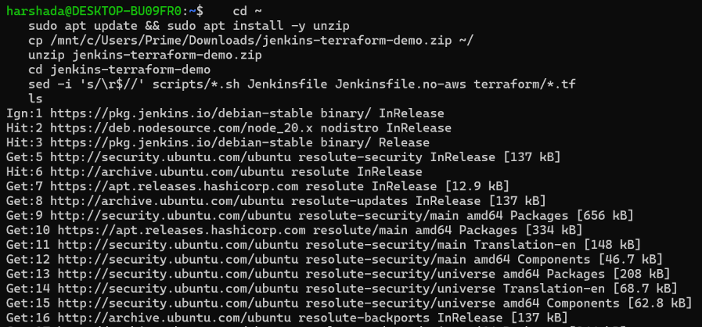  Figure 1: Project folder copied into the Ubuntu (WSL2) home directory. | 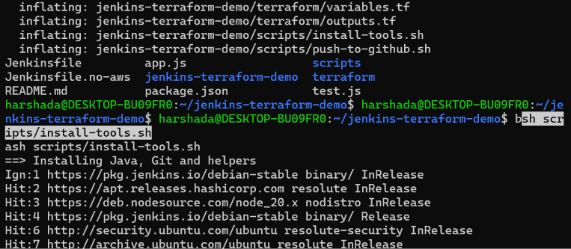  Figure 2: Install script started, setting up Java, Node.js, Jenkins and Terraform.
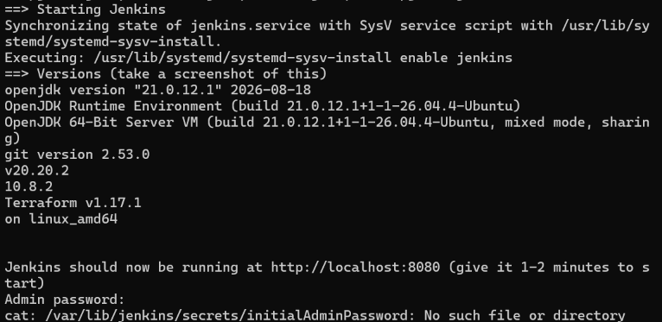
Figure 3: Installed versions of Java 21, Git, Node.js, npm and Terraform.

3. Source code repository
The whole project is in one public GitHub repository: Harshadagujar2005/jenkins-terraform-demo (branch main). It holds a small Node.js application, its tests, the Jenkinsfile and the Terraform configuration.
Path | What it does
app.js | Sample application with add and greet functions
test.js | Unit tests using Node's built-in test runner
package.json | Defines npm run build (node --check app.js) and npm test (node --test)
Jenkinsfile | Declarative pipeline: checkout, build, test, Terraform init, validate, plan, approval, apply
Jenkinsfile.no-aws | Reduced pipeline without AWS (init and validate only), kept as a fallback
terraform/main.tf | Provider, AMI lookup, security group and EC2 instance
terraform/variables.tf | Region and instance type variables
terraform/outputs.tf | Outputs the instance ID and public IP
scripts/ | Helper scripts to install the tools and push to GitHub
docs/ and logs/ | This report, screenshots and execution logs

4. Jenkins configuration and GitHub integration
Jenkins is running on the local Linux machine, is connected to the GitHub repository, and checked out the code successfully on its first build (Figures 4 to 9).
- Install and start Jenkins. Jenkins was installed from its official apt repository and started as a service. It needs Java 21, so OpenJDK 21 was installed first. The Jenkins dashboard opened at http://localhost:8080 (Figure 4).
- Check plugins. The Git, Pipeline and Credentials Binding plugins are installed and enabled.
- Store the AWS key securely. A credential of kind Username with password, scope Global, ID aws-creds, holds the AWS access key for Terraform (Figures 5 and 6). The secret is masked in Jenkins and in build logs, and is never committed to GitHub. The pipeline reads it only inside a withCredentials block.
- Create the pipeline job. A new item of type Pipeline named jenkins-terraform-pipeline was created (Figure 7).
- Connect it to GitHub. The job uses Pipeline script from SCM with SCM set to Git, the repository URL https://github.com/Harshadagujar2005/jenkins-terraform-demo.git, branch */main, script path Jenkinsfile and no credentials, because the repository is public (Figure 8).
The first build log confirms the integration: Jenkins reports Obtained Jenkinsfile from git https://github.com/Harshadagujar2005/jenkins-terraform-demo.git, then clones the repository into its workspace (Figure 9).
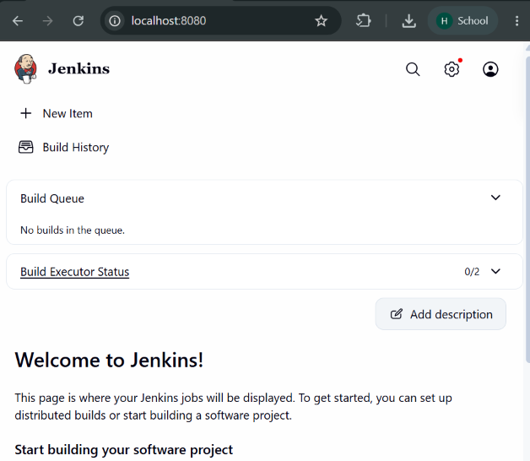  Figure 4: Jenkins dashboard running at localhost:8080. | 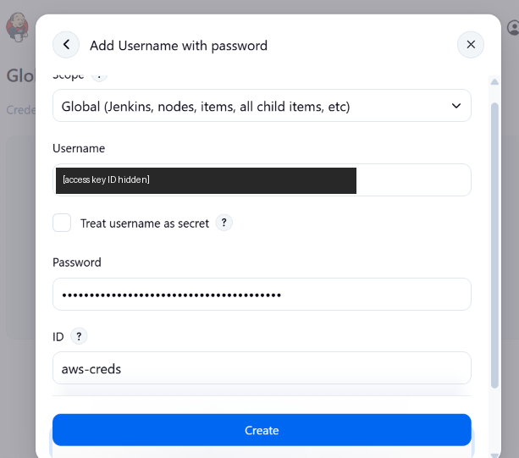  Figure 5: Adding the aws-creds credential. The key ID is hidden here and the secret is masked.
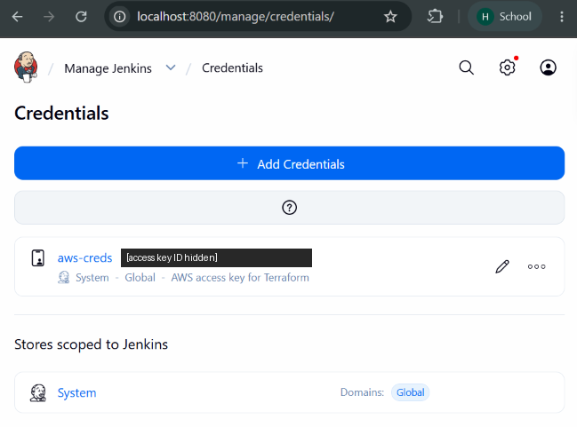  Figure 6: The aws-creds credential listed in Jenkins (key ID hidden). | 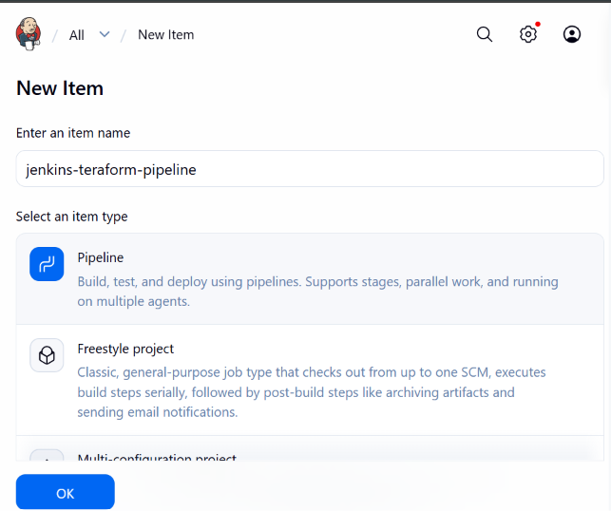  Figure 7: Creating a new Pipeline item for the job.
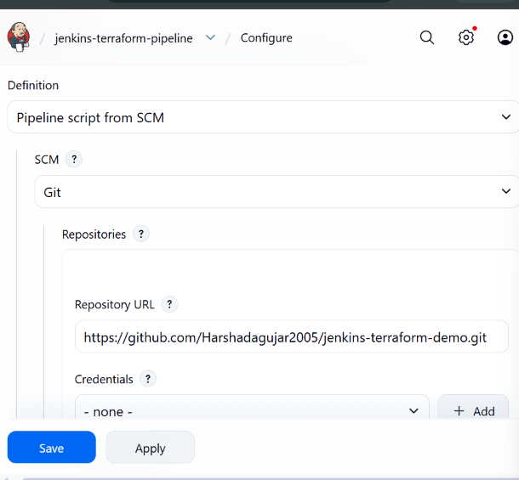  Figure 8: Pipeline script from SCM, with Git and the GitHub repository URL. | 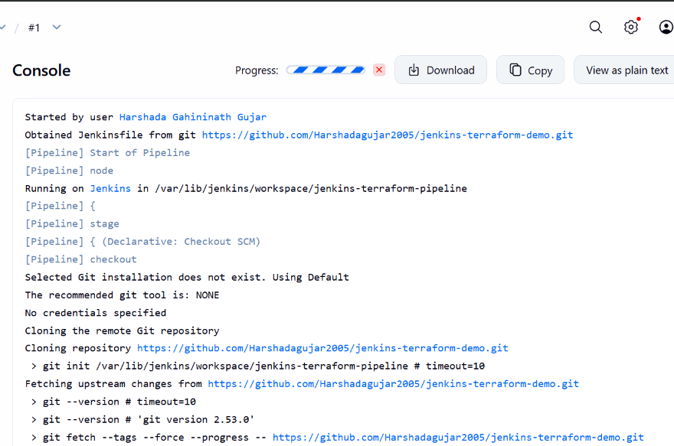  Figure 9: Console output of build #1 obtaining the Jenkinsfile from GitHub and cloning the repository.

5. Jenkinsfile and CI/CD pipeline
The Jenkinsfile defines a declarative pipeline with eight stages, and build #1 ran through all of them and ended with Finished: SUCCESS (Figures 10 to 14).
Stage | What it does | Command
Checkout | Gets the source from GitHub | checkout scm
Build | Checks the Node version and the app's syntax | npm run build
Test | Runs the unit tests | npm test
Terraform Init | Downloads the AWS provider and prepares the working directory | terraform init -input=false
Terraform Validate | Checks formatting and syntax of the configuration | terraform fmt -check, terraform validate
Terraform Plan | Previews the changes and saves them as tfplan, using the aws-creds credential | terraform plan -input=false -out=tfplan
Approval | Pauses until a person approves creating the instance | input step
Terraform Apply | Creates the resources from the saved plan | terraform apply -input=false tfplan
The Approval stage is a deliberate safety gate. The pipeline stops after the plan, and only a person clicking Proceed lets it create real cloud resources. In the demonstration the build was approved by Harshada Gahininath Gujar (Figure 12). A post block prints Pipeline completed successfully or Pipeline failed, check the console output.
Results:
- Local build and test passed before pushing: npm run build succeeded and npm test reported 6 passed, 0 failed. The three tests in test.js ran twice because the local folder held a duplicate copy of the project (Figure 11).
- Build #1 started by the user, checked out the code from GitHub, passed every stage up to the plan, and was approved at the Approval stage.
- After approval, Terraform Apply finished, printed the public_ip output, and the build ended with Pipeline completed successfully and Finished: SUCCESS (Figure 13).
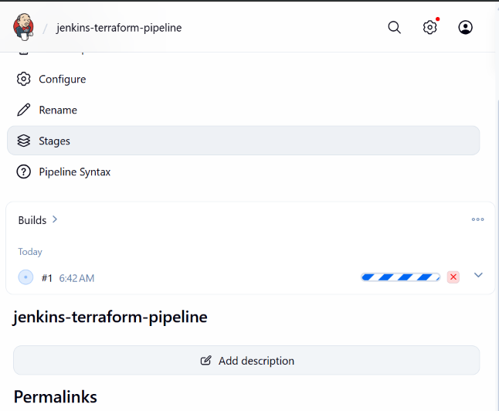  Figure 10: Build #1 of the pipeline running. | 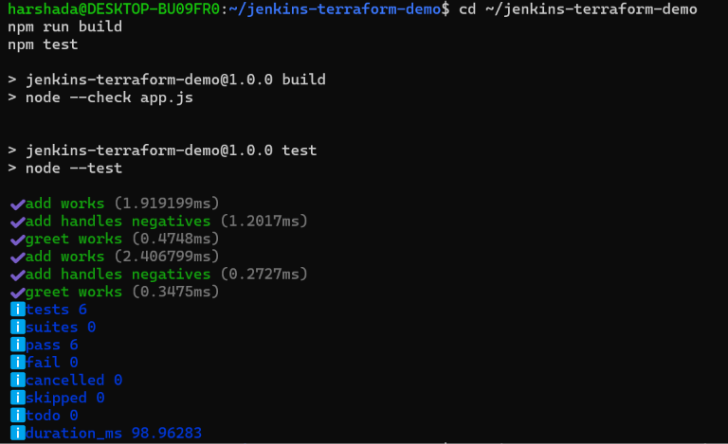  Figure 11: npm run build and npm test passing locally before the push.
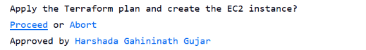  Figure 12: Approval stage, approved by the user. | 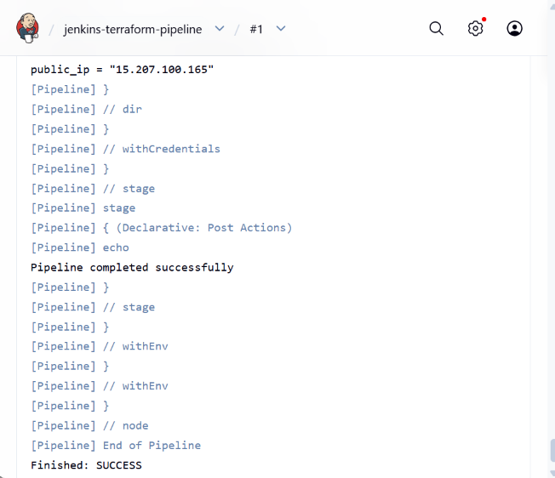  Figure 13: End of the console output, showing the public_ip output, Pipeline completed successfully and Finished: SUCCESS.
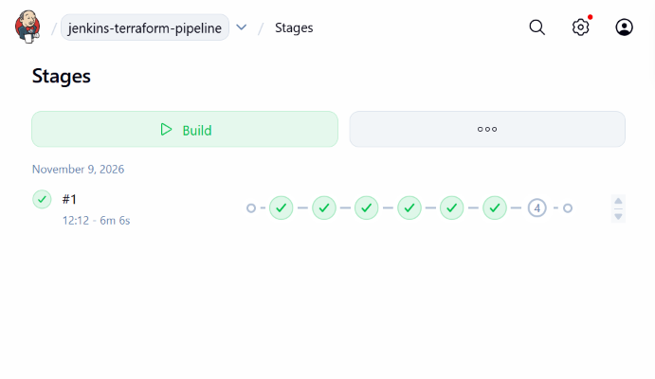
Figure 14: Stage view of build #1 (6 min 6 s).

6. Terraform configuration
The configuration in the terraform/ folder defines one EC2 instance and the security group it uses, split across three files so it stays readable.
File | Contents
main.tf | terraform block (Terraform 1.3 or newer, AWS provider ~> 5.0), the aws provider, the AMI lookup, the security group and the EC2 instance
variables.tf | aws_region (default ap-south-1) and instance_type (default t3.micro)
outputs.tf | instance_id and public_ip of the new instance
Resources in main.tf:
Block | Purpose
data.aws_ami.amazon_linux | Finds the latest Amazon Linux 2023 image, so no AMI ID is hard-coded
aws_security_group.web_sg | Named jenkins-demo-sg; allows inbound SSH (port 22) and HTTP (port 80) and all outbound traffic
aws_instance.web | The server: that AMI, the instance type from the variable, the security group, and the tag Name = jenkins-terraform-demo
Using variables for the region and instance type means the same files can be reused in another region or with a different size without editing the resources. For a real deployment the SSH rule would be limited to a trusted IP range instead of 0.0.0.0/0.

7. Terraform validation and provisioning workflow
The configuration passed terraform validate, produced a correct plan of 2 resources to add, and was applied through Jenkins to create a running EC2 instance (Figures 15 and 16).
Step | Result
terraform init | Ran as the Terraform Init stage in Jenkins and passed
terraform fmt -check | No formatting problems reported
terraform validate | Success! The configuration is valid.
terraform plan | Plan: 2 to add, 0 to change, 0 to destroy. with the outputs instance_id and public_ip shown as known after apply
terraform apply | Run by the pipeline from the saved plan tfplan after approval
The plan reads the AMI (ami-00531e78dd10fb3be, Amazon Linux 2023) and will create two resources: aws_security_group.web_sg (jenkins-demo-sg, allowing ports 22 and 80) and aws_instance.web (type t3.micro, tag Name = jenkins-terraform-demo). The plan was run both on the command line and inside the Jenkins pipeline, with the same result.
Provisioning result, checked in the AWS Console (Figure 16):
Item | Value
Instance name | jenkins-terraform-demo
Instance ID | i-00faadbbb73f5543f
State | Running
Region | Asia Pacific (Mumbai), ap-south-1
Public IPv4 address | 15.207.100.165 (matches the public_ip output in the Jenkins log)
Private IPv4 address | 172.31.7.220
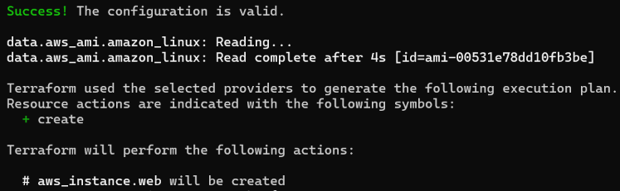  Figure 15: terraform validate succeeding and terraform plan reading the AMI and listing the resources to create. | 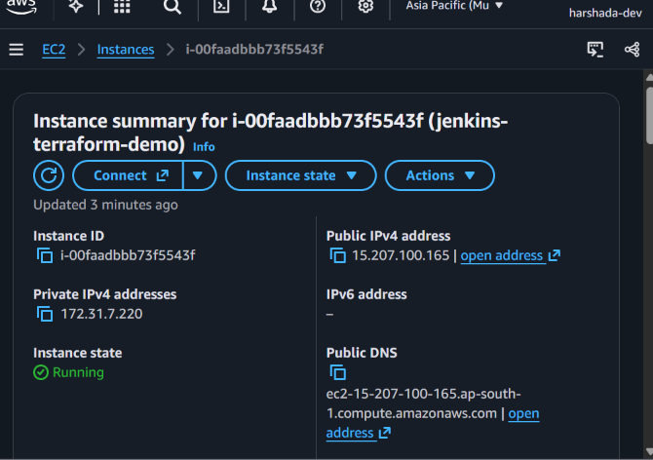  Figure 16: The jenkins-terraform-demo instance in the Running state in the AWS Console (Mumbai).

8. Integration of CI/CD and Infrastructure as Code
CI/CD automates how code is built, tested and delivered, and Infrastructure as Code automates how the servers it runs on are created. Jenkins joins the two in one pipeline, so a single change in GitHub can lead to tested code and a described, reviewable infrastructure change.
How they connect in this project:
- A developer pushes code and the Jenkinsfile to GitHub.
- Jenkins checks out the repository and runs the build and test stages. A failure here stops the pipeline before any infrastructure is touched.
- Jenkins runs terraform init, fmt and validate to check that the infrastructure code is correct.
- terraform plan shows exactly what would change in AWS and saves it as tfplan.
- A person approves the plan.
- terraform apply creates the security group and EC2 instance from that saved plan, so what was reviewed is exactly what gets built.
Why this is useful:
- Repeatable: the same files create the same infrastructure every time, with no manual console clicks.
- Version controlled: the infrastructure definition lives in Git next to the application, so every change has a history.
- Safer: tests, validation, a plan preview and a manual approval gate catch mistakes before resources are created.
- Faster: one button (or one push) runs the whole path from source code to a running server.
- Secure: the AWS key is held in the Jenkins credential store and exposed only to the stages that need it.
The next section lists everything submitted for this activity, including the recorded demonstration.

9. Conclusion and submission contents
A Jenkins pipeline now takes code from GitHub, builds and tests it, validates and plans Terraform, and after approval creates an AWS EC2 instance, with the whole run finishing in Finished: SUCCESS. The activity showed that application delivery and infrastructure provisioning can sit in one automated, repeatable and reviewable workflow.
Expected submission | Where to find it
Jenkinsfile | Jenkinsfile in the GitHub repository
Source-code repository | Harshadagujar2005/jenkins-terraform-demo
Terraform .tf files | terraform/main.tf, variables.tf, outputs.tf in the repository
Execution logs and screenshots | Figures 1 to 16 in this report, and docs/screenshots/ and logs/ in the repository
Validation output | Section 7 of this report and logs/ in the repository
Recorded demonstration | Video submitted with this report

