Jenkins CI/CD + Terraform Mini Project
Short Report
Name | Harshada Gahininath Gujar
Programme | B.Tech Computer Engineering, MIT Academy of Engineering, Pune
PRN / Roll No. | [fill in your PRN]
GitHub repository | https://github.com/Harshadagujar2005/jenkins-terraform-mini-project
Demo video link | [paste video link after recording]

1. Objective
To design a basic CI/CD workflow in Jenkins that automatically fetches source code, builds, tests and deploys a Node.js application, and to use Terraform to demonstrate Infrastructure as Code (IaC) and resource provisioning.

2. Tools and Technologies
Tool | Purpose
Node.js / Express | Sample web application with health endpoint
Git / GitHub | Source-code repository and Jenkins integration
Jenkins (in Docker) | Pipeline automation (Jenkinsfile)
Docker | Packages the app as an image; runs the deployed container
Terraform | Infrastructure as Code: AWS config and local Docker deployment

3. CI/CD Pipeline Design
The Jenkinsfile is stored in the repository and Jenkins runs it using "Pipeline script from SCM". The pipeline stages are:
- Checkout: pulls the latest code from GitHub.
- Install Dependencies and Test: runs npm install and npm test; a failing test stops the pipeline.
- Build Docker Image: builds the image tagged with the Jenkins build number.
- Terraform AWS (Init, Validate, Plan): validates the AWS configuration and shows the execution plan; an optional Apply runs only when an AWS account is available.
- Terraform Docker (Init, Validate, Plan, Apply): provisions and deploys the application container.
- Verify Deployment: calls the /health endpoint to confirm the app is running.

4. Infrastructure as Code with Terraform
Infrastructure as Code means describing infrastructure in version-controlled configuration files instead of creating it manually. This makes environments repeatable, reviewable and easy to recreate or destroy.
- AWS configuration (terraform/aws): defines an S3 bucket with versioning, a security group allowing HTTP, and a t2.micro EC2 instance. Variables and outputs make it reusable. A real terraform apply was run against an AWS account in region ap-south-1 (Mumbai) through the Jenkins pipeline (credentials stored as the Jenkins credential aws-creds), creating the S3 bucket and EC2 instance, which were verified in the AWS console and are destroyed with terraform destroy after the demo to avoid charges.
- Docker configuration (terraform/docker): uses a reusable module (app_container) to create the application container; executed with terraform init, plan and apply from Jenkins.
Core commands: terraform init downloads providers; plan previews changes; apply creates resources; destroy removes them. The state file records the resources Terraform manages.

5. Execution Results
Screenshots of the pipeline execution are given below.
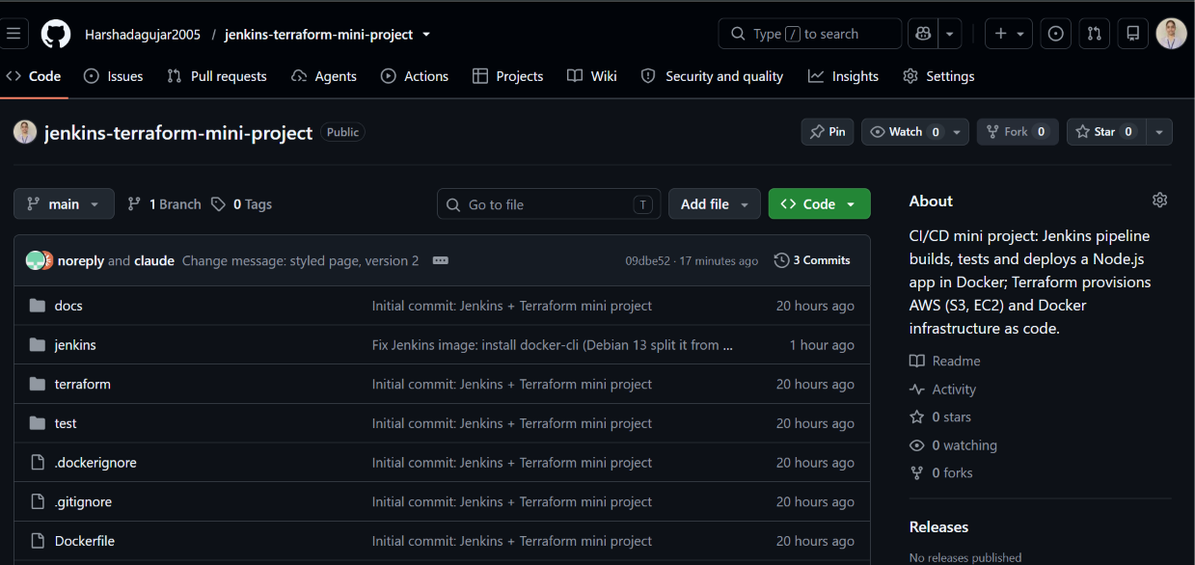
Figure 1: GitHub repository containing the Jenkinsfile, terraform/, Dockerfile and application code.
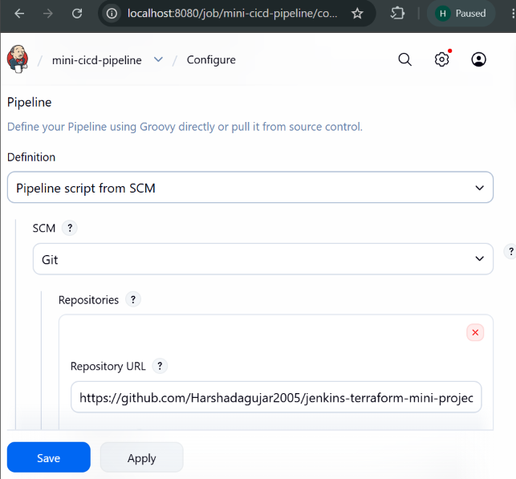
Figure 2: Jenkins job configuration - Pipeline script from SCM with the GitHub repository.
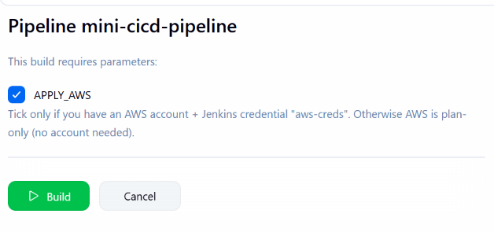
Figure 3: Build with Parameters - APPLY_AWS ticked for the real AWS apply.
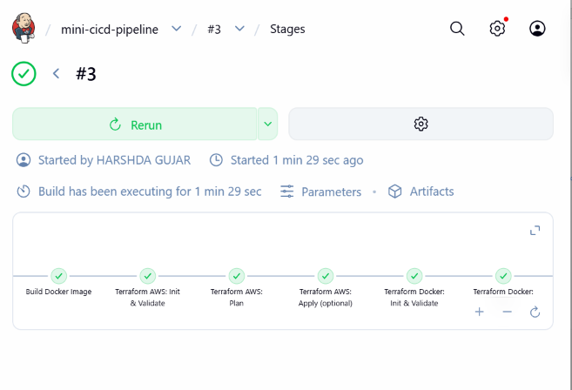
Figure 4: Build #3 stage view - all stages green including Terraform AWS Apply.
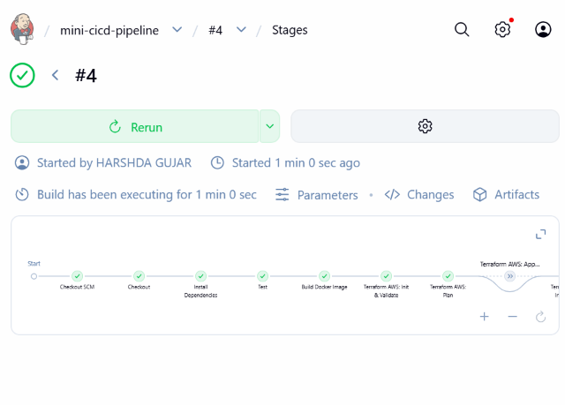
Figure 5: Build #4 stage view after the code change (automatic redeploy).
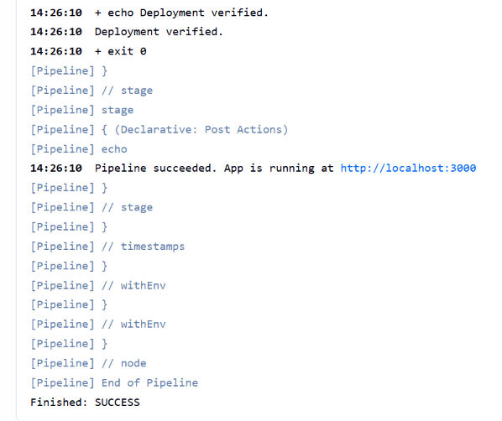
Figure 6: Console output - "Deployment verified." and "Finished: SUCCESS".
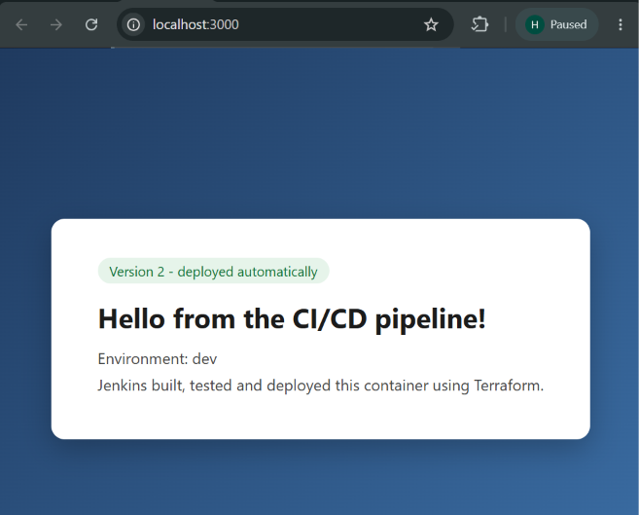
Figure 7: Application running at http://localhost:3000 (Version 2 page after the code change).
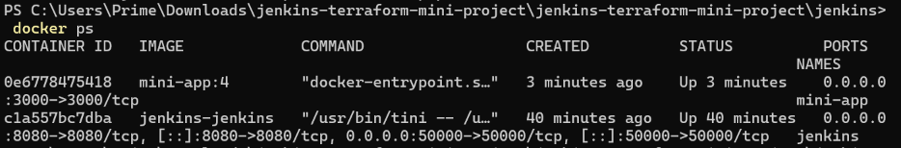
Figure 8: docker ps showing the mini-app container (image mini-app:4) and the Jenkins container.
[Still to add: console screenshots of npm test (2 passing), terraform plan and "Apply complete! Resources: 4 added", the AWS console showing the S3 bucket and EC2 instance in ap-south-1, and docker ps / terraform state list.]
Build #1 failed at the Build Docker Image stage because the Docker CLI was missing in the Jenkins image; after fixing the Jenkins Dockerfile, build #2 (APPLY_AWS unticked) completed successfully: tests passed, the Docker image was built, the AWS plan ran, the container was deployed with Terraform and the /health check passed. Build #3 was run with APPLY_AWS ticked and applied the AWS resources (S3 bucket and EC2 instance) for real. After editing the message in server.js and pushing to GitHub, build #4 rebuilt the image (mini-app:4) and replaced the container, and the new page appeared at http://localhost:3000.

6. Challenges and Learning
Docker CLI missing in Jenkins: the first build failed with "docker: not found" because the newer Debian base image ships the CLI in a separate docker-cli package; I added it to the Jenkins Dockerfile and rebuilt the image. Jenkins login: I lost the admin credentials, so I recreated the Jenkins volume and re-added the aws-creds credential and the pipeline job. Slow terraform init: the AWS provider is about 700 MB, so the first init took several minutes; later builds were faster. I also learned to keep secrets (AWS keys) in Jenkins credentials and never in Git, and to destroy cloud resources after the demo to avoid charges.

7. Conclusion
The project demonstrates an automated workflow from source commit to deployment using Jenkins, and shows how Terraform provisions infrastructure through code. Together they reduce manual effort, improve consistency and make deployments repeatable.

