Project Planning Phase
Iteration Planning and Delivery Tracking
Book A Doctor — Digital Healthcare Appointment Scheduling System
Report Prepared On | 13 July 2026
Team Identifier | 2026-9150
Solution Name | Book A Doctor — Digital Healthcare Appointment Scheduling System
Evaluation Weight | 5 Marks

1. Purpose of This Document
This document records how the Book A Doctor backlog was broken into sprints, how much work each sprint carried, and how actual delivery compared with the plan. It closes with a short primer on two standard agile measurements — velocity and burn-down — and shows how each would be computed and read for this project.

2. Product Backlog and Sprint Assignment
The backlog below groups every planned story by the sprint in which it was delivered. Each row names the capability area the story belongs to, restates the story itself in first-person form, and records its size estimate in story points, its relative priority, and the team member responsible for it.
Sprint | Story ID | Capability Area | Narrative | Est. (pts) | Priority | Owner
Sprint 1 | US-01 | Account Creation | As a new user, I want to register as either a patient or a doctor using my name, e-mail, password, and phone number, so that I can begin using the platform. | 3 | High | Kunapareddy Srivalli
Sprint 1 | US-02 | Session Authentication | As a registered user, I want to sign in with my e-mail and password and receive a session token, so that I remain authenticated for later requests. | 2 | High | Bodi Deepak Sai
Sprint 1 | US-03 | Role-Based Routing | As the platform, I want to direct each authenticated request to the correct Patient, Doctor, or Admin view based on the caller's role, so that users only see screens relevant to them. | 2 | High | Kuthada Bindu Lavanya
Sprint 2 | US-04 | Physician Discovery | As a patient, I want to search and filter the doctor list by name or specialization, so that I can narrow down my options quickly. | 3 | High | Chinthala Prasanth
Sprint 2 | US-05 | Profile Viewing | As a patient, I want to open a doctor's full profile — fee, qualifications, and availability — so that I can decide whether to book with them. | 2 | Medium | Raja Ravi Varma Vemula
Sprint 2 | US-06 | Profile Management | As a doctor, I want to edit my own profile and set my weekly availability, so that patients always see accurate scheduling information. | 3 | High | Kunapareddy Srivalli
Sprint 3 | US-07 | Appointment Scheduling | As a patient, I want to reserve an open date and time slot with a doctor, so that I can confirm a consultation. | 3 | High | Bodi Deepak Sai
Sprint 3 | US-08 | Appointment Management | As a doctor, I want to confirm, decline, or mark a patient's appointment as complete, so that the booking record reflects reality. | 3 | High | Kuthada Bindu Lavanya
Sprint 3 | US-09 | Clinical File Exchange | As a patient, I want to attach a report or prescription to my appointment, so that my doctor has the relevant history in advance. | 2 | Medium | Chinthala Prasanth
Sprint 4 | US-10 | In-App Alerts | As a platform user, I want to receive in-app alerts for booking requests, confirmations, and status changes, so that I stay informed without polling manually. | 2 | Medium | Raja Ravi Varma Vemula
Sprint 4 | US-11 | Doctor Governance | As an administrator, I want to approve or revoke doctor accounts, so that only vetted physicians remain visible to patients. | 3 | High | Kunapareddy Srivalli
Sprint 4 | US-12 | Platform Oversight | As an administrator, I want to view every appointment across the platform, so that I can monitor overall activity. | 2 | Medium | Bodi Deepak Sai

3. Delivery Tracker
Table 2 compares what each sprint committed to against what was actually completed by its planned end date. Every sprint in this project ran for a fixed six-day window, and in each case the delivered point total matched the plan, so the recorded and actual release dates coincide.
Sprint | Planned Points | Duration | Start Date | Planned End | Points Delivered | Actual Release
Sprint 1 | 7 | 6 days | 15 Jun 2026 | 20 Jun 2026 | 7 | 20 Jun 2026
Sprint 2 | 8 | 6 days | 22 Jun 2026 | 27 Jun 2026 | 8 | 27 Jun 2026
Sprint 3 | 8 | 6 days | 29 Jun 2026 | 04 Jul 2026 | 8 | 04 Jul 2026
Sprint 4 | 7 | 6 days | 06 Jul 2026 | 11 Jul 2026 | 7 | 11 Jul 2026

4. Velocity
Velocity measures how many story points a team completes, on average, within one sprint; dividing that figure by the sprint's length in days yields an average daily throughput that can be used to sanity-check future estimates. As a worked example distinct from this project's own sprint lengths: a team whose measured velocity is 20 points across a 10-day sprint is completing work at an average rate of 2 points per day.
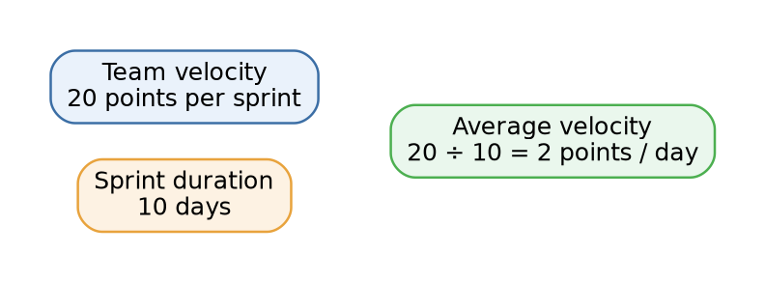
Figure 1. Average velocity as a function of total points and sprint length.

5. Burn-Down Chart
A burn-down chart plots the story points still outstanding against the days elapsed in a sprint, giving the team an at-a-glance signal of whether delivery is on pace, ahead, or falling behind the plan. The technique originated in Scrum but generalises to any effort where progress can be expressed as a shrinking quantity of remaining work over time.
Figure 2 illustrates the pattern using Sprint 1 of this project as an example: a planned, straight-line ideal descent from seven points to zero across six days, plotted against a hypothetical day-by-day recording of points actually remaining. Divergence between the two lines — running above the ideal line signals the team is behind, below it signals ahead — is the chart's main diagnostic value.
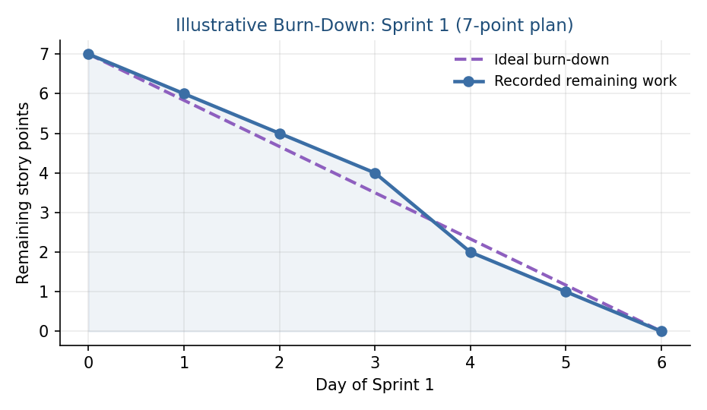
Figure 2. Illustrative burn-down for Sprint 1, plotted against the ideal linear descent.

6. Reference Material
General background on agile estimation, sprint planning, and the two charts discussed above can be found at the following sources:
- Atlassian — agile project management overview: https://www.atlassian.com/agile/project-management
- Atlassian — running Scrum with Jira Software: https://www.atlassian.com/agile/tutorials/how-to-do-scrum-with-jira-software
- Atlassian — epics: https://www.atlassian.com/agile/tutorials/epics
- Atlassian — sprints: https://www.atlassian.com/agile/tutorials/sprints
- Atlassian — estimation: https://www.atlassian.com/agile/project-management/estimation
- Atlassian — burn-down charts: https://www.atlassian.com/agile/tutorials/burndown-charts
- Visual Paradigm — Scrum burn-down chart: https://www.visual-paradigm.com/scrum/scrum-burndown-chart/

