Ideation Phase
Empathize & Discover

Date | 19 July 2026
Team ID | SWTID-2026-9150
Project Name | Book A Doctor – Online Healthcare Appointment Booking Platform
Maximum Marks | 4 Marks

Empathy Map Canvas:
An empathy map is a simple, easy-to-digest visual that captures knowledge about a user’s behaviours and attitudes.

It is a useful tool to helps teams better understand their users.
Creating an effective solution requires understanding the true problem and the person who is experiencing it. The exercise of creating the map helps participants consider things from the user’s perspective along with his or her goals and challenges.
Empathy Map Canvas Structure — Book A Doctor Project:
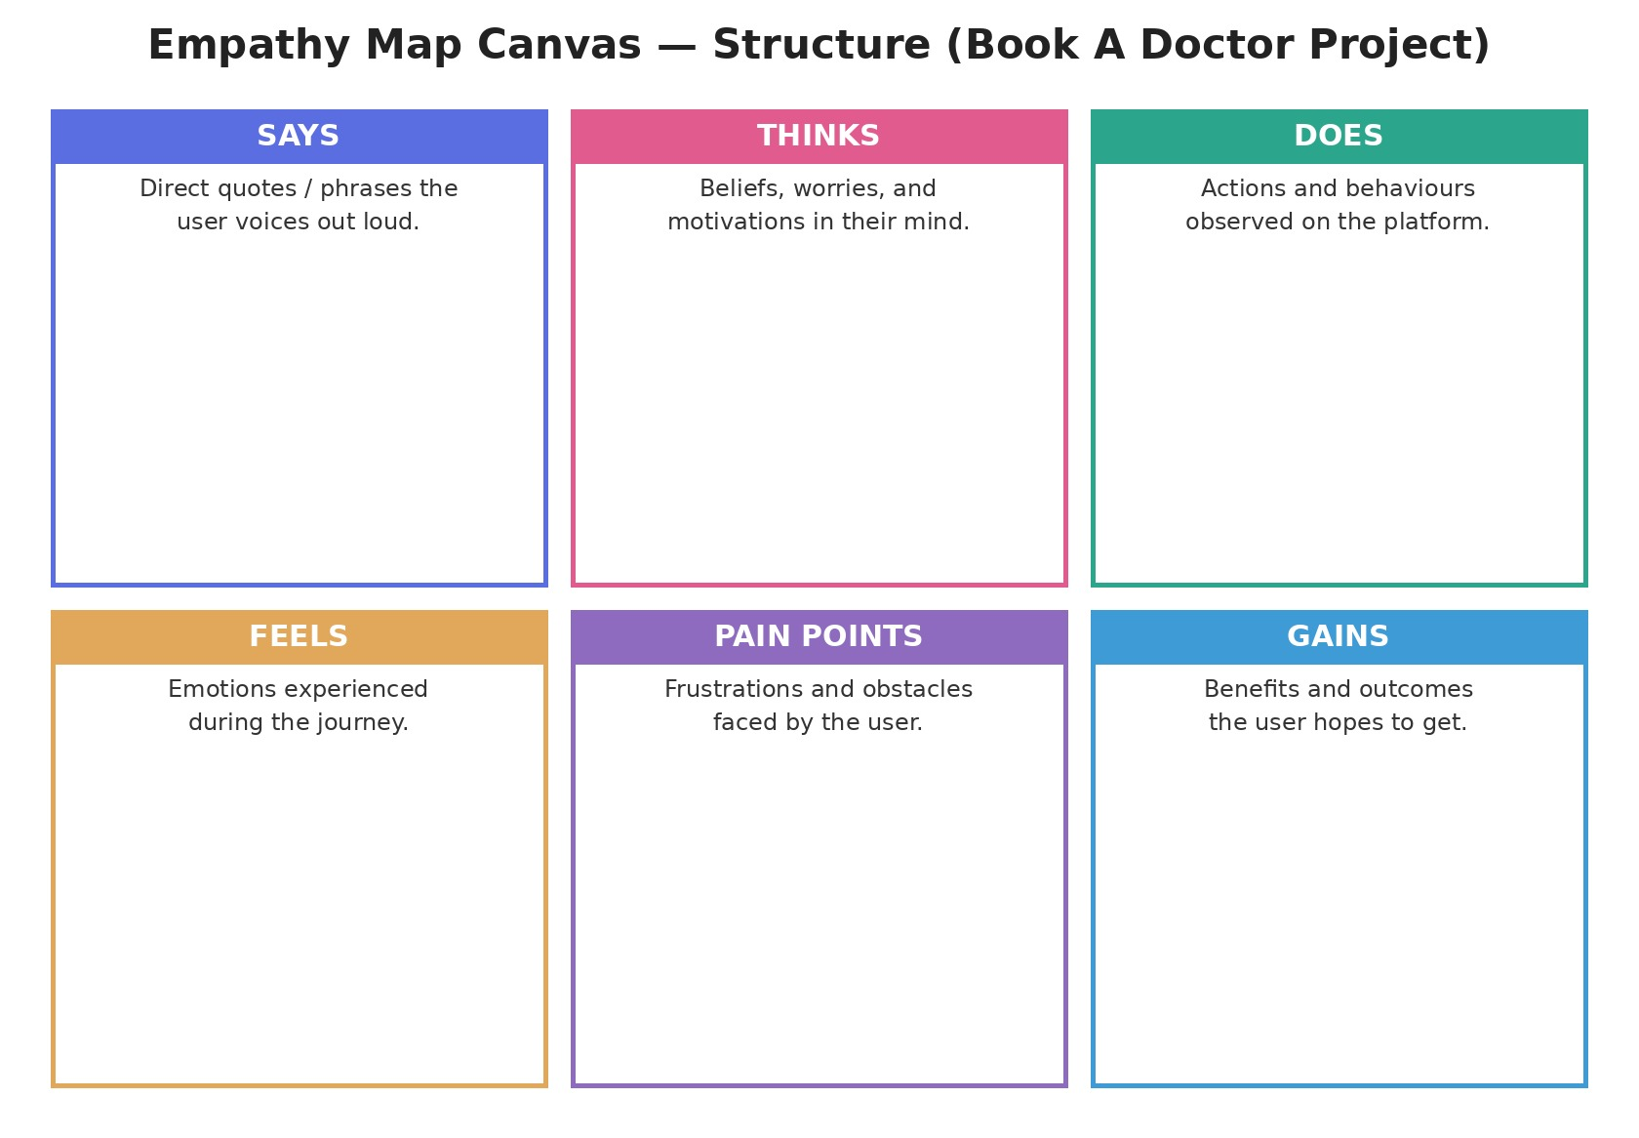

Example: Book A Doctor — e-Scheduling Application (Patient Persona)
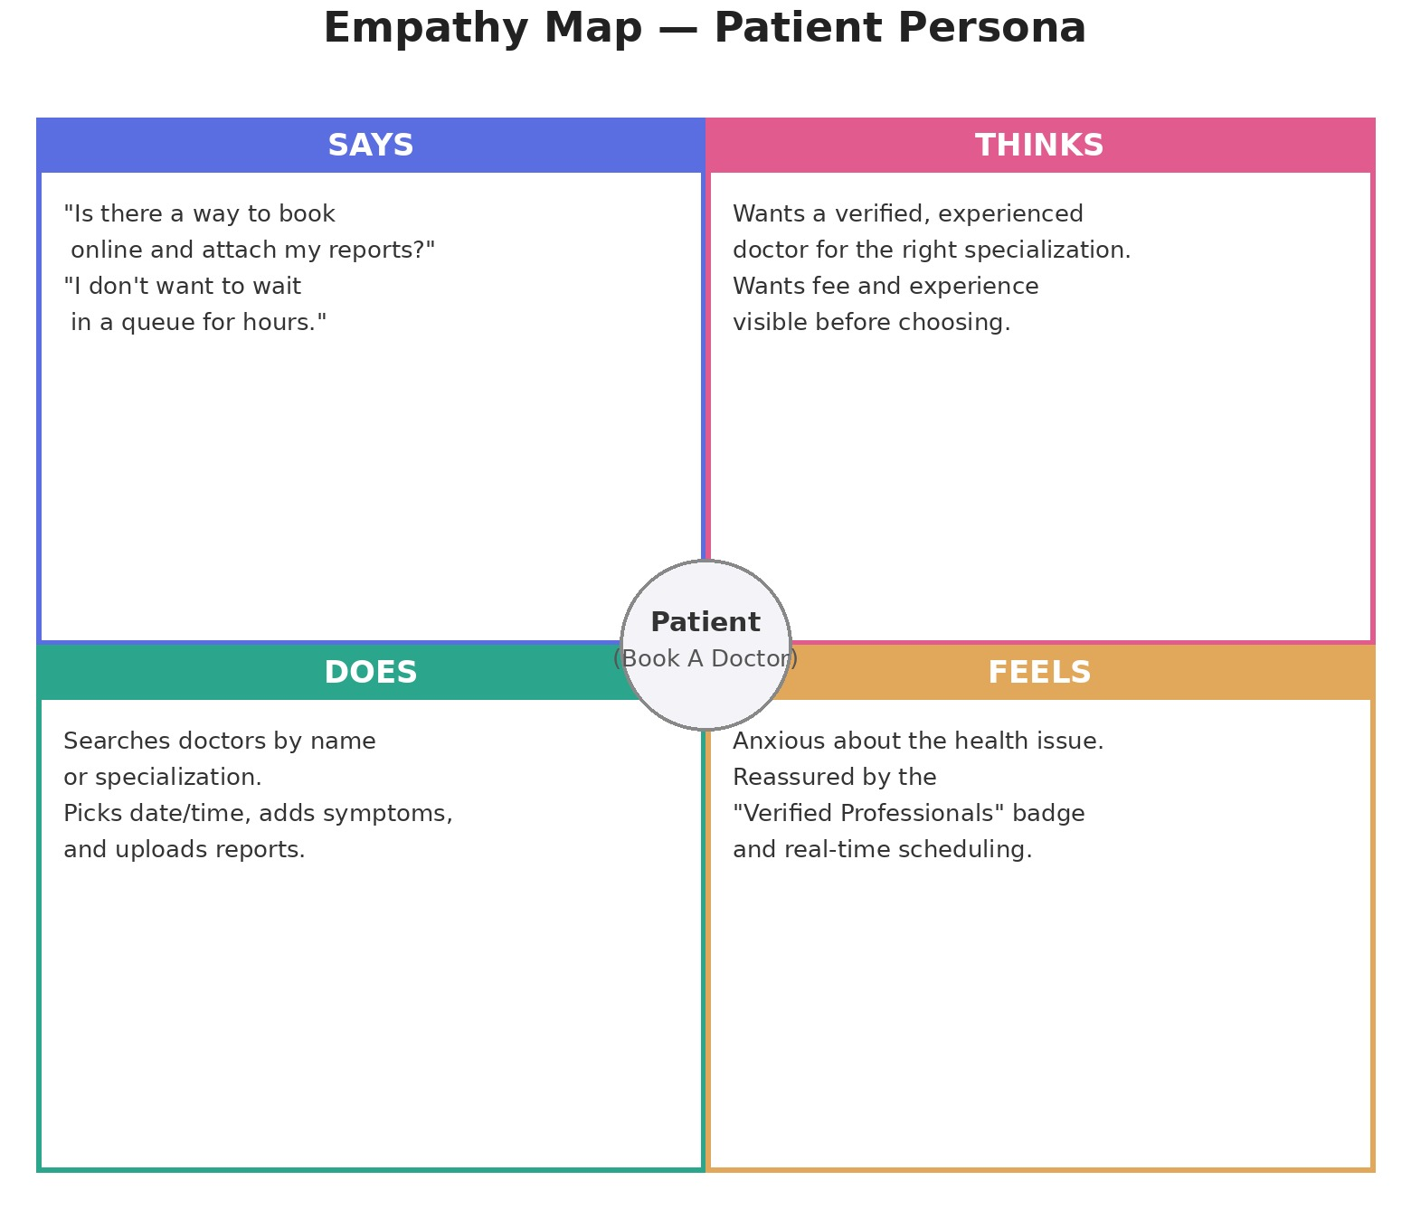

Empathy Map — Patient Persona (Primary User)
Quadrant | Notes
Says | “I don't know which doctor treats my problem.” “I don't want to wait in a queue for hours.” “Is there a way to book a specific time slot online and attach my reports?”
Thinks | Worried the health issue may be serious; hopes to find a verified, experienced doctor for the right specialization; wants to see experience and consultation fee upfront before choosing a doctor.
Does | Registers on the platform as a patient; searches and filters doctors by name or specialization on the Find Doctors page; compares experience and consultation fee; picks a consultation date and session time, enters the reason/symptoms, and uploads reports before submitting the request.
Feels | Anxious about the health concern; reassured on seeing "Verified Professionals" and clear experience/fee details; confident that real-time scheduling means no double-booking; relieved once the appointment request is submitted.
Pain Points | Hard to judge which doctor suits a symptom without checking many profiles; no easy way to attach medical history/prescriptions at the time of booking; uncertainty about slot conflicts without real-time updates.
Gains | One page to discover doctors with specialization, experience, and fee visible; ability to pick exact date/time and describe symptoms; secure upload of reports/prescriptions (PDF, PNG, JPEG up to 5 MB); instant confirmation on "Request Appointment".

Empathy Map — Doctor Persona (Secondary User)
Quadrant | Notes
Says | “I need an easier way to manage my daily appointments.” “I want patients to see my experience and fee clearly before they book.”
Thinks | Wants to spend more time on patient care and less on scheduling; wants the "Verified Professionals" badge to build patient trust; wants patient files shared securely instead of over calls.
Does | Registers on the platform as a doctor/practitioner with name, specialization, experience and consultation fee; waits for admin verification before appearing on the Find Doctors page; reviews reason/symptoms and uploaded reports before each session.
Feels | Reassured by the verification process and the "Verified Professionals" badge; concerned that profile details (experience/fee) stay accurate since patients see them publicly; relieved that real-time scheduling avoids double-booking.
Pain Points | No structured way to publish available session times; no single place to see uploaded reports/prescriptions before a session; approval by admin can delay onboarding.
Gains | A verified profile listed with specialization, experience and fee on the Find Doctors page; secure file sharing so reports/prescriptions are stored safely; real-time scheduling that guarantees no double-bookings.

Empathy Map — Admin/Receptionist Persona (Tertiary User)
Quadrant | Notes
Says | “I need one panel to approve doctors before they go live.” “I need to make sure only verified professionals show up in Find Doctors.” “Patients keep asking whether a doctor is genuine.”
Thinks | Wants a single dashboard to oversee all doctors and bookings; worried about approving an unverified or fraudulent doctor profile; wants fewer repetitive phone queries from patients.
Does | Manually checks doctor credentials before approval; answers repeated phone calls about slot availability; updates spreadsheets to track cancellations and no-shows.
Feels | Stretched thin managing many doctors and patients at once; anxious about approving the wrong credentials; satisfied when the platform runs smoothly without escalations.
Pain Points | No centralized panel to approve/reject doctor registrations; no audit trail of cancellations or disputes; repetitive manual work that could be automated.
Gains | An admin dashboard to approve/reject doctor profiles, monitor all bookings and cancellations in real time, generate reports, and reduce repetitive phone-based coordination.

