Project Design Phase
Solution Architecture

Date | 19 July 2026
Team ID | SWTID-2026-9150
Project Name | Book A Doctor – Online Healthcare Appointment Booking Platform
Maximum Marks | 4 Marks

Solution Architecture:
Solution architecture is a complex process – with many sub-processes – that bridges the gap between business problems and technology solutions. Its goals are to:
- Find the best tech solution to solve existing business problems.
- Describe the structure, characteristics, behavior, and other aspects of the software to project stakeholders.
- Define features, development phases, and solution requirements.
- Provide specifications according to which the solution is defined, managed, and delivered.

Example - Solution Architecture Diagram:


Figure 1: Architecture and data flow of the voice patient diary sample application

Our Solution Architecture: Book A Doctor
The application follows a 3-tier MERN architecture: a React.js single-page front end, a Node.js/Express.js REST API layer with role-based middleware, and a MongoDB data store, with a separate file storage layer for uploaded documents.
Each tier is independently deployable and communicates over stateless HTTPS/REST calls, which keeps the front end, API, and database loosely coupled and lets any layer scale or be replaced (e.g. swapping local disk storage for cloud object storage) without redesigning the others. JWT-based sessions carry the authenticated user's role end-to-end, so the same API and database layer safely serve three distinct clients — Patient, Doctor, and Admin — from a single codebase.
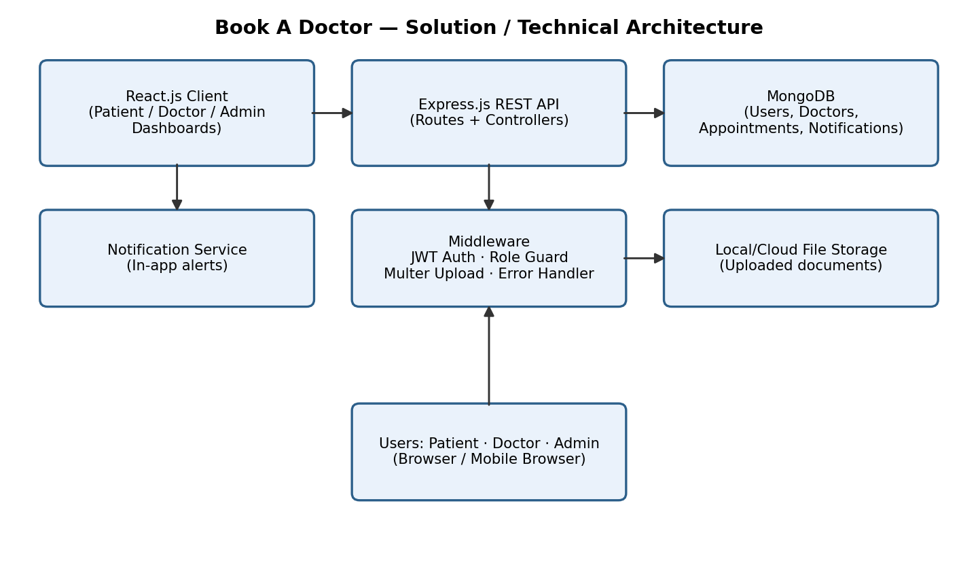
Figure: Architecture and data flow of the Book A Doctor application

Access Flow
- Patient / Doctor / Admin open the app in a browser and interact only with the React.js SPA (Presentation layer).
- The SPA calls the Express.js REST API over HTTPS via Axios, attaching the user's JWT in the request header.
- authMiddleware verifies the JWT and checks the user's role before letting the request reach the matching controller (auth, doctor, appointment, or notification).
- Controllers read/write data through Mongoose models against MongoDB; document uploads are routed through uploadMiddleware to file storage instead of the database.
- The API response flows back through the same path to update the SPA view; errorMiddleware intercepts and formats any failure at any step along the way.

Architecture Layers
Layer | Details
Presentation (Client) | React.js, React Router, Axios; pages for Login/Register, Doctor List/Profile, Patient Dashboard, Doctor Dashboard, Admin Dashboard, Notifications; AuthContext for session state.
Application (API) | Express.js routers (auth, doctors, appointments, notifications) mapped to controllers (authController, doctorController, appointmentController, notificationController).
Middleware | authMiddleware (JWT verification & role guard), uploadMiddleware (Multer for document uploads), errorMiddleware (centralized error handling).
Data (Database) | MongoDB via Mongoose models: User, Doctor, Appointment, Notification, with indexes on doctor/date/timeSlot and specialization for fast queries.
File Storage | Uploaded patient documents (reports/prescriptions) stored on disk (backend/uploads) in development; can be swapped for cloud object storage (e.g. S3) in production.
Security | JWT-based authentication, bcrypt password hashing, role-based access control for Patient/Doctor/Admin routes.

