System Architecture and Technology Stack Specification
Book A Doctor — Digital Healthcare Appointment Scheduling System
Report Prepared On | 19 July 2026
Team Identifier | [To be assigned]
Solution Name | Book A Doctor — Digital Healthcare Appointment Scheduling System
Evaluation Weight | 4 Marks

1. Purpose of This Document
This specification defines the layered technical architecture and the associated technology choices for the Book A Doctor platform, a web-based system that allows patients to locate physicians and reserve consultation slots online. The document consolidates the structural view of the system, a walkthrough of a representative booking transaction, and a categorised inventory of the frameworks, libraries, and hosting services that realise each architectural responsibility. It is intended to give reviewers a single reference for how the client, service, and data layers cooperate, and which quality attributes the chosen stack is expected to deliver.

2. Architectural Overview
The platform follows a three-tier separation of concerns. A browser-based single-page client handles all presentation logic and communicates exclusively through JSON-based REST calls. A cluster of Express.js-hosted services performs identity verification, scheduling logic, and notification generation. A document-oriented data store, mirrored in a managed cloud cluster for production use, retains all persistent records. Several integration points — messaging, payment processing, and an ML-driven recommendation engine — are architected as future extensions and are represented in the diagram below as reserved, but currently inactive, capabilities.
The diagram groups components by tier rather than by individual request path, which keeps the boundary between presentation, service, and persistence responsibilities explicit and makes it easier to reason about where a given cross-cutting concern (security, scaling, observability) should be enforced.
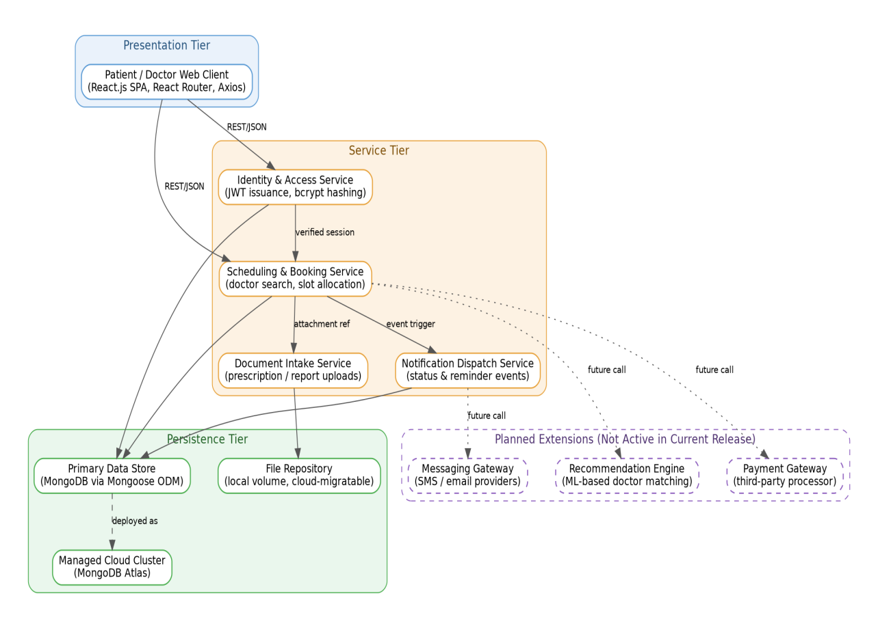
Figure 1. Layered system architecture, grouped by presentation, service, persistence, and planned-extension tiers.

2.1 Illustrative Transaction: Appointment Reservation Under High Demand
To ground the architecture in a concrete scenario, consider a surge period — for example, a period of elevated demand for consultations — during which many patients attempt to book the same specialist within a short window. The sequence below traces a single booking request end to end, illustrating how the service tier mediates contention for a limited number of time slots before the transaction is committed to the data layer.
Figure 2. Step-by-step trace of a single appointment-booking transaction.
This pattern generalises to other event-driven interactions in the system, including cancellation, rescheduling, and reminder dispatch, each of which follows the same validate-allocate-persist-notify sequence with a different terminal action in place of slot reservation.

3. Solution Building Blocks
Table 1 enumerates the architectural layers introduced above and maps each to its concrete implementation technology. Layers marked "Planned" correspond to the reserved extension points shown in the dashed region of Figure 1 and are not exercised by the current build.
Ref. | Architectural Layer | Functional Responsibility | Supporting Technology
L1 | Client Interface Layer | Renders booking screens, manages navigation, and issues asynchronous calls to backend services on behalf of patients and doctors. | React.js, React Router, Axios, HTML5, CSS3
L2 | Identity & Access Layer | Verifies user credentials, issues session tokens, and enforces role-based access between patient and doctor accounts. | Node.js, Express.js, JSON Web Tokens, bcryptjs
L3 | Scheduling & Booking Layer | Executes doctor discovery, time-slot allocation, and appointment status transitions. | Express.js route controllers (doctor and appointment logic modules)
L4 | Notification Layer | Generates and dispatches status updates tied to appointment lifecycle events. | Express.js notification controller and helper utilities
L5 | Operational Data Store | Persists patient, doctor, appointment, and notification records for the active environment. | MongoDB with Mongoose object-document mapping
L6 | Managed Data Platform | Provides a hosted, production-grade instance of the operational data store. | MongoDB Atlas
L7 | Document Repository | Retains uploaded clinical attachments such as prescriptions and diagnostic reports. | Multer-based local storage, extensible to cloud object storage
L8 | Messaging Integration (Planned) | Reserved for outbound SMS and e-mail confirmations; not exercised in the present release. | Prospective: Twilio, Nodemailer, or equivalent gateway
L9 | Payment Integration (Planned) | Reserved for transactional fee collection; not exercised in the present release. | Prospective: Razorpay, Stripe, or equivalent processor
L10 | Recommendation Engine (Planned) | Reserved for intelligent doctor-matching based on patient history; not exercised in the present release. | Prospective machine-learning scoring service
L11 | Deployment & Hosting Layer | Separates frontend and backend deployment; local development uses a self-hosted Node.js and MongoDB instance, while the production environment relies on managed platforms for each tier. | Backend: Render / Railway. Frontend: Vercel / Netlify. Database: MongoDB Atlas. Local: Node.js 18+, local MongoDB instance

4. Quality Attributes and Their Technical Basis
Beyond functional correctness, the stack was selected to satisfy a set of non-functional expectations common to healthcare scheduling systems: transparent tooling, defensible security practice, room to scale, resilience to individual node failure, and acceptable response times under typical load. Table 2 relates each attribute to the design decision and supporting technology that addresses it.
Quality Attribute | Design Rationale | Enabling Technology
Reliance on Open-Source Foundations | The client and server layers are assembled almost entirely from community-maintained open-source frameworks and packages, reducing licensing overhead and easing long-term maintenance. | React.js, Express.js, Mongoose, Axios, Multer
Defense-in-Depth Security | Authentication is stateless and token-based; passwords are one-way hashed; route access is gated by role; inputs are validated before processing; and errors are handled centrally to avoid leaking internals. | JSON Web Tokens, bcryptjs, Express middleware chain
Horizontal Scalability | A three-tier separation of client, service, and data layers allows additional Node.js instances to be introduced behind a load balancer without redesigning the application. | Node.js clustering, load balancer, MongoDB replica set
Continuity of Service | Because API instances are stateless, several can run concurrently across nodes; the managed database layer offers replica sets so that a single node failure does not interrupt service. | MongoDB Atlas replica set, multiple Node.js service instances
Responsiveness Under Load | Frequently filtered fields are indexed to accelerate lookups, authentication tokens are cached client-side to avoid repeated handshakes, and the API is structured to support paginated results and lazily loaded views. | MongoDB indexes, Axios interceptors, React lazy loading, CDN-served static assets

5. Reference Material
The architectural pattern adapted for this document, along with general guidance on technical diagramming and cloud reference architectures, draws on the following external resources:
- C4 Model for visualising software architecture — https://c4model.com/
- IBM Developer pattern on backend systems for order processing during periods of high demand — https://developer.ibm.com/patterns/online-order-processing-system-during-pandemic/
- IBM Cloud architecture reference centre — https://www.ibm.com/cloud/architecture
- AWS architecture reference centre — https://aws.amazon.com/architecture
- Guidance on drawing useful technical architecture diagrams — https://medium.com/the-internal-startup/how-to-draw-useful-technical-architecture-diagrams-2d20c9fda90d

