Design Phase II
Data Flow Perspective and User Stories
Book A Doctor — Digital Healthcare Appointment Scheduling System
Report Prepared On | 13 July 2026
Team Identifier | 2026-9150
Solution Name | Book A Doctor — Digital Healthcare Appointment Scheduling System
Evaluation Weight | 4 Marks

1. Purpose of This Document
This document presents two complementary views of the Book A Doctor solution. The first is a data flow perspective, which traces how information moves between the people who use the system, the platform itself, and the records the platform keeps. The second is a catalogue of user stories, which translates that same functionality into short, testable statements of value from each actor's point of view. Read together, the two views should let a reviewer confirm that every data movement implied by the architecture has a corresponding, plannable piece of work.

2. Data Flow Perspective
A data flow diagram is a notational tool for tracing how information travels through a system: where it originates, which activity transforms it, where it comes to rest, and who ultimately receives it. Rather than describing internal code logic, it stays at the level of information movement, which makes it a useful bridge between a requirements discussion and a technical design.
Four symbol types recur throughout this notation: an external entity that originates or consumes data, a process that transforms data in transit, a data store where records persist between interactions, and a labelled flow line indicating the direction and content of movement between them.
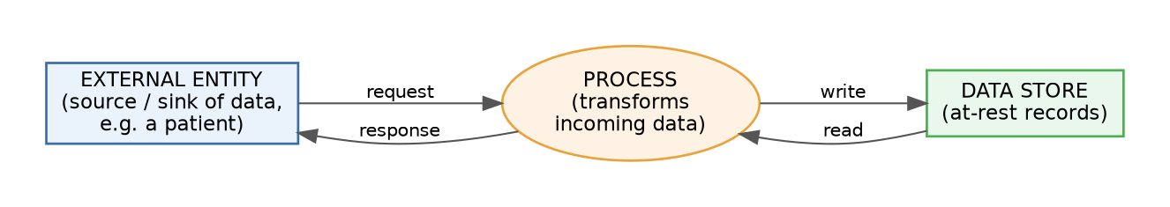
Figure 1. The four recurring symbol types used in a data flow diagram.

2.1 Context-Level View of the Platform
Figure 2 applies this notation to the Book A Doctor platform itself. Three external actors — the patient, the doctor, and the administrator — exchange requests and responses with a single central process representing the platform as a whole. That process, in turn, reads from and writes to four categories of persistent record: account data, appointment data, uploaded clinical documents, and outgoing notifications. Framing the diagram at this level keeps the emphasis on what crosses the system boundary, deferring the internal breakdown of the platform into individual services to the architecture specification.
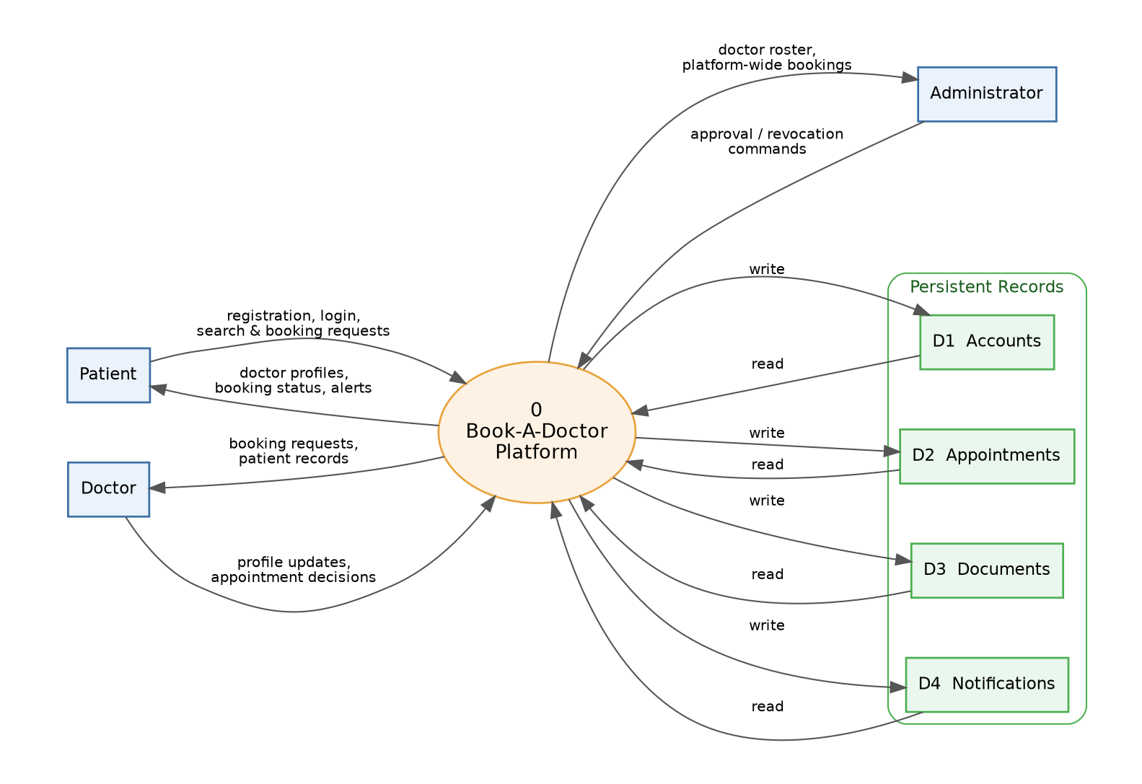
Figure 2. Context-level data flow diagram for the Book A Doctor platform.
Two observations follow directly from this view. First, the administrator's interaction is asymmetric: rather than generating bookings, the administrator issues governance commands that gate which doctors are visible to patients at all. Second, every patient- or doctor-initiated flow ultimately touches the appointments store, which makes that store the natural anchor for reasoning about consistency and concurrent access.

3. User Story Catalogue
Table 1 restates the platform's functionality as a set of independently deliverable user stories, grouped by the actor who benefits and the capability area they belong to. Each entry follows the familiar "As a ⟨role⟩, I want ⟨capability⟩, so that ⟨benefit⟩" phrasing and is paired with a concrete, checkable condition for calling the story finished, along with an indicative priority and sprint assignment.
Story ID | Actor | Capability Area | Narrative | Definition of Done | Priority | Sprint
US-01 | Patient | Account Creation | As a patient, I want to create an account with my name, e-mail, password, and phone number, so that I can access the booking platform. | Successful sign-up leads directly into an authenticated session. | High | Sprint 1
US-02 | Patient | Account Creation | As a patient, I want my session to remain authenticated after login, so that I don't have to re-enter my credentials on every request. | A session token is stored locally and sent with every subsequent API call. | High | Sprint 1
US-03 | Patient | Physician Discovery | As a patient, I want to search and filter doctors by name or specialization, so that I can quickly find a suitable physician. | The results list shows only doctors matching the filter, each with a brief profile summary. | High | Sprint 2
US-04 | Patient | Physician Discovery | As a patient, I want to open a doctor's complete profile, so that I can review their fee, qualifications, and open slots before booking. | The profile view loads consultation fee, credentials, and current availability. | High | Sprint 2
US-05 | Patient | Appointment Scheduling | As a patient, I want to reserve an open date and time slot with a doctor, so that I can secure a consultation. | A new appointment record is created with a 'pending' status and appears on my dashboard. | High | Sprint 3
US-06 | Patient | Clinical File Exchange | As a patient, I want to attach a report or prescription to my appointment, so that my doctor can review it beforehand. | The uploaded file is listed under the corresponding appointment's document section. | Medium | Sprint 3
US-07 | Patient | In-App Alerts | As a patient, I want to be alerted when my appointment is confirmed, declined, or completed, so that I stay informed without checking manually. | A corresponding alert is added to my notification list as soon as the status changes. | Medium | Sprint 4
US-08 | Doctor | Profile Management | As a doctor, I want to update my specialization, qualifications, fee, and availability, so that patients always see accurate information. | Edits are reflected immediately on my public-facing profile. | High | Sprint 2
US-09 | Doctor | Appointment Management | As a doctor, I want to view every appointment booked with me, so that I can plan my consultation schedule. | My dashboard lists all associated appointments together with the relevant patient details. | High | Sprint 3
US-10 | Doctor | Appointment Management | As a doctor, I want to confirm, decline, or complete an appointment and attach consultation notes, so that the record stays current. | The appointment status updates accordingly and the patient receives a notification. | High | Sprint 3
US-11 | Administrator | Doctor Governance | As an administrator, I want to review registered doctors and approve or revoke their accounts, so that only vetted physicians are bookable. | Only administrator-approved doctors appear as searchable and bookable to patients. | High | Sprint 4
US-12 | Administrator | Platform Oversight | As an administrator, I want to view every appointment across the platform, so that I can monitor overall system activity. | The administrator dashboard lists all appointments together with their current status. | Medium | Sprint 4

