

LUNAR IMAGE SIMULATION AND VISUALIZATION

Report submitted for completion of training

(Satellite Meteorology and Oceanography Research and Training)

Programme of Space Applications Centre

**Submitted by**

**HARSHALKUMAR SUNILKUMAR PATEL**

**(Registration No. RS02034)**

B.Tech. (Computer Science and Engineering)

**Under the guidance of**

**Sri. K.SURESH**

SCI/ENG – SG

PSPD/PMPG/SIPA

Space Applications Centre(SAC), ISRO Ahmedabad

**Institution**

**PARUL University**

Vadodara– 391760

Gujarat

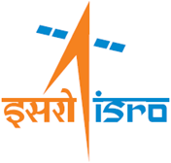

**SRTD-RTMG-MISA**

**S**pace **A**pplications **C**entre(SAC) , ISRO

Ahmedabad, Guajrat

09 December 2024 to 12 April 2025