Infosys Springboard Virtual Internship 6.0 Completion Report

Team Details
Mentor : SELCIYA
Batch Number : 13 ( Group – 2 ; Team - D)
Start date : 02-02-2026
Names:
- CHELIKANI HARSHAL
- SATBIR SINGH
- ARUN KUMAR
- N. AKHILA
- G. SRILAKSHMI
Internship Duration: 8 Weeks

1. Project Title
HotelRevAI - AI Driven Revenue Analysis for Hotels

2. Project Objective
The primary objective of this internship project is to design and develop an interactive, data-driven revenue analysis system for the hotel industry using Microsoft Power BI. The project, titled "HotelRevAI — AI Driven Revenue Analysis for Hotels", aims to transform raw hotel booking data into meaningful, actionable business insights through advanced data visualization techniques.
The specific objectives of this project are:
- To load, clean, and preprocess a real-world hotel booking dataset containing 1,17,430 records using Power Query Editor in Power BI
- To build calculated columns and DAX measures that compute key hospitality business metrics such as Revenue, Occupancy %, ADR, RevPAR, and Cancellation Rate
- To design and develop 5 fully interactive dashboards covering Revenue Performance, Occupancy Analysis, Guest Segmentation, Cancellation Forecasting, and Revenue Strategy
- To enable hotel General Managers and Revenue Managers to make faster, more informed decisions by consolidating all key metrics into a single, filterable reporting system
- To demonstrate how data visualization and business intelligence tools can replace manual reporting in the hospitality sector
This project is highly relevant to real-world hotel operations as it directly addresses the challenge of underutilized data in the hospitality industry — a sector that generates enormous volumes of transactional data but historically relies on static spreadsheet reports for decision making.

3. Project description in detail

Approach
The project was executed in a structured, phase-by-phase approach following the 4 milestones defined by the Infosys Springboard internship program. Each milestone built upon the previous one, progressing from raw data to a fully functional dashboard system.
Phase 1 — Orientation & Data Loading: The internship began with understanding the project scope and the hospitality domain. The dataset — hotel_booking_main.xlsx — was studied in detail to understand its structure, column definitions, and data quality. The file was then loaded into Microsoft Power BI Desktop using the Excel data connector, and the Transform Data option was selected to open it in Power Query Editor for preprocessing.
Phase 2 — Data Transformation & Modelling: The raw dataset required significant cleaning before it could be used for analysis. Column profiling was enabled to identify null values, data type errors, and irrelevant columns. Null values in the country, agent, company, and children columns were replaced with appropriate defaults. Six unnecessary columns were removed including personal data fields (email, phone) and fields not relevant to revenue analysis. Four custom calculated columns were created — total_nights, guest_type, season, and revenue — using Power Query M language formulas. After all transformations, the data was loaded into Power BI with 1,17,430 rows and 32 columns.
Phase 3 — DAX & Business Metrics: Thirteen DAX measures were created to calculate the key hotel performance indicators required for the dashboards. These included Total Revenue, Total Bookings, Cancellation Rate, Avg Daily Rate, Occupancy %, RevPAR, Avg Lead Time, Total Nights Stayed, Repeat Guest %, Avg Special Requests, Total Cancelled, No Show Count, and Revenue per Booking. All measures were formatted consistently with appropriate currency, percentage, or whole number formats to ensure uniform display across all dashboard cards.
Phase 4 — Visualization & Storytelling: Five fully interactive dashboards were designed and built in Power BI Report View, each targeting a specific aspect of hotel revenue management. Each dashboard contains KPI cards, multiple chart types, and cross-filtering slicers that allow managers to drill down into specific time periods, hotel types, seasons, and guest segments.

Technology Used
Technology | Purpose
Microsoft Power BI Desktop | Primary dashboard development tool
Power Query Editor | Data cleaning and transformation
DAX (Data Analysis Expressions) | Business metric calculations
Microsoft Excel (.xlsx) | Source data format
M Language | Custom column formulas in Power Query

Dashboards Built
Dashboard | Title | Key Visuals
1 | Revenue & Booking Performance | KPI cards, Revenue trend, Channel donut, Market segment bar, Occupancy by month
2 | Occupancy & Revenue Analysis | ADR vs RevPAR trend, Weekend vs Weekday, Revenue by Room Type, ADR by Room Type
3 | Guest Analysis & Segmentation | Map visual, Guest type donut, Lead time by guest, Top 10 countries, Meal plan donut
4 | Cancellation & Forecasting Trends | Cancellation by month, Lead time histogram, Forecast line, Deposit type analysis
5 | Revenue Strategy & Pricing Insights | ADR by room & season, Revenue by segment, Country revenue, Meal plan revenue

Real World Impact
In real-world hotel operations, this dashboard system would directly replace manual Excel-based reporting, saving revenue managers several hours of report preparation every week. The interactive nature of the dashboards allows hotel GMs to instantly answer critical business questions such as:
- Which months have the highest cancellation rates and why?
- Which room types and seasons generate the highest ADR?
- Which countries send the most valuable guests?
- How does City Hotel performance compare to Resort Hotel?
- What is the forecasted booking trend for the next 30 days?
By having all this information consolidated in one interactive system, hotels can respond faster to market changes, optimize pricing dynamically, and reduce revenue leakage from high cancellation rates.

4. Timeline Overview
Week | Activities Planned | Activities Completed
Week 1 | Understanding project scope and dataset | Studied hotel_booking_main.xlsx, explored all 36 columns and 1,19,390 rows
Week 2 | Data loading and preprocessing | Loaded data into Power BI, handled null values in country, agent and company columns, removed unnecessary columns
Week 3 | Data transformation and custom columns | Created total_nights, guest_type, season and revenue custom columns using Power Query M language
Week 4 | KPI development using DAX | Created 13 DAX measures including Total Revenue, ADR, Occupancy %, RevPAR, Cancellation Rate and Revenue per Booking
Week 5 | Dashboard 1 and Dashboard 2 creation | Built Revenue & Booking Performance and Occupancy & Revenue Analysis dashboards with KPI cards, charts and slicers
Week 6 | Dashboard 3 and Dashboard 4 creation | Built Guest Analysis & Segmentation and Cancellation & Forecasting Trends dashboards including map visual and forecast line
Week 7 | Dashboard 5 and insights | Built Revenue Strategy & Pricing Insights dashboard, derived key business insights across all 5 dashboards
Week 8 | Final documentation and completion report | Completed all 4 milestone documents, Completion Report, and final dashboard review

5a. Key Milestones
Milestone | Description | Date Achieved
Project Kickoff | Orientation session, project scope defined, dataset received and studied. | 05-02-2026
Prototype/First Draft | Data loaded into Power BI, Power Query cleaning completed, custom columns created. | 11-02-2026
Mid-Term Review | All 13 DAX measures created, first 2 dashboards built and reviewed with mentor. | 20-02-2026
Final Submission | All 5 dashboards completed, formatted, and tested with cross-filtering. | 13-02-2026
Presentation | Project presented to mentor with dashboard walkthrough. | 24-02-2026

5b. Project execution details
The HotelRevAI project was executed over 8 weeks following a structured milestone-based approach under the guidance of mentor Selciya as part of Infosys Springboard Virtual Internship 6.0, Batch 13.
Week 1-2 — Orientation & Data Understanding: The first two weeks were dedicated to understanding the internship structure, the project requirements, and the hospitality domain. The hotel_booking_main.xlsx dataset was studied in detail. Each of the 36 columns was examined to understand what data it contains and how it could be used for revenue analysis. Microsoft Power BI Desktop was set up and the data was loaded using the Excel connector.
Week 3-4 — Data Cleaning & Transformation: Power Query Editor was used extensively during this phase. Column profiling was enabled to identify data quality issues across all 1,19,390 rows. Null values were identified in country (< 1%), agent (14%), and company (94%) columns and replaced with appropriate default values. Six unnecessary columns were removed. Four custom columns — total_nights, guest_type, season, and revenue — were created using M language formulas. Data types were corrected for all columns and rows with adr = 0 were filtered out. The final clean dataset contained 1,17,430 rows and 32 columns.
Week 5 — DAX Measures & Business Metrics: Thirteen DAX measures were created covering all key hotel KPIs. Special attention was given to percentage measures (Cancellation Rate, Occupancy %, Repeat Guest %) to ensure they were formatted correctly without the double-multiplication error. All measures were formatted with consistent currency ($), percentage (%), or whole number formats and tested on card visuals to verify correct output.
Week 6-7 — Dashboard Development: All 5 dashboards were built in Power BI Report View. Each dashboard was designed with a distinct color-coded title bar, a row of KPI cards at the top, multiple analytical charts in the body, and interactive slicers at the bottom. The dark purple theme was applied across all pages for visual consistency. Cross-filtering was tested on each page to ensure all visuals responded correctly to slicer selections.
Week 8 — Review & Documentation: The final week was used for reviewing all dashboards, fixing formatting issues (display units, percentage formatting), and completing the milestone documentation. All 4 milestone documents were prepared covering Orientation & Data Loading, Data Transformation & Modelling, DAX & Business Metrics, and Visualization & Storytelling.

6. Snapshots / Screenshots

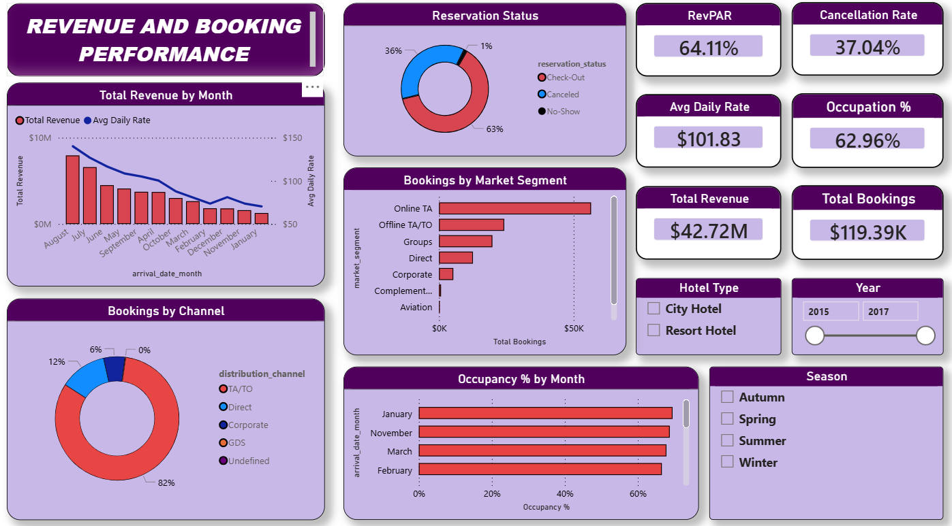

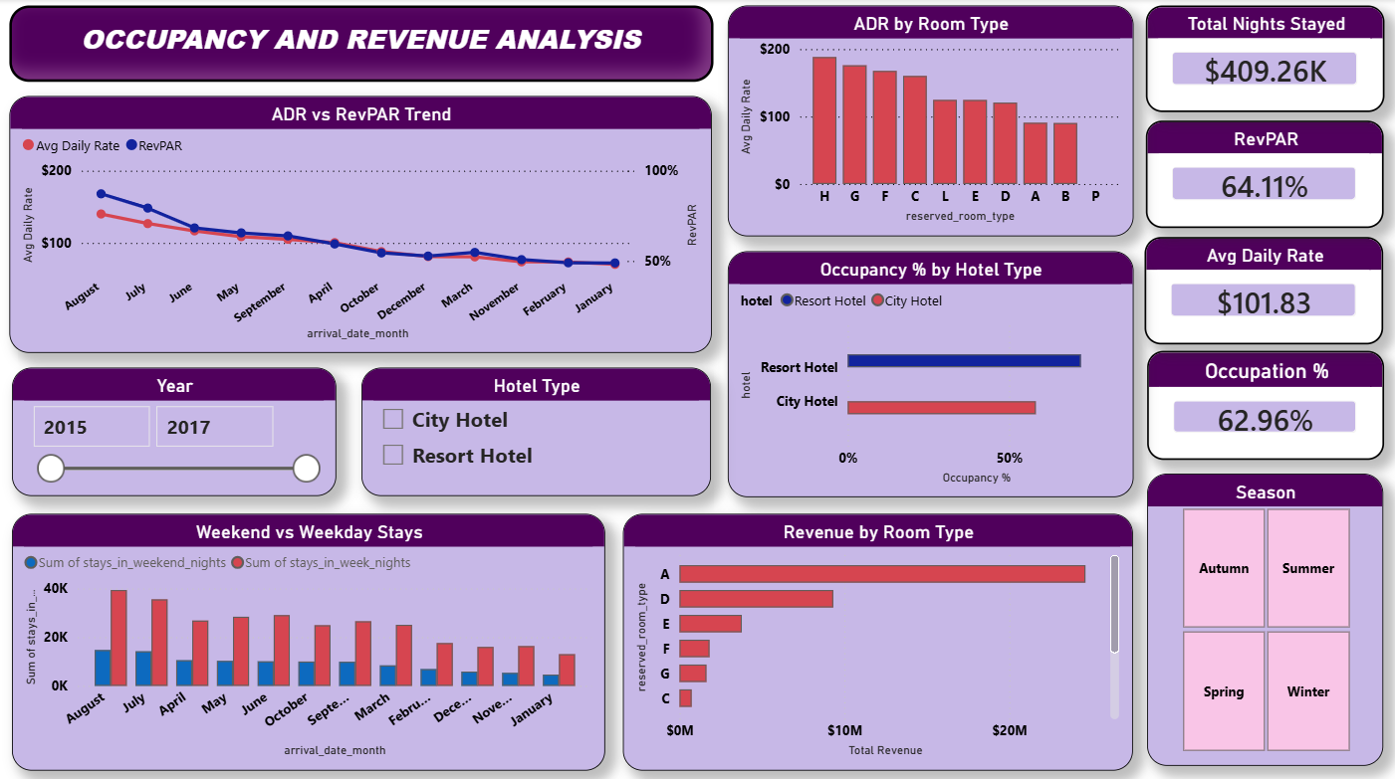

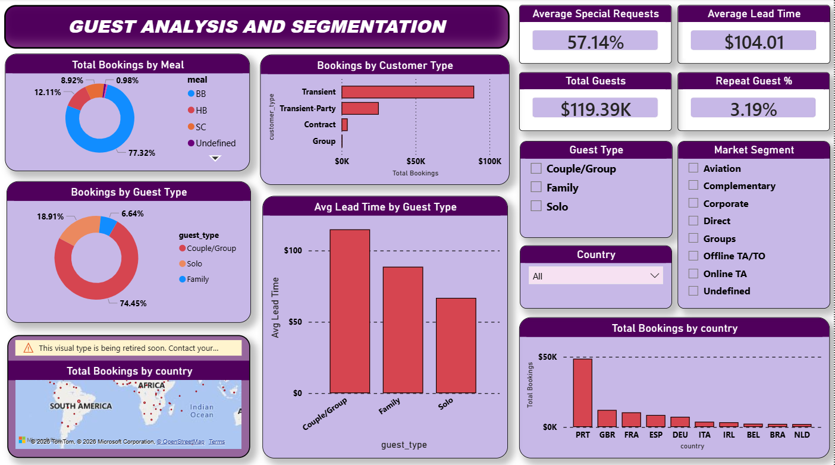

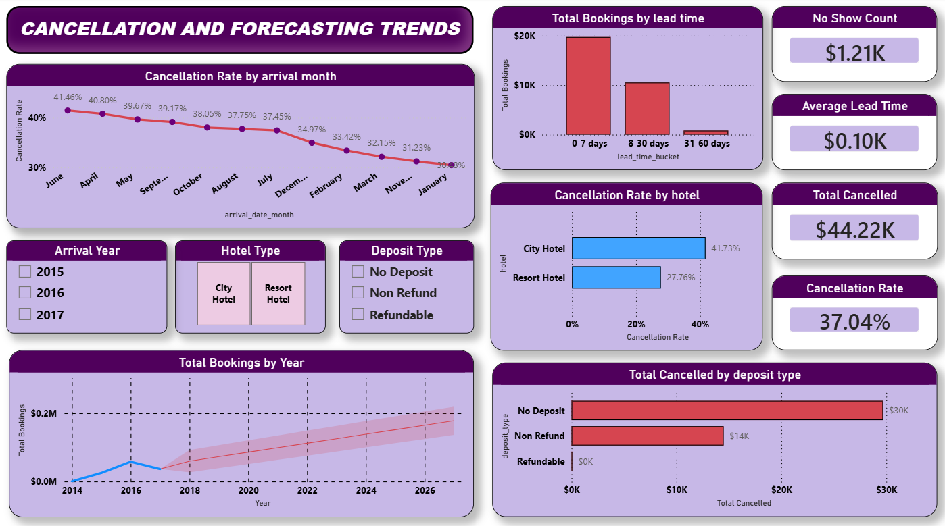

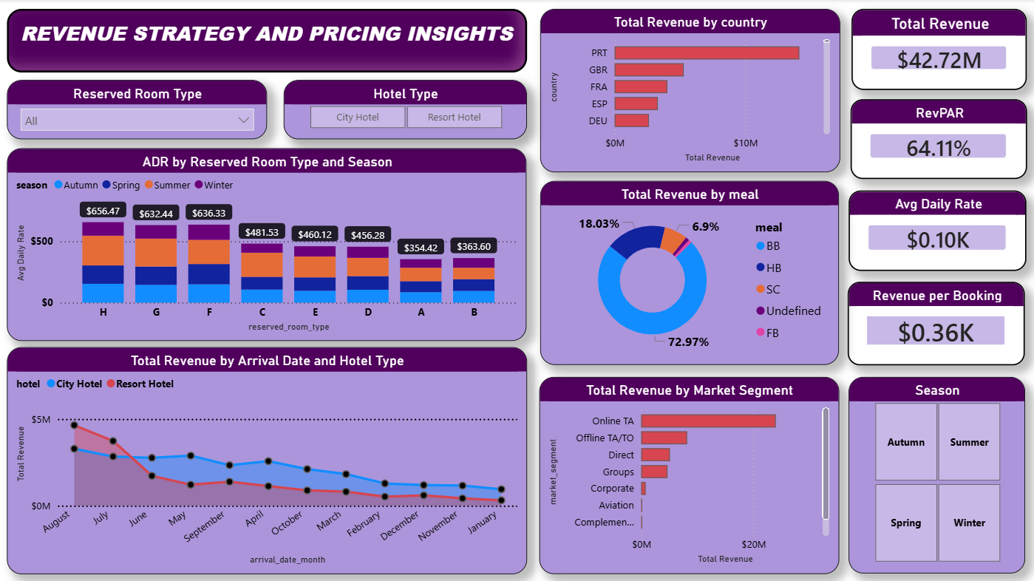

7. Challenges Faced
Challenge 1 — Null Value Replacement in Numeric Columns When attempting to replace null values in the agent and company columns (both numeric type), the Replace Values dialog box would not enable the OK button. This was because Power BI requires a numeric replacement value for numeric columns and shows a type mismatch warning when the field is left empty. The issue was resolved by identifying that the columns were Whole Number type and providing 0 as the replacement value instead of leaving it blank or using text.
Challenge 2 — guest_type Formula Crash The custom guest_type column formula initially crashed with the error: "We cannot convert the value null to type Logical." This occurred because some rows had null values in the children column, and the formula attempted to compare null with a number. The issue was resolved by using the null-coalescing operator ?? 0 in the formula, which instructs Power Query to treat any null value as 0 before performing the comparison.
Challenge 3 — Duplicate Removal Reducing Data to 15 Rows When the Remove Duplicates step was applied, the row count dropped from 1,19,390 to only 15 rows. Investigation revealed that this dataset contains many legitimate bookings with identical values across most columns (same hotel, same dates, same room type, same price) that are real separate bookings, not true duplicates. Since the dataset has no unique booking ID column, Power BI treated all identical-looking rows as duplicates. The Remove Duplicates step was skipped to preserve all valid records.
Challenge 4 — KPI Cards Showing Incorrect Values (K format for percentages) Several KPI cards were displaying percentage values in thousands format — for example, Cancellation Rate showed "0.04K" instead of "37.04%". This was caused by Power BI's automatic Display Units setting being set to "Auto", which converted percentage decimal values to the K (thousands) format. The issue was resolved by manually setting Display Units to "None" on each card visual's Callout Value formatting options.
Challenge 5 — Double Multiplication Error on Percentage Measures When percentage measures were formatted using the Measure Tools percentage format, values like Cancellation Rate displayed as "3704.16%" instead of "37.04%". This occurred because the original DAX formula multiplied by 100 (DIVIDE(...) * 100), and then applying the percentage format multiplied by 100 again. The fix was to remove the * 100 from all percentage DAX formulas and rely entirely on the Measure Tools percentage format for the multiplication.
Challenge 6 — ADR vs RevPAR Chart Showing Incorrect Trend Direction The ADR vs RevPAR line chart showed a continuously declining trend because Power BI was sorting months alphabetically (April, August, December...) instead of chronologically (January, February, March...). The issue was resolved by changing the sort order of the chart to sort by arrival_date_month in chronological order.

8. Learnings & Skills Acquired

Technical Skills
Microsoft Power BI Desktop: Gained comprehensive hands-on experience with Power BI including data loading, Power Query transformation, DAX measure creation, report design, visual formatting, and cross-filtering configuration. Progressed from a complete beginner to building 5 professional-grade interactive dashboards.
Power Query & M Language: Learned how to use Power Query Editor for real-world data cleaning tasks including null handling, column removal, data type correction, and custom column creation using M language formulas including conditional logic and null-coalescing operators.
DAX (Data Analysis Expressions): Learned and implemented 13 DAX measures using functions including SUM, AVERAGE, COUNTROWS, FILTER, and DIVIDE. Understood the critical difference between measures and calculated columns, and the importance of filter context in DAX calculations.
Data Visualization Principles: Learned best practices for dashboard design including visual hierarchy, color consistency, KPI card formatting, chart selection based on data type, slicer placement, and storytelling through data.

Domain Knowledge
Hotel Revenue Management: Gained a strong understanding of the hospitality industry's key performance indicators — ADR, RevPAR, Occupancy %, Cancellation Rate, and Lead Time. Understood how these metrics are interconnected and how hotel managers use them for pricing and operational decisions.
Business Intelligence Concepts: Understood the concepts of Star Schema data modelling, flat table vs relational data structures, and how BI tools transform raw transactional data into executive-level insights.

Soft Skills
- Problem solving — Independently researched and resolved multiple technical errors encountered during the project
- Documentation — Developed structured technical documentation across 4 milestone reports
- Attention to detail — Ensured consistent formatting, correct metric calculations, and accurate visual representations across all 5 dashboards
- Time management — Completed all 4 milestones and 5 dashboards within the 8-week internship schedule

9. Testimonials from team
"The HotelRevAI project was a transformative experience for me. Building 5 interactive dashboards from scratch using Power BI — starting from raw data cleaning all the way to DAX measures and visual storytelling — gave me a complete picture of what real-world data analytics looks like. The structured milestone approach ensured that every concept was properly understood before moving to the next phase. This internship has genuinely strengthened my confidence in working with large datasets and business intelligence tools.”
- CHELIKANI HARSHAL

"This internship gave me my first real exposure to Microsoft Power BI and the world of business intelligence. Working on hotel revenue data taught me how even a single dataset can answer dozens of complex business questions when approached with the right tools and methodology. The DAX section was particularly insightful — understanding how measures dynamically respond to filters completely changed the way I think about data analysis."
- SATBIR SINGH

"Contributing to the HotelRevAI project was a rewarding experience that helped me bridge the gap between theoretical knowledge and practical application. The data preprocessing phase using Power Query was especially valuable — learning how to handle nulls, fix data types, and engineer new features like guest_type and season taught me that data preparation is just as important as the final visualization. I leave this internship with a much stronger foundation in data analytics."
- ARUN KUMAR

"Working on this project gave me a deep appreciation for data-driven decision making in the hospitality industry. I was particularly fascinated by how key metrics like RevPAR and ADR tell a complete story about a hotel's pricing performance when visualized correctly. Power BI's cross-filtering capability was a revelation — the ability to click one slicer and watch all charts update instantly shows the true power of interactive business intelligence."
- N. AKHILA

"The Infosys Springboard internship gave me hands-on experience that no classroom could replicate. Working with a real hotel booking dataset of over 1 lakh records made the project feel genuinely impactful. The most valuable lesson I take away is understanding the full data analytics pipeline — from raw Excel data to a polished, interactive dashboard that a hotel GM could use to make real business decisions on a daily basis. This experience has been a significant step forward in my data analytics journey."
- G. SRILAKSHMI

10. Conclusion
The HotelRevAI internship project successfully demonstrated how data visualization and business intelligence tools can transform raw hotel booking data into strategic, actionable insights for hotel management.
Over the course of 8 weeks, the project progressed through four structured milestones — from understanding the dataset and cleaning it in Power Query, to creating 13 DAX business metrics, and finally building 5 fully interactive Power BI dashboards. The final deliverable is a comprehensive revenue analysis system that covers every critical dimension of hotel performance — booking trends, occupancy patterns, guest segmentation, cancellation analysis, and pricing strategy.
The project conclusively proved that even a single flat-table dataset of 1,17,430 records can be transformed into an executive-level decision support system when combined with the right data transformation techniques, business metric calculations, and visualization design.
From an academic perspective, this internship provided invaluable practical experience that directly complements the theoretical concepts studied in the areas of data analytics, business intelligence, and machine learning applications. The skills acquired in Power BI, DAX, and data storytelling are directly applicable to industry roles in data analytics, business intelligence, and revenue management.
This project has laid a strong foundation for pursuing a career in data analytics and has demonstrated the real-world value of turning data into decisions.

11. Acknowledgements
We would like to express my sincere gratitude to Infosys Springboard for providing this Virtual Internship 6.0 opportunity and for designing such a well-structured, milestone-based learning program that bridges the gap between academic learning and industry practice.
We extend our heartfelt thanks to our mentor Selciya for her continuous guidance, timely feedback, and encouragement throughout the 8-week internship. Her support was instrumental in helping us navigate challenges and deliver a complete, professional-grade project.

