A
DSBDA Mini Project Report submitted to Savitribai Phule Pune University, Pune

Stock Analyzer


In partial Fulfillment for the awards of Degree of Engineering in Computer Engineering
Submitted by

Mr. Tanmay Kulkarni (T1902404335)

Mr. Harshal Gosavi (T1902404291)

Mr. Amey Mahajani (T1902404346)

Under the Guidance of

Prof. Rubi Mandal

Department of Computer Engineering

2024-25



Certificate

This is to certify that,

Mr. Tanmay Kulkarni (T1902404335)

Mr. Amey Mahajani (T1902404346)

Mr. Harshal Gosavi (T1902404291)

have successfully completed the Mini project entitled “Stock Analyzer” under my guidance in partial fulfillment of the requirements for the Third Year of Engineering in Computer Engineering under the Savitribai Phule Pune University during the academic year 2024-2025.

Date: ………………. Place: ……………….

Prof. Rubi Mandal
Dr. Vinod Kimbahune
Project Guide HOD

Dr. Nitin Sherje Principal

Acknowledgement

With a deep sense of gratitude, we would like to thank all those who have lit our path with their kind guidance and support throughout the course of this project. We are sincerely grateful to the individuals who have extended their valuable time, effort, and expertise to help us in completing our work.
It is our proud privilege to express heartfelt thanks to Dr. Nitin Sherje, Principal of our institute, for his constant encouragement and kind permission to carry out this project. We remain deeply indebted to Dr. Vinod Kimbahune, Head of the Computer Engineering Department, for his timely suggestions, motivation, and valuable insights that guided our efforts in the right direction.
A special word of gratitude goes to our project guide, Prof. Rubi Mandal, for her excellent mentorship and precious guidance throughout the project. Her encouragement and support were instrumental in completing this work successfully.We also wish to thank our colleagues for their consistent help and motivation during the project. We are grateful to the various industry professionals and lab technicians whose technical support played an important role in the implementation of our system.
Our heartfelt thanks extend to our parents, whose unwavering support and encouragement have been the backbone of our academic journey.
Finally, we would like to express our sincere appreciation to all our friends and every individual who directly or indirectly contributed to the successful completion of this project.

Mr. Tanmay Kulkarni
Mr. Amey Mahajani
Mr. Harshal Gosavi

Abstract

Stock Analyzer is a Python-based data analysis project designed to help users understand and visualize stock performance through historical data. Using Coca-Cola (Ticker: KO) as a case study, the project demonstrates how to fetch real-time stock data, process it, and generate insightful visualizations using powerful Python libraries like yfinance, pandas, matplotlib, and seaborn.
The project aims to equip users—especially students and beginner investors—with hands-on experience in stock market analysis through coding. It includes features like data preprocessing, calculation of moving averages, and trend analysis, which are essential tools for understanding market behavior.
By automating data collection and analysis, Stock Analyzer reduces the complexity of manual analysis and allows users to make informed decisions based on visual and statistical evidence. This project serves as a foundational tool for further development in financial modeling and machine learning-based prediction systems.

Table of Contents

Abstract
Table of Contents List of Abbreviations List of Figures
List of Tables 1 Introduction
  - Overview
  - Aim/Motivation
  - Objective
  - Organization of Report
- Literature Survey
- Problem Statement
- Software Requirements Specification
  - Hardware Requirements
  - Software Requirements
- System Design
  - Project Block Diagram
- Conclusion and Future Scope
References

List of Abbreviations

Sr. No. | Abbreviation | Full Form
1 | CSV | Comma Separated Values
2 | API | Application Programming Interface
3 | OHLC | Open-High-Low-Close (Stock Price Data)
4 | EDA | Exploratory Data Analysis
5 | NYSE | New York Stock Exchange

List of Figures
Figure 1 The General layout of the system 15

Chapter 1 Introduction

Overview

The Stock Analyzer project is a Python-based application designed to perform analysis on stock market data. It helps users visualize and interpret stock trends by fetching historical stock prices and generating informative charts and metrics. This project uses Coca-Cola (KO) as a reference stock to demonstrate how real-time data can be extracted and analyzed efficiently.
By leveraging libraries such as yfinance, pandas, matplotlib, and seaborn, the application provides key insights such as moving averages, daily returns, and performance trends over specific time intervals. These insights assist users—especially beginners and students—in understanding financial data and improving their data analysis skills.
The project bridges the gap between raw financial data and practical decision-making by converting complex datasets into easy-to-understand visual formats. It can be extended further to support additional stocks, predictive modeling, and personalized portfolio analysis.

  - Aim/Motivation
The primary aim of the Stock Analyzer project is to create a simple yet effective tool that allows users to analyze and visualize stock market data using Python. The motivation behind this project stems from the growing interest in financial markets and the increasing need for tools that can simplify complex data for better understanding and decision-making.
With the rise of data-driven investing and financial literacy, many individuals—including students, researchers, and beginner investors—seek accessible platforms for stock analysis. Traditional financial tools can often be overwhelming or expensive. This project addresses that gap by providing an open-source, educational, and customizable solution.
By using real-time stock data (e.g., Coca-Cola), the project encourages hands-on learning of concepts like moving averages, price trends, and returns. It also introduces users to core Python libraries and data analysis techniques that are widely applicable in finance and data science fields.

  - Objective
The main objectives of the Stock Analyzer project are:
- To develop a Python-based tool that can fetch and analyze real-time and historical stock market data.
- To visualize stock performance using line plots, moving averages, and return analysis.
- To simplify complex financial data for educational and analytical purposes.
- To demonstrate the use of Python libraries such as yfinance, pandas, matplotlib, and seaborn for financial data analysis.
- To provide a case study on Coca-Cola (KO) stock, serving as a practical example for learners and finance enthusiasts.
- To create a foundation that can be extended for portfolio analysis, predictive modeling, or integration with other financial APIs.

1.4 Organization of Report
This report is organized into the following chapters to provide a systematic understanding of the Stock Analyzer project:
- Chapter 1: Introduction
Provides an overview of the project, including its aim, motivation, and objectives.
- Chapter 2: Literature Survey
Discusses existing tools, research, and technologies related to stock market analysis and how this project differentiates itself.
- Chapter 3: System Analysis
Covers the problem definition, feasibility study, and system requirements.
- Chapter 4: System Design
Describes the system architecture, data flow diagrams, and design considerations used in the development of the project.
- Chapter 5: Implementation
Explains the implementation details, tools, technologies used, and code logic with snapshots.
- Chapter 6: Results and Discussion
Presents the output of the system, sample visualizations, and interpretation of results.
- Chapter 7: Conclusion and Future Scope
Summarizes the project achievements and highlights potential enhancements for future development.
- References
Lists the sources, libraries, and documentation referred to during the development of the project.

Chapter 2
Literature Survey

2.1 Literature Survey Table:

Tool/Platform | Features | Limitations

Stock Analyzer (Proposed) | Real-time stock data fetching, stock price prediction using machine learning, interactive charts (moving averages, RSI, etc.), historical data analysis | Requires internet connection for real-time data; accuracy of predictions depends on the model used; complex data processing could be slow for large datasets

yfinance | Fetches historical stock data from Yahoo Finance, easy to use in Python, supports real-time data | Limited to Yahoo Finance data; data may not always be accurate or real-time

Pandas | Data manipulation and analysis, supports time-series data, easy integration with other Python libraries | Performance could degrade with very large datasets; requires additional libraries for advanced charting

Matplotlib & Seaborn | Customizable data visualization, supports stock price charts, moving averages, and other financial plots | Not specifically designed for stock data; may require customization to generate financial charts

NumPy & SciPy | Numerical and statistical analysis, regression modeling, and moving averages | May require significant coding effort for complex analysis; limited visualization capabilities

Scikit-learn | Provides machine learning algorithms for stock price prediction, like regression and classification | Model accuracy is highly dependent on data quality; needs fine-tuning for better predictions in volatile markets

Plotly/Dash | Interactive stock data visualizations, dashboards, real-time chart updates | More complex to set up than static visualizations, may require more resources for real-time updates

Chapter 3 Problem Statement
With the growing complexity of the financial markets, predicting stock prices and analyzing their movements has become crucial for investors, traders, and analysts. Traditional methods of stock analysis, such as fundamental and technical analysis, often fall short in providing real-time insights and predictive accuracy.
The Stock Analyzer tool aims to bridge this gap by leveraging real-time data and advanced machine learning algorithms to predict stock trends, analyze historical data, and provide insights into price movements. This tool will allow users to track the stock prices, generate predictive models, and visualize stock data using various charts and indicators like moving averages, Relative Strength Index (RSI), and more.
The project aims to:
- Fetch real-time stock market data and historical stock prices.
- Use machine learning models to predict future stock prices based on historical data and market trends.
- Provide an intuitive, interactive dashboard for visualizing stock price movements, indicators, and trends.
- Support users with actionable insights derived from the analysis, aiding better decision-making in trading and investment.
Key Features:
- Real-time stock data fetching.
- Price prediction using machine learning techniques.
- Historical data analysis.
- Visualization of stock trends using moving averages, RSI, and other technical indicators.
- An interactive, user-friendly dashboard.
Challenges:
- Ensuring real-time data accuracy.
- Selecting and fine-tuning appropriate machine learning models for stock price prediction.
- Handling large datasets and optimizing performance for faster analysis.
By developing this tool, the aim is to make stock analysis more accessible, accurate, and actionable for users, particularly in educational settings where hands-on learning of stock analysis is crucial.

Chapter 4
Software Requirements Specification

4.1 Software & Tools Used
Tool/Library | Purpose
Python | Core programming language
yfinance | Fetching real-time and historical stock data
Pandas, NumPy | Data handling and numerical analysis
Matplotlib, Seaborn | Visualization of stock data
Scikit-learn | Implementing machine learning models for prediction
Streamlit / Dash | Web interface/dashboard

Chapter 5
System Design and Result

  - Project Block Diagram
Project Block Diagram Description for each component:
- User Interface (UI) allows users to input stock symbols, select date ranges, and view visualized analysis and predictions.
- Request Handler processes user input and forwards requests to the backend for data retrieval and prediction.
- Data Fetcher (API) retrieves real-time and historical stock data from external sources like Yahoo Finance.
- Data Preprocessing cleans, filters, and structures the raw data for analysis and machine learning.
- ML Prediction Module applies machine learning algorithms to forecast future stock prices based on historical trends.
- Visualization Engine generates interactive charts and graphs such as candlesticks, line charts, moving averages, and RSI.
- Output Renderer sends the processed data and visualizations back to the UI for display to the user.

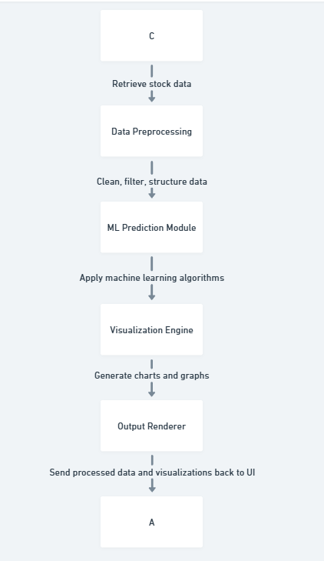

  - GUI of Working System

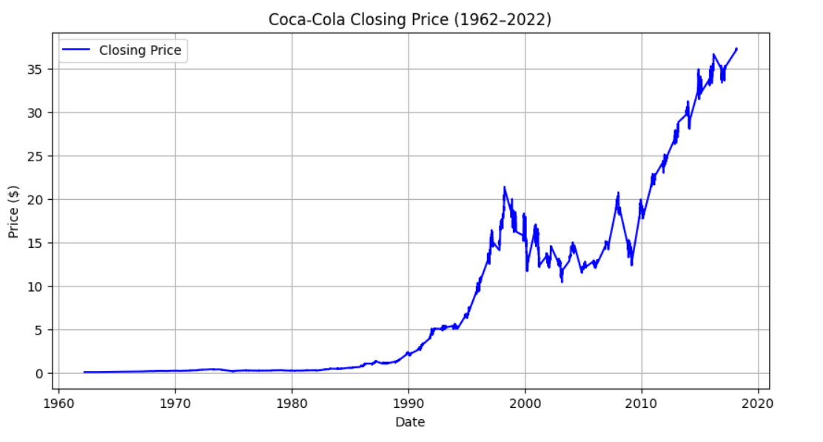

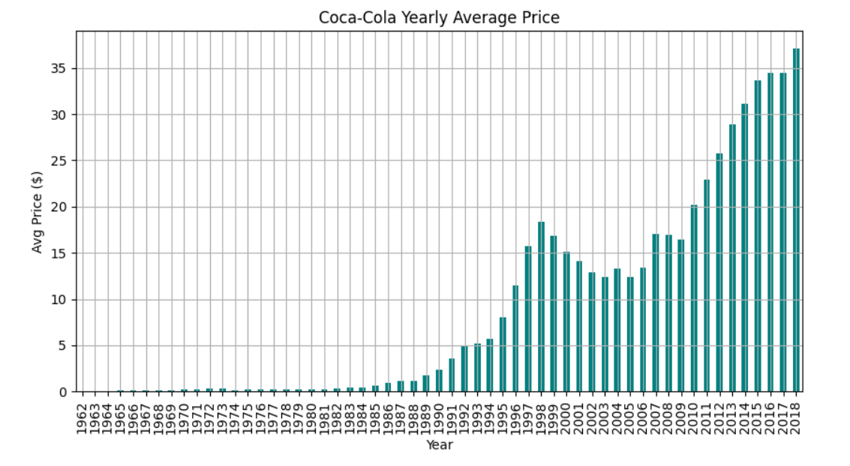

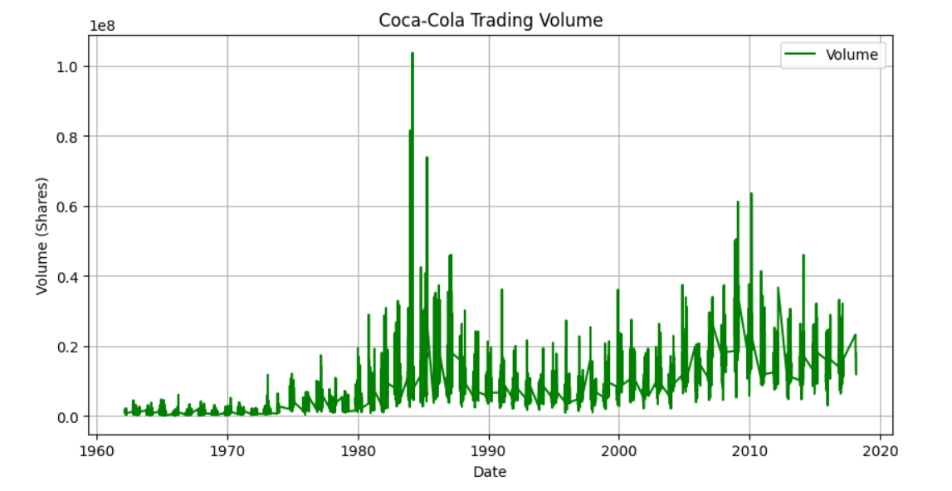

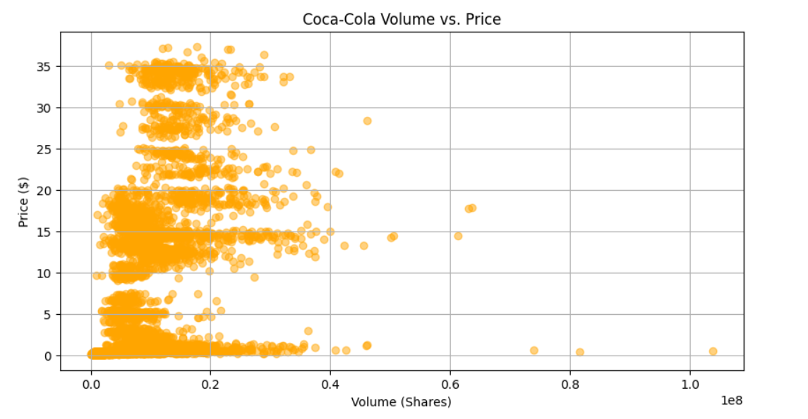

Chapter 6
Conclusion and Future Scope

6.1 Conclusion
The Stock Analyzer project successfully integrates data fetching, preprocessing, machine learning, and visualization to provide users with insightful analysis of stock market trends. It serves as a practical tool for investors and financial enthusiasts to track and predict stock performance based on historical data and technical indicators. The web-based interface ensures accessibility and ease of use, making it a helpful assistant for informed decision-making.

6.2 Future Scope
- Portfolio Tracking: Enable users to add and monitor their own investment portfolios within the tool.
- News Sentiment Analysis: Integrate real-time financial news feeds and analyze sentiment to correlate with stock trends.
- Mobile App Version: Develop a mobile application for better accessibility and user engagement.
- Multilingual Support: Add support for multiple languages to cater to a global audience.
- Advanced ML Models: Incorporate deep learning models like LSTM for more accurate time-series predictions.
- Global Market Support: Extend functionality to support international stock exchanges beyond the default (e.g., NYSE, NASDAQ).
- Real-Time Alerts: Implement SMS/email notifications for price alerts and market changes.

References

- Yahoo Finance API / yfinance library
https://pypi.org/project/yfinance/
Used for fetching historical and real-time stock market data.
- Pandas Documentation
https://pandas.pydata.org/docs/
Used for data manipulation and preprocessing tasks.
- Matplotlib & Plotly Documentation
https://matplotlib.org/
https://plotly.com/python/
Used for creating interactive and static visualizations of stock data.
- Scikit-learn Documentation
https://scikit-learn.org/stable/documentation.html
Used for implementing machine learning algorithms for stock prediction.
- Dash by Plotly
https://dash.plotly.com/
Used to build the web-based user interface for visualization and interaction.
- Medium & Towards Data Science Blogs
Articles and tutorials on stock price prediction, technical indicators, and data visualization best practices.
- Stack Overflow
https://stackoverflow.com/
Helped in resolving programming issues and optimizing Python scripts.
- Investopedia
https://www.investopedia.com/
Used for understanding stock market concepts, indicators, and investment strategies.

