practical 5

Harshal Maratthe

2023-09-15

#install.packages("ggplot2")  
#install.packages("plotly")  
library("ggplot2")

## Warning: package 'ggplot2' was built under R version 4.2.3

library("plotly")

## Warning: package 'plotly' was built under R version 4.2.3

##   
## Attaching package: 'plotly'

## The following object is masked from 'package:ggplot2':  
##   
## last_plot

## The following object is masked from 'package:stats':  
##   
## filter

## The following object is masked from 'package:graphics':  
##   
## layout

#install.packages("webshot2")

#Q1

#View(iris)  
#Q1Use the iris dataset to create a scatter plot between Sepal.Length and Sepal.Width  
  
#ggplot()  
ggplot(data=iris)+  
 geom_point(mapping=aes(x=Sepal.Length,y=Sepal.Width))+  
 labs(title = "Scatter Plot betwn Sepal length and sepal width",x="Sepal Length",y="Sepal Width")

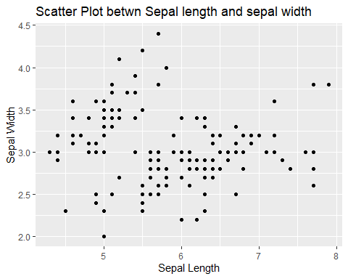

#or  
ggplot(data=iris,mapping=aes(x=Sepal.Length,y=Sepal.Width))+  
 geom_point()

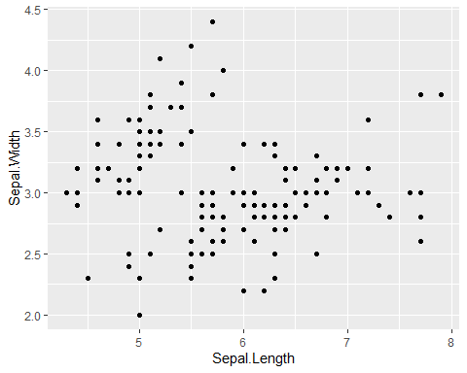

#or  
ggplot(data=iris,aes(x=Sepal.Length,y=Sepal.Width))+  
 geom_point()



#plotly()  
plot_ly(data=iris,x=~Sepal.Length,y=~Sepal.Width,type="scatter",mode="markers",color = ~Species)%>% layout(title="Scatter Plot betwn Sepal length and sepal width",xaxis=list(title="Sepal Length"),yaxis=list(title="Sepal Width"))

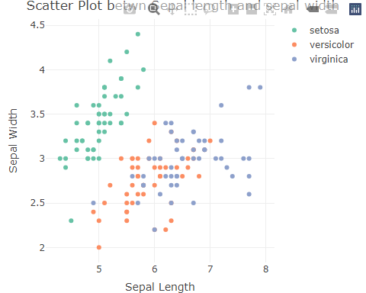 #Q2

#Q2Create a bar chart using the diamonds dataset, displaying the cut variable with respect to clarity.  
  
#View(diamonds)  
ggplot(data=diamonds)+  
 geom_bar(mapping=aes(x=cut,fill=clarity))+  
 labs(title = "Bar chart of cut variable w.r.t clarity",x="Cut",y="Clarity")

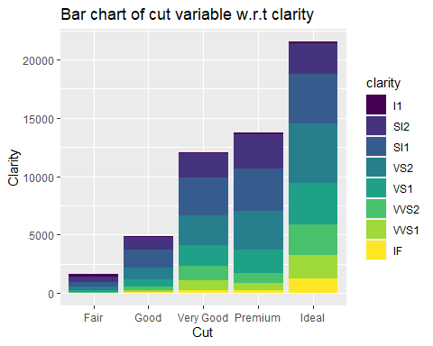

ggplot(data=diamonds,aes(x=cut,fill=clarity))+  
 geom_bar(position="dodge")

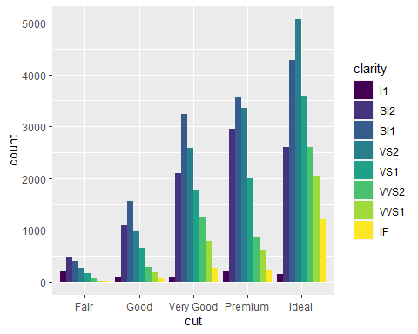

plot_ly(data=diamonds,x=~cut,y=~clarity,type="bar",color = ~clarity)%>% layout(title="Bar chart of cut variable w.r.t clarity",xaxis=list(title="Cut"),yaxis=list(title="Clarity"))

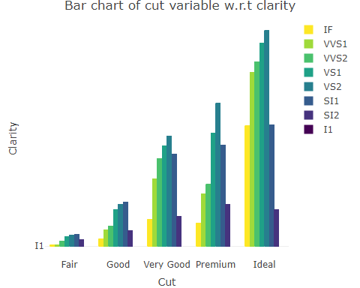 #Q3

#Q3Generate a line chart using the economics dataset to visualize the relationship between the date variable and the unemploy variable  
#View(economics)  
ggplot(data=economics)+  
 geom_line(mapping=aes(x=date,y=unemploy))+  
 labs(title = "line chart betwn date and unemploy",x="Date",y="Unemployment")

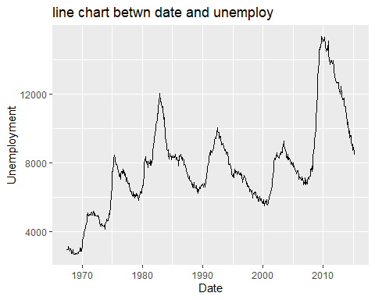

plot_ly(data=economics,x=~date,y=~unemploy,type="scatter",mode="line") %>% layout(title="line chart betwn date and unemploy",xaxis=list(title="Date"),yaxis=list(title="Unemployment"))

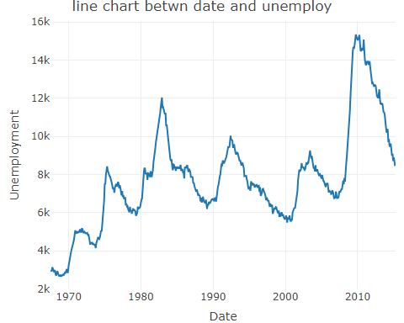 #Q4 = =

#Q4Produce a box plot using the mpg dataset to show the distribution of the hwy variable across different vehicle classes (class)  
#View(mpg)  
ggplot(data=mpg)+  
 geom_boxplot(mapping = aes(x=reorder(class,hwy,FUN=median),y=hwy))+  
 labs(title = "Boxplot of hwy variable across different classes",x="Classes of vehicle",y="highway per gallon")

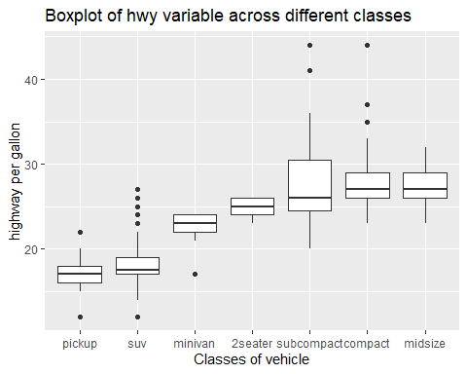

plot_ly(data=mpg,x=~class,y=~hwy,type="box",color=~class) %>% layout(title="Boxplot of hwy variable across different classes",xaxis=list(title="Classes of vehicle"),yaxis=list(title="highway per gallon"))

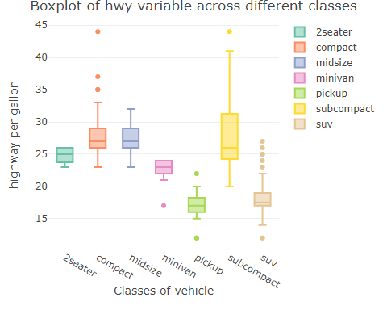

#Q5

#Q5Use the mtcars dataset to create a histogram of mpg values.  
#View(mtcars)  
ggplot(data=mtcars)+  
 geom_histogram(mapping = aes(mpg),binwidth = 5)+  
 labs(title = "Histogram of mpg variable",x="miles per gallon",y="frequency")

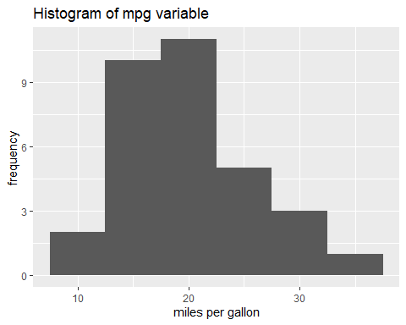

plot_ly(data=mtcars,x=~mpg,type = "histogram",color = I("black")) %>% layout(title="Histogram of mpg variable",xaxis=list(title="Miles per Gallon"),yaxis=list(title="Frequency"))

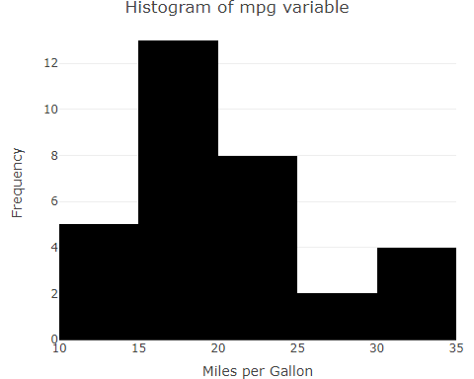

#OR  
  
plot_ly(data=mtcars,x=~mpg,type = "histogram",marker =list(color=c("RED","BLACK","PINK","BLUE","GREY"),size=5))%>% layout(title="Histogram of mpg variable",xaxis=list(title="Miles per Gallon"),yaxis=list(title="Frequency"))

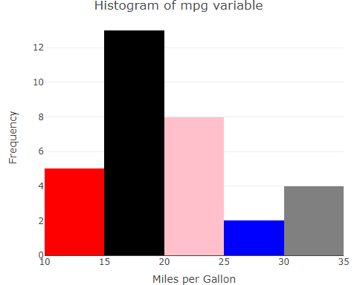 #Q6

#Q6Using the ChickWeight dataset, draw a line chart to show the weight gain over time for a specific diet.  
  
#View(ChickWeight)  
ggplot(data=ChickWeight)+  
 geom_line(mapping=aes(x=Time,y=weight,color=Diet))+  
 labs(title = "line chart for weight gain over time for a specific diet",x="Time",y="Weight")

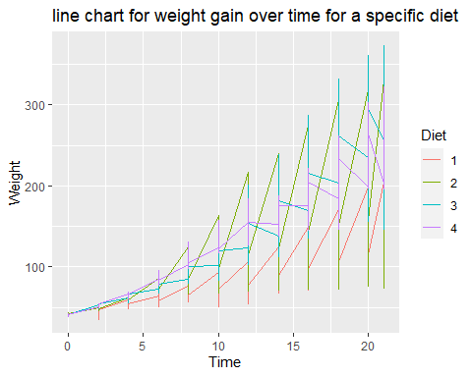

plot_ly(data=ChickWeight,x=~Time,y=~weight,type="scatter",mode="lines",color=~Diet) %>% layout(title="line chart for weight gain over time for a specific diet",xaxis=list(title="Time",yaxis=list(title="Weight")))

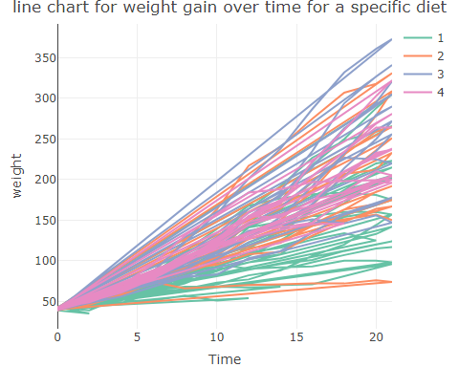 #Q7

#Q7Create a scatter plot with the faithful dataset to visualize the relationship between eruptions duration and waiting time.  
#View(faithful)  
ggplot(data=faithful)+  
 geom_point(mapping = aes(x=eruptions,y=waiting))+  
 labs(title = "Scatter plot for relation betw eruptions and waiting time",x="Time",y="Weight")

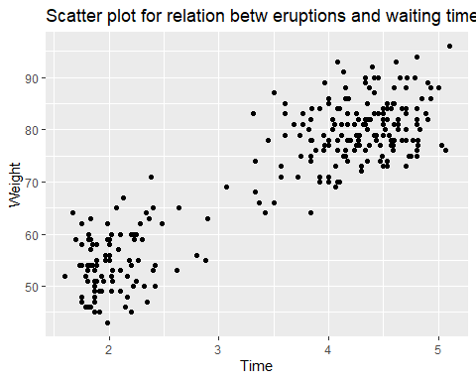

plot_ly(data=faithful,x=~eruptions,y=~waiting,type="scatter",mode="markers") %>% layout(title="Scatter plot for relation betw eruptions and waiting time",xaxis=list(title="Eruptions"),yaxis=list(title="waiting"))

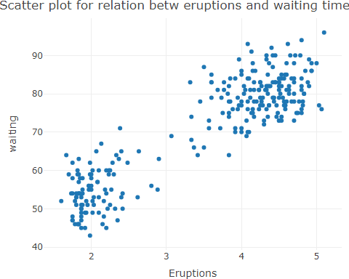 #Q8

#Q8Generate a bar chart using the Titanic dataset to show the count of passengers by class (Class).  
#View(Titanic)  
  
ggplot(data=as.data.frame(Titanic))+  
 geom_col(mapping = aes(x=Class,y=Freq))+  
 labs(title = "count of passengers",x="Class",y="passenger count")

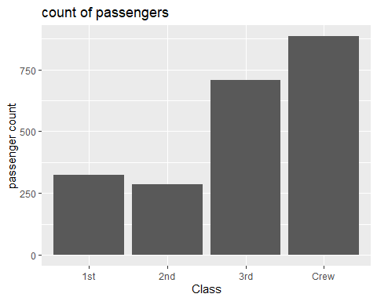

plot_ly(data=as.data.frame(Titanic),x=~Class,y=~Freq,type="bar",color=~Class)%>% layout(title="Class wise count",xaxis=list(title="Class"),yaxis=list(title="Counts"))

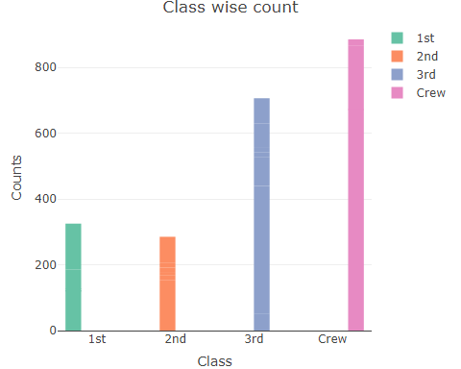 #Q9

#Q9 Use the USArrests dataset to create a box plot of the murder rate (Murder) .  
#View(USArrests)  
ggplot(data=USArrests)+  
 geom_boxplot(mapping=aes(x=Murder))+  
 labs(title = "Boxplot of Murder",x="Murder")

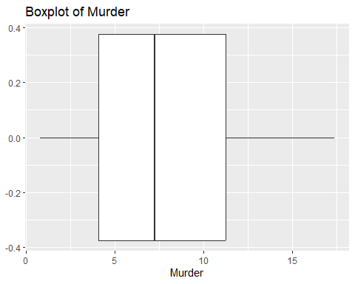

plot_ly(data=USArrests,x=~Murder,type="box")%>% layout(title="Boxplot of Murder",xaxis=list(title="Murder"))

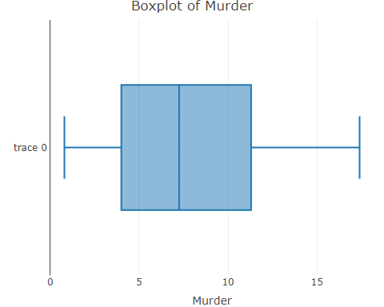 #Q10

#Q10Create a density plot using the diamonds dataset to visualize the distribution of diamond prices (price) by diamond cut (cut).  
  
#View(diamonds)  
fit <- density(diamonds$price)  
ggplot(data=diamonds)+  
 geom_density(mapping = aes(x=price,fill=cut),alpha=0.1)+  
 labs(title="density plot of price by cut",x="Price",y="Cut")

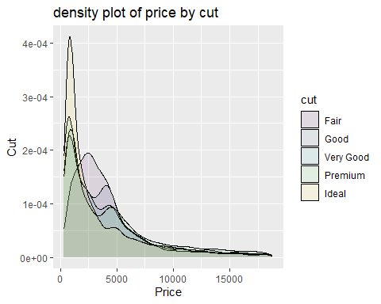

plot_ly(data=diamonds,x=~price,y=~cut,type = "histogram") %>% add_trace(x=fit$price,y=fit$cut,mode="lines",fill="tozeroy")%>% layout(yaxis2 = list(overlaying = "y", side = "right"))

## Warning: Can't display both discrete & non-discrete data on same axis

## Warning: 'histogram' objects don't have these attributes: 'mode', 'fill'  
## Valid attributes include:  
## '_deprecated', 'alignmentgroup', 'autobinx', 'autobiny', 'bingroup', 'cliponaxis', 'constraintext', 'cumulative', 'customdata', 'customdatasrc', 'error_x', 'error_y', 'histfunc', 'histnorm', 'hoverinfo', 'hoverinfosrc', 'hoverlabel', 'hovertemplate', 'hovertemplatesrc', 'hovertext', 'hovertextsrc', 'ids', 'idssrc', 'insidetextanchor', 'insidetextfont', 'legendgroup', 'legendgrouptitle', 'legendrank', 'marker', 'meta', 'metasrc', 'name', 'nbinsx', 'nbinsy', 'offsetgroup', 'opacity', 'orientation', 'outsidetextfont', 'selected', 'selectedpoints', 'showlegend', 'stream', 'text', 'textangle', 'textfont', 'textposition', 'textsrc', 'texttemplate', 'transforms', 'type', 'uid', 'uirevision', 'unselected', 'visible', 'x', 'xaxis', 'xbins', 'xcalendar', 'xhoverformat', 'xsrc', 'y', 'yaxis', 'ybins', 'ycalendar', 'yhoverformat', 'ysrc', 'key', 'set', 'frame', 'transforms', '_isNestedKey', '_isSimpleKey', '_isGraticule', '_bbox'

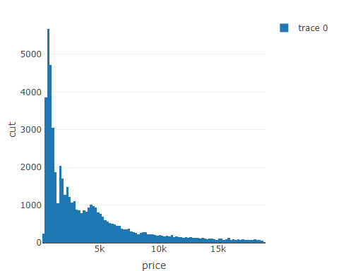

#plot_ly(x = x, type = "histogram", name = "Histogram") %>% add_trace(x = fit$x, y = fit$y, mode = "lines", fill = "tozeroy", yaxis = "y2", name = "Density")

#11

View(mtcars)  
ggplot(data=mtcars)+  
 geom_bar(mapping=aes(x=factor(cyl),fill=rownames(mtcars)))+  
 labs(title = "stacked bar graph",x="model")

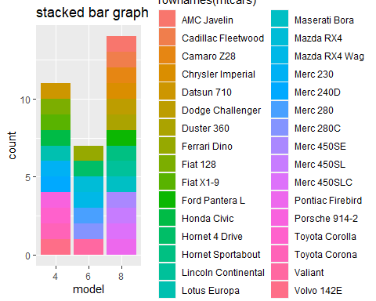

#or  
ggplot(data=mtcars)+  
 geom_bar(mapping=aes(x=factor(cyl)))

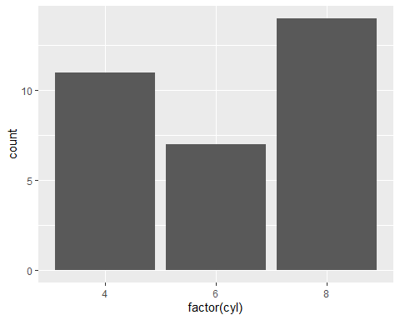

plot_ly(data=mtcars,x=~factor(cyl),type="bar")

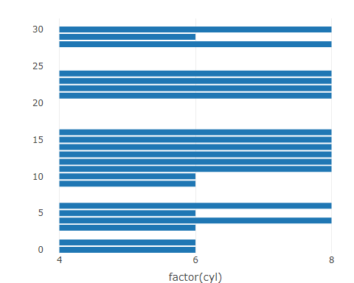

plot_ly(data=mtcars,x = ~factor(cyl),y=~row.names(mtcars), type = 'bar')

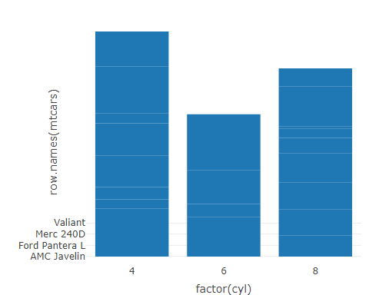

#12

View(volcano)  
fig <- plot_ly(as.data.frame(volcano), x = ~V1, y = ~V2,z=~V3, colors = c('#BF382A', '#0C4B8E'))

#13

ggplot(data=ChickWeight)+  
 geom_violin(mapping=aes(x=Diet,y=weight,fill=Diet))+  
 labs(title = "Violin plot of Weight dained by Diet type",x="Diet Type",y="Weight")

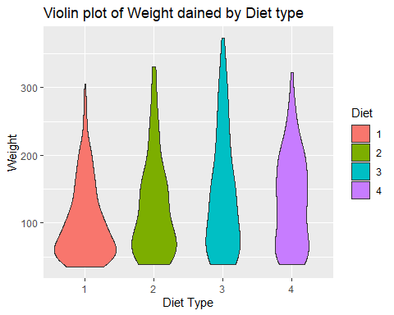

plot_ly(data=ChickWeight,x=~Diet,y=~weight,type='violin',box=list(visible=TRUE)) %>%   
 layout(title="Violin plot of Weight dained by Diet",xaxis=list(title="Diet Type"),yaxis=list(title="Weight"))

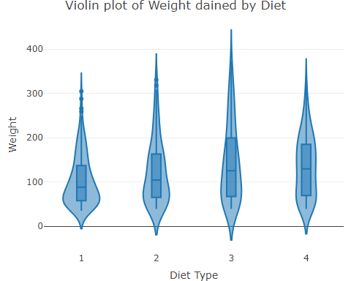 #Q14

View(CO2)  
ggplot(data=CO2)+  
 geom_line(mapping=aes(x=uptake,y=conc))+  
 labs(title="Time series plot of conc vs uptake",x="uptake",y="concentration")

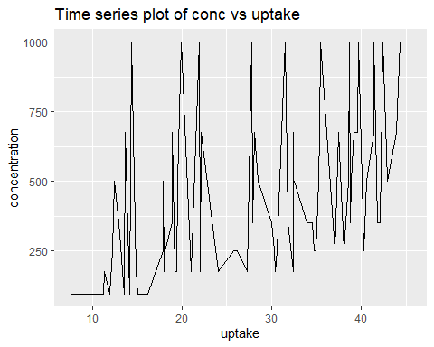

plot_ly(data=CO2,x=~uptake,y=~conc,type="scatter",color=~Plant,mode='lines')

