**Practical No: 6**

**Aim: IP Security (IPsec) Configuration**

**Theory:**

Some theoretical aspects of IPSec and the concept of an IPSec VPN tunnel:

1. IPSec Overview:

- IPSec (Internet Protocol Security) is a comprehensive suite of protocols and standards used for securing communication over IP networks, such as the Internet.

- It ensures the confidentiality, integrity, and authenticity of data transmitted between devices or networks.

2. Security Goals of IPSec:

- Confidentiality: IPSec achieves data privacy through encryption.

- Integrity: It guarantees that data remains unaltered during transit.

- Authentication: IPSec verifies the identity of communicating parties to prevent unauthorized access and impersonation.

3. Components of IPSec:

- IPSec comprises multiple protocols and elements, including Authentication Header (AH), Encapsulating Security Payload (ESP), Security Associations (SAs), and key management protocols.

4. IPSec VPN Tunnel:

- An IPSec VPN tunnel is a secure, encrypted connection established between two endpoints or networks over the Internet or untrusted networks.

- It is created using the IPSec suite to provide a secure and private channel for data transmission.

5. Establishing a VPN Tunnel:

- The process begins with the negotiation and establishment of Security Associations (SAs) between the endpoints.

- These SAs define parameters like encryption methods, authentication, and shared keys.

6. Modes of Operation:

- VPN tunnels can operate in either Transport Mode (securing data payload) or Tunnel Mode (securing entire IP packets, including headers).

- Transport Mode is often used for host-to-host communication, while Tunnel Mode is suitable for network-to-network connections.

7. Data Encryption and Authentication:

- Data transmitted through the VPN tunnel is encrypted using algorithms specified in the SAs, ensuring data privacy.

- Authentication and data integrity checks prevent tampering or unauthorized access.

8. Routing and Secure Communication:

- Once established, the VPN tunnel allows secure data routing between the endpoints or networks.

- Applications and services on either side can communicate securely, even over untrusted networks like the Internet.

9. Use Cases:

- IPSec VPN tunnels are used for various purposes, including remote access VPNs, site-to-site VPNs, secure data transfer, and protecting real-time communication like VoIP and video conferencing.

10. Key Management:

- Secure key management is critical for the long-term security of IPSec VPN tunnels.

- Keys can be generated manually or through automated key exchange protocols like Internet Key Exchange (IKE).

11. Security Policies:

- Organizations define security policies that determine when and how IPSec should be applied to protect specific types of traffic or communication.

12. Interoperability:

- IPSec is widely adopted, ensuring interoperability between different vendors' equipment and making it a versatile choice for securing networks and data.

Understanding the principles of IPSec and IPSec VPN tunnels is essential for designing, deploying, and managing secure communication in various network environments, ensuring data remains confidential, unaltered, and protected from unauthorized access.

**Topology:**

We use the following topology for the present case

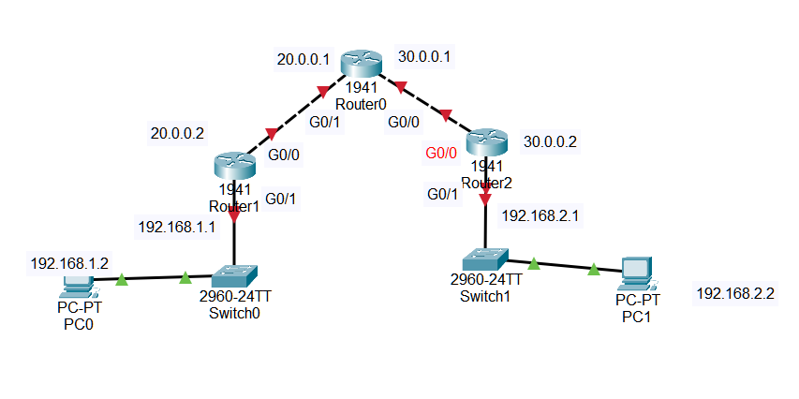



**Configuring PC0 and PC1:  
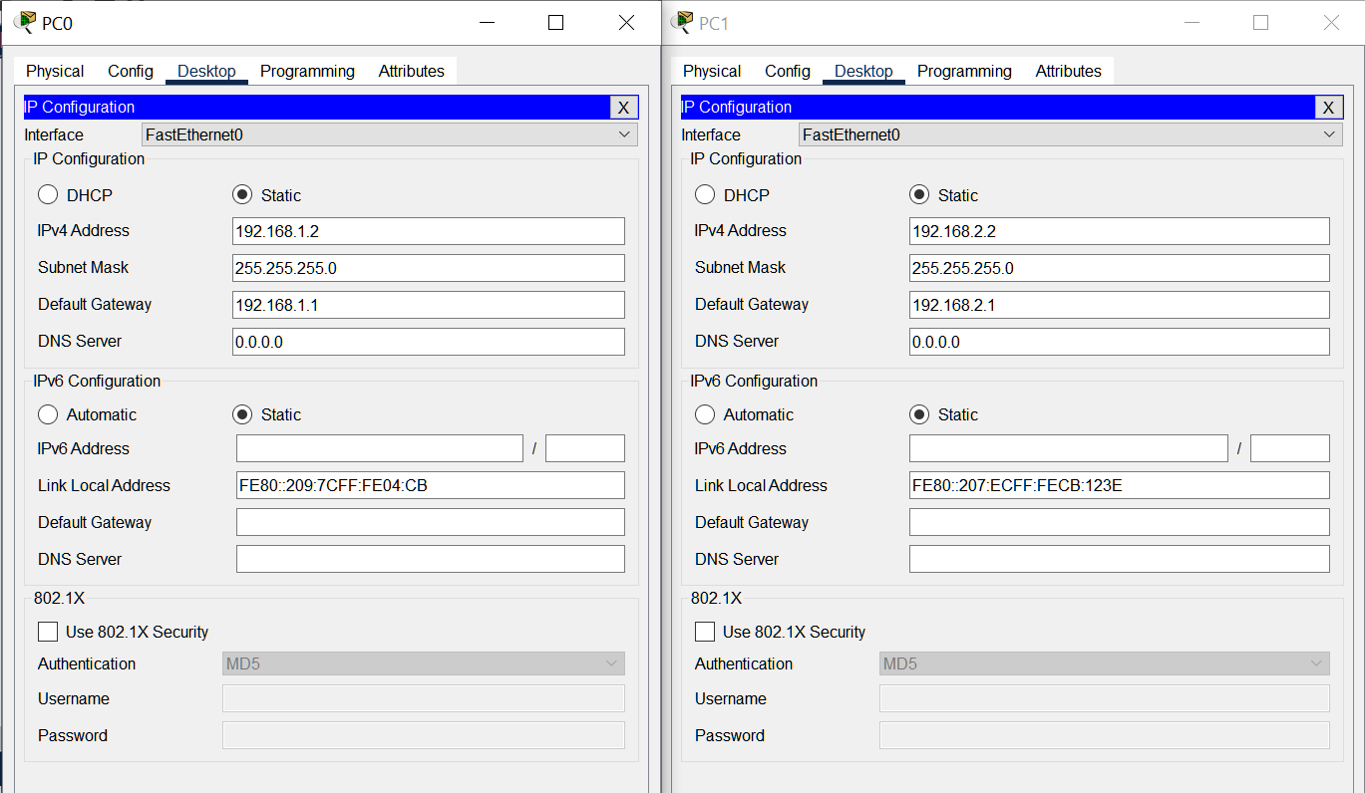**

**Configuring Router0:**

**Interface GigabitEthernet0/1:**

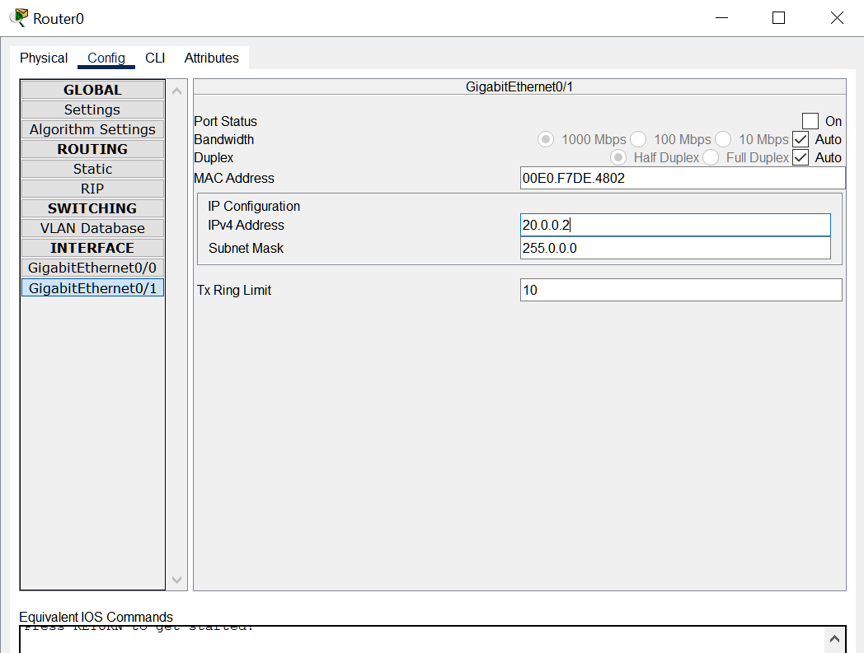

**Interface GigabitEthernet0/0:**

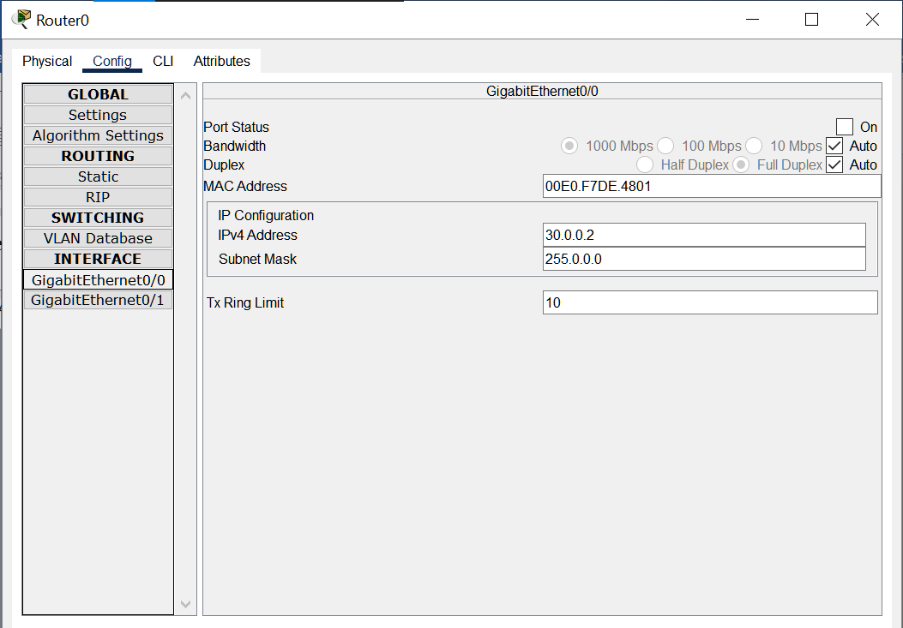

**Configuring Router1:**

**Interface GigabitEthernet0/0:**

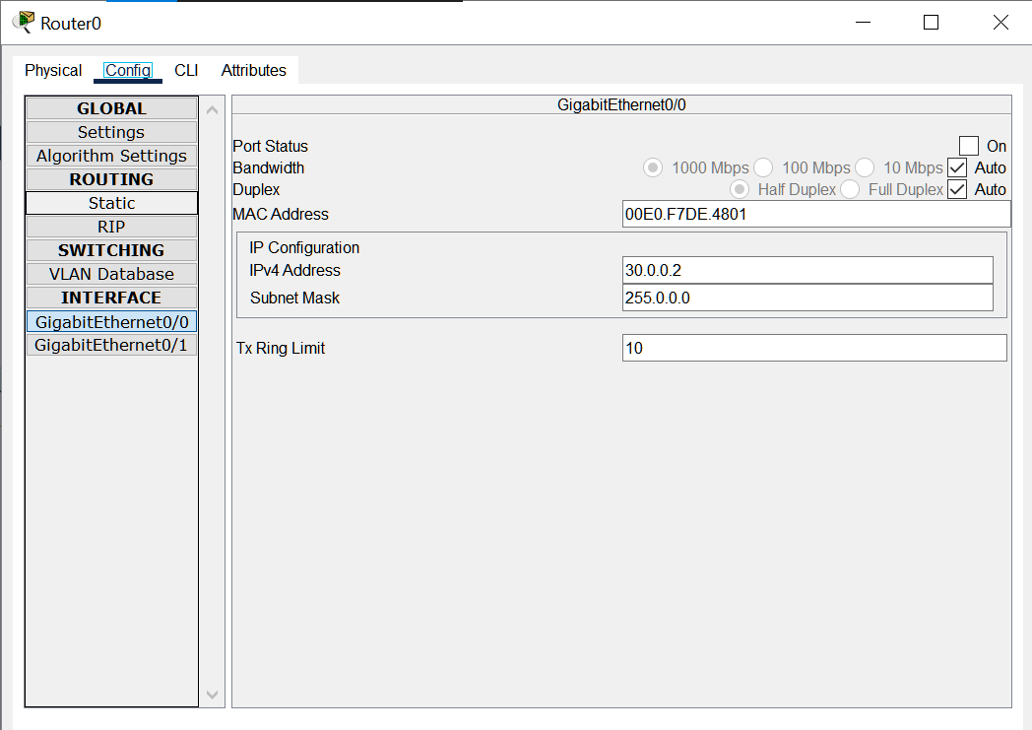

**Interface GigabitEthernet0/1:**

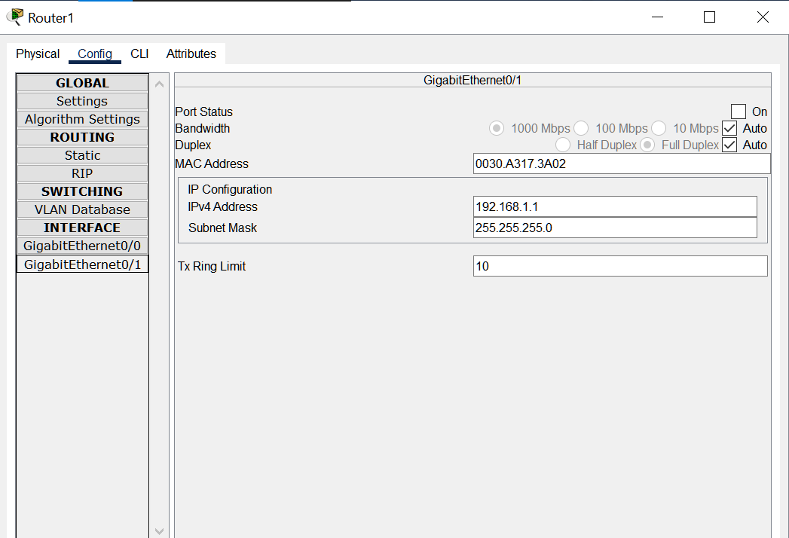

**Configuring Router2:**

**Interface GigabitEthernet0/1:**

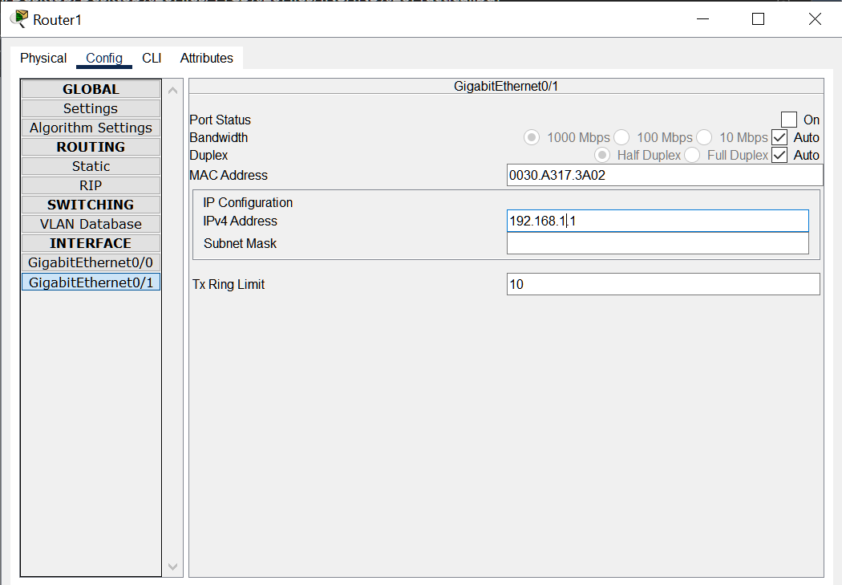

**Interface GigabitEthernet0/1:**

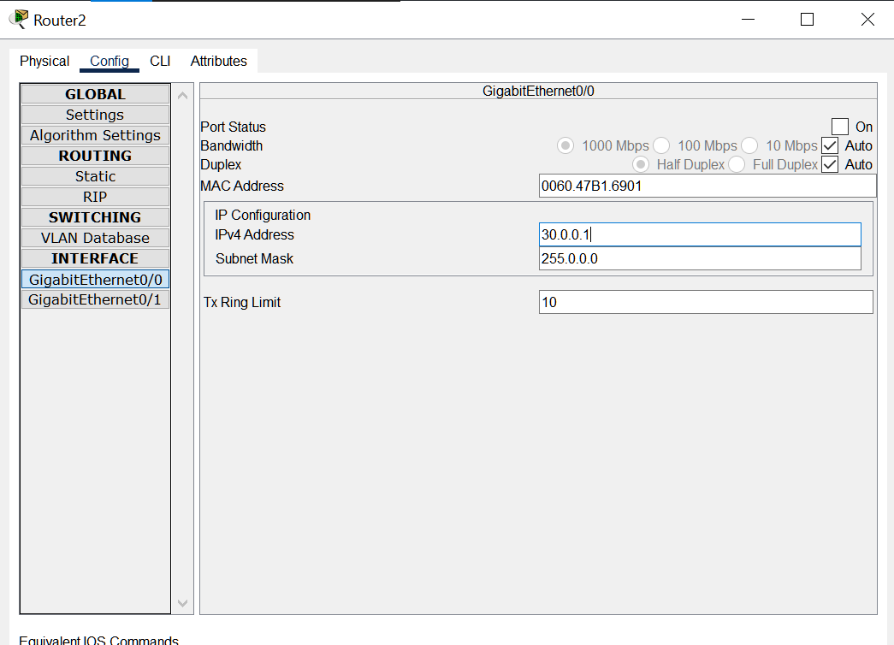

**Checking and Enabling the Security features in Router R1 and R2:**

**Enter the following command in the CLI mode of Router2**

Router(config)#ip route 0.0.0.0 0.0.0.0 20.0.0.2

Router(config)#hostname R1

R1(config)#exit

R1#show version

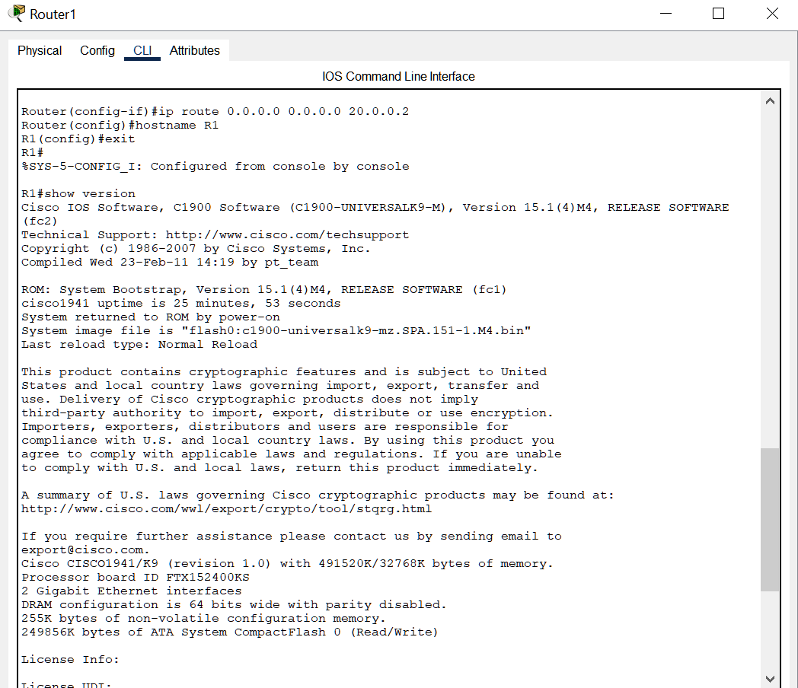

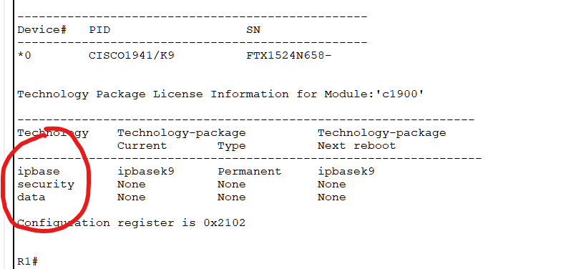

(We see that the security feature is not enabled, hence we need to enable the security package

R1#

R1#configure terminal

Enter configuration commands, one per line. End with CNTL/Z.

R1(config)#

R1(config)#license boot module c1900 technology-package securityk9

R1(config)#exit

R1#

R1#copy run startup-config

R1#reload

R1>enable

R1#show version

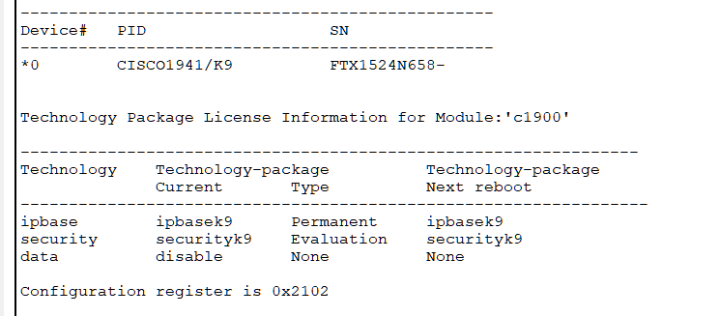

(The security package is enabled)

**Enter the following command in the CLI mode of Router3**

Router>enable

Router#configure terminal

Router(config)#ip route 0.0.0.0 0.0.0.0 30.0.0.2

Router(config)#hostname R2

R2(config)#exit

R2#show version

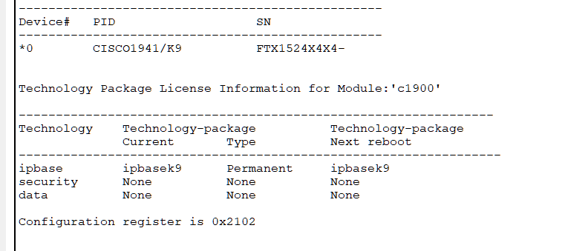

(We see that the security feature is not enabled, hence we need to enable the security package

R2#

R2#configure terminal

Enter configuration commands, one per line. End with CNTL/Z.

R2(config)#

R2(config)#license boot module c1900 technology-package securityk9

R2(config)#exit

R2#copy run startup-config

R2#reload

R2>enable

R2#show version

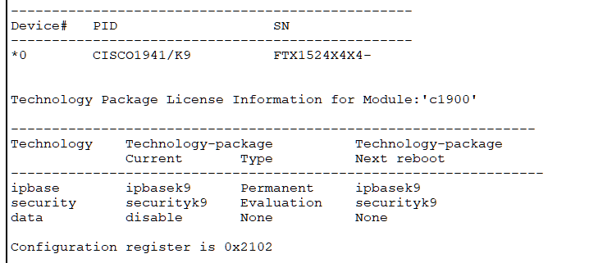

**Enter the following command in the CLI mode of Router0**

Router>enable

Router#configure terminal

Router(config)#hostname R0

R0(config)#

**Defining the Hostname for all Routers and Configuring the Routers R1 and R2 for IPSec VPN tunnel**

(Router 1 – Left side)

R1#configure terminal

R1(config)#access-list 100 permit ip 192.168.1.0 0.0.0.255 192.168.2.0 0.0.0.255

R1(config)#crypto isakmp policy 10

R1(config-isakmp)#encryption aes 256

R1(config-isakmp)#authentication pre-share

R1(config-isakmp)#group 5

R1(config-isakmp)#exit

R1(config)#crypto isakmp key ismile address 30.0.0.1

R1(config)#crypto ipsec transform-set R1->R2 esp-aes 256 esp-sha-hmac

R1(config)#

R2#

R2#configure terminal

R2(config)#access-list 100 permit ip 192.168.2.0 0.0.0.255 192.168.1.0 0.0.0.255

R2(config)#crypto isakmp policy 10

R2(config-isakmp)#encryption aes 256

R2(config-isakmp)#authentication pre-share

R2(config-isakmp)#group 5

R2(config-isakmp)#exit

R2(config)#crypto isakmp key ismile address 20.0.0.1

R2(config)#crypto ipsec transform-set R2->R1 esp-aes 256 esp-sha-hmac

R2(config)#

R1>enable

R1#configure terminal

R1(config)#crypto map IPSEC-MAP 10 ipsec-isakmp

R1(config-crypto-map)#set peer 30.0.0.1

R1(config-crypto-map)#set pfs group5

R1(config-crypto-map)#set security-association lifetime seconds 86400

R1(config-crypto-map)#set transform-set R1->R2

We verify the working of the IPSec VPN tunnel using the ping command as follows

Pinging PC2(192.168.2.2) from PC1 and then PC1(192.168.1.2) from PC2

Output:

