DevOps Project
Ansible-Provisioned Microfinance Repayment Tracker
Task 3: Requirements, Architecture and Technology Setup
Field | Details
Student Name | Harshal Suresh Patil
Roll No. | 23102A0041
Branch | CMPN-A
Subject | DevOps
Faculty Name | Snehal Andhere
College / University | Vidyalankar Institute of Technology, Wadala, Mumbai
Academic Year | 2026-27
Submission Date | [DD/MM/YYYY]

Contents
1. Introduction
2. SRS Summary
3. Use-Case Diagram and Use Cases
4. Technology Selection and Architecture
5. Data Model
6. API (Route) List
7. Traceability: Stories to Requirements to Tests
8. Local Development Setup
Appendix A: Setup Evidence
References
Deliverable covered: SRS summary, use-case diagram, architecture diagram, data model and API list, and working local setup.

1. Introduction
Task 1 froze the scope (five MVP features, 15 tasks) and Task 2 turned it into user stories, a backlog and a sprint plan. This document designs the minimum application that delivers those five features: it states the requirements, shows who uses the system, selects the technology stack, describes the architecture and the data model, lists the pages and endpoints, and records a working local development setup.
The design is deliberately small. It adds no features beyond the frozen scope, and every choice is made so that the later DevOps tasks (Git, Jenkins, Selenium, Docker, Ansible) work smoothly.

2. SRS Summary

2.1 Purpose, scope and users
The Microfinance Repayment Tracker is a web application that lets loan officers record borrowers, loans and repayments, and lets branch managers see how much was lent, how much was collected and which repayments are late. It is a single-branch system without login, using dummy data only.
User | What they do in the system
Loan Officer | Adds borrowers, creates loans, records repayments, searches records
Branch Manager | Reads summary indicators, opens status lists, reviews alerts

2.2 Functional requirements
ID | Requirement | Story
FR1 | Add a borrower with name (required), phone (10 digits) and village. | US1
FR2 | Create a loan for an existing borrower with amount (greater than 0), start date, number of installments (1 or more) and frequency (weekly or monthly). | US2
FR3 | On loan creation, generate the full repayment schedule automatically (one repayment row per installment). | US2
FR4 | Record a payment against a repayment; the amount must be greater than 0 and not exceed the amount still due. | US3
FR5 | Set the repayment status automatically: PAID, PENDING or OVERDUE (rules in 2.4). | US3
FR6 | Show a dashboard table of loans with borrower name, village, loan amount, amount paid and loan status. | US4
FR7 | Search the dashboard by borrower name (partial, not case sensitive) and by village. | US4
FR8 | Show summary indicators: total disbursed, total collected, overdue count and collection rate %. | US5
FR9 | Let the user click Paid, Pending or Overdue to open the list of matching repayments. | US6
FR10 | Show an alert list of repayments overdue by more than 7 days. | US7
FR11 | Show an exception list of invalid payments (negative amount or amount above the amount due) and of loans with a missing schedule (fewer repayment rows than installments). | US7
FR12 | Validate every form and show a clear error message; nothing invalid is saved. | US1-US3
FR13 | Load dummy demonstration data at start-up so that dashboards and tests have stable data. | US4-US7
FR14 | Expose a health endpoint that returns HTTP 200 when the application is running. | US8-US11

2.3 Non-functional requirements
Quality | Requirement | Measure
Performance | Search and dashboard pages respond quickly with up to 1,000 loans | Search result in under 5 seconds
Usability | Simple forms; the overdue list is reachable from the dashboard without searching | 2 clicks or fewer
Accuracy | All totals and statuses are calculated by the service from stored data, never typed by hand | 100% match with entered data
Reliability | Invalid input is rejected; the application restarts cleanly; a health endpoint exists | HTTP 200 on health check
Testability | Pages use stable element ids (for example search-box, overdue-link) and seed data for Selenium | 3 to 5 journeys, all passing
Portability | Same package runs on Windows, Linux, Tomcat and Docker | Runs in all four
Maintainability | Layered code (controller, service, repository), standard Maven layout, meaningful names | Code review checklist
Deployability | Packaged as one WAR; built, tested and deployed by Jenkins; provisioned by Ansible | Commit to container without manual steps
Security (basic) | Server-side validation, parameterised queries through JPA, dummy data only; login is out of scope | No real customer data
Compatibility | Works in current Chrome, Edge and Firefox | Manual check plus Selenium on Chrome

2.4 Business rules
ID | Rule
BR1 | The loan amount is the total amount to be repaid in equal installments. Interest and charges are out of scope for the MVP.
BR2 | Installment amount = loan amount / number of installments, rounded to 2 decimals; the last installment absorbs any rounding difference.
BR3 | Due dates: start date plus 7 days for each installment (weekly) or plus one month for each installment (monthly).
BR4 | A repayment is PAID when amount paid is at least the amount due.
BR5 | A repayment is OVERDUE when it is not PAID and its due date is before today.
BR6 | A repayment is PENDING when it is not PAID and its due date is today or later.
BR7 | An alert is raised when a repayment is OVERDUE and today is more than 7 days after its due date.
BR8 | Total disbursed = sum of all loan amounts. Total collected = sum of all amounts paid. Overdue count = number of OVERDUE repayments.
BR9 | Collection rate % = total collected / total amount due up to today x 100 (shown as 0 when nothing is due yet).

Assumptions and constraints from Task 1 still apply: single developer, free tools only, H2 database, dummy data, no login, payment gateway, SMS or mobile app.

3. Use-Case Diagram and Use Cases
Figure 1 shows the two actors and the seven use cases that correspond to the five MVP features. The green use cases are steps the system performs automatically.
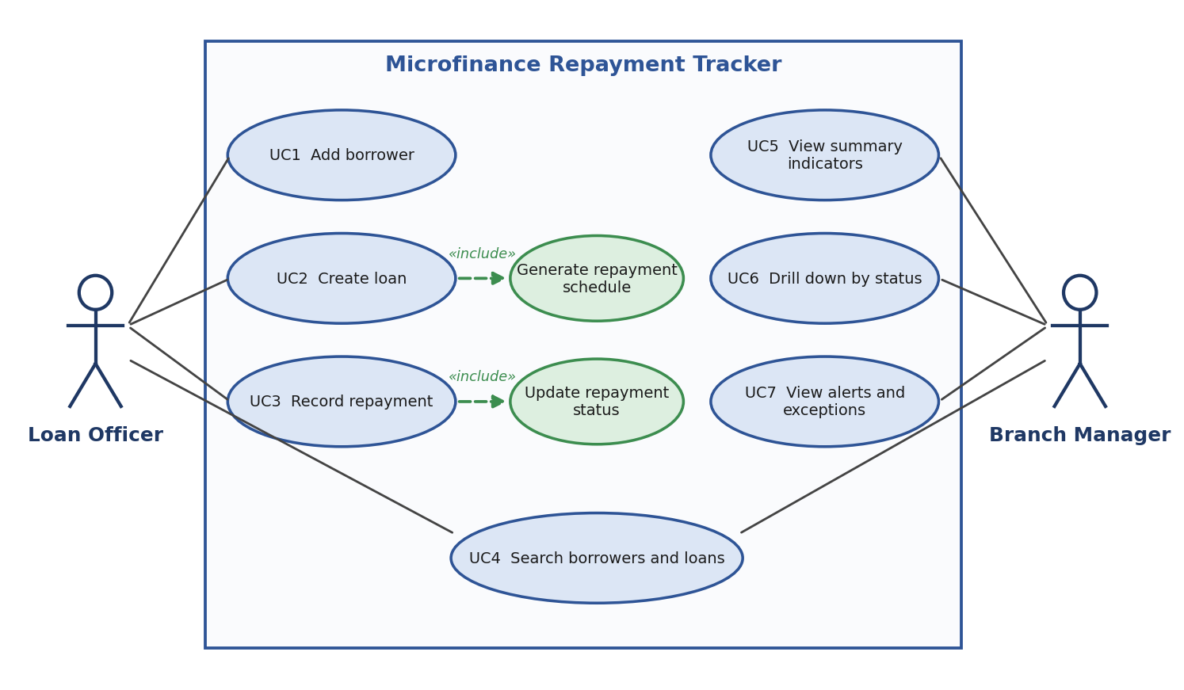
Figure 1: Use-case diagram
ID | Use case | Actor | Main flow | Result
UC1 | Add borrower | Loan Officer | Open form, enter name, phone and village, submit | Borrower saved (FR1)
UC2 | Create loan | Loan Officer | Choose borrower, enter amount, start date, installments and frequency, submit; system generates the schedule | Loan and repayment rows saved (FR2, FR3)
UC3 | Record repayment | Loan Officer | Open a loan, choose an installment, enter the amount paid, submit; system updates the status | Payment and status saved (FR4, FR5)
UC4 | Search borrowers and loans | Loan Officer, Branch Manager | Type a name or village in the search box on the dashboard | Matching rows shown (FR6, FR7)
UC5 | View summary indicators | Branch Manager | Open the dashboard | Four indicators shown (FR8)
UC6 | Drill down by status | Branch Manager | Click Paid, Pending or Overdue on the dashboard | Matching repayments listed (FR9)
UC7 | View alerts and exceptions | Branch Manager | Open the alerts page | Late and invalid items listed (FR10, FR11)

4. Technology Selection and Architecture

4.1 Technology stack and reasons
Area | Choice | Why | Alternatives considered
Language and framework | Java 17, Spring Boot 4.x (latest stable in Spring Initializr), Spring MVC, Thymeleaf | Widely used in industry; server-rendered HTML is easy to test with Selenium; builds a WAR or JAR | Node.js with Express, Python with Django
Build tool | Maven 3.10.0 | Standard lifecycle (clean, test, package) that Jenkins runs directly | Gradle, Ant
Database | H2 (in-memory) for the MVP | No installation, resets on restart, ideal for tests | MySQL (optional later)
Deployment target | Apache Tomcat 11 | Runs Java WAR files. Spring Boot 4 needs Servlet 6.1, which is Tomcat 11 | Nginx (web server and reverse proxy only; it cannot run a Java WAR by itself)
Version control | Git and GitHub | Required for the branching and pull-request tasks | None
IDE | IntelliJ IDEA Community (or VS Code, Eclipse) | Free, strong Java and Maven support | Any
Testing (later) | JUnit and Selenium WebDriver | Runs through Maven, so Jenkins can run it | Cypress, Playwright

Version note: Spring Boot 4.x requires at least Java 17 and supports embedded Tomcat 11 (Servlet 6.1). An external Tomcat must therefore be version 11. Older Tomcat 10 matches Spring Boot 3 and will not run this application.

4.2 Architecture
The application is a classic layered web application. The browser sends an HTTP request, the controller receives it, the service applies the business rules, the repository reads or writes the database, and a Thymeleaf template turns the result into an HTML page. Figure 2 shows the layers.
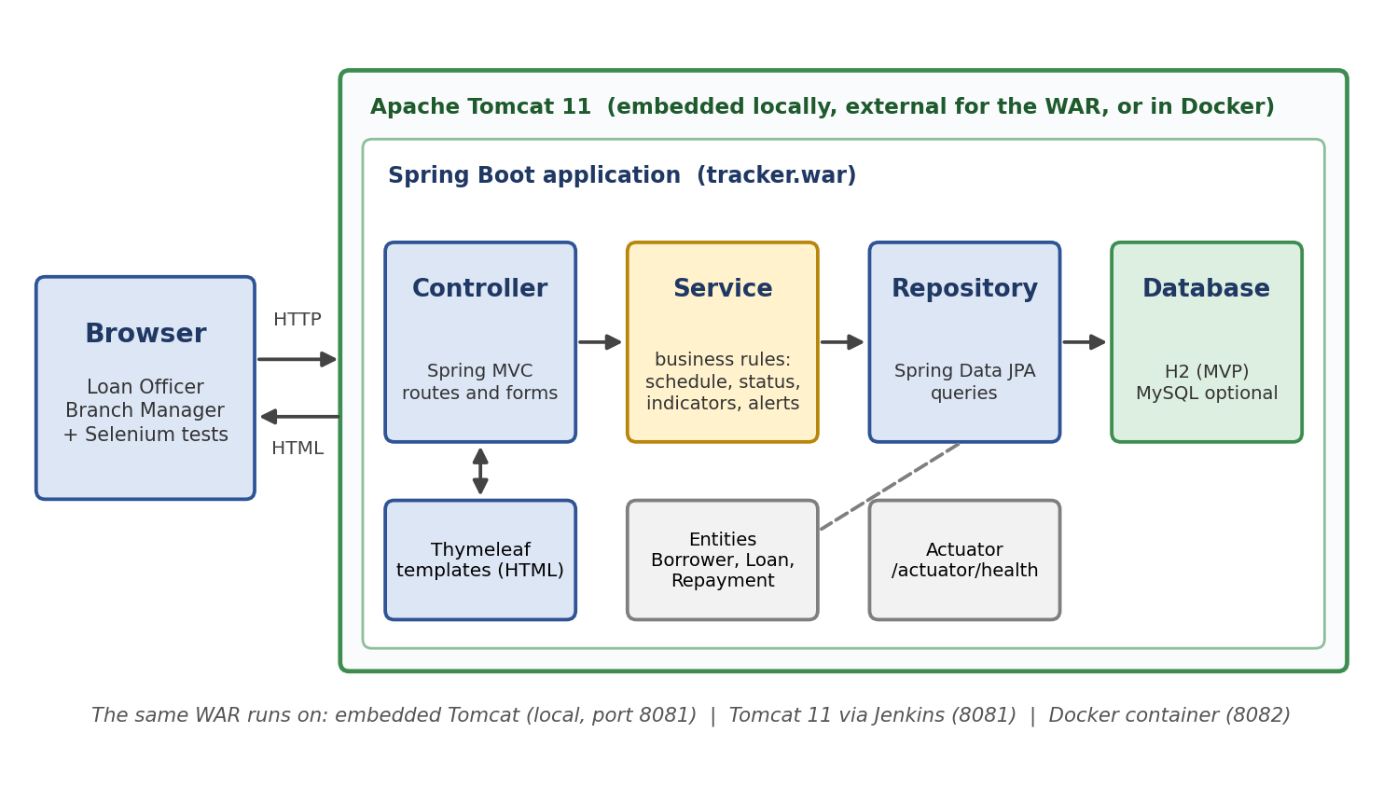
Figure 2: Architecture of the Microfinance Repayment Tracker
Layer | Responsibility
Controller | Maps URLs to methods, reads form fields, validates input, picks the template
Service | Contains the business rules: schedule generation, status calculation, indicators, alert rules
Repository | Spring Data JPA interfaces that store and query Borrower, Loan and Repayment
Database | H2 in memory; the schema is created from the entity classes; dummy data loads from data.sql
View | Thymeleaf HTML templates (dashboard, forms, lists, alerts)
Actuator | Provides /actuator/health for the health check used in Task 14

4.3 Where the application runs in each phase
Phase | Port | How it runs
Local development | 8081 | mvn spring-boot:run (embedded Tomcat) from the IDE or terminal
Jenkins deployment (Tasks 8, 10) | 8081 | tracker.war copied to the webapps folder of Tomcat 11
Docker (Tasks 11, 12) | 8082 | Container built from a Tomcat 11 base image holding tracker.war
Ansible node (Tasks 13, 14) | 8082 | Playbook installs Docker and runs the versioned container
Jenkins itself | 8080 | Reserved for Jenkins so that there are no port conflicts

4.4 Project structure
tracker/
pom.xml
Jenkinsfile (Task 8)
Dockerfile (Task 11)
ansible/ (Task 13)
docs/ (task documents)
src/main/java/com/mfi/tracker/
TrackerApplication.java
ServletInitializer.java (needed for WAR deployment)
controller/ service/ repository/ model/
src/main/resources/
application.properties
data.sql (dummy data)
templates/ (Thymeleaf pages)
src/test/java/ (Selenium tests, Task 9)

5. Data Model
There are three entities. One borrower can take many loans, and one loan has many repayments (one per installment). Figure 3 shows the entity-relationship diagram.
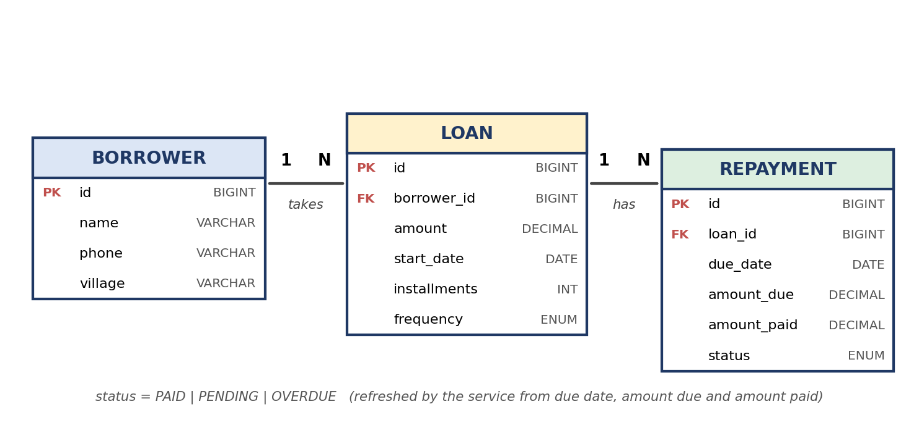
Figure 3: Entity-relationship diagram
Frequency is stored on the loan so that the schedule can be generated as weekly or monthly. It supports the existing scope and adds no new feature.

5.1 Data dictionary
Borrower field | Type | Constraint
id | BIGINT | Primary key, generated automatically
name | VARCHAR(100) | Required
phone | VARCHAR(10) | Required, exactly 10 digits
village | VARCHAR(100) | Required

Loan field | Type | Constraint
id | BIGINT | Primary key, generated automatically
borrower_id | BIGINT | Foreign key to Borrower, required
amount | DECIMAL(12,2) | Greater than 0
start_date | DATE | Required
installments | INT | 1 or more
frequency | ENUM | WEEKLY or MONTHLY

Repayment field | Type | Constraint
id | BIGINT | Primary key, generated automatically
loan_id | BIGINT | Foreign key to Loan, required
due_date | DATE | Required
amount_due | DECIMAL(12,2) | Greater than 0
amount_paid | DECIMAL(12,2) | Default 0
status | ENUM | PAID, PENDING or OVERDUE; refreshed by the service when a payment is recorded and whenever the dashboard loads

Forms prevent invalid amounts, but data loaded from outside the forms (such as the seed file) can contain them. The alert view (FR11) therefore checks the stored values directly.

6. API (Route) List
The application serves HTML pages. When the WAR is deployed to Tomcat, every URL below is prefixed with the context path /tracker (for example /tracker/dashboard).
Method | URL | Purpose | Parameters | Response
GET | / | Redirect to the dashboard | none | 302
GET | /dashboard | Indicators and searchable loan table | q (optional search text) | HTML 200
GET | /borrowers/new | Show the add-borrower form | none | HTML 200
POST | /borrowers | Save a new borrower | name, phone, village | 302 or form with errors
GET | /loans/new | Show the create-loan form | none | HTML 200
POST | /loans | Save a loan and generate its schedule | borrowerId, amount, startDate, installments, frequency | 302 or form with errors
GET | /loans/{id} | Show one loan with its repayment schedule | id | HTML 200
POST | /repayments/{id}/pay | Record a payment | amountPaid | 302 or error message
GET | /repayments | List repayments by status | status = PAID, PENDING or OVERDUE | HTML 200
GET | /alerts | Late (more than 7 days) and invalid items | none | HTML 200
GET | /actuator/health | Health check | none | JSON status UP, HTTP 200

7. Traceability: Stories to Requirements to Tests
This table links each story to its requirements, use case and route, and shows which of the five Selenium journeys planned for Task 9 will check it.
Story | Requirements | Use case | Route | Planned Selenium journey
US1 | FR1, FR12 | UC1 | POST /borrowers | J1: Add a borrower
US2 | FR2, FR3, FR12 | UC2 | POST /loans | J2: Add a loan and see its schedule
US3 | FR4, FR5, FR12 | UC3 | POST /repayments/{id}/pay | Covered inside J5 (totals change)
US4 | FR6, FR7 | UC4 | GET /dashboard?q= | J3: Search for a borrower
US5 | FR8 | UC5 | GET /dashboard | J5: Dashboard totals are correct
US6 | FR9 | UC6 | GET /repayments?status= | J4: Open the overdue list
US7 | FR10, FR11 | UC7 | GET /alerts | Manual check, optional extra journey
US8 to US11 | FR14 | none | GET /actuator/health | Pipeline health check (Tasks 8, 10, 14)

8. Local Development Setup
This section is the working local setup required by the task. Follow the steps on your own computer and collect the screenshots listed in Appendix A as evidence.

8.1 Tools to install
Tool | Version | Download | Check command
JDK (Temurin) | 17 | adoptium.net | java -version
Apache Maven | 3.10.0 | maven.apache.org | mvn -version
Git | latest | git-scm.com | git --version
IDE | IntelliJ IDEA Community | jetbrains.com/idea | Open the project
Apache Tomcat | 11.0.x (zip) | tomcat.apache.org | bin\version.bat
Browser | Chrome or Edge | already installed | none
WSL2 and Docker Desktop | later | needed in Tasks 11 to 14 | install when required

8.2 Install and verify
- Install JDK 17, then set the JAVA_HOME environment variable to the JDK folder and add its bin folder to Path.
- Unzip Maven (for example to C:\tools\maven), add its bin folder to Path, and open a new terminal.
- Install Git with the default options and open a new terminal.
Verify in a new terminal. Each command must print a version, and Maven must report Java 17:
java -version
mvn -version
git --version

8.3 Create the project with Spring Initializr
Open start.spring.io and choose the following settings, then click Generate and unzip the downloaded file:
Setting | Value
Project / Language | Maven / Java
Spring Boot | Latest stable 4.x release (do not choose SNAPSHOT or M versions)
Group / Artifact / Name | com.mfi / tracker / tracker
Packaging | War
Java | 17
Dependencies | Spring Web, Thymeleaf, Spring Data JPA, H2 Database, Validation, Spring Boot Actuator

Open the unzipped folder in the IDE. In pom.xml, add a finalName inside the build section so the package is always named tracker.war:
<build>
<finalName>tracker</finalName>
... (keep the existing plugins) ...
</build>

8.4 Add a first page and run the application
Edit src/main/resources/application.properties:
spring.application.name=tracker
server.port=8081
spring.datasource.url=jdbc:h2:mem:trackerdb
management.endpoints.web.exposure.include=health

Create src/main/java/com/mfi/tracker/HomeController.java:
package com.mfi.tracker;

import org.springframework.stereotype.Controller;
import org.springframework.web.bind.annotation.GetMapping;

@Controller
public class HomeController {
@GetMapping("/")
public String home() { return "home"; }
}

Create src/main/resources/templates/home.html:
<!DOCTYPE html>
<html xmlns:th="http://www.thymeleaf.org">
<head><meta charset="UTF-8"><title>Microfinance Repayment Tracker</title></head>
<body>
<h1 id="page-title">Microfinance Repayment Tracker</h1>
<p>The application is running.</p>
</body>
</html>

Run it from the project folder and open the two addresses below in the browser:
mvn spring-boot:run

http://localhost:8081/ (shows the home page)
http://localhost:8081/actuator/health (shows {"status":"UP"})

8.5 Build the WAR and deploy it to Tomcat 11
- Stop the running application (Ctrl+C), because the embedded server and Tomcat both use port 8081.
- Build the package: mvn clean package. The file target\tracker.war is created.
- Unzip Tomcat 11 (for example to C:\tomcat). Set JAVA_HOME, then open conf\server.xml and change the HTTP connector port from 8080 to 8081.
- Copy target\tracker.war into Tomcat's webapps folder.
- Start Tomcat with bin\startup.bat. Open http://localhost:8081/tracker/ and http://localhost:8081/tracker/actuator/health.
- Stop Tomcat with bin\shutdown.bat when you finish.

8.6 Troubleshooting
Problem | Fix
Port 8081 already in use | Run netstat -ano | findstr :8081, then stop that program, or close the other run of the app
mvn or java not recognised | Check Path and JAVA_HOME, then open a new terminal
Maven says it needs Java 17 or a different version | Point JAVA_HOME to JDK 17 and check mvn -version
WAR gives 404 or class errors on Tomcat | Use Tomcat 11, not 10; check that the file is named tracker.war and the context path is /tracker
Spring Initializr offers no 4.x version | Choose the newest stable release listed (not SNAPSHOT or M) and use Tomcat 11 only if the chosen release is 4.x; Spring Boot 3.x needs Tomcat 10.1
Changes do not show | Stop and restart the application; H2 in-memory data is cleared at every restart

Appendix A: Setup Evidence
Paste your own screenshots here. Each should show the window title or browser address bar and, for the browser, the full URL.

Evidence 1: Installed versions
Shows: Terminal showing java -version, mvn -version and git --version
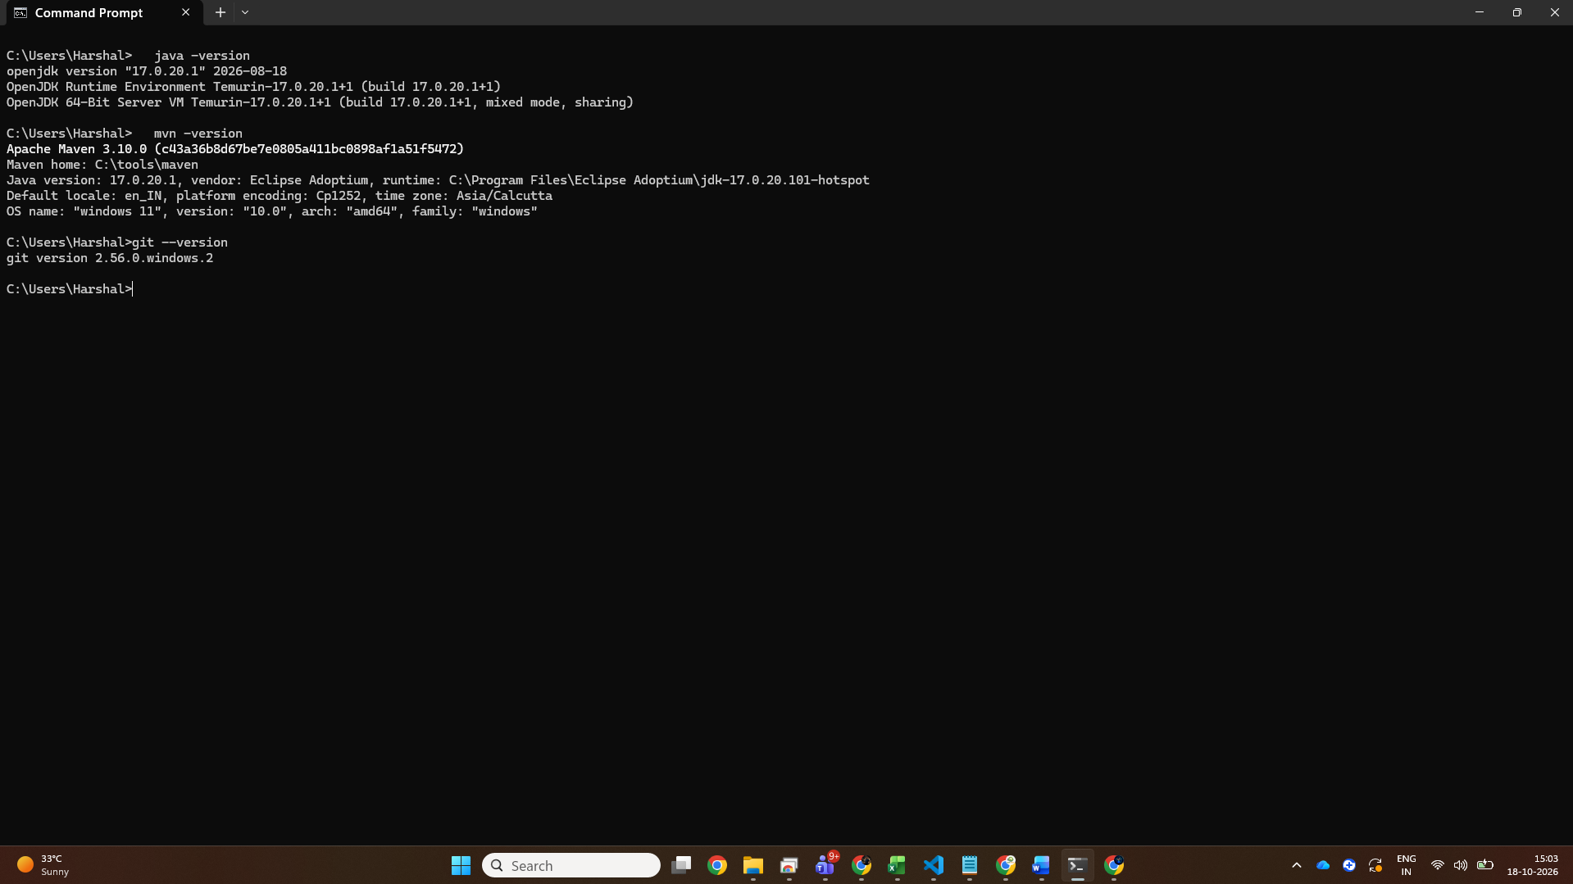

Evidence 2: Spring Initializr settings
Shows: start.spring.io with Maven, Java 17, War and the six dependencies selected
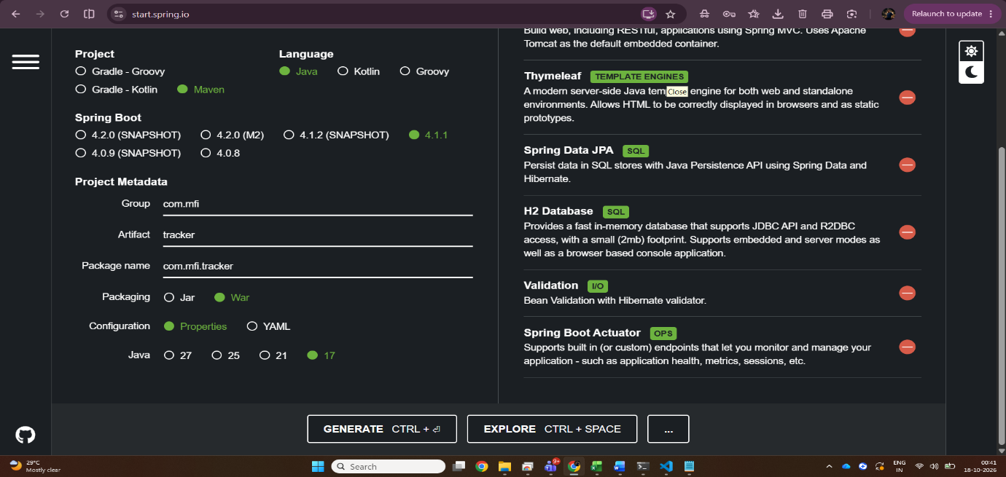
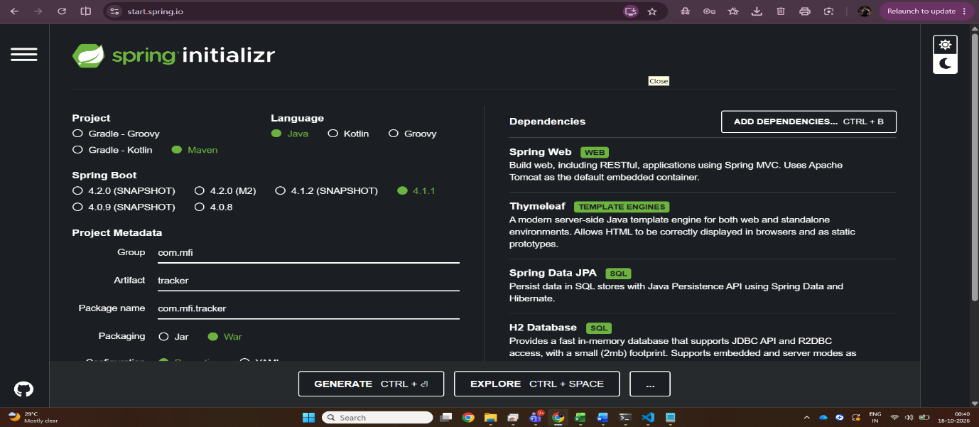

Evidence 3: Project open in the IDE
Shows: Project folder structure with pom.xml, HomeController and home.html
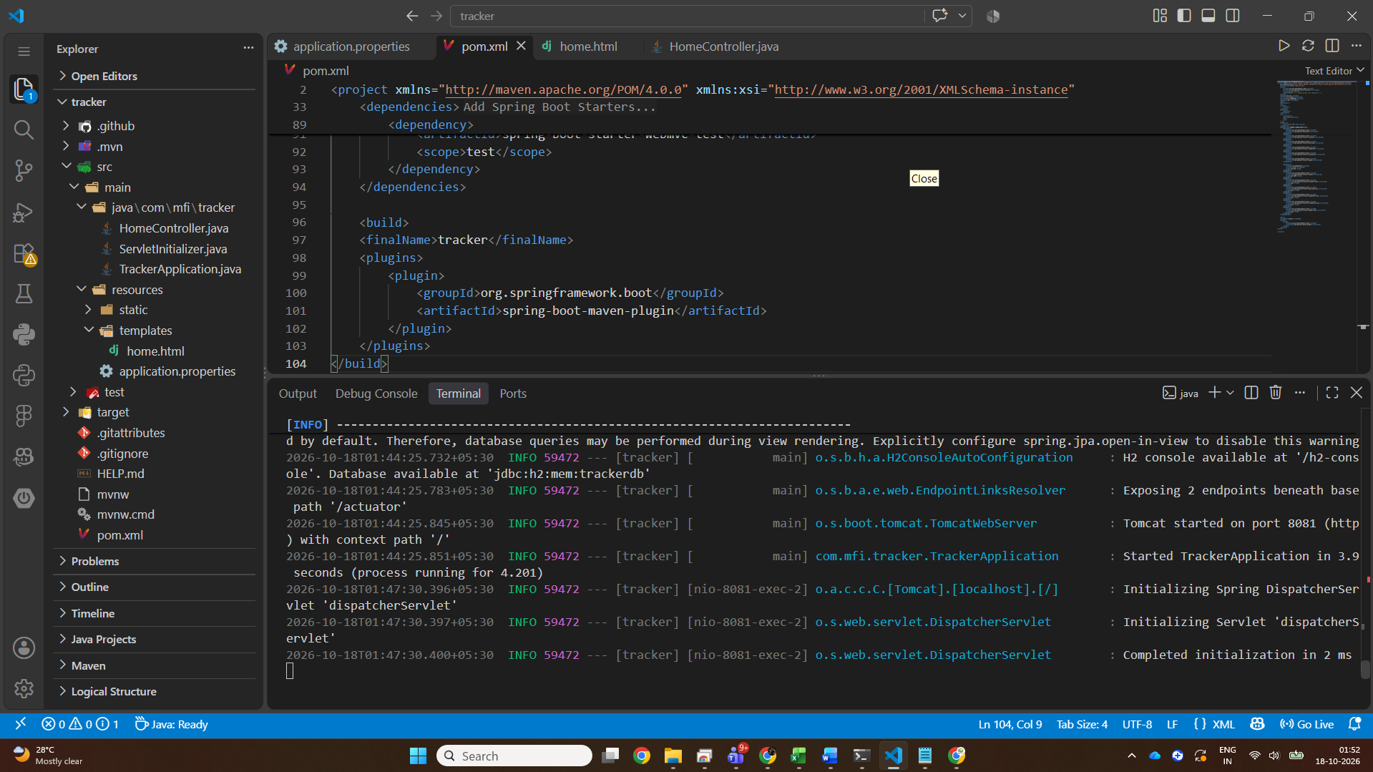

Evidence 4: Application running locally
Shows: Browser showing http://localhost:8081/ with the home page
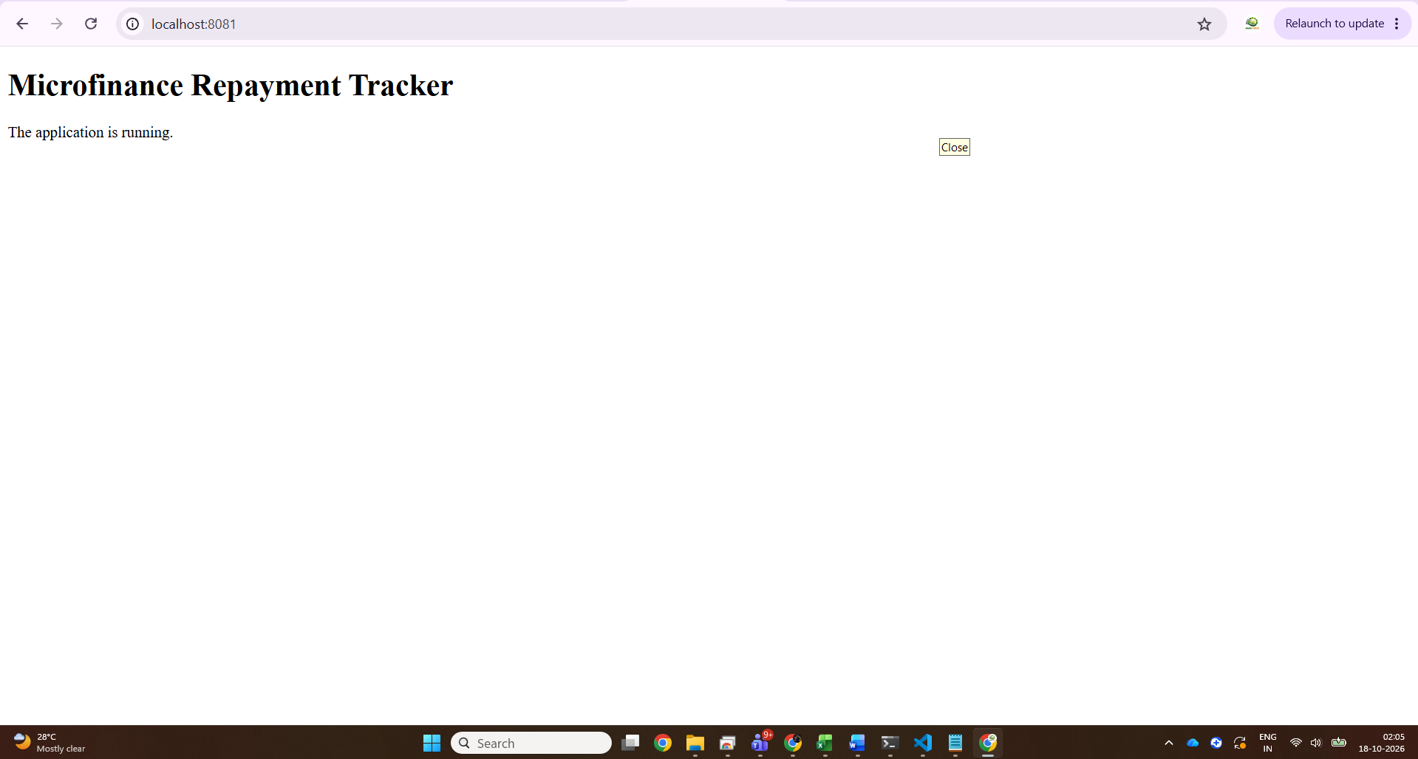

Evidence 5: Health check
Shows: Browser showing http://localhost:8081/actuator/health with status UP
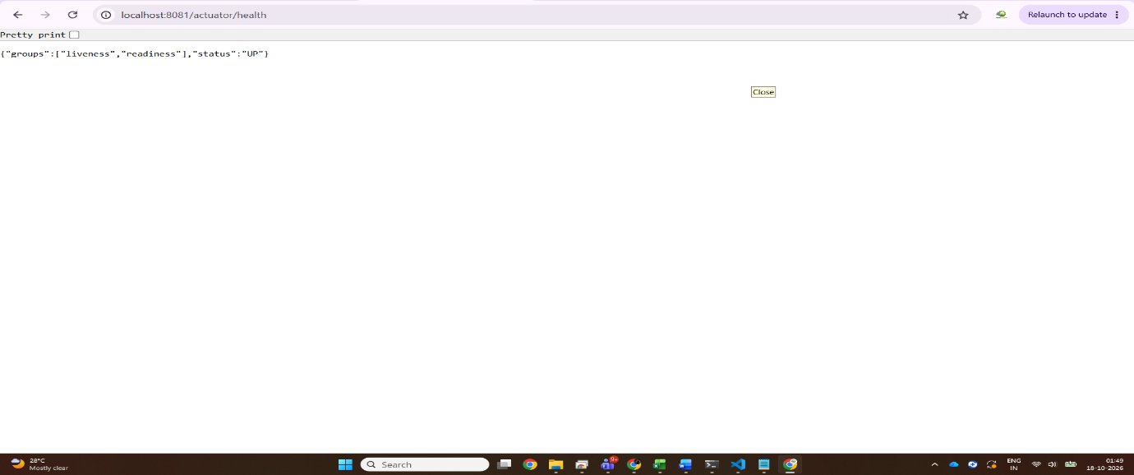

Evidence 6: WAR deployed on Tomcat 11
Shows: Browser showing http://localhost:8081/tracker/ after deploying tracker.war
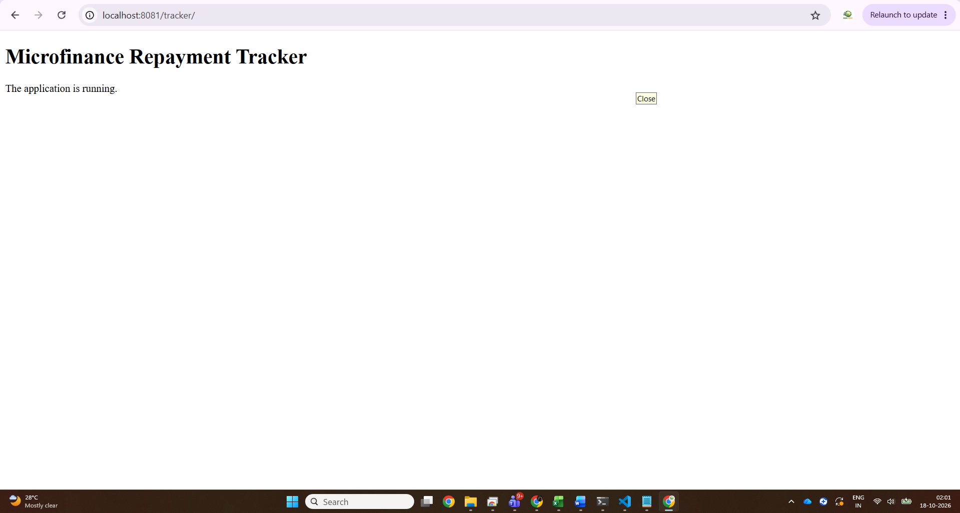

Evidence 7: Task Board After Task 3 (Tasks 1 to 3 in Done)
Shows: GitHub Projects board showing T1, T2 and T3 in Done
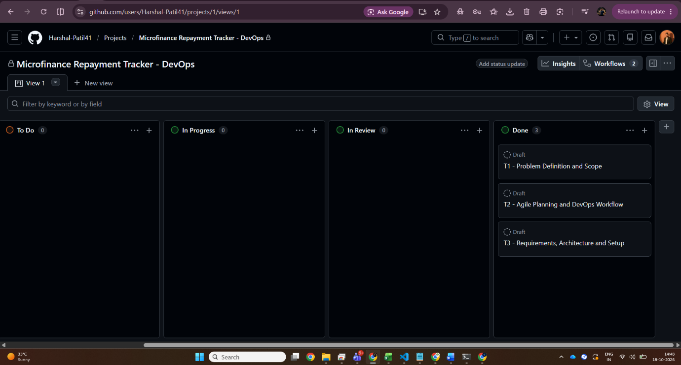
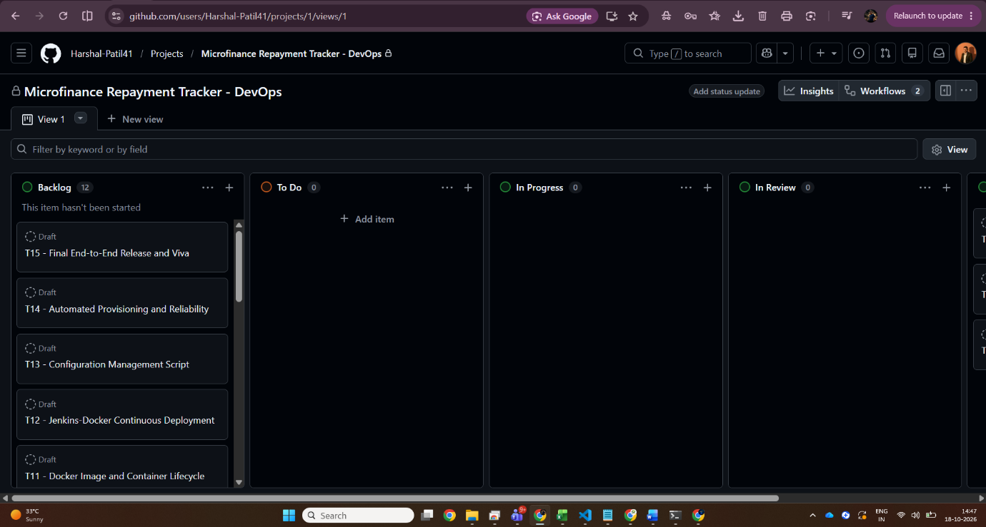

References
- Spring Boot reference, System Requirements, docs.spring.io/spring-boot/system-requirements.html
- Spring Initializr, start.spring.io
- Thymeleaf documentation, thymeleaf.org
- Apache Tomcat 11 documentation, tomcat.apache.org/tomcat-11.0-doc
- Apache Maven documentation, maven.apache.org
- H2 Database Engine, h2database.com
- Eclipse Temurin JDK, adoptium.net

