DevOps Project
Ansible-Provisioned Microfinance Repayment Tracker
Task 2: Agile Planning and DevOps Workflow
Field | Details
Student Name | Harshal Suresh Patil
Roll No. | 23102A0041
Branch | CMPN-A
Subject | DevOps
Faculty Name | Snehal Andhere
College / University | Vidyalankar Institute of Technology, Wadala, Mumbai
Academic Year | 2026-27
Submission Date | [DD/MM/YYYY]

Contents
1. Introduction
2. Agile Approach and Roles
3. User Stories and Acceptance Criteria
4. Product Backlog
5. Sprint Plan
6. 15-Task Kanban Board
7. Definition of Ready and Definition of Done
8. DevOps Lifecycle and Workflow Diagram
Appendix A: Task Board Evidence
References
Deliverable covered: Backlog, task board, sprint plan, Definition of Done and DevOps workflow diagram.

1. Introduction
Task 1 defined the problem (repayment data kept in manual, scattered records) and froze a small MVP of five features and 15 tasks. This document turns that frozen scope into a plan that can be executed: user stories with acceptance criteria, a prioritised product backlog, a sprint plan, a Kanban task board, a Definition of Done and a DevOps lifecycle diagram that shows how code travels from development to operations.
The plan keeps the scope frozen in Task 1. It adds no new features. It only organises the same work so that progress can be tracked and every task produces evidence.

2. Agile Approach and Roles
The project uses a lightweight Scrum plan (five short sprints) together with a Kanban board for day-to-day tracking. Because this is a single-developer academic project, one person plays every role, and the ceremonies are kept small.

2.1 Roles
Role | Played by | Responsibility
Product Owner | Student (for stakeholder needs) | Owns the backlog and decides priority within the frozen scope
Development team / DevOps engineer | Student | Builds, tests, packages and deploys the application
Scrum Master | Student | Keeps the board current and removes blockers
Stakeholder / reviewer | Faculty | Reviews deliverables and approves scope changes

2.2 Ceremonies (kept small)
Ceremony | When | Output
Sprint planning | Start of each sprint | Sprint goal and the tasks pulled onto the board
Daily check | Each working day (5 minutes) | One line in the project log: done, next, blocked
Sprint review | End of each sprint | Demo and evidence (screenshots, logs) for the sprint's tasks
Retrospective | End of each sprint | Three lines in the README or log: what went well, what did not, what to change

2.3 Estimation and priority
- Effort is estimated in story points using the Fibonacci scale (1, 2, 3, 5, 8). One point is roughly a small, well-understood piece of work.
- Priority uses MoSCoW: Must have, Should have, Could have. All items remain inside the scope frozen in Task 1.

3. User Stories and Acceptance Criteria
Each story follows the format "As a <user>, I want <goal>, so that <benefit>". Acceptance criteria are written as testable Given / When / Then statements so that they can later become Selenium test cases (Task 9).

3.1 Application stories (MVP features 1 to 5)
ID / Priority | User story | Acceptance criteria
US1  Must, 3 pts  Task 5 | As a loan officer, I want to add a borrower with name, phone and village, so that I can start a loan record for them. | Given the add-borrower form, when I submit valid details, then the borrower appears in the list.  When the name is empty, then the form shows an error and nothing is saved.
US2  Must, 5 pts  Task 6 | As a loan officer, I want to create a loan for a borrower with an amount, start date and number of installments, so that a repayment schedule is generated. | Given an existing borrower, when I create a loan of 10 weekly installments, then 10 repayment rows are created with due dates.  When the amount is zero or negative, then the loan is rejected with a message.
US3  Must, 5 pts  Task 6 | As a loan officer, I want to record a repayment against an installment, so that the borrower's status is always up to date. | Given an installment of Rs 500, when I record Rs 500 paid, then its status becomes PAID.  When I record less than the amount due, then it stays PENDING (or OVERDUE if the due date has passed).
US4  Must, 3 pts  Task 6 | As a loan officer, I want to search the dashboard by borrower name, so that I can find a loan and its status quickly. | Given 20 borrowers, when I type part of a name, then only matching rows are shown in under 5 seconds.  When nothing matches, then a "No records found" message is shown.
US5  Must, 5 pts  Task 6 | As a branch manager, I want summary indicators (total disbursed, total collected, overdue count, collection rate), so that I can judge branch performance at a glance. | Given the entered data, when I open the dashboard, then the totals match the data exactly (100%).  Collection rate = total collected / total due, shown as a percentage.
US6  Should, 3 pts  Task 6 | As a branch manager, I want to click Paid, Pending or Overdue and see the matching repayments, so that I can follow up on late accounts. | Given the dashboard, when I click Overdue, then only OVERDUE repayments are listed, in 2 clicks or fewer.
US7  Should, 5 pts  Task 6 | As a branch manager, I want an alert view of repayments overdue by more than 7 days and of invalid or missing payments, so that exceptions do not go unnoticed. | Given a repayment 8 days past due, when I open the alert view, then it is listed.  A repayment 5 days past due is not listed.  A repayment with a missing or negative amount is flagged as invalid.

3.2 DevOps stories
ID / Priority | User story | Acceptance criteria
US8  Must, 5 pts  Tasks 7-8 | As a developer, I want Jenkins to build and package the application on every commit and deploy it to Tomcat, so that releases are repeatable. | Given a new commit on develop, when Jenkins polls the repository, then it builds, archives the WAR file and deploys it.  The environment (dev/test) is selectable through a pipeline parameter.
US9  Must, 5 pts  Task 10 | As a developer, I want failing Selenium tests to stop the deployment, so that broken code never reaches the server. | Given a deliberately introduced defect, when the pipeline runs, then the Test stage fails and the Deploy stage does not run.  After the fix, the rerun is green and the deployment completes.
US10  Must, 5 pts  Tasks 11-12 | As a DevOps engineer, I want a versioned Docker image built, pushed to a registry and run automatically, so that the same package runs everywhere. | Given passing tests, when the pipeline reaches Docker stages, then an image tagged with the build number is pushed and a fresh container replaces the old one.  The app is reachable on the container port (8082).
US11  Must, 8 pts  Tasks 13-14 | As a system administrator, I want Ansible to provision a clean server and deploy the application, so that setup is automated, repeatable and reversible. | Given a clean node, when I run the playbook, then Docker is installed and the app container runs.  A second run shows changed=0 (idempotent).  A health check returns HTTP 200, and rerunning with the previous version restores the old release (rollback).

Note: US1 to US7 are the five MVP features frozen in Task 1 (data entry is split into US1 to US3). US6 and US7 are marked Should only to order the work inside the sprint; they remain in the frozen scope.

4. Product Backlog
The backlog lists every item of work, ordered by priority. Technical and documentation items are included because each of the 15 tasks must produce a deliverable.
ID | Backlog item | Type | Priority | Pts | Sprint | Task | Status
TB0 | Problem definition and scope document | Task | Must | 2 | 1 | 1 | Done
TB6 | User stories, backlog, board, DoD, DevOps diagram | Task | Must | 3 | 1 | 2 | Done
TB2 | SRS, architecture, ER diagram, local setup | Task | Must | 5 | 1 | 3 | Done
TB1 | GitHub repository, README, branch policy | Task | Must | 3 | 2 | 4 | To do
US1 | Add borrower | Story | Must | 3 | 2 | 5 | To do
US2 | Create loan and schedule | Story | Must | 5 | 2 | 6 | To do
US3 | Record repayment | Story | Must | 5 | 2 | 6 | To do
US4 | Searchable dashboard | Story | Must | 3 | 2 | 6 | To do
US5 | Summary indicators | Story | Must | 5 | 2 | 6 | To do
US6 | Status drill-down | Story | Should | 3 | 2 | 6 | To do
US7 | Alert / exception view | Story | Should | 5 | 2 | 6 | To do
US8 | Jenkins CI job and pipeline as code | Story | Must | 5 | 3 | 7-8 | To do
TB3 | Selenium test design and local run | Task | Must | 8 | 3 | 9 | To do
US9 | Selenium quality gate in Jenkins | Story | Must | 5 | 4 | 10 | To do
US10 | Docker image and Jenkins-Docker CD | Story | Must | 5 | 4 | 11-12 | To do
US11 | Ansible provisioning and reliability | Story | Must | 8 | 5 | 13-14 | To do
TB5 | Final release, report, demo and viva | Task | Must | 5 | 5 | 15 | To do

Total estimate: 78 story points. The backlog is updated at the end of every sprint (a requirement of Task 6, "updated backlog").

5. Sprint Plan
The 15 tasks are grouped into five sprints that match the project phases from Task 1. Durations are suggestions and can be stretched or compressed to fit the semester.
Sprint | Tasks | Sprint goal | Backlog items | Points | Suggested duration
Sprint 1 | 1 to 3 | Plan the project and set up the development environment | TB0, TB6, TB2 | 10 | 1 week
Sprint 2 | 4 to 6 | Put the code under Git and build the complete MVP | TB1, US1 to US7 | 32 | 2 weeks
Sprint 3 | 7 to 9 | Automate the build and design the Selenium tests | US8, TB3 | 13 | 1 week
Sprint 4 | 10 to 12 | Add the quality gate and containerise the release | US9, US10 | 10 | 1 week
Sprint 5 | 13 to 15 | Provision with Ansible, prove reliability, release | US11, TB5 | 13 | 2 weeks

Sprint 2 is the heaviest because it holds the whole application. The features are small CRUD pages, and the plan is to build and merge feature 1 first (Task 5) so that the remaining work in Task 6 follows an established pattern.

Definition of each sprint's exit evidence
Sprint | Evidence collected at the sprint review
Sprint 1 | This document, SRS and diagrams, board screenshot, application running on localhost
Sprint 2 | Repository URL, pull request and merge screenshots, resolved conflict, tag v1.0, updated backlog
Sprint 3 | Jenkins build log, archived WAR, Jenkinsfile run, deployed URL, Selenium test plan and local report
Sprint 4 | Failed and passed pipeline runs, defect-fix commit, Dockerfile, registry evidence, commit-to-container run
Sprint 5 | Playbook and logs, idempotency (changed=0), health check, rollback demo, final report, PPT and viva notes

6. 15-Task Kanban Board
The board is created in GitHub Projects (Board view) or Trello. It has five columns and one card per task, so progress is visible at a glance.

6.1 Board design
Column | WIP limit | Meaning
Backlog | none | All 15 task cards that are not yet planned for the current sprint
To Do (sprint) | none | Cards committed for the current sprint
In Progress | 2 | Work being done now; the limit stops starting too many things at once
In Review / Testing | 2 | Work finished and waiting for its checks (self-review, pull request, tests)
Done | none | Meets the Definition of Done in Section 7, with evidence attached

Each card has: the task number and title, a sprint label (Sprint 1 to 5), a checklist of the key activities from the task description, and a link to its evidence (screenshot, commit or log) when done.

6.2 Board at the start of Task 2 (planned snapshot)
# | Card | Sprint | Column
1 | Problem Definition and Scope | Sprint 1 | Done
2 | Agile Planning and DevOps Workflow | Sprint 1 | In Progress
3 | Requirements, Architecture and Setup | Sprint 1 | To Do (Backlog)
4 | Git and GitHub Initialization | Sprint 2 | To Do (Backlog)
5 | Feature Development with Branching | Sprint 2 | To Do (Backlog)
6 | MVP Completion and Git Collaboration | Sprint 2 | To Do (Backlog)
7 | Jenkins Installation and CI Job | Sprint 3 | To Do (Backlog)
8 | Pipeline as Code and Deployment | Sprint 3 | To Do (Backlog)
9 | Selenium Test Design | Sprint 3 | To Do (Backlog)
10 | Continuous Testing in Jenkins | Sprint 4 | To Do (Backlog)
11 | Docker Image and Container Lifecycle | Sprint 4 | To Do (Backlog)
12 | Jenkins-Docker Continuous Deployment | Sprint 4 | To Do (Backlog)
13 | Configuration Management Script | Sprint 5 | To Do (Backlog)
14 | Automated Provisioning and Reliability | Sprint 5 | To Do (Backlog)
15 | Final End-to-End Release and Viva | Sprint 5 | To Do (Backlog)

6.3 How the board is used
- Pull a card to In Progress only when fewer than 2 cards are already there.
- Move a card to Done only when every point of the Definition of Done is met and the evidence is attached.
- At each sprint review, take a screenshot of the board and add it to the evidence section (Appendix A).

7. Definition of Ready and Definition of Done

7.1 Definition of Ready (a card may enter a sprint when)
- It has a clear title, a short description and acceptance criteria.
- Its effort is estimated in story points.
- Its dependencies (earlier tasks, tools installed) are available.

7.2 Definition of Done (a card is Done when)
The following common points apply to every card:
- The work meets every acceptance criterion of the story or task.
- The code or script is committed to Git with a meaningful commit message, on a feature branch, and merged through a pull request.
- The change was reviewed (peer review, or a documented self-review checklist when working alone).
- Automated checks pass: the build succeeds and all existing tests pass.
- The change runs correctly on the target environment (local, Tomcat or container as applicable).
- Documentation is updated: README, notes or this backlog.
- Evidence is saved (screenshot, log or report) and linked on the board card.
- The card is moved to Done and the backlog status is updated.

7.3 Extra checks by type of work
Type of work | Additional Done criteria
Application feature | Validated input; works with dummy data; a Selenium or manual test case exists for the main journey
Jenkins / pipeline | Jenkinsfile is committed to the repository; build log is archived; a failing test or build stops the pipeline
Docker | Image is tagged with a version; container starts, answers on its port and can be stopped and removed cleanly
Ansible | Playbook runs without errors; a second run shows changed=0; the health check returns HTTP 200
Documentation | Spelling checked, diagrams readable, references listed, file saved in the docs folder of the repository

8. DevOps Lifecycle and Workflow Diagram
DevOps joins development and operations in one continuous loop. Figure 1 shows the eight stages of the lifecycle and the tool and task that covers each stage in this project. The red arrow shows feedback from operations back into planning.
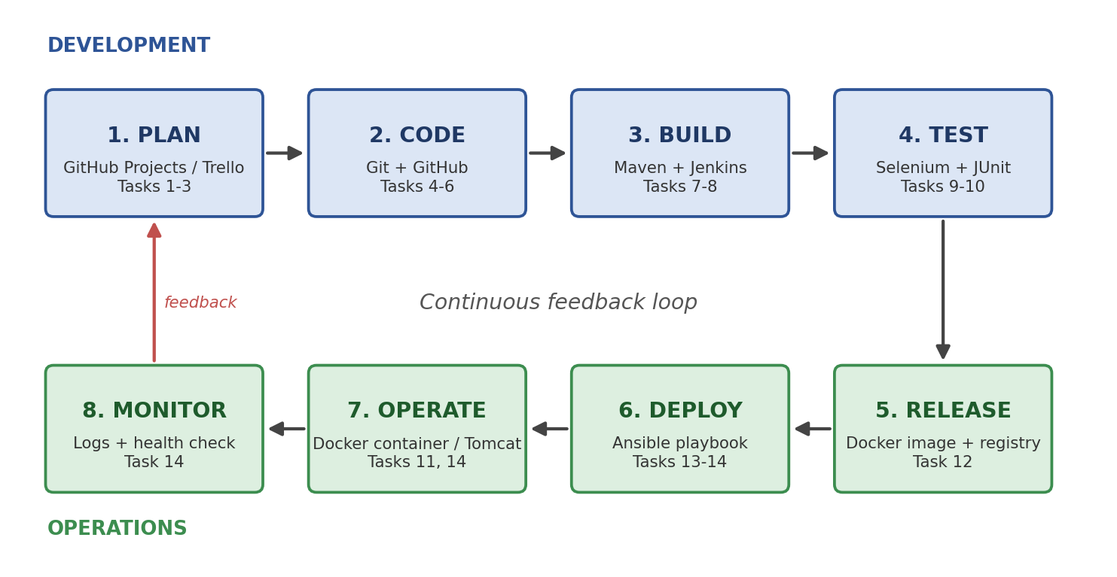
Figure 1: DevOps lifecycle for the Microfinance Repayment Tracker
Stage | Tool | Task | Output / evidence
Plan | GitHub Projects or Trello | 1 to 3 | Backlog, board, SRS
Code | Git and GitHub | 4 to 6 | Repository, pull requests, tag v1.0
Build | Maven and Jenkins | 7 to 8 | WAR artefact, Jenkinsfile run
Test | Selenium WebDriver with JUnit | 9 to 10 | Test report, failing-test gate
Release | Docker and a registry | 11 to 12 | Versioned image
Deploy | Ansible | 13 to 14 | Playbook, provisioned node
Operate | Docker container or Tomcat | 11, 14 | Running application
Monitor | Container logs and health check | 14 | HTTP 200 result, rollback proof

Figure 2 shows the automated path a single commit follows. A failed test stops the pipeline before deployment, and a failed health check triggers a rollback to the previous stable version.
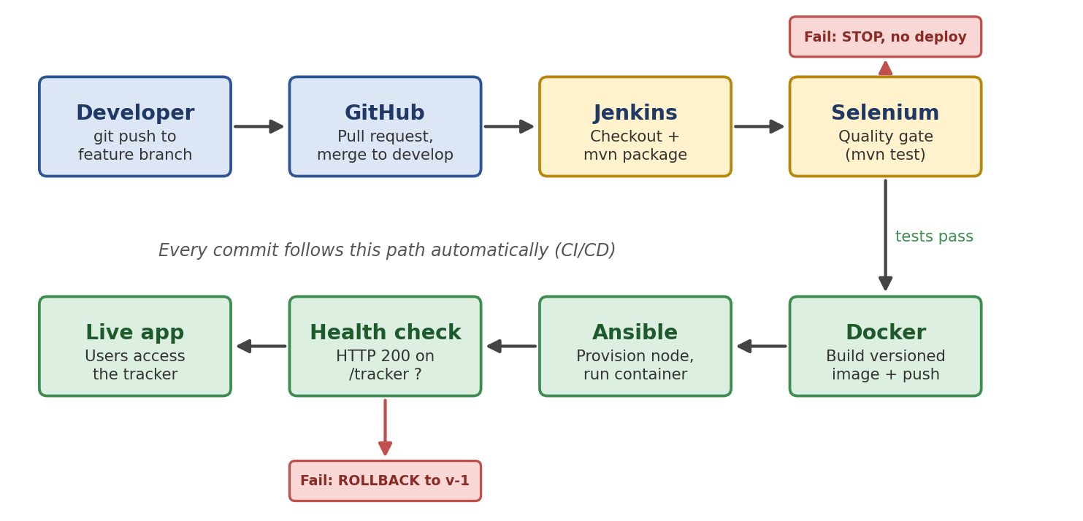
Figure 2: Commit-to-deployment pipeline with quality gate and rollback

8.1 Branching and commit rules
Item | Rule
Branches | main holds stable, tagged releases; develop is the integration branch; each piece of work uses feature/<short-name> created from develop
Pull requests | Every feature branch is merged into develop through a pull request after a review and a green Jenkins build
Commit messages | Prefix with feat:, fix:, test:, docs: or chore: followed by a short description, for example feat: add borrower entry form
Ports | Jenkins 8080, Tomcat 8081, Docker container 8082 (no clashes)

Appendix A: Task Board Evidence
The board is shown in two parts because of screen size. Each part shows the project name and the column counts. Evidence 1: Task board at the start (all cards created)
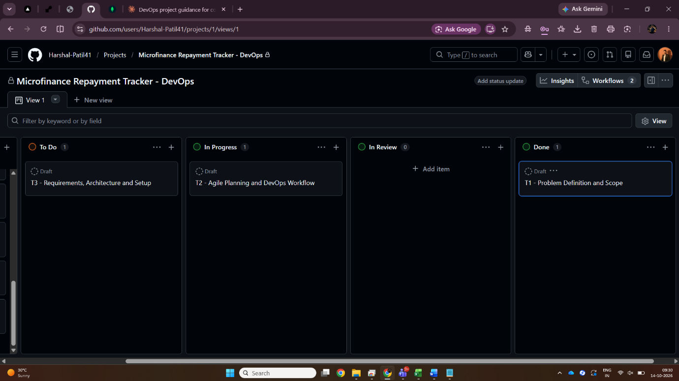
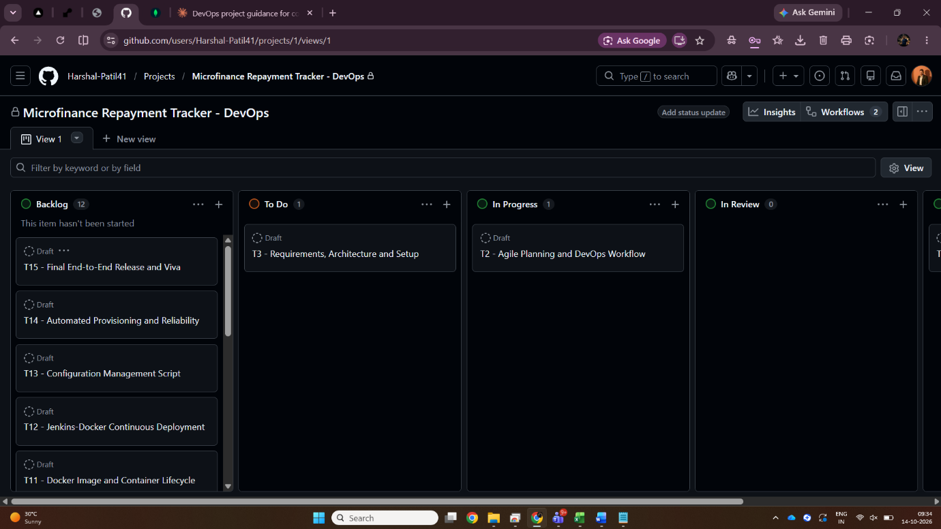

Evidence 2: Task board at submission (Tasks 1 and 2 in Done)
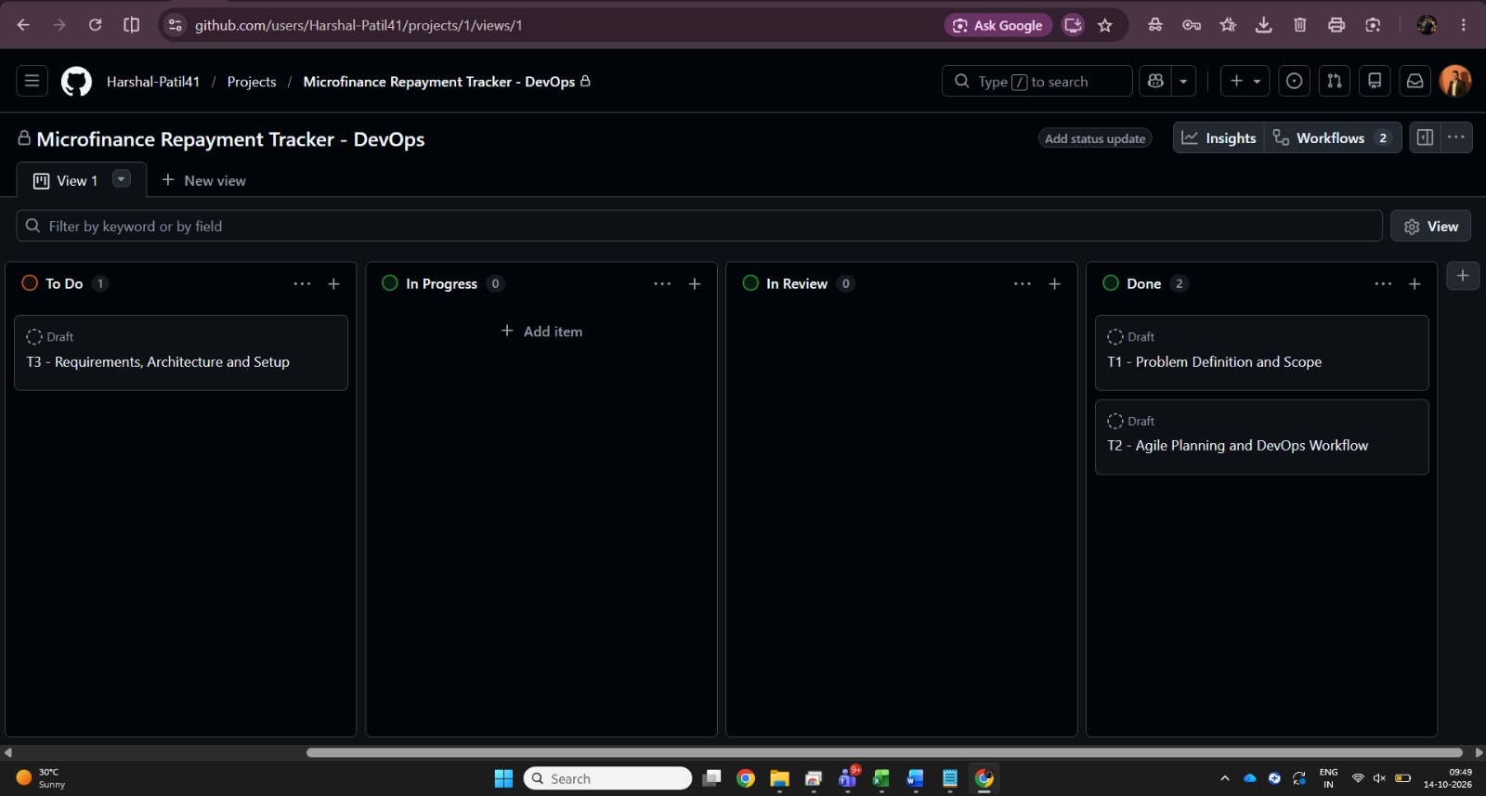
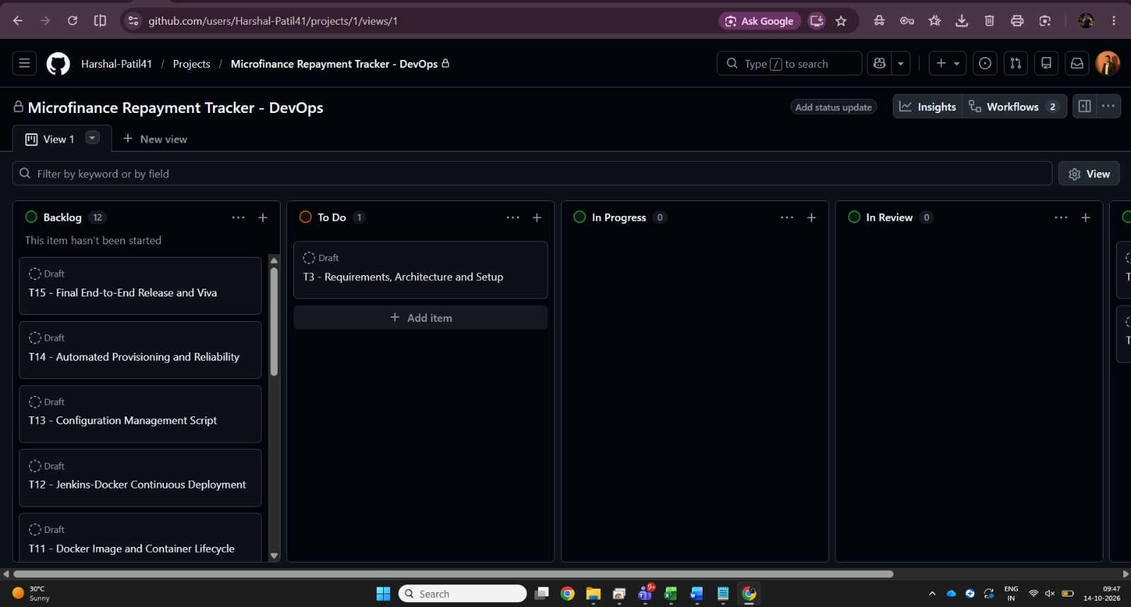
Kanban board at submission, shown in two parts. Part 1: Backlog (12 cards, T4 to T15), To Do (T3), In Progress (none), In Review (none). Part 2: To Do (T3), In Progress (none), In Review (none), Done (T1 and T2). Accessed on 14/10/2026.

References
- The Scrum Guide, scrumguides.org
- GitHub Docs, Planning and tracking with Projects, docs.github.com
- Atlassian, Kanban resources, atlassian.com/agile/kanban
- Atlassian, What is DevOps, atlassian.com/devops
- Jenkins documentation, jenkins.io/doc
- Ansible documentation, docs.ansible.com

