
CREDIT CARD STATEMENT

15112020_1
MR NAYANI SAGAR
H.NO 4-31, HONNAJIPET
DHARPALLY, NIZAMABAD

Download the iMobile app to -
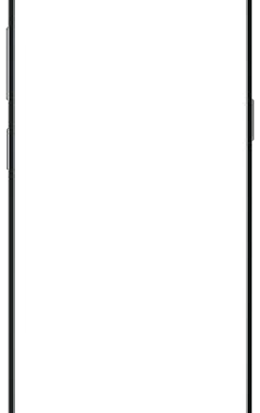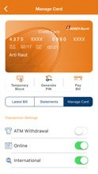View statement instantly
Block/unblock ATM withdrawal, online transactions & international transactions in a single click

Scan to Download

SMS iMobile to 5676766 to get the download link or give a missed call on 9222299998 to get assistance on call.

STATEMENT DATE

June 22, 2024

T&C apply

All communications are being sent to your registered e-mail ID and mobile number
- To update email ID and registered mailing address, visit www.icicibank.com > Login > Customer Service > Service Requests > Credit Card > Request for address change or visit the nearest ICICI Bank

PAYMENT DUE DATE

July 22, 2024

branch
- To update mobile number, visit the nearest ATM or branch

Scan to Pay using
Any Upi

STATEMENT SUMMARY



Total Amount due

`90,567.90

Minimum Amount due

`11,810.00
Interest will be charged if your total amount due is not paid

Previous Balance Purchases / Charges Cash Advances Payments / Credits
= + + -
`42,136.00 `1,18,303.90 `0.00 `69,872.00

CREDIT SUMMARY

Credit Limit (Including cash) Available Credit (Including cash) Cash Limit Available Cash

`1,20,000.00 `2,885.50 `18,000.00 `2,885.50

SPENDS OVERVIEW
02/07/2020 | 4598236064 | UPI Payment Received | 0 | 1,000.00 CR
03/07/2020 | 4598236633 | UPI Payment Received | 0 | 1,000.00 CR
03/07/2020 | 4598237294 | UPI Payment Received | 0 | 1,000.00 CR
04/07/2020 | 4598237841 | UPI Payment Received | 0 | 1,000.00 CR
06/07/2020 | 4598238320 | UPI Payment Received | 0 | 1,000.00 CR
08/07/2020 | 4598239140 | UPI Payment Received | 0 | 5,200.00 CR
08/07/2020 | 4598239443 | UPI Payment Received | 0 | 9.00 CR
09/07/2020 | 4598239958 | UPI Payment Received | 0 | 7.00 CR
10/07/2020 | 4598240518 | UPI Payment Received | 0 | 13.00 CR
10/07/2020 | 4598241537 | UPI Payment Received | 0 | 8.00 CR
10/07/2020 | 4598242275 | UPI Payment Received | 0 | 5.00 CR
10/07/2020 | 4598243250 | UPI Payment Received | 0 | 5.00 CR

Date SerNo. Transaction Details Reward Points

Intl.# amount

Amount (in`)

100%

Others-100%

Get 2.5% cashback and savings of 1% surcharge on fuel spends with ICICI Bank
15/07/2020 | 4611958898 | REL RETAIL LTD-DIGITAL HYDERABAD IN | -450 | 22,500.00 CR
18/07/2020 | 4611964239 | INSTANT EMI OFFUS CONVERSION | 0 | 0.00 CR

4375XXXXXXXX4006

22/06/2020 | 4566690290 | RELIANCE DIGITAL HYDERABAD IN | 530 | 26,499.00
29/06/2020 | 4586912601 | UPI Payment Received | 0 | 2,000.00 CR
28/06/2020 | 4588191045 | AMAZON HTTP://WWW.AM IN | 162 | 8,099.10

HPCL | Credit Card |  | 13/07/2020 | 4607470614 | REL RETAIL LTD-DIGITAL HYDERABAD IN | 450 | 22,500.00
KNOW MORE | T&C apply.
 |  |  | 22/07/2020 | 4611964240 | Interest Amount Amortization - <1/3> | 0 | 243.56

For ICICI Bank Limited| Amarjit S. Walia | Head - Consumer & Commercial Cards

1/1

For detailed summary of Reward Points, please click here
Points Earned | Points Transferred to PAYBACK | PAYBACK  Account Number
1762 | 1762 | 9401164815200001

ICICI Bank Credit Card GST Number: 27AAACI1195H3ZK HSN Code: 9971 Financial and Related Services
Statement period : October 16, 2020 to November 15, 2020 Place of supply: Maharashtra
State Code: 27

For any query, you may write to us on customer.care@icicibank.com or call us at 1860 120 7777.

IMPORTANT MESSAGES
- Safe Banking Tips -
- Our registered office address: ICICI Bank Tower, Near Chakli Circle, Old Padra Road, Vadodara, 390 007.
- Making only minimum payment every month can lead to repayment stretching over years with consequent interest payment on outstanding balance.
- Please pay your Credit Card outstanding before the payment due date to avoid penal fees and interest charges.
- For any clarification or more information, you may contact us through the ‘Get in Touch’ option at www.icicibank.com
- Mark-up fee and corresponding GST levied is included in the transaction amount displayed.
- For Visa/Mastercard Credit Cards: Fuel surcharge and corresponding Goods and Services Tax (GST) levied is included in the transaction amount displayed.
- Payment through UPI is subject to the limits set by respective payment service providers.

Date | SerNo. | Transaction Details | Reward Points | Intl.# amount | Amount (in`)
06/07/2020 | 4611964241 | SGST-CI@9% | 0 |  | 21.92
06/07/2020 | 4611964244 | CGST-CI@9% | 0 |  | 21.92
06/07/2020 | 4611964250 | Principal Amount Amortization - <1/3> | 0 |  | 7,419.40
10/07/2020 | 4622891364 | Flipkart Internet Priv BANGALORE IN | 140 |  | 6,999.00
13/17/2020 | 4630382456 | RELIANCE DIGITAL HYDERABAD IN | 930 |  | 46,500.00
4375XXXXXXXX4105
1/1
28/06/2020 | 4586187640 | UPI Payment Received | 0 | 5,000.00 CR
28/06/2020 | 4586187713 | UPI Payment Received | 0 | 13.00 CR
28/06/2020 | 4586616481 | UPI Payment Received | 0 | 5,001.00 CR
28/06/2020 | 4586616553 | UPI Payment Received | 0 | 14.00 CR
02/07/2020 | 4597454579 | UPI Payment Received | 0 | 1,000.00 CR
06/07/2020 | 4597455177 | UPI Payment Received | 0 | 1,000.00 CR
08/07/2020 | 4597455732 | UPI Payment Received | 0 | 1,000.00 CR
10/07/2020 | 4597456234 | UPI Payment Received | 0 | 1,000.00 CR
10/07/2020 | 4597456656 | UPI Payment Received | 0 | 1,000.00 CR
10/07/2020 | 4597457112 | UPI Payment Received | 0 | 7.00 CR
10/07/2020 | 4597458004 | UPI Payment Received | 0 | 5,000.00 CR
13/07/2020 | 4597459574 | UPI Payment Received | 0 | 20.00 CR
14/07/2020 | 4597476373 | UPI Payment Received | 0 | 12.00 CR
14/07/2020 | 4597482360 | UPI Payment Received | 0 | 6.00 CR
16/07/2020 | 4597489209 | UPI Payment Received | 0 | 9.00 CR
16/07/2020 | 4597490199 | UPI Payment Received | 0 | 6.00 CR
16/07/2020 | 4597490909 | UPI Payment Received | 0 | 5,000.00 CR
16/07/2020 | 4597492046 | UPI Payment Received | 0 | 5,000.00 CR
16/07/2020 | 4597497936 | UPI Payment Received | 0 | 11.00 CR
18/07/2020 | 4597505459 | UPI Payment Received | 0 | 13.00 CR
18/07/2020 | 4598170209 | UPI Payment Received | 0 | 5,000.00 CR
18/07/2020 | 4600771444 | UPI Payment Received | 0 | 13.00 CR
# International Spends

EMI / PERSONAL LOAN ON CREDIT CARDS

Transaction/ LoanType | Creation Date | Finish Date | No. of Installments | EMI/Loan Amount | Pending Installments | Outstanding Amount* | Monthly Installment Amount
Merchant EMI conversions | 06/06/2024 | 06/08/2024 | 3 | 22,500.00 | 1 | 7,662.96 | 7,662.96
*For EMI Purchases and Loans within Credit Card limit, the credit limit of the credit card will be blocked by the amount which is equal to outstanding amount + Applicable Taxes and fees.
*For loan on Credit Card-over the limit (PLCC OTL), the credit limit of the credit card will be blocked by the amount which is equal to billed EMI/EMIs + Applicable Taxes and fees.

MOST IMPORTANT TERMS AND CONDITIONS (MITC)
1/1

To get the complete version of Credit Cards – Most Important Terms and Conditions (MITC), please visit:

ICICI Bank Website>Products>Credit Cards>Terms and Conditions and FAQs>Most Important Terms and Conditions
Or visit the link: https://www.icicibank.com/managed-assets/docs/personal/cards/MITC_cc.pdf

GREAT OFFERS ON YOUR CARD


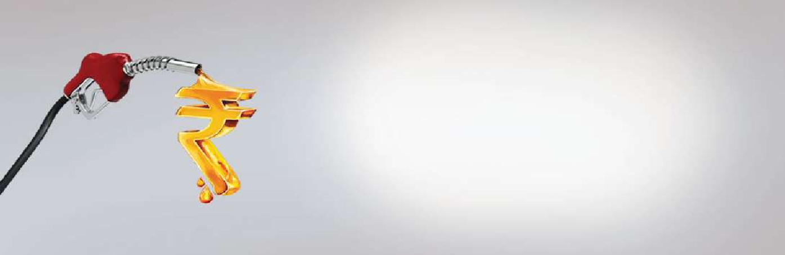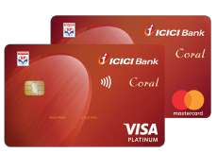
Save on fuel spends with ICICI Bank HPCL
Credit Card
Get 2.5% cashback and savings of 1% surcharge on fuel spends

KNOW MORE
* Terms and Conditions apply.


1/1
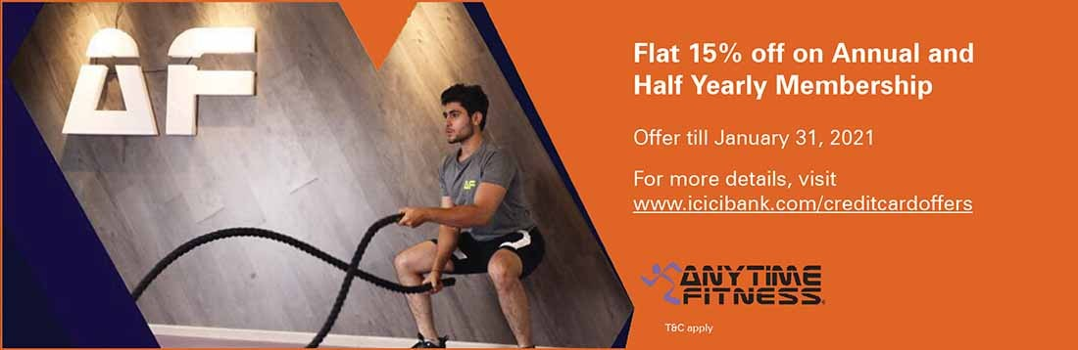
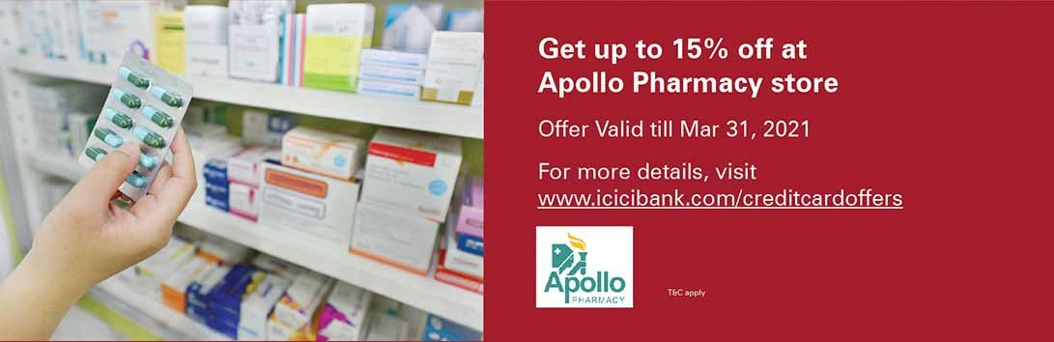

Avail of No Cost* EMI on WhiteHat Jr courses
Offer valid on ICICI Bank Credit Card EMI
For more details, visit www.icicibank.com/emioffers Offer valid till 31st Dec’20
T&C apply

This is an authenticated intimation/statement. Customers are requested to immediately notify the Bank of any discrepancy in the statement.

