
B.Tech – Electronics and Communication Engineering

MICRO / MINI PROJECT REPORT
Course Code: BEC306P
Course Title: Digital Communication Systems Lab
Academic Year: 2026–27

TASK-AWARE DYNAMIC SEMANTIC COMPRESSION
FRAMEWORK FOR 6G DEEP JSCC

Submitted by
1. Harshal Yadav – 24BEC0639
2. Milind Sharma – 24BEC0078
3. P. Chaitanyaprasad – 24BEC0551
4. Abhrant R. Pal – 24BEC0545

Under the Guidance of
Dr. Thanikaiselvan V.
Professor Higher Academic Grade
School of Electronics Engineering

Contents
S. No. | Contents | Page No.
1 | Abstract | 3
2 | Motivation and Problem Identification | 3
3 | Novelty and Innovative Aspects | 3
4 | Design Methodology | 4
5 | Proposed Block Diagram / System Architecture | 5
6 | Project Implementation and Experimental Setup | 5
7 | Project Results and Discussion | 6
8 | Conclusion and Future Scope | 8
9 | References | 8
10 | Program Outcome (PO) Mapping with Justification | 10
11 | Washington Accord Complex Engineering Problem Solving Profile (WP) Mapping with Justification | 10
12 | Sustainable Development Goal (SDG) Mapping with Justification | 10
13 | Outcomes of the Project (If applicable) | 11

1. Abstract
This project presents a dual-mode semantic communication framework for traffic imagery in a 6G-style wireless link. It supports two receiver objectives using separate payload paths: a human-oriented path encodes an image with a frozen Stable Diffusion VAE and reconstructs it at the receiver, while a machine-oriented path maps the image to a 128-value semantic vector for highway-versus-urban classification. An additive white Gaussian noise (AWGN) channel is simulated over SNR values from −5 dB to 25 dB. The presentation reports human-mode PSNR from 8.86 dB at −5 dB to 26.34 dB at 25 dB, and machine-mode test accuracy between 71.7% and 75.0% across the tested SNR range (60 test images). The transmitted latent-value count is 16,384 for human mode and 128 for machine mode, compared with 786,432 raw image values. These figures demonstrate a reduction in representation size; they do not by themselves establish equal savings in physical radio bandwidth, latency, or energy. The digital-cliff comparison is conceptual rather than a measured digital baseline.

2. Motivation and Problem Identification

2.1 Motivation
Traffic-monitoring systems may transmit images to a human operator or to an automated system. These receivers do not always need the same information: a human needs a visually interpretable reconstruction, whereas a classifier may need only features that distinguish the scene class. Sending the full image in every case can consume unnecessary payload resources. The project therefore investigates a mode-selectable encoder and noisy channel that support reconstruction and classification with different representation sizes.

2.2 Problem statement
Design and evaluate a lightweight dual-mode image communication demonstrator that (i) reconstructs images for a human receiver, (ii) transmits a compact semantic vector for machine classification, and (iii) measures image fidelity, classification accuracy, and representation-size reduction under AWGN at multiple SNR values.

2.3 Existing limitations and engineering challenge
- A single pixel-reconstruction objective does not directly optimize machine-task performance.
- A task-only representation may not preserve the visual information needed by a human receiver.
- The channel adds noise to both representations, so fidelity and task accuracy must be measured across SNR.
- A conceptual digital-outage curve is not equivalent to a controlled comparison with a complete JPEG/BPG plus channel-coding baseline.
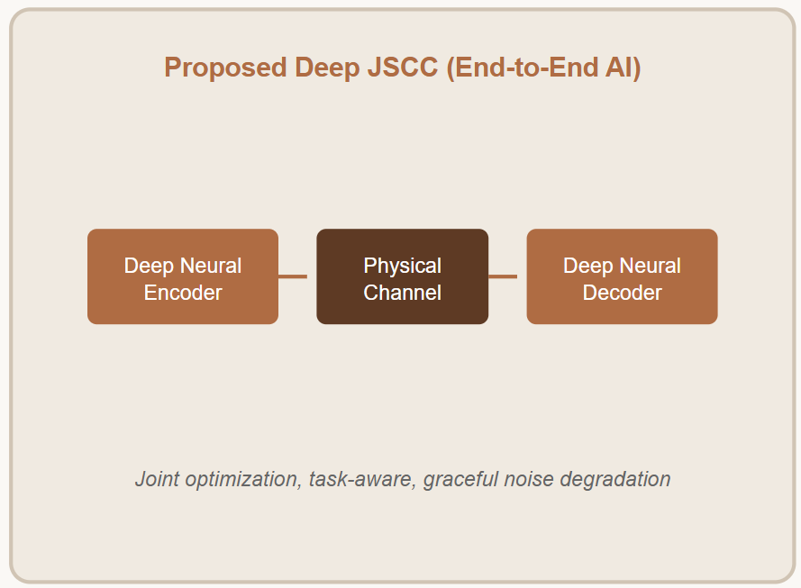
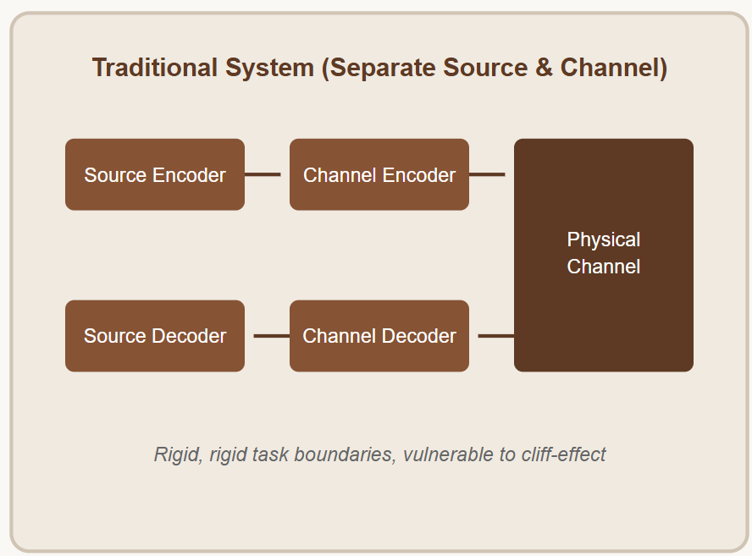
- Payload element counts are not a full physical-layer bandwidth or energy measurement.

Fig 1. Traditional vs JSCC approach

3. Novelty and Innovative Aspects
The project contribution is a practical, two-mode demonstrator rather than a claim of a fundamentally new JSCC theory. The reported distinguishing aspects are:
- Dual receiver objectives: human-mode image reconstruction and machine-mode highway/urban classification within one project workflow.
- Different payload sizes: 16,384 latent values for the VAE path and 128 values for the machine path.
- SNR-randomized training for the machine branch, drawing batch SNR from {25, 20, 15, 10, 5, 0, −5} dB.
- Evaluation across seven AWGN SNR points using PSNR for reconstruction and accuracy for classification.
- A payload-count comparison against the raw 512×512×3 image representation.
The presentation reports 97.92% fewer values for human mode and 99.98% fewer values for machine mode relative to the raw image. These are representation-size calculations, not verified end-to-end radio-resource savings. A novelty or patentability claim would require a separate prior-art analysis.

4. Design Methodology

4.1 Overall approach
The input is a 512×512×3 traffic image. A mode selector routes it to either the human branch or the machine branch. Both branches pass through a simulated AWGN channel. The human receiver decodes the noisy VAE latent into an image; the machine receiver applies a linear classifier to the noisy semantic vector.
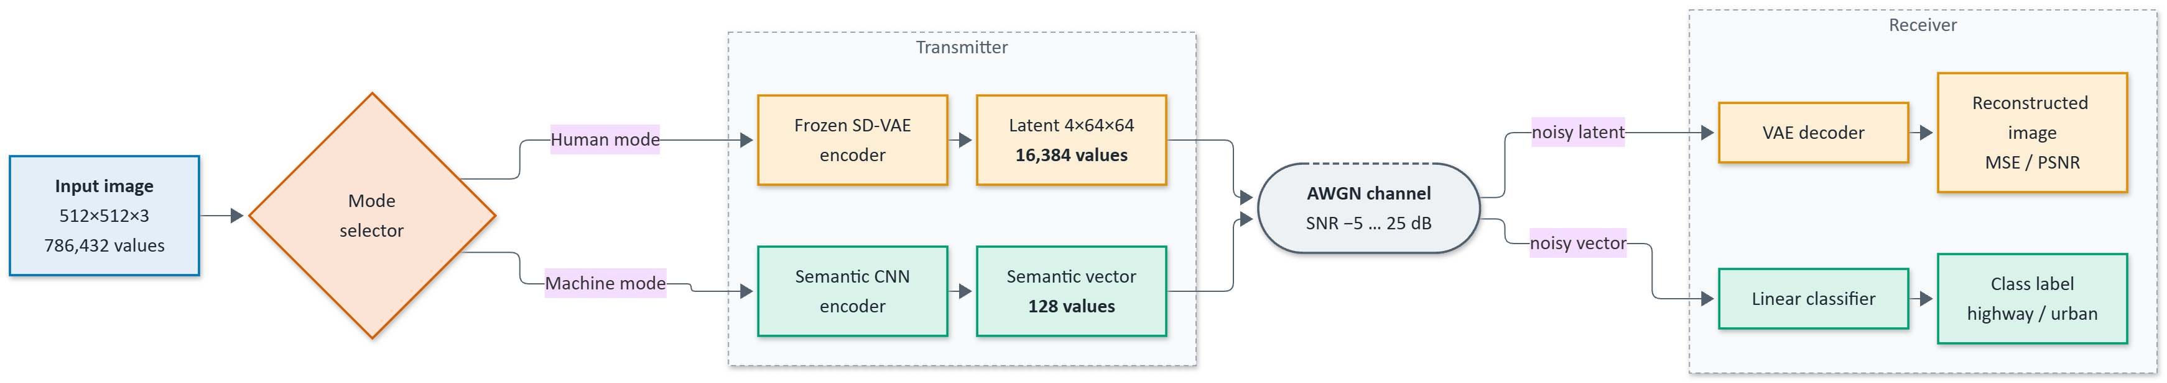
Fig 2. Overall dual-mode semantic communication system.

4.2 Human mode
The human path uses the pretrained stabilityai/sd-vae-ft-mse AutoencoderKL encoder and decoder. The encoder is frozen. The input image is mapped to a 4×64×64 latent tensor, equivalent to 16,384 values. The latent is scaled by 0.18215 before channel transmission and rescaled before decoding. Reconstruction quality is evaluated using mean squared error (MSE) and peak signal-to-noise ratio (PSNR).
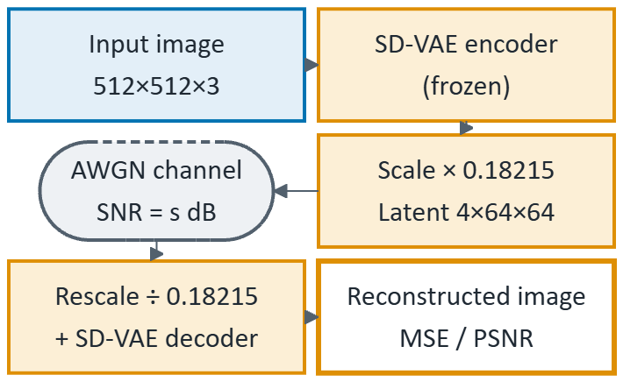
Fig 3. Human Mode Branch

4.3 Machine mode
The machine path uses a lightweight CNN. The slide deck specifies input 3×512×512 normalized to [−1, 1], followed by convolutional layers 3→24 (5×5, stride 4), 24→48 (3×3, stride 2), 48→96 (3×3, stride 2), and 96→128 (3×3, stride 2), each with batch normalization and GELU. Global average pooling and a linear layer produce a 128-value vector. A Linear(128→2) head predicts highway or urban.
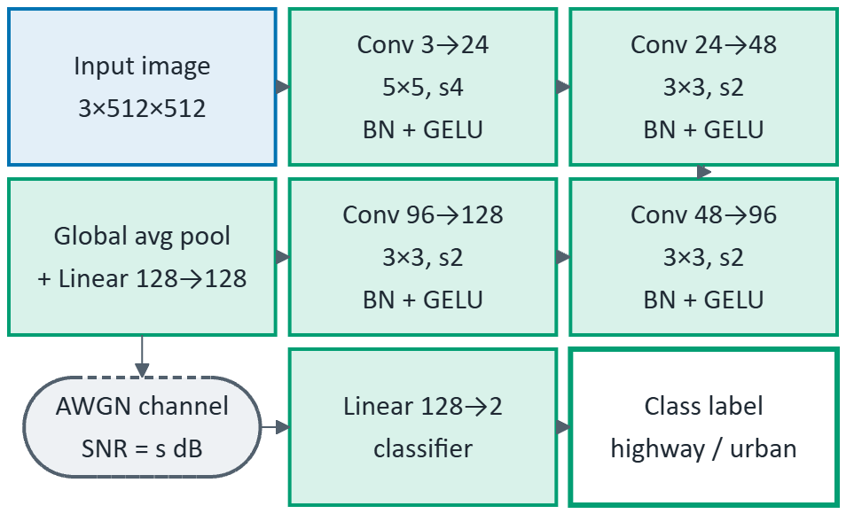
Fig 4. Machine Mode Branch

4.4 AWGN channel model
For a target SNR in decibels, the noise variance is set relative to signal power using the relationship P_noise = P_signal / 10^(SNR/10). Machine-mode training randomizes SNR across the seven listed values. Both branches are evaluated at −5, 0, 5, 10, 15, 20, and 25 dB.

4.5 Training and evaluation procedure
- Load traffic_data, resize images to 512×512, normalize, and create a stratified split.
- Use 140 training images; the deck reports 60 machine-test images and 20 human-test images.
- Train the machine branch for 80 epochs using AdamW, learning rate 1e−3, weight decay 1e−4, cross-entropy loss, and seed 6.
- Evaluate human reconstruction using MSE/PSNR and machine inference using classification accuracy at seven SNR levels.
- Compute the representation-value counts for raw, human-mode, and machine-mode payloads.
- Use a conceptual 5 dB digital-outage threshold only as an illustrative comparison; it is not a measured coded digital baseline.

5. Proposed Block Diagram / System Architecture
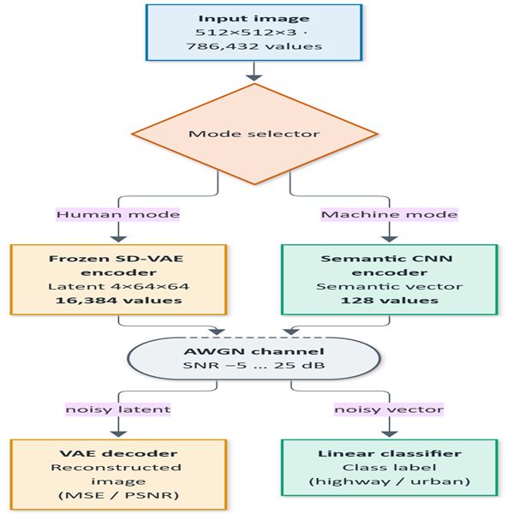
Fig 5. System overview
The architecture contains an input image, mode selector, two transmitter branches, AWGN channel, and two receiver branches. The human path uses a frozen VAE encoder and decoder. The machine path uses a semantic CNN encoder and linear classifier. The two outputs are a reconstructed image and a highway/urban class label, respectively.

6. Project Implementation and Experimental Setup

6.1 Software and libraries
The presentation lists Python 3, PyTorch, torchvision, Hugging Face diffusers (AutoencoderKL), scikit-learn, NumPy, Matplotlib, and Seaborn, with Jupyter Notebook as the execution environment. The pretrained model is stabilityai/sd-vae-ft-mse.

6.2 Dataset and split
The reported traffic_data dataset contains 200 images across two classes: highway and urban. Images are resized to 512×512. The reported split is 140 training images (87 highway and 53 urban), 60 machine-test images (37 highway and 23 urban), and 20 human-test images (12 highway and 8 urban). Because the dataset is small, the presentation itself notes a train–test gap and recommends larger datasets.

6.3 Implementation settings
Parameter | Reported setting
Image size | 512×512×3
Human latent | 4×64×64 = 16,384 values
Machine latent | 128 values
Channel | Power-normalized AWGN
SNR sweep | −5, 0, 5, 10, 15, 20, 25 dB
Optimizer | AdamW
Learning rate | 1×10⁻³
Weight decay | 1×10⁻⁴
Epochs | 80
Loss | Cross-entropy for machine classification
Random seed | 6

7. Project Results and Discussion

7.1 Human-mode reconstruction
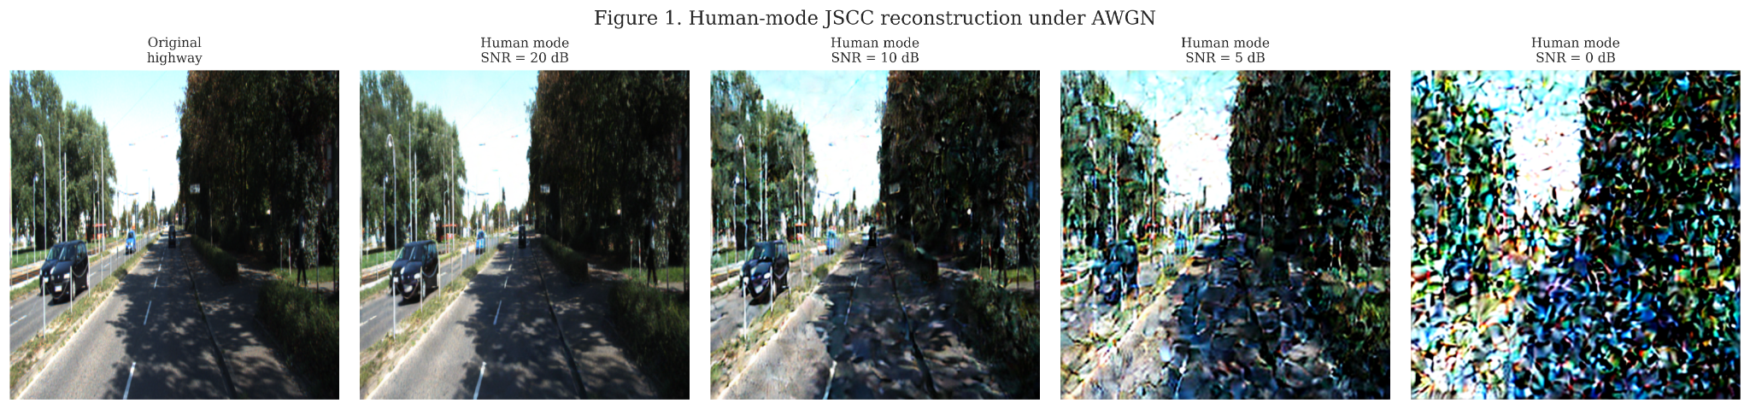
Fig 6. Human-mode reconstruction examples at different SNR values, as presented in the project materials.
The presented reconstruction examples show progressively stronger visible distortion as SNR decreases. The reported PSNR increases with SNR, from 8.86 dB at −5 dB to 26.34 dB at 25 dB. This is consistent with the qualitative observation that higher channel SNR preserves more reconstruction detail.

7.2 Performance versus SNR
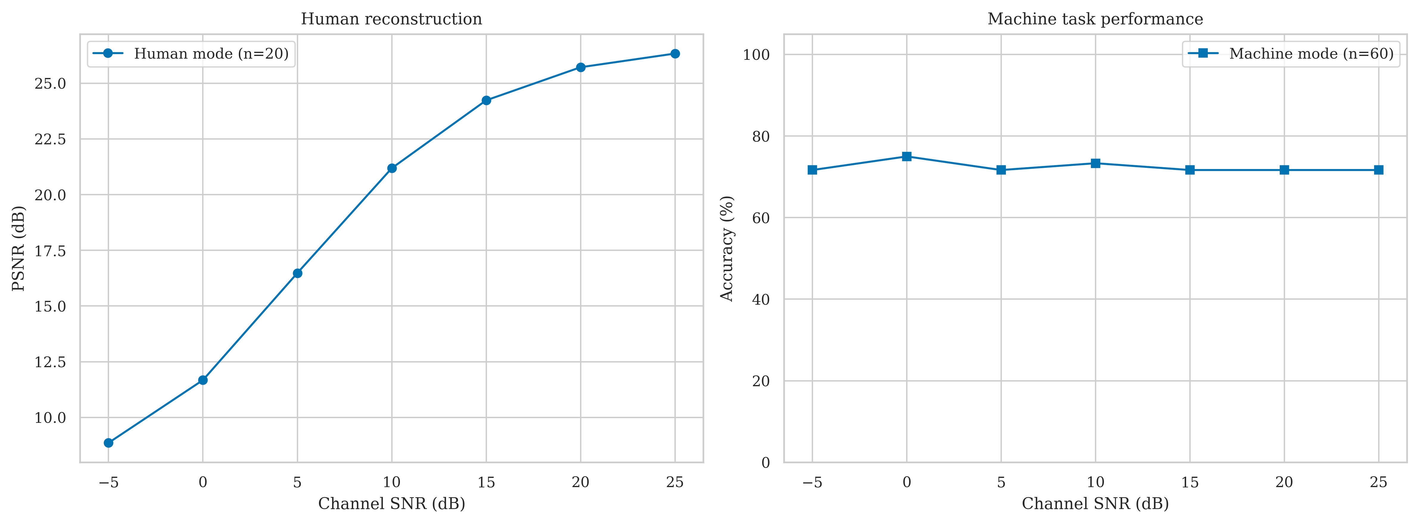
Fig 7. Reported human-mode PSNR and machine-mode classification accuracy versus SNR.
The model reports machine accuracy in the range 71.7–75.0% over the SNR sweep, with n=60 test images, and 73.33% accuracy at 10 dB. It also reports training accuracy reaching 98% after 80 epochs. The gap between training and held-out accuracy suggests possible overfitting, which is plausible with only 140 training images. Accuracy remaining in a narrow range across SNR is encouraging but does not alone prove general channel robustness; repeated seeds, confidence intervals, class-wise metrics, and a larger independent test set would strengthen the evidence.

7.3 Training behavior and confusion matrix
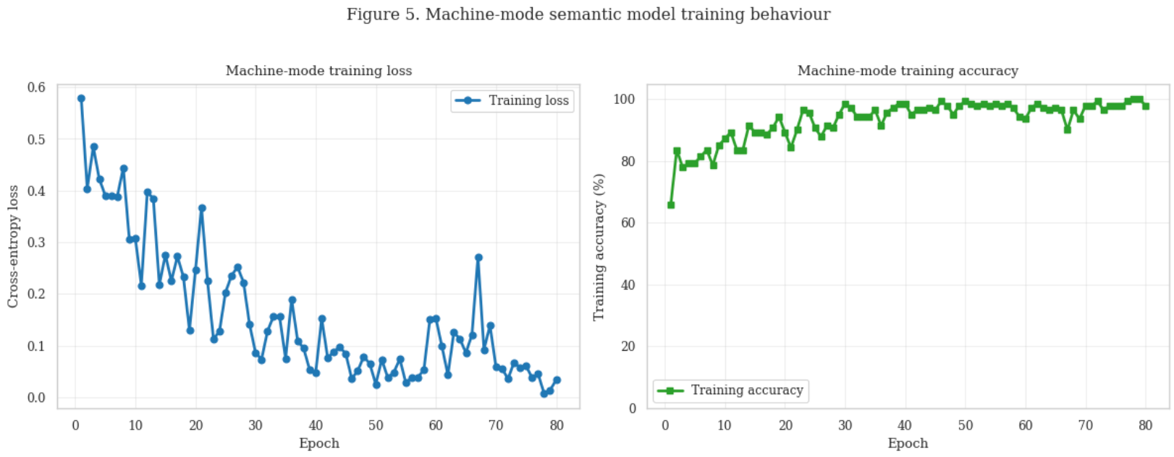
Figure 8. Machine-branch training over 80 epochs (train accuracy 98%).

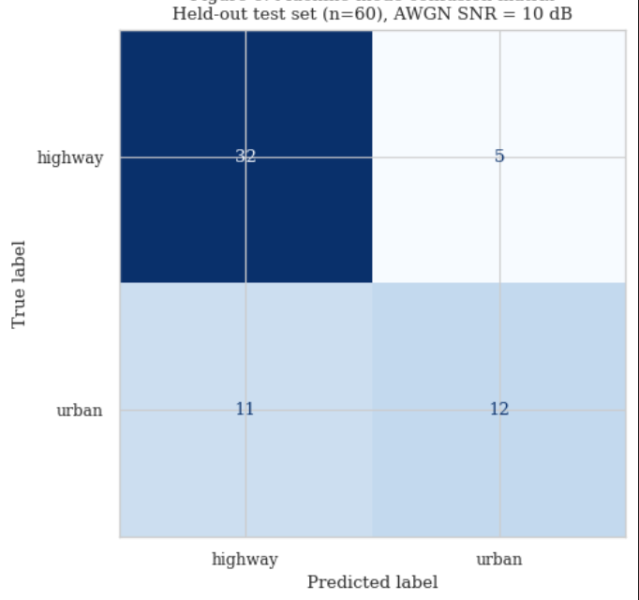
Figure 9. Confusion Matrix at 10 dB SNR

7.4 Payload-size comparison
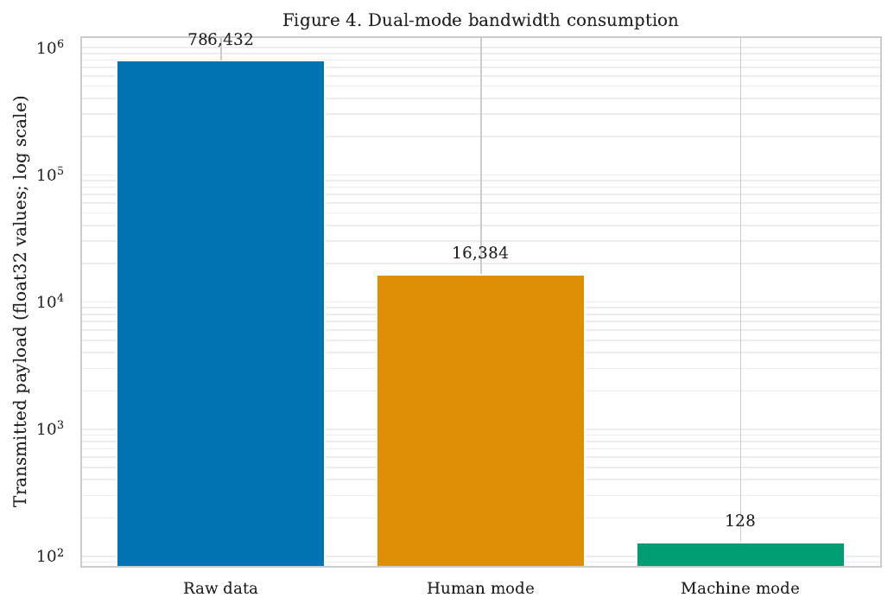
Figure 10. Representation-value counts reported for the raw image and the two compressed modes.
Representation | Values | Approx. float32 payload | Reduction vs raw
Raw image | 786,432 | 3.15 MB | Baseline
Human mode | 16,384 | 65.5 KB | 97.92% fewer values; 48×
Machine mode | 128 | 512 B | 99.98% fewer values; 6,144×
The machine-mode representation contains 128 times fewer values than the human-mode latent. Payload byte estimates assume 32-bit floating-point values and exclude headers, quantization, framing, channel coding, retransmissions, and physical-layer overhead. Consequently, these numbers quantify latent representation size only; they should not be labelled measured RF bandwidth savings.

7.5 Graceful degradation versus digital cliff
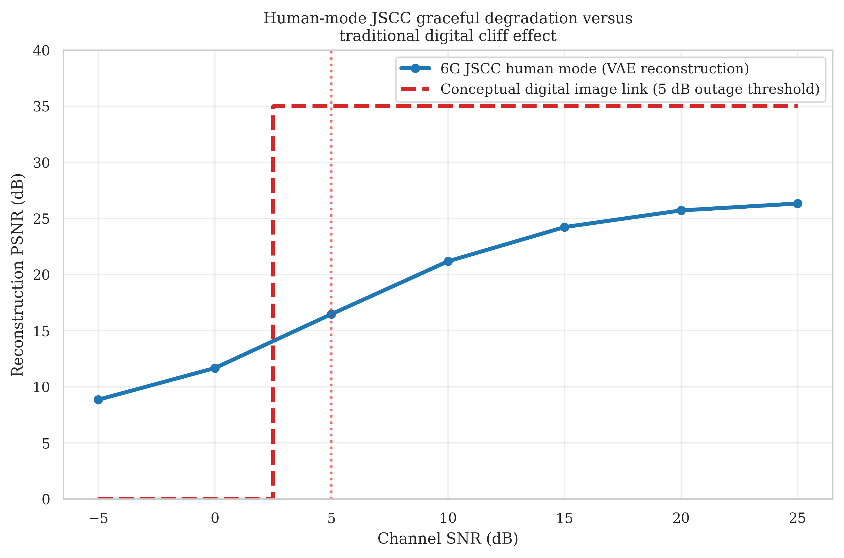
Fig 11. JSCC behavior compared with an illustrative digital-outage model.
The digital baseline in the presentation is explicitly conceptual, with an assumed 5 dB outage threshold. It illustrates the common cliff-effect idea but is not an experimental comparison against a digital codec and channel code. A stronger future experiment should implement a specified digital pipeline (for example, JPEG/BPG plus LDPC or another documented channel code), match the source quality and rate, and compare under the same channel and SNR sweep.

7.6 Limitations
- Only 200 images and two classes are reported; the result may not generalize to other roads, weather, lighting, cameras, or class distributions.
- The training accuracy (98%) is notably higher than held-out accuracy (about 72–75%), indicating a generalization gap.
- The simulated channel is AWGN; fading, MIMO, mobility, and real RF hardware are not evaluated.
- The digital-cliff baseline is conceptual, not a measured end-to-end baseline.
- Latent-value counts do not include quantization, protocol overhead, coding, actual symbol mapping, RF bandwidth, latency, or energy measurements.
- The deck’s result values are reported as project outputs; this report does not independently reproduce training or verify notebook execution.

8. Conclusion and Future Scope
The project demonstrates a dual-mode semantic image communication pipeline: a VAE-based human path for image reconstruction and a compact CNN-based machine path for highway/urban classification. Under the reported AWGN setup, human-mode PSNR improves with SNR, while machine-mode accuracy remains between 71.7% and 75.0% across the tested range. The reported payload representation falls from 786,432 raw image values to 16,384 human-mode latent values or 128 machine-mode values. These results support the feasibility of task-dependent representation sizes, but do not yet establish physical-layer bandwidth or energy savings.

8.1 Future work
- Expand the dataset and add more classes; use independent test data and multiple training seeds.
- Investigate the training–test gap with regularization, data augmentation, class-wise precision/recall, and confusion-matrix analysis.
- Evaluate fading channels and MIMO links.
- Compare against a fully implemented digital baseline using a documented image codec and channel code.
- Study latent quantization and actual transmitted bits/symbols, then measure throughput, latency, and energy under matched link settings.
- Explore a trainable human-mode JSCC branch and a SwinJSCC-style backbone, as suggested in the presentation.
- Validate the pipeline with software-defined radio hardware after simulation results are stable.

9. References
The following entries are transcribed from the project presentation’s reference slides (slides 22–23). Several entries in the presentation lack full author, page, volume, or DOI information; the missing metadata has not been invented and should be verified before final submission.
[1] J. Huang, K. Yuan, C. Huang, K. Huang, “D²-JSCC: Digital deep joint source-channel coding for semantic communications,” IEEE Journal on Selected Areas in Communications, 2025, doi:10.1109/JSAC.2025.3531546.
[2] L. X. Nguyen, A. D. Raha, P. S. Aung, D. Niyato, Z. Han, C. S. Hong, “A contemporary survey on semantic communications: Theory of mind, generative AI, and deep JSCC,” IEEE Communications Surveys & Tutorials, 2025, doi:10.1109/COMST.2025.3616973.
[3] K. Yang, S. Wang, J. Dai, X. Qin, K. Niu, P. Zhang, “SwinJSCC: Taming Swin Transformer for deep joint source-channel coding,” IEEE Transactions on Cognitive Communications and Networking, 2025, pp. 90–104.
[4] Y. Diao, Y. Zhang, C. She, P. G. Zhao, E. L. Li, “Aligning task- and reconstruction-oriented communications for edge intelligence,” IEEE Journal on Selected Areas in Communications, 2025, doi:10.1109/JSAC.2025.3559121.
[5] T. Zhao, F. Li, H. Du and L. Sun, "Deep Reinforcement Learning- and Information Bottleneck-Enabled Task-Oriented Semantic Communication," in IEEE Journal on Selected Areas in Communications, vol. 43, no. 12, pp. 4198-4214, Dec. 2025, doi: 10.1109/JSAC.2025.3623199.
[6] C. Cai, X. Yuan and Y. -J. A. Zhang, "End-to-End Learning for Task-Oriented Semantic Communications Over MIMO Channels: An Information-Theoretic Framework," in IEEE Journal on Selected Areas in Communications, vol. 43, no. 4, pp. 1292-1307, April 2025, doi: 10.1109/JSAC.2025.3531575.
[7] F. Jiang, C. Tang, L. Dong, K. Wang, K. Yang and C. Pan, "Visual Language Model-Based Cross-Modal Semantic Communication Systems," in IEEE Transactions on Wireless Communications, vol. 24, no. 5, pp. 3937-3948, May 2025, doi: 10.1109/TWC.2025.3539526.
[8] M. Zhang, H. Wu, G. Zhu, R. Jin, X. Chen and D. Gündüz, "Semantics-Guided Diffusion for Deep Joint Source-Channel Coding in Wireless Image Transmission," in IEEE Transactions on Wireless Communications, vol. 25, pp. 1547-1564, 2026, doi: 10.1109/TWC.2025.3591456.
[9] H. Gao et al., "Rate Splitting Multiple Access-Enabled Adaptive Panoramic Video Semantic Transmission," in IEEE Transactions on Wireless Communications, vol. 24, no. 11, pp. 9050-9068, Nov. 2025, doi: 10.1109/TWC.2025.3570465.
[10] M. F. Zia, M. A. Ouameur, M. Bagaa, D. Massicotte, A. Ksentini, “A survey on explainable AI for semantic communication: Architecture, challenges, and future opportunities,” Computer Networks, 2026, doi:10.1016/j.comnet.2026.112142.
[11] K. Jain, P. Krishnan, P. Pachiyannan, L. Jaganathan, M. Attique Khan and Y. Li, "Toward Smart 5G and 6G: Standardization of AI-Native Network Architectures and Semantic Communication Protocols," in IEEE Communications Standards Magazine, vol. 10, no. 3, pp. 236-247, Sept. 2026, doi: 10.1109/MCOMSTD.2025.3618114.
[12] M. Xu et al., "Semantic-Aided Parallel Image Transmission Compatible With Practical System," in IEEE Transactions on Wireless Communications, vol. 24, no. 10, pp. 8476-8491, Oct. 2025, doi: 10.1109/TWC.2025.3566886.
[13] B. Xu et al., "Semantic Prior Aided Channel-Adaptive Equalizing and De-Noising Semantic Communication System With Latent Diffusion Model," in IEEE Transactions on Wireless Communications, vol. 24, no. 6, pp. 4614-4630, June 2025, doi: 10.1109/TWC.2025.3543167.
[14] Y. Zheng, F. Wang, W. Xu and P. Zhang, "Semantic Base Enabled Image Transmission With Fine-Grained HARQ," in IEEE Transactions on Wireless Communications, vol. 24, no. 4, pp. 3606-3622, April 2025, doi: 10.1109/TWC.2025.3532501.
[15] J. Ren, Y. Sun, H. Du, W. Yuan, C. Wang, X. Wang, Y. Zhou, Z. Zhu, F. Wang, S. Cui, “Generative Semantic Communication: Architectures, Technologies, and Applications”, Engineering, Volume 56, 2026, Pages 45-61, ISSN 2095-8099, https://doi.org/10.1016/j.eng.2025.07.022.
[16] C. Liang et al., "Generative AI-Driven Semantic Communication Networks: Architecture, Technologies, and Applications," in IEEE Transactions on Cognitive Communications and Networking, vol. 11, no. 1, pp. 27-47, Feb. 2025, doi: 10.1109/TCCN.2024.3435524.
[17] C. Liang et al., "Generative AI-Driven Semantic Communication Networks: Architecture, Technologies, and Applications," in IEEE Transactions on Cognitive Communications and Networking, vol. 11, no. 1, pp. 27-47, Feb. 2025, doi: 10.1109/TCCN.2024.3435524.
[18] Q. Zhijin et al., "Ten challenges in semantic communications," in China Communications, vol. 22, no. 6, pp. 24-43, June 2025, doi: 10.23919/JCC.ja.2024-0188.
[19] R. Gu, W. Xu, Z. Yang, D. Niyato and A. Yener, "Task-Oriented Low-Label Semantic Communication With Self-Supervised Learning," in IEEE Transactions on Wireless Communications, vol. 24, no. 11, pp. 9629-9644, Nov. 2025, doi: 10.1109/TWC.2025.3574468.
[20] L. Guo, W. Chen, Y. Sun, B. Ai, N. Pappas, T. Quek, “Diffusion-driven semantic communication for generative models with bandwidth constraints,” 2025. Doi: 10.1109/TWC.2025.3553851

10. Program Outcome (PO) Mapping with Justification
The mapping below is a draft based on the work described in the presentation. The official PO levels/attainment values must be assigned using the programme’s approved NBA methodology and faculty guidance; no numerical attainment level is asserted here.
PO | Project-based justification
PO1 – Engineering knowledge | Applies image representation, neural-network, signal/noise, and SNR concepts to a communication pipeline.
PO2 – Problem analysis | Identifies the trade-off between image reconstruction and task inference and evaluates performance over seven SNR points.
PO3 – Design/development of solutions | Designs two payload paths, an AWGN channel model, a VAE reconstruction receiver, and a classifier receiver.
PO4 – Investigation | Uses PSNR, accuracy, training behavior, and payload counts; validation is limited by dataset size and a conceptual digital baseline.
PO5 – Modern tool usage | Uses Python, PyTorch, diffusers, scikit-learn, NumPy, and plotting tools.
PO7 – Environment and sustainability | A smaller representation could reduce communication resources, but energy savings were not measured.
PO10 – Communication | Documents architecture, results, limitations, and future work in a presentation/report.

11. Washington Accord Complex Engineering Problem Solving Profile (WP) Mapping with Justification
The supplied format requires WP1 and allows a maximum of four profiles. This proposed mapping is qualitative and should be checked against the exact WP definitions adopted by VIT before submission.
WP profile | Justification from this project
WP1 – Depth of knowledge required (mandatory) | The design combines deep JSCC concepts, neural image encoding, AWGN channel modeling, and task-based classification.
WP2 – Conflicting requirements | The human receiver prioritizes reconstruction quality, while the machine receiver prioritizes classification using a much smaller representation.
WP4 – Familiarity of issues | Performance depends on dataset size, noise level, model generalization, payload representation, and the difference between simulation and a practical wireless link.
WP6 – Consequences | The intended traffic-monitoring use case could affect bandwidth usage and incident-monitoring workflows, but safety impact and field performance have not been validated.

12. Sustainable Development Goal (SDG) Mapping with Justification
SDG / target area | Connection to project | Evidence and limitation
SDG 9 – Industry, Innovation and Infrastructure | Explores AI-native, task-aware communication for future wireless infrastructure. | The demonstrator compares compact latent representations; it is not a deployed 6G system.
SDG 11 – Sustainable Cities and Communities | Potential application to bandwidth-efficient traffic scene monitoring. | Only highway/urban image classification is tested; no real-time city deployment is evaluated.
SDG 3 – Good Health and Well-being | Could support traffic awareness and road-safety workflows if integrated into a validated system. | No accident detection, emergency response, or safety outcome is measured in this project.
SDG 13 – Climate Action | Reducing transmitted data may offer an opportunity to reduce communication resources. | Energy and carbon savings are not measured; this is a potential benefit, not a demonstrated result.

13. Outcomes of the Project
- 1. Dual-Mode Framework: Developed a system that reconstructs images for human users and performs semantic classification for machines.
- 2. Performance Testing: Evaluated both modes under a simulated AWGN channel at seven SNR levels, from −5 to 25 dB.
- 3. Image Reconstruction: PSNR ranged from 8.86 dB at −5 dB SNR to 26.34 dB at 25 dB SNR.
- 4. Classification Accuracy: Machine-mode accuracy ranged from 71.7% to 75.0% across the tested SNR levels.
- 5. Payload Reduction: Representation size was reduced by 97.92% in human mode and 99.98% in machine mode compared with raw image values.
- 6. Future Improvements: Explore larger datasets, a digital baseline, additional channel models, and physical-layer resource measurements.

