**Name:-**

**Practical No:-01**

**Practical Name** **Demonstrate string manipulation by displaying at the middle of the screen in the red color with white background with change in fonts & styles of text.**

**Class:- SY.MCA Roll No.:-**

**Activity_main.xml:**

*<?*xml version="1.0" encoding="utf-8"*?>*<androidx.constraintlayout.widget.ConstraintLayout xmlns:android="http://schemas.android.com/apk/res/android"  
 xmlns:app="http://schemas.android.com/apk/res-auto"  
 xmlns:tools="http://schemas.android.com/tools"  
 android:layout_width="match_parent"  
 android:layout_height="match_parent"  
 tools:context=".MainActivity">  
  
 <TextView  
 android:layout_width="wrap_content"  
 android:layout_height="wrap_content"  
 android:text="Hello World!"  
 android:textColor="#F50057"  
 android:textSize="20sp"  
 app:layout_constraintBottom_toBottomOf="parent"  
 app:layout_constraintEnd_toEndOf="parent"  
 app:layout_constraintStart_toStartOf="parent"  
 app:layout_constraintTop_toTopOf="parent" />  
  
</androidx.constraintlayout.widget.ConstraintLayout>

**OUTPUT:-**

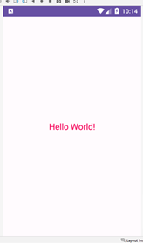

**Name:-**

**Practical No:-02**

**Practical Name** :- **Write a program to populate resources (res>>value folder). Show resource on changing selection of the resources.**

**Class:- SY.MCA Roll No.:-**

**MainActivity.java:-**

package com.example.testtt;  
import androidx.appcompat.app.AppCompatActivity;  
import android.os.Bundle;  
import android.widget.TextView;  
  
public class MainActivityextends AppCompatActivity{  
TextViewt1,t2,t3;  
@Override  
protected void onCreate(Bundle savedInstanceState) {  
super.onCreate(savedInstanceState);  
setContentView(R.layout.*activity_main*);

t1=(TextView) findViewById(R.id .*textView*);  
t2=(TextView) findViewById(R.id .*textView2* );  
t3=(TextView) findViewById(R.id .*textView3* );  
t1.setText("Jalgaon");  
t2.setText("IMCA");  
t3.setText("IMR");  
 }  
}

**activity_main.xml:-**

*<?*xml version="1.0" encoding="utf-8"*?>*<LinearLayoutxmlns:android="http://schemas.android.com/apk/res/android"  
xmlns:app="http://schemas.android.com/apk/res-auto"  
xmlns:tools="http://schemas.android.com/tools"  
android:layout_width="match_parent"  
android:layout_height="match_parent"  
tools:context=".MainActivity">  
<TextView  
android:id="@+id/textView"  
android:layout_width="wrap_content"  
android:layout_height="wrap_content"  
android:layout_weight="1"  
android:text="TextView"  
android:background="@color/Lokesh" />  
<TextView  
android:id="@+id/textView3"  
android:layout_width="wrap_content"  
android:layout_height="wrap_content"  
android:layout_weight="1"  
android:text="TextView" />  
<TextView  
android:id="@+id/textView2"  
android:layout_width="wrap_content"  
android:layout_height="296dp"  
android:layout_weight="1"  
android:text="@string/Lokesh" />  
<ImageView  
android:id="@+id/imageView"  
android:layout_width="263dp"  
android:layout_height="315dp"  
android:layout_weight="1"  
app:srcCompat="@drawable/tp" />  
</LinearLayout>

**OUTPUT:-**

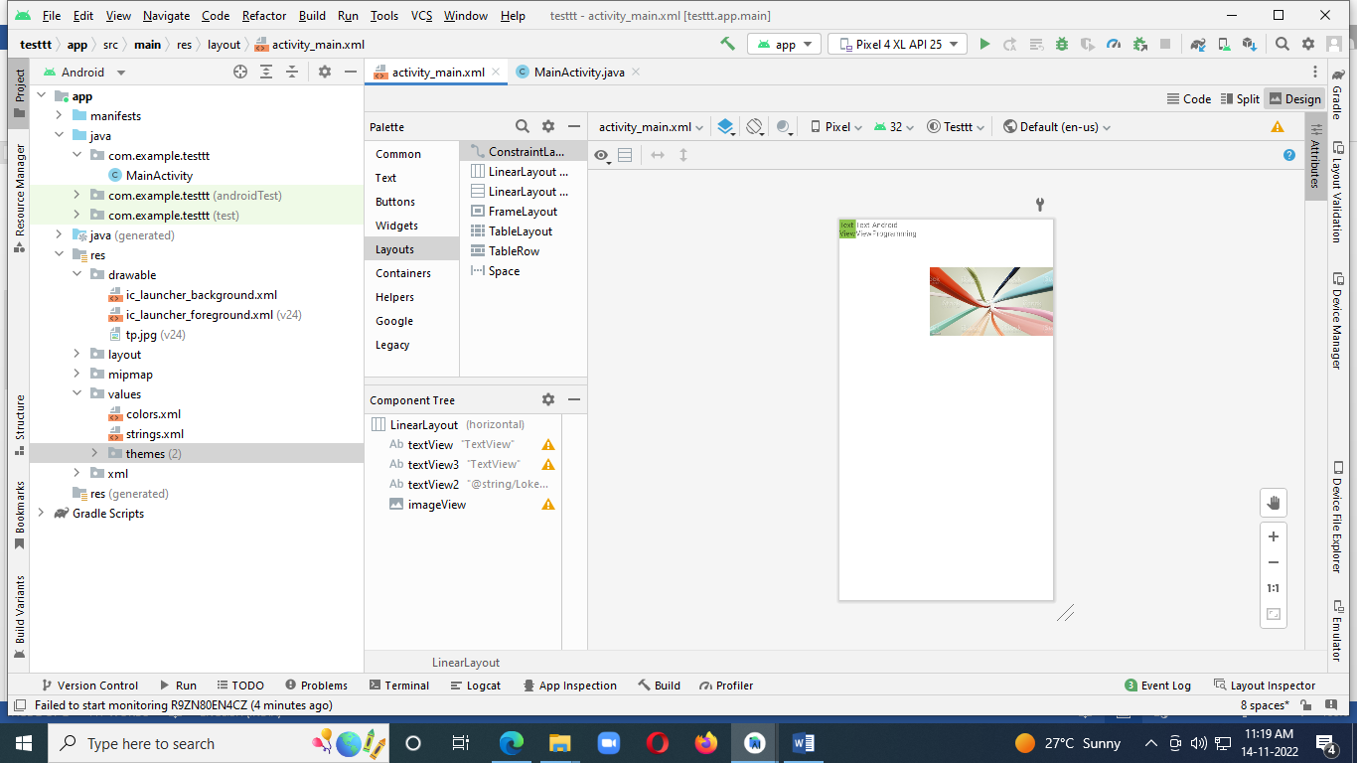

**Name:-**

**Practical No:-03**

**Practical Name:- Write a program to create UI with one screen having radio button of the types of cars. On selecting any car name, next screen should show car details.**

**Class:- SY.MCA Roll No.:-**

**ActivityMain.xml:-***<?*xml version="1.0" encoding="utf-8"*?>*<androidx.constraintlayout.widget.ConstraintLayout xmlns:android="http://schemas.android.com/apk/res/android"  
 xmlns:app="http://schemas.android.com/apk/res-auto"  
 xmlns:tools="http://schemas.android.com/tools"  
 android:layout_width="match_parent"  
 android:layout_height="match_parent"  
 tools:context=".MainActivity">  
  
 <TextView  
 android:id="@+id/text"  
 android:layout_width="wrap_content"  
 android:layout_height="wrap_content"  
 android:text="Select car"  
 app:layout_constraintBottom_toBottomOf="parent"  
 app:layout_constraintEnd_toEndOf="parent"  
 app:layout_constraintHorizontal_bias="0.434"  
 app:layout_constraintStart_toStartOf="parent"  
 app:layout_constraintTop_toTopOf="parent"  
 app:layout_constraintVertical_bias="0.136" />  
  
 <RadioGroup  
 android:id="@+id/group"  
 android:layout_width="217dp"  
 android:layout_height="135dp"  
 app:layout_constraintBottom_toBottomOf="parent"  
 app:layout_constraintEnd_toEndOf="parent"  
 app:layout_constraintStart_toStartOf="parent"  
 app:layout_constraintTop_toTopOf="parent" >  
  
 <RadioButton  
 android:id="@+id/radioButton1"  
 android:layout_width="match_parent"  
 android:layout_height="wrap_content"  
 android:text="Baleno" />  
  
 <RadioButton  
 android:id="@+id/radioButton2"  
 android:layout_width="match_parent"  
 android:layout_height="wrap_content"  
 android:text="Kwid" />  
 </RadioGroup>  
  
 <Button  
 android:id="@+id/button_apply"  
 android:layout_width="102dp"  
 android:layout_height="45dp"  
 android:text="Maruti"  
 app:layout_constraintBottom_toBottomOf="parent"  
 app:layout_constraintEnd_toEndOf="parent"  
 app:layout_constraintHorizontal_bias="0.118"  
 app:layout_constraintStart_toStartOf="parent"  
 app:layout_constraintTop_toTopOf="parent"  
 app:layout_constraintVertical_bias="0.795" />  
  
 <Button  
 android:id="@+id/button1"  
 android:layout_width="wrap_content"  
 android:layout_height="wrap_content"  
 android:text="Renault"  
 app:layout_constraintBottom_toBottomOf="parent"  
 app:layout_constraintEnd_toEndOf="parent"  
 app:layout_constraintHorizontal_bias="0.793"  
 app:layout_constraintStart_toStartOf="parent"  
 app:layout_constraintTop_toTopOf="parent"  
 app:layout_constraintVertical_bias="0.795" />  
</androidx.constraintlayout.widget.ConstraintLayout>

**OUTPUT:-**

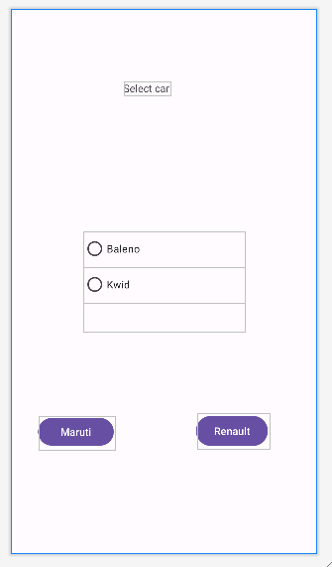

**ActivityMain2.xml:-**

*<?*xml version="1.0" encoding="utf-8"*?>*<androidx.constraintlayout.widget.ConstraintLayout xmlns:android="http://schemas.android.com/apk/res/android"  
 xmlns:app="http://schemas.android.com/apk/res-auto"  
 xmlns:tools="http://schemas.android.com/tools"  
 android:layout_width="match_parent"  
 android:layout_height="match_parent">  
  
 <TextView  
 android:id="@+id/textView"  
 android:layout_width="wrap_content"  
 android:layout_height="wrap_content"  
 android:text="Activity2"  
 android:textSize="34dp"  
 app:layout_constraintBottom_toBottomOf="parent"  
 app:layout_constraintEnd_toEndOf="parent"  
 app:layout_constraintStart_toStartOf="parent"  
 app:layout_constraintTop_toTopOf="parent" />  
</androidx.constraintlayout.widget.ConstraintLayout>

**OUTPUT:-**

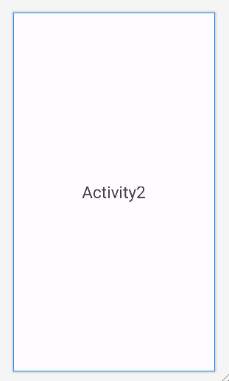

**ActivityMain3.xml:-**

*<?*xml version="1.0" encoding="utf-8"*?>*<androidx.constraintlayout.widget.ConstraintLayout xmlns:android="http://schemas.android.com/apk/res/android"  
 xmlns:app="http://schemas.android.com/apk/res-auto"  
 xmlns:tools="http://schemas.android.com/tools"  
 android:layout_width="match_parent"  
 android:layout_height="match_parent">  
  
 <TextView  
 android:id="@+id/textView2"  
 android:layout_width="wrap_content"  
 android:layout_height="wrap_content"  
 android:text="Activity3"  
 android:textSize="34dp"  
 app:layout_constraintBottom_toBottomOf="parent"  
 app:layout_constraintEnd_toEndOf="parent"  
 app:layout_constraintStart_toStartOf="parent"  
 app:layout_constraintTop_toTopOf="parent" />  
</androidx.constraintlayout.widget.ConstraintLayout>

**OUTPUT:-**

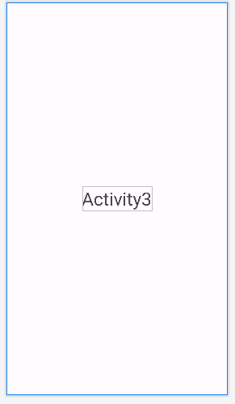

**MainActivity.java:-**

package com.example.car;  
  
import androidx.appcompat.app.AppCompatActivity;  
import android.content.Intent;  
import android.os.Bundle;  
import android.view.View;  
import android.widget.Button;  
import android.widget.RadioButton;  
import android.widget.RadioGroup;  
import android.widget.TextView;  
import android.widget.Toast;  
  
  
public class MainActivity extends AppCompatActivity {  
 RadioGroup radioGroup;  
 RadioButton radioButton1,radioButton2;  
 TextView textView;  
 Button buttonApply,button ;  
 @Override  
 protected void onCreate(Bundle savedInstanceState) {  
 super.onCreate(savedInstanceState);  
 setContentView(R.layout.*activity_main*);  
  
 radioGroup = findViewById(R.id.*group*);  
 textView = findViewById(R.id.*text* );  
  
 Button buttonApply = findViewById(R.id.*button_apply*);  
 Button button = findViewById(R.id.*button1* );  
 buttonApply.setOnClickListener(new View.OnClickListener() {  
 @Override  
 public void onClick(View v) {  
 int radioId = radioGroup.getCheckedRadioButtonId();  
  
 radioButton1 = findViewById(radioId);  
 Intent intent = new Intent(getBaseContext() ,MainActivity2 .class );  
 startActivity(intent);  
  
 *//textView.setText("Your choice: " + radioButton1.getText());  
  
  
 //textView.setText("Your choice: " + radioButton2.getText());* }  
 });  
 button .setOnClickListener(new View.OnClickListener() {  
 @Override  
 public void onClick(View v) {  
 int radioId = radioGroup.getCheckedRadioButtonId();  
 radioButton2 = findViewById(radioId);  
 Intent intent = new Intent(getBaseContext() , MAinActivity3.class );  
 startActivity(intent);  
 }  
 }) ;  
 }  
  
 public void checkButton(View v) {  
 int radioId = radioGroup.getCheckedRadioButtonId();  
  
 radioButton1 = findViewById(radioId);  
  
 Toast.*makeText*(this, "Selected Radio Button: " + radioButton1.getText(),  
 Toast.*LENGTH_SHORT*).show();  
 radioButton2 = findViewById(radioId);  
  
 Toast.*makeText*(this, "Selected Radio Button: " + radioButton2.getText(),  
 Toast.*LENGTH_SHORT*).show();  
 }  
}

**MainActivity2.java:-**

package com.example.car;  
  
import android.os.Bundle;  
import android.widget.TextView;  
import android.widget.Toast;  
  
import androidx.appcompat.app.AppCompatActivity;  
  
public class MainActivity2 extends AppCompatActivity {  
 TextView textView ;  
  
  
 @Override  
 protected void onCreate(Bundle savedInstanceState) {  
 super.onCreate(savedInstanceState);  
 setContentView(R.layout.*activity_main2*);  
  
 textView =(TextView) findViewById(R.id.*textView* );  
 textView .setText("Car was launched on 14 December 1983 and manufactured by Maruti Suzuki in India");  
  
 Toast.*makeText*(this, "Activity 2", Toast.*LENGTH_SHORT*).show();  
 }  
}

**MainActivity3.java:-**

package com.example.car;  
  
import android.os.Bundle;  
import android.widget.TextView;  
import android.widget.Toast;  
  
  
import androidx.appcompat.app.AppCompatActivity;  
  
public class MAinActivity3 extends AppCompatActivity {  
 TextView textView3 ;  
  
  
 @Override  
 protected void onCreate(Bundle savedInstanceState) {  
 super.onCreate(savedInstanceState);  
 setContentView(R.layout.*activity_main3*);  
  
  
  
 textView3 =(TextView) findViewById(R.id.*textView2*);  
 textView3 .setText("Car was launched in year 2012 and"  
 +"Renault India Private Limted is a wholly"  
 +" owned subsidiary of Renault S.A.France");  
  
 Toast.*makeText*(this, "Activity 3", Toast.*LENGTH_SHORT*).show();  
 }  
}

**AndroidMenifest.xml:-**

*<?*xml version="1.0" encoding="utf-8"*?>*<manifest xmlns:android="http://schemas.android.com/apk/res/android"  
 xmlns:tools="http://schemas.android.com/tools">  
  
 <application  
 android:allowBackup="true"  
 android:dataExtractionRules="@xml/data_extraction_rules"  
 android:fullBackupContent="@xml/backup_rules"  
 android:icon="@mipmap/ic_launcher"  
 android:label="@string/app_name"  
 android:roundIcon="@mipmap/ic_launcher_round"  
 android:supportsRtl="true"  
 android:theme="@style/Theme.Car"  
 tools:targetApi="31">  
 <activity  
 android:name=".MainActivity"  
 android:exported="true">  
 <intent-filter>  
 <action android:name="android.intent.action.MAIN" />  
  
 <category android:name="android.intent.category.LAUNCHER" />  
 </intent-filter>  
 </activity>  
 <activity android:name=".MainActivity2"></activity>  
 <activity android:name=".MAinActivity3"></activity>  
 </application>  
  
</manifest>

**OUTPUT:-**

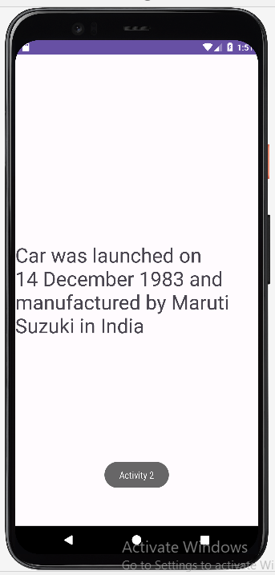

**Name:-**

**Practical No:-04**

**Practical Name:- Write a program for android application to demonstrate android life cycle stages.**

**Class:- SY.MCA Roll No.:-**

**MainActivity:-**

package com.example.lifecycle;

import androidx.appcompat.app.AppCompatActivity;

import android.os.Bundle;

import android.util.Log;

public class MainActivity extends AppCompatActivity {

@Override

protected void onCreate(Bundle savedInstanceState) {

super.onCreate(savedInstanceState);

setContentView(R.layout.activity_main);

Log.d("Lifecycle","onStart invoked");

}

@Override

protected void onResume(){

super.onResume();

Log.d("Lifecycle","onResume invoked");

}

@Override

protected void onPause(){

super.onPause();

Log.d("Lifecycle","onPause invoked");

}

@Override

protected void onStop(){

super.onStop();

Log.d("Lifecycle","onStop invoked");

}

@Override

protected void onRestart(){

super.onRestart();

Log.d("Lifecycle","onRestart invoked");

}

@Override

protected void onDestroy(){

super.onDestroy();

Log.d("Lifecycle","onDestroy invoked");

}

}

**OUTPUT:-**

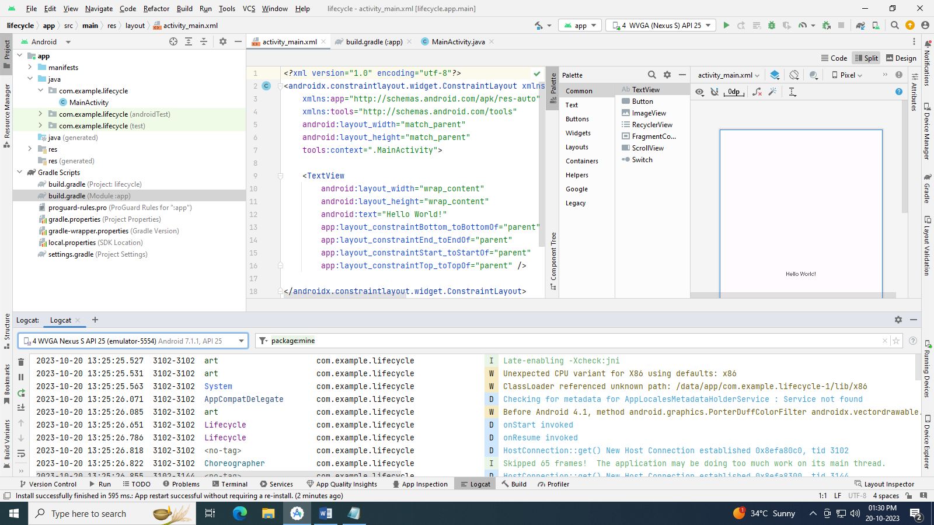

**Name:-**

**Practical No:-05**

**Practical Name:- Create the application that will change color of screen based on selected option from the menu**

**Class:- SY.MCA Roll No.:-**

**Activity_main.xml:-**

*<?*xml version="1.0" encoding="utf-8"*?>*<androidx.constraintlayout.widget.ConstraintLayout xmlns:android="http://schemas.android.com/apk/res/android"  
 xmlns:app="http://schemas.android.com/apk/res-auto"  
 xmlns:tools="http://schemas.android.com/tools"  
 android:layout_width="match_parent"  
 android:layout_height="match_parent"  
 tools:context=".MainActivity">  
  
 <LinearLayout  
 android:id="@+id/linear"  
 android:layout_width="408dp"  
 android:layout_height="659dp"  
 android:orientation="horizontal"  
 app:layout_constraintBottom_toBottomOf="parent"  
 app:layout_constraintEnd_toEndOf="parent"  
 app:layout_constraintStart_toStartOf="parent"  
 app:layout_constraintTop_toTopOf="parent">  
  
 <TextView  
 android:layout_width="wrap_content"  
 android:layout_height="wrap_content"  
 android:text="Hello World!" />  
 </LinearLayout>  
  
</androidx.constraintlayout.widget.ConstraintLayout>

**example_menu.xml:-**

*<?*xml version="1.0" encoding="utf-8"*?>*<menu xmlns:android="http://schemas.android.com/apk/res/android">  
 <item android:id="@+id/item1"  
 android:title="Item 1"/>  
 <item android:id="@+id/item2"  
 android:title="Item 2"/>  
 <item android:id="@+id/item3"  
 android:title="Item 3"/>  
</menu>

**OUTPUT:-**

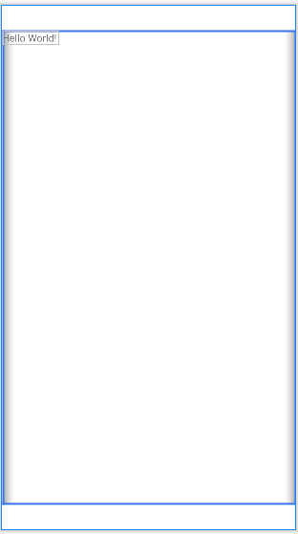

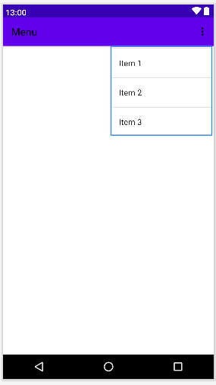

**MainActivity:-**

package com.example.menu;  
  
import androidx.appcompat.app.AppCompatActivity;  
  
import android.graphics.Color;  
import android.os.Bundle;  
import android.view.Menu;  
import android.view.MenuItem;  
import android.widget.LinearLayout;  
import android.widget.Toast;  
public class MainActivity extends AppCompatActivity {  
 LinearLayout l;  
 @Override  
 protected void onCreate(Bundle savedInstanceState) {  
 super.onCreate(savedInstanceState);  
 setContentView(R.layout.*activity_main*);  
 l=(LinearLayout) findViewById(R.id .*linear*);  
 }  
 @Override  
 public boolean onCreateOptionsMenu(Menu menu) {  
 *// Inflate the menu; this adds items to the action bar if it is present.* getMenuInflater().inflate(R.menu.*example_menu* , menu);  
 return true;  
 }  
  
 @Override  
 public boolean onOptionsItemSelected(MenuItem item) {  
 Toast.*makeText*(this, "Selected Item"+item.getTitle() , Toast.*LENGTH_SHORT*).show();  
 int id = item.getItemId();  
 switch (id){  
 case R.id.*item1*:  
 l.setBackgroundColor(Color.*RED*);  
 Toast.*makeText*(getApplicationContext(),"Item 1 Selected",Toast.*LENGTH_LONG*).show();  
 return true;  
 case R.id.*item2*:  
 l.setBackgroundColor(Color.*MAGENTA* );  
 Toast.*makeText*(getApplicationContext(),"Item 2 Selected",Toast.*LENGTH_LONG*).show();  
 return true;  
 case R.id.*item3*:  
 l.setBackgroundColor(Color.*GREEN* );  
 Toast.*makeText*(getApplicationContext(),"Item 3 Selected",Toast.*LENGTH_LONG*).show();  
 return true;  
 default:  
 return super.onOptionsItemSelected(item);  
 }  
 }  
}

**OUTPUT:-**

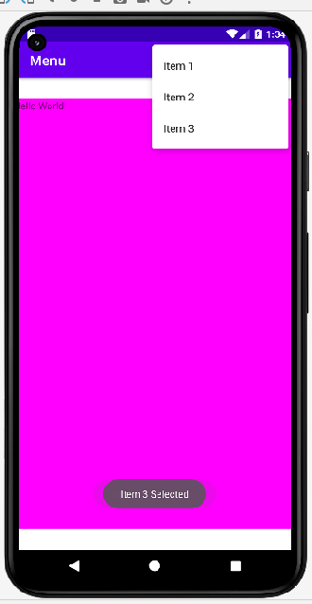

**Name:-**

**Practical No:- 06**

**Practical Name:- Write an android application that takes input from user and shows messages on screen.**

**Class:- SY.MCA Roll No.:-**

**Activity_main.xml:-**

*<?*xml version="1.0" encoding="utf-8"*?>*<androidx.constraintlayout.widget.ConstraintLayout xmlns:android="http://schemas.android.com/apk/res/android"  
 xmlns:app="http://schemas.android.com/apk/res-auto"  
 xmlns:tools="http://schemas.android.com/tools"  
 android:layout_width="match_parent"  
 android:layout_height="match_parent"  
 tools:context=".MainActivity">  
  
 <TextView  
 android:id="@+id/Text"  
 android:layout_width="wrap_content"  
 android:layout_height="wrap_content"  
 android:text="Hello World!"  
 app:layout_constraintBottom_toBottomOf="parent"  
 app:layout_constraintEnd_toEndOf="parent"  
 app:layout_constraintStart_toStartOf="parent"  
 app:layout_constraintTop_toTopOf="parent"  
 app:layout_constraintVertical_bias="0.139" />  
  
 <EditText  
 android:id="@+id/editTextText"  
 android:layout_width="wrap_content"  
 android:layout_height="wrap_content"  
 android:ems="10"  
 android:inputType="text"  
 android:hint="Name"  
 app:layout_constraintBottom_toBottomOf="parent"  
 app:layout_constraintEnd_toEndOf="parent"  
 app:layout_constraintHorizontal_bias="0.552"  
 app:layout_constraintStart_toStartOf="parent"  
 app:layout_constraintTop_toTopOf="parent"  
 app:layout_constraintVertical_bias="0.4" />  
  
 <Button  
 android:id="@+id/button"  
 android:layout_width="wrap_content"  
 android:layout_height="wrap_content"  
 android:text="Button"  
 android:onClick="onclick"  
 app:layout_constraintBottom_toBottomOf="parent"  
 app:layout_constraintEnd_toEndOf="parent"  
 app:layout_constraintStart_toStartOf="parent"  
 app:layout_constraintTop_toTopOf="parent"  
 app:layout_constraintVertical_bias="0.695" />  
  
</androidx.constraintlayout.widget.ConstraintLayout>

**OUTPUT:-**

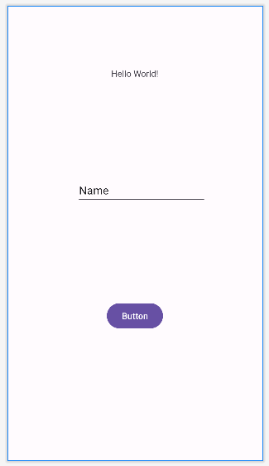

**MainActivity:-**

package com.example.inputfromuser;  
  
import androidx.appcompat.app.AppCompatActivity;  
  
import android.os.Bundle;  
import android.view.View;  
import android.widget.Button;  
import android.widget.EditText;  
import android.widget.TextView;  
import android.widget.Toast;  
  
public class MainActivity extends AppCompatActivity {  
 Button btn;  
 EditText ee;  
 TextView textView ;  
 @Override  
 protected void onCreate(Bundle savedInstanceState) {  
 super.onCreate(savedInstanceState);  
 setContentView(R.layout.*activity_main*);  
  
 btn =(Button) findViewById(R.id .*button* );  
 ee =(EditText) findViewById(R.id .*editTextText* );  
 textView =(TextView ) findViewById(R.id .*Text* );  
  
 btn .setOnClickListener(new View.OnClickListener() {  
 @Override  
 public void onClick(View v) {  
 String str=ee .getText() .toString() ;  
 textView .setText("Welcome "+str);  
 Toast.*makeText*(MainActivity.this, "Hello "+str , Toast.*LENGTH_SHORT*).show();  
 }  
 }) ;  
  
 }  
}

**OUTPUT:-**

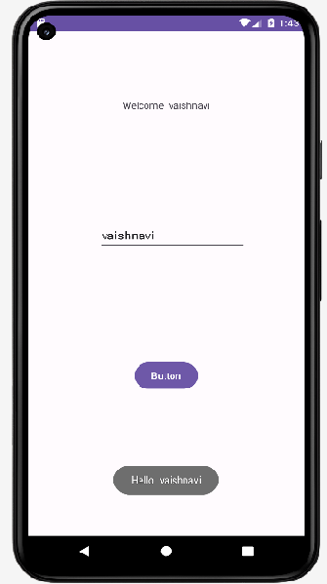

**Name:-**

**Practical No:- 07**

**Practical Name:- Create foreground application that will display toast (Message) on specific interval time.**

**Class:- SY.MCA Roll No.:-**

**MainActivity:-**

package com.example.toastinterval;  
  
import androidx.appcompat.app.AppCompatActivity;  
  
import android.os.Bundle;  
import android.widget.Toast;  
  
public class MainActivity extends AppCompatActivity {  
 private Toast toast;  
  
 @Override  
 protected void onCreate(Bundle savedInstanceState) {  
 super.onCreate(savedInstanceState);  
 setContentView(R.layout.*activity_main*);  
  
 toast = Toast.*makeText*(this, "This is Toast", Toast.*LENGTH_SHORT*);  
  
  
 Thread t = new Thread(new Runnable() {  
 @Override  
 public void run() {  
 for (int i = 0; i < 1000; i++) {  
 try {  
 Thread.*sleep*(1000);  
 toast.show();  
 Thread.*sleep*(1000);  
 } catch (InterruptedException e) {  
 e.printStackTrace();  
 }  
 }  
 }  
 });  
 t.start();  
 }  
}

**OUTPUT:-**

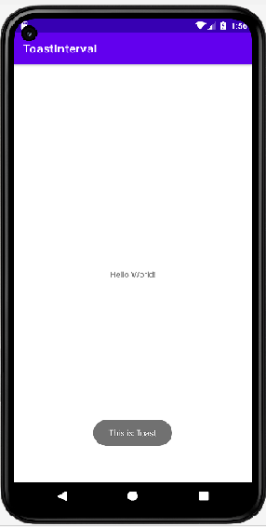

**Name:-**

**Practical No:- 08**

**Practical Name:- Demonstrate use of intents for any 3 native intents.**

**Class:- SY.MCA Roll No.:-**

**Activity_main.xml:-**

<?xml version="1.0" encoding="utf-8"?>

<androidx.constraintlayout.widget.ConstraintLayout

xmlns:android="http://schemas.android.com/apk/res/android"

xmlns:tools="http://schemas.android.com/tools"

xmlns:app="http://schemas.android.com/apk/res-auto"

android:layout_width="match_parent"

android:layout_height="match_parent"

tools:context=".MainActivity">

<TextView

android:id="@+id/textView"

android:layout_width="wrap_content"

android:layout_height="wrap_content"

android:text="Hello World!"

app:layout_constraintBottom_toBottomOf="parent"

app:layout_constraintEnd_toEndOf="parent"

app:layout_constraintStart_toStartOf="parent"

app:layout_constraintTop_toTopOf="parent" />

<Button

android:id="@+id/button"

android:layout_width="wrap_content"

android:layout_height="wrap_content"

android:text="Exlpicit"

app:layout_constraintBottom_toBottomOf="parent"

app:layout_constraintEnd_toEndOf="parent"

app:layout_constraintHorizontal_bias="0.179"

app:layout_constraintStart_toStartOf="parent"

app:layout_constraintTop_toTopOf="parent"

app:layout_constraintVertical_bias="0.762" />

<Button

android:id="@+id/button2"

android:layout_width="wrap_content"

android:layout_height="wrap_content"

android:text="Imlpicit"

app:layout_constraintBottom_toBottomOf="parent"

app:layout_constraintEnd_toEndOf="parent"

app:layout_constraintHorizontal_bias="0.908"

app:layout_constraintStart_toStartOf="parent"

app:layout_constraintTop_toTopOf="parent"

app:layout_constraintVertical_bias="0.762" />

</androidx.constraintlayout.widget.ConstraintLayout>

**Activity_main2.xml:-**

*<?*xml version="1.0" encoding="utf-8"*?>*<androidx.constraintlayout.widget.ConstraintLayout xmlns:android="http://schemas.android.com/apk/res/android"  
 android:layout_width="match_parent"  
 android:layout_height="match_parent">  
  
</androidx.constraintlayout.widget.ConstraintLayout>

**Activity_main.xml:- Activity_main2.xml:-**

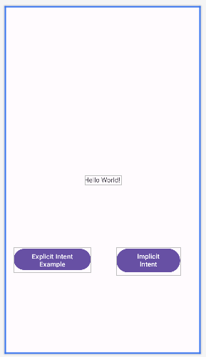 

**AndroidMenifest:-**

*<?*xml version="1.0" encoding="utf-8"*?>*<manifest xmlns:android="http://schemas.android.com/apk/res/android"  
 xmlns:tools="http://schemas.android.com/tools">  
  
 <application  
 android:allowBackup="true"  
 android:5dataExtractionRules="@xml/data_extraction_rules"  
 android:fullBackupContent="@xml/backup_rules"  
 android:icon="@mipmap/ic_launcher"  
 android:label="@string/app_name"  
 android:roundIcon="@mipmap/ic_launcher_round"  
 android:supportsRtl="true"  
 android:theme="@style/Theme.IntentsMCA"  
 tools:targetApi="31">  
 <activity  
 android:name=".MainActivity"  
 android:exported="true">  
 <intent-filter>  
 <action android:name="android.intent.action.MAIN" />  
  
 <category android:name="android.intent.category.LAUNCHER" />  
 </intent-filter>  
 </activity>  
 <activity android:name=".maiActivity2"></activity>  
 </application>  
  
</manifest>

**MainActivity:-**

package com.example.impexp;

import androidx.appcompat.app.AppCompatActivity;

import android.content.Intent;

import android.net.Uri;

import android.os.Bundle;

import android.view.View;

import android.widget.Button;

public class MainActivity extends AppCompatActivity {

Button explicit_btn,implicit_btn;

@Override

protected void onCreate(Bundle savedInstanceState) {

super.onCreate(savedInstanceState);

setContentView(R.layout.activity_main);

explicit_btn = (Button) findViewById(R.id.button);

implicit_btn = (Button) findViewById(R.id.button2);

explicit_btn.setOnClickListener(new View.OnClickListener() {

@Override

public void onClick(View view) {

Intent intent = new Intent(getBaseContext(),mainActivity2.class);

startActivity(intent);

}

});

//implicit onclick event for implicit intent

implicit_btn.setOnClickListener(new View.OnClickListener() {

@Override

public void onClick(View view) {

Intent intent = new Intent(Intent.ACTION_VIEW);

intent.setData(Uri.parse("https://www.google.com"));

startActivity(intent);

}

});

}

}

**MainActivity2.java:-**

package com.example.impexp;

import android.os.Bundle;

import android.widget.Toast;

import androidx.appcompat.app.AppCompatActivity;

public class mainActivity2 extends AppCompatActivity {

@Override

protected void onCreate(Bundle savedInstanceState) {

super.onCreate(savedInstanceState);

setContentView(R.layout.activity_main);

Toast.makeText(getApplicationContext(), "We are moved to second activity", Toast.LENGTH_LONG).show();

}

}

**OUTPUT:-**

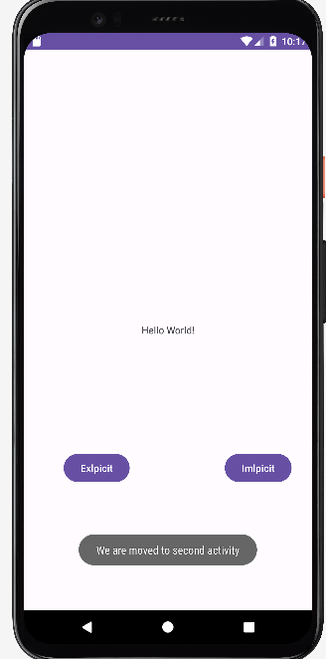 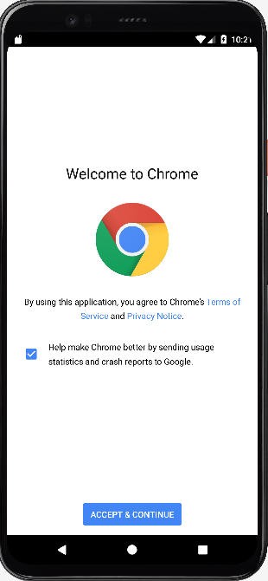

**Name:-**

**Practical No:-09**

**Practical Name** :- **Create the android application that will read phonebook contact using content providers and display in list on selecting specific contact makes a call to selected contact.**

**Class:- SY.MCA Roll No.:-**

**Acitivity_main.xml :-**

*<?*xml version="1.0" encoding="utf-8"*?>*<LinearLayout xmlns:android="http://schemas.android.com/apk/res/android"  
 android:layout_width="match_parent"  
 android:layout_height="match_parent"  
 android:orientation="vertical">  
  
 <Button  
 android:id="@+id/contact_pick"  
 android:layout_width="192dp"  
 android:layout_height="wrap_content"  
 android:text="@string/contact_pick_text" />  
 <Button  
 android:id="@+id/contact_name"  
 android:layout_width="205dp"  
 android:layout_height="wrap_content"  
 android:text="@string/contact_name_text" />  
 </LinearLayout>

**AndroidManifest.xml :-**

*<?*xml version="1.0" encoding="utf-8"*?>*<manifest xmlns:android="http://schemas.android.com/apk/res/android"  
 xmlns:tools="http://schemas.android.com/tools">  
 <uses-permission android:name = "android.permission.READ_CONTACTS" />  
 <application  
 android:allowBackup="true"  
 android:dataExtractionRules="@xml/data_extraction_rules"  
 android:fullBackupContent="@xml/backup_rules"  
 android:icon="@mipmap/ic_launcher"  
 android:label="@string/app_name"  
 android:roundIcon="@mipmap/ic_launcher_round"  
 android:supportsRtl="true"  
 android:theme="@style/Theme.Phonecall"  
 tools:targetApi="31">  
 <activity  
 android:name=".MainActivity"  
 android:exported="true">  
 <intent-filter>  
 <action android:name="android.intent.action.MAIN" />  
  
 <category android:name="android.intent.category.LAUNCHER" />  
 </intent-filter>  
  
 <meta-data  
 android:name="android.app.lib_name"  
 android:value="" />

</activity>  
 </application>  
  
</manifest>

**MainAcitivity.java :-**

package com.example.phonecall;

import androidx.appcompat.app.AppCompatActivity;  
import android.Manifest;  
import android.app.Activity;  
import android.content.Intent;  
import android.content.pm.PackageManager;  
import android.database.Cursor;  
import android.net.Uri;  
import android.os.Bundle;  
import android.provider.ContactsContract;  
import android.view.View;  
import android.widget.Button;  
  
import androidx.annotation.NonNull;  
import androidx.appcompat.app.AppCompatActivity;  
import androidx.core.app.ActivityCompat;  
import androidx.core.content.ContextCompat;  
  
public class MainActivity extends AppCompatActivity  
{  
 private static final int *REQUEST_READ_CONTACTS_PERMISSION* = 0;  
 private static final int *REQUEST_CONTACT* = 1;  
 private Button mContactPick;  
 private Button mContactName;  
  
 @Override  
 public void onRequestPermissionsResult(int requestCode, @NonNull String[] permissions,  
 @NonNull int[] grantResults)  
 {  
 super.onRequestPermissionsResult(requestCode, permissions, grantResults);  
  
 if (requestCode == *REQUEST_READ_CONTACTS_PERMISSION* && grantResults.length > 0)  
 {  
 updateButton(grantResults[0] == PackageManager.*PERMISSION_GRANTED*);  
 }  
 }  
  
 @Override  
 public void onActivityResult(int requestCode, int resultCode, Intent data)  
 {  
 super.onActivityResult(requestCode, resultCode, data);  
 if (resultCode != Activity.*RESULT_OK*) return;  
 if (requestCode == *REQUEST_CONTACT* && data != null)  
 {  
 Uri contactUri = data.getData(); String[] queryFields = new String[]{ContactsContract.Contacts.*DISPLAY_NAME*};Cursor cursor = this.getContentResolver()  
 .query(contactUri, queryFields, null, null, null);  
 try  
 {if (cursor.getCount() == 0) return;cursor.moveToFirst();  
  
 String name = cursor.getString(0);  
 mContactName.setText(name);  
  
 }  
 finally  
 {  
 cursor.close();  
 }  
 }  
 }  
  
 @Override  
 protected void onCreate(Bundle savedInstanceState)  
 {  
 super.onCreate(savedInstanceState);  
 setContentView(R.layout.*aa* );

final Intent pickContact = new Intent(Intent.*ACTION_PICK*, ContactsContract.Contacts.*CONTENT_URI*);  
  
 mContactPick = findViewById(R.id.*contact_pick*);  
 mContactName = findViewById(R.id.*contact_name*);  
 mContactPick.setOnClickListener(new View.OnClickListener()  
 {  
 @Override  
 public void onClick(View view)  
 {  
 startActivityForResult(pickContact, *REQUEST_CONTACT*);  
 }  
 });  
  
 requestContactsPermission();  
 updateButton(hasContactsPermission());  
 }  
  
 public void updateButton(boolean enable)  
 {  
 mContactPick.setEnabled(enable);  
 mContactName.setEnabled(enable);  
 }  
  
 private boolean hasContactsPermission()  
 {  
 return ContextCompat.*checkSelfPermission*(this, Manifest.permission.*READ_CONTACTS*) ==  
 PackageManager.*PERMISSION_GRANTED*;  
 }private void requestContactsPermission()  
 {  
 if (!hasContactsPermission())  
 {  
 ActivityCompat.*requestPermissions*(this,  
 new String[]{Manifest.permission.*READ_CONTACTS*}, *REQUEST_READ_CONTACTS_PERMISSION*);  
 }  
 }  
}

**ExampleUnitTest.java :-**

package com.example.phonecall;  
  
import org.junit.Test;  
  
import static org.junit.Assert.*;  
public class ExampleUnitTest {  
 @Test  
 public void addition_isCorrect() {  
 *assertEquals*(4, 2 + 2);  
 }  
}

**ExampleInstrumentedTest.java :-**

package com.example.phonecall;  
  
import android.content.Context;  
import androidx.test.platform.app.InstrumentationRegistry;  
import androidx.test.ext.junit.runners.AndroidJUnit4;  
import org.junit.Test;  
import org.junit.runner.RunWith;  
import static org.junit.Assert.*;  
@RunWith(AndroidJUnit4.class)  
public class ExampleInstrumentedTest {  
 @Test  
 public void useAppContext() {  
 Context appContext = InstrumentationRegistry.*getInstrumentation*().getTargetContext();  
 *assertEquals*("com.example.phonecall", appContext.getPackageName());  
 }  
}

**BuildConfig.java :-**

package com.example.phonecall;  
  
public final class BuildConfig {  
 public static final boolean *DEBUG* = Boolean.*parseBoolean*("true");  
 public static final String *APPLICATION_ID* = "com.example.phonecall";  
 public static final String *BUILD_TYPE* = "debug";  
 public static final int *VERSION_CODE* = 1;  
 public static final String *VERSION_NAME* = "1.0";  
}

**OUTPUT:-**

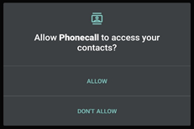 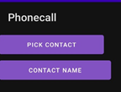

**Name:-**

**Practical No:- 10**

**Practical Name:- Develop android application to take a picture using native application.**

**Class:- SY.MCA Roll No.:-**

**Activity_main.xml:-**

*<?*xml version="1.0" encoding="utf-8"*?>*<androidx.constraintlayout.widget.ConstraintLayout xmlns:android="http://schemas.android.com/apk/res/android"  
 xmlns:app="http://schemas.android.com/apk/res-auto"  
 xmlns:tools="http://schemas.android.com/tools"  
 android:layout_width="match_parent"  
 android:layout_height="match_parent"  
 tools:context=".MainActivity">  
  
 <Button  
 android:id="@+id/button1"  
 android:layout_width="wrap_content"  
 android:layout_height="wrap_content"  
 android:layout_alignParentBottom="true"  
 android:layout_centerHorizontal="true"  
 android:text="Take a Photo"  
 app:layout_constraintBottom_toBottomOf="parent"  
 app:layout_constraintEnd_toEndOf="parent"  
 app:layout_constraintStart_toStartOf="parent"  
 app:layout_constraintTop_toTopOf="parent"></Button>  
  
 <ImageView  
 android:id="@+id/imageView1"  
 android:layout_width="237dp"  
 android:layout_height="147dp"  
 android:layout_above="@+id/button1"  
 android:layout_alignParentTop="true"  
 android:src="@drawable/ic_launcher_background"  
 app:layout_constraintBottom_toBottomOf="parent"  
 app:layout_constraintEnd_toEndOf="parent"  
 app:layout_constraintStart_toStartOf="parent"  
 app:layout_constraintTop_toTopOf="parent"  
 app:layout_constraintVertical_bias="0.184"></ImageView>  
  
</androidx.constraintlayout.widget.ConstraintLayout>

**OUTPUT:-**

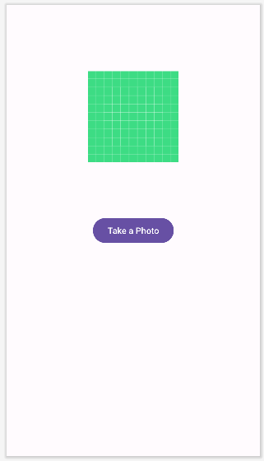

**AndroidMenifest:-**

*<?*xml version="1.0" encoding="utf-8"*?>*<manifest xmlns:android="http://schemas.android.com/apk/res/android"  
 xmlns:tools="http://schemas.android.com/tools">  
  
 <application  
 android:allowBackup="true"  
 android:dataExtractionRules="@xml/data_extraction_rules"  
 android:fullBackupContent="@xml/backup_rules"  
 android:icon="@mipmap/ic_launcher"  
 android:label="@string/app_name"  
 android:roundIcon="@mipmap/ic_launcher_round"  
 android:supportsRtl="true"  
 android:theme="@style/Theme.Camera"  
 tools:targetApi="31">  
 <activity  
 android:name=".MainActivity"  
 android:exported="true">  
 <intent-filter>  
 <action android:name="android.intent.action.MAIN" />  
  
 <category android:name="android.intent.category.LAUNCHER" />  
 </intent-filter>  
 </activity>  
 </application>  
  
</manifest>

**MainActivity:-**

package com.example.camera;  
  
import androidx.appcompat.app.AppCompatActivity;  
import android.content.Intent;  
import android.graphics.Bitmap;  
import android.os.Bundle;  
import android.view.Menu;  
import android.view.View;  
import android.widget.Button;  
import android.widget.ImageView;  
  
public class MainActivity extends AppCompatActivity {  
 private static final int *CAMERA_REQUEST* = 1888;  
 ImageView imageView;  
 @Override  
 protected void onCreate(Bundle savedInstanceState) {  
 super.onCreate(savedInstanceState);  
 setContentView(R.layout.*activity_main*);  
  
 imageView = (ImageView) this.findViewById(R.id.*imageView1*);  
 Button photoButton = (Button) this.findViewById(R.id.*button1*);  
  
 photoButton.setOnClickListener(new View.OnClickListener() {  
  
 @Override  
 public void onClick(View v) {  
 Intent cameraIntent = new Intent(android.provider.MediaStore.*ACTION_IMAGE_CAPTURE*);  
 startActivityForResult(cameraIntent, *CAMERA_REQUEST*);  
 }  
 });  
 }  
  
 protected void onActivityResult(int requestCode, int resultCode, Intent data) {  
 if (requestCode == *CAMERA_REQUEST*) {  
 Bitmap photo = (Bitmap) data.getExtras().get("data");  
 imageView.setImageBitmap(photo);  
 }  
 }  
  
 @Override  
 public boolean onCreateOptionsMenu(Menu menu) {  
 *// Inflate the menu; this adds items to the action bar if it is present.* getMenuInflater().inflate(R.menu.*activity_main*, menu);  
 return true;  
 }  
  
}

**OUTPUT:-**

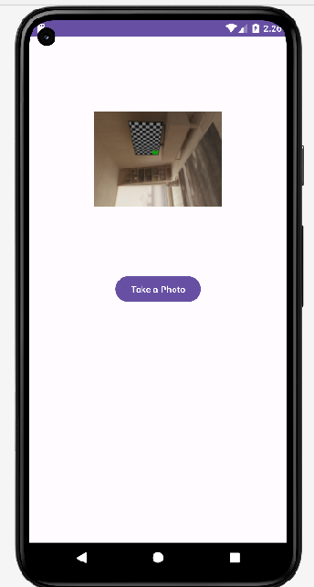

**Name:-**

**Practical No:- 12**

**Practical Name:- Create the android application that will send SMS using your android application. Class:- SY.MCA Roll No.:-**

**Activity_main.xml:-**

*<?*xml version="1.0" encoding="utf-8"*?>*<androidx.constraintlayout.widget.ConstraintLayout xmlns:android="http://schemas.android.com/apk/res/android"  
 xmlns:app="http://schemas.android.com/apk/res-auto"  
 xmlns:tools="http://schemas.android.com/tools"  
 android:layout_width="match_parent"  
 android:layout_height="match_parent"  
 tools:context=".MainActivity">  
  
 <EditText  
 android:id="@+id/edit"  
 android:layout_width="wrap_content"  
 android:layout_height="wrap_content"  
 android:ems="10"  
 android:inputType="text"  
 android:hint="Mobile No."  
 app:layout_constraintBottom_toBottomOf="parent"  
 app:layout_constraintEnd_toEndOf="parent"  
 app:layout_constraintHorizontal_bias="0.542"  
 app:layout_constraintStart_toStartOf="parent"  
 app:layout_constraintTop_toTopOf="parent"  
 app:layout_constraintVertical_bias="0.174" />  
  
 <EditText  
 android:id="@+id/edit2"  
 android:layout_width="wrap_content"  
 android:layout_height="wrap_content"  
 android:ems="10"  
 android:inputType="textMultiLine"  
 android:hint="Message"  
 app:layout_constraintBottom_toBottomOf="parent"  
 app:layout_constraintEnd_toEndOf="parent"  
 app:layout_constraintHorizontal_bias="0.542"  
 app:layout_constraintStart_toStartOf="parent"  
 app:layout_constraintTop_toTopOf="parent"  
 app:layout_constraintVertical_bias="0.322" />  
  
 <Button  
 android:id="@+id/button"  
 android:layout_width="wrap_content"  
 android:layout_height="wrap_content"  
 android:text="Send SMS"  
 app:layout_constraintBottom_toBottomOf="parent"  
 app:layout_constraintEnd_toEndOf="parent"  
 app:layout_constraintStart_toStartOf="parent"  
 app:layout_constraintTop_toTopOf="parent" />  
</androidx.constraintlayout.widget.ConstraintLayout>

**OUTPUT:-**

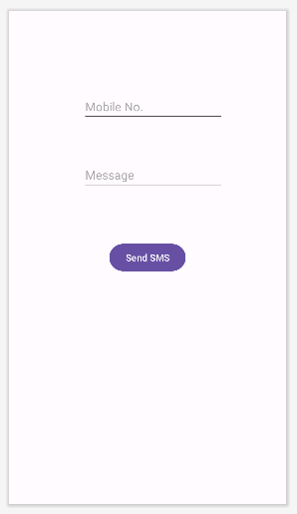

**AndroidMenifest.xml:-**

*<?*xml version="1.0" encoding="utf-8"*?>*<manifest xmlns:android="http://schemas.android.com/apk/res/android"  
 xmlns:tools="http://schemas.android.com/tools">  
  
 <uses-feature  
 android:name="android.hardware.telephony"  
 android:required="false" />  
 <uses-permission android:name="android.permission.SEND_SMS" />  
  
 <application  
 android:allowBackup="true"  
 android:dataExtractionRules="@xml/data_extraction_rules"  
 android:fullBackupContent="@xml/backup_rules"  
 android:icon="@mipmap/ic_launcher"  
 android:label="@string/app_name"  
 android:roundIcon="@mipmap/ic_launcher_round"  
 android:supportsRtl="true"  
 android:theme="@style/Theme.SMS"  
 tools:targetApi="31">  
 <activity  
 android:name=".MainActivity"  
 android:exported="true">  
 <intent-filter>  
 <action android:name="android.intent.action.MAIN" />  
  
 <category android:name="android.intent.category.LAUNCHER" />  
 </intent-filter>  
 </activity>  
 </application>  
  
</manifest>

**MainActivity:-**

package com.example.sms;  
  
import androidx.appcompat.app.AppCompatActivity;  
import androidx.core.app.ActivityCompat;  
import androidx.core.content.ContextCompat;  
  
import android.os.Bundle;  
import android.Manifest;  
import android.content.pm.PackageManager;  
import android.telephony.SmsManager;  
import android.util.Log;  
import android.view.Menu;  
import android.view.View;  
  
import android.widget.Button;  
import android.widget.EditText;  
import android.widget.Toast;  
  
public class MainActivity extends AppCompatActivity {  
 private static final int *MY_PERMISSIONS_REQUEST_SEND_SMS* =0 ;  
 Button sendBtn;  
 EditText txtphoneNo;  
 EditText txtMessage;  
 String phoneNo;  
 String message;  
 @Override  
 protected void onCreate(Bundle savedInstanceState) {  
 super.onCreate(savedInstanceState);  
 setContentView(R.layout.*activity_main*);  
  
 sendBtn = (Button) findViewById(R.id.*button* );  
 txtphoneNo = (EditText) findViewById(R.id.*edit*);  
 txtMessage = (EditText) findViewById(R.id.*edit2*);  
  
 sendBtn.setOnClickListener(new View.OnClickListener() {  
 public void onClick(View view) {  
 sendSMSMessage();  
 }  
 });  
 }  
  
 protected void sendSMSMessage() {  
 phoneNo = txtphoneNo.getText().toString();  
 message = txtMessage.getText().toString();  
  
 if (ContextCompat.*checkSelfPermission*(this,  
 Manifest.permission.*SEND_SMS*)  
 != PackageManager.*PERMISSION_GRANTED*) {  
 if (ActivityCompat.*shouldShowRequestPermissionRationale*(this,  
 Manifest.permission.*SEND_SMS*)) {  
 } else {  
 ActivityCompat.*requestPermissions*(this,  
 new String[]{Manifest.permission.*SEND_SMS*},  
 *MY_PERMISSIONS_REQUEST_SEND_SMS*);  
 }  
 }  
 }  
  
 @Override  
 public void onRequestPermissionsResult(int requestCode,String permissions[], int[] grantResults) {  
 switch (requestCode) {  
 case *MY_PERMISSIONS_REQUEST_SEND_SMS*: {  
 if (grantResults.length > 0  
 && grantResults[0] == PackageManager.*PERMISSION_GRANTED*) {  
 SmsManager smsManager = SmsManager.*getDefault*();  
 smsManager.sendTextMessage(phoneNo, null, message, null, null);  
 Toast.*makeText*(getApplicationContext(), "SMS sent.",  
 Toast.*LENGTH_LONG*).show();  
 } else {  
 Toast.*makeText*(getApplicationContext(),  
 "SMS faild, please try again.", Toast.*LENGTH_LONG*).show();  
 return;  
 }  
 }  
 }  
  
 }  
}

**OUTPUT:-**

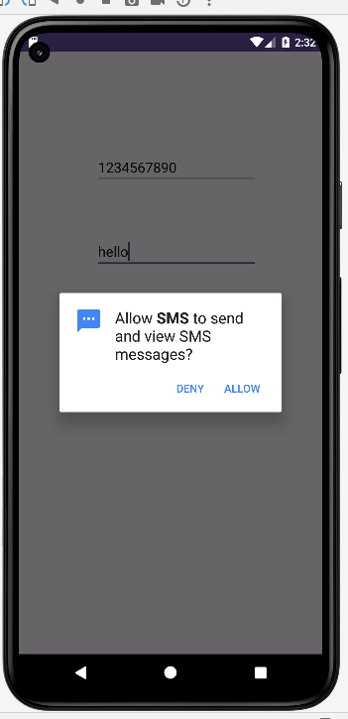 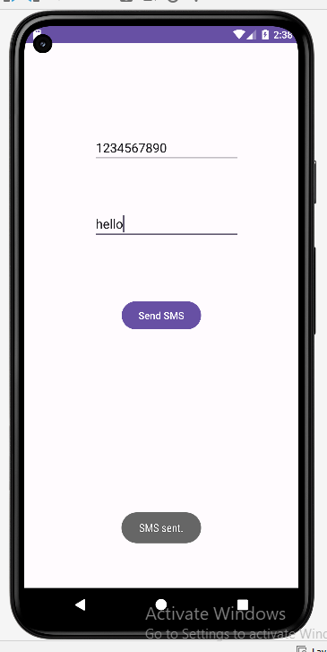

**Name:-**

**Practical No:- 13**

**Practical Name:- Write a android background service that will open activity on specific time. Class:- SY.MCA Roll No.:-**

**Activity_main.xml:-**

*<?*xml version="1.0" encoding="utf-8"*?>*<RelativeLayout xmlns:android="http://schemas.android.com/apk/res/android"  
 xmlns:app="http://schemas.android.com/apk/res-auto"  
 xmlns:tools="http://schemas.android.com/tools"  
 android:layout_width="match_parent"  
 android:layout_height="match_parent"  
 tools:context=".MainActivity">  
  
 <Button  
 android:id="@+id/button"  
 android:layout_width="wrap_content"  
 android:layout_height="wrap_content"  
 android:layout_alignParentBottom="true"  
 android:layout_alignParentTop="true"  
 android:layout_centerHorizontal="true"  
 android:layout_marginBottom="103dp"  
 android:layout_marginTop="581dp"  
 android:text="Start" />  
  
 <EditText  
 android:id="@+id/time"  
 android:hint="Enter time"  
 android:layout_width="wrap_content"  
 android:layout_height="wrap_content"  
 android:layout_alignParentBottom="true"  
 android:layout_alignParentEnd="true"  
 android:layout_alignParentStart="true"  
 android:layout_alignParentTop="true"  
 android:layout_marginBottom="553dp"  
 android:layout_marginEnd="98dp"  
 android:layout_marginStart="104dp"  
 android:layout_marginTop="133dp"  
 android:ems="10" />  
  
</RelativeLayout>

**OUTPUT:-**

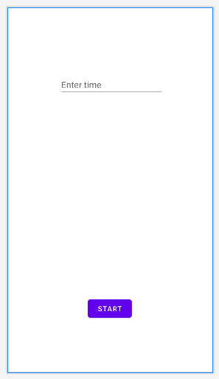

**MainActivity:-**

package com.example.alarm;  
  
import androidx.appcompat.app.AppCompatActivity;  
import android.os.Bundle;  
import android.app.AlarmManager;  
import android.app.PendingIntent;  
import android.content.Intent;  
import android.view.View;  
import android.widget.Button;  
import android.widget.EditText;  
import android.widget.Toast;  
  
public class MainActivity extends AppCompatActivity {  
 Button start;  
 @Override  
 protected void onCreate(Bundle savedInstanceState) {  
 super.onCreate(savedInstanceState);  
 setContentView(R.layout.*activity_main*);  
 start= findViewById(R.id.*button*);  
  
 start.setOnClickListener(new View.OnClickListener() {  
 @Override  
 public void onClick(View view) {  
 startAlert();  
 }  
 });  
 }  
  
 public void startAlert(){  
 EditText text = findViewById(R.id.*time*);  
 int i = Integer.*parseInt*(text.getText().toString());  
 Intent intent = new Intent(this, MyBroadcastReceiver.class);  
 PendingIntent pendingIntent = PendingIntent.*getBroadcast*(  
 this.getApplicationContext(), 234324243, intent, 0);  
 AlarmManager alarmManager = (AlarmManager) getSystemService(*ALARM_SERVICE*);  
 alarmManager.set(AlarmManager.*RTC_WAKEUP*, System.*currentTimeMillis*()  
 + (i * 1000), pendingIntent);  
 Toast.*makeText*(this, "Alarm set in " + i + " seconds",Toast.*LENGTH_LONG*).show();  
 }  
}

**MyBroadcastReceiver:-**

package com.example.alarm;  
import android.content.BroadcastReceiver;  
import android.content.Context;  
import android.content.Intent;  
import android.media.MediaPlayer;  
import android.widget.Toast;  
  
public class MyBroadcastReceiver extends BroadcastReceiver {  
 MediaPlayer mp;  
 @Override  
 public void onReceive(Context context, Intent intent) {  
 mp=MediaPlayer.*create*(context, R.raw.*alarm* );  
 mp.start();  
 Toast.*makeText*(context, "Alarm....", Toast.*LENGTH_LONG*).show();  
 }  
}

**OUTPUT:-**

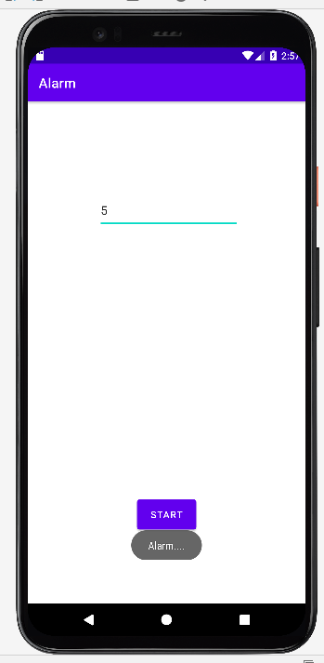

**Name:-**

**Practical No:- 14**

**Practical Name:- Demonstrate use of shared preferences.**

**Class:- SY.MCA Roll No.:-**

**Activity_main.xml:-**

*<?*xml version="1.0" encoding="utf-8"*?>*<androidx.constraintlayout.widget.ConstraintLayout xmlns:android="http://schemas.android.com/apk/res/android"  
 xmlns:app="http://schemas.android.com/apk/res-auto"  
 xmlns:tools="http://schemas.android.com/tools"  
 android:layout_width="match_parent"  
 android:layout_height="match_parent"  
 tools:context=".MainActivity">  
  
 *<!--EditText to take the data from the user and save the data in SharedPreferences-->* <TextView  
 android:id="@+id/textview"  
 android:layout_width="wrap_content"  
 android:layout_height="wrap_content"  
 android:layout_centerHorizontal="true"  
 android:text="Shared Preferences Demo"  
 android:textColor="@android:color/black"  
 android:textSize="24sp"  
 app:layout_constraintBottom_toBottomOf="parent"  
 app:layout_constraintEnd_toEndOf="parent"  
 app:layout_constraintStart_toStartOf="parent"  
 app:layout_constraintTop_toTopOf="parent"  
 app:layout_constraintVertical_bias="0.185" />  
  
 *<!--EditText to take the data from the user and save the data in SharedPreferences-->* <EditText  
 android:id="@+id/edit1"  
 android:layout_width="288dp"  
 android:layout_height="45dp"  
 android:layout_below="@+id/textview"  
 android:hint="Enter your Name"  
 android:padding="10dp"  
 app:layout_constraintBottom_toBottomOf="parent"  
 app:layout_constraintEnd_toEndOf="parent"  
 app:layout_constraintStart_toStartOf="parent"  
 app:layout_constraintTop_toTopOf="parent"  
 app:layout_constraintVertical_bias="0.304" />  
  
 <EditText  
 android:id="@+id/edit2"  
 android:layout_width="289dp"  
 android:layout_height="42dp"  
 android:layout_below="@+id/edit1"  
 android:hint="Enter your Age"  
 android:inputType="number"  
 android:padding="10dp"  
 app:layout_constraintBottom_toBottomOf="parent"  
 app:layout_constraintEnd_toEndOf="parent"  
 app:layout_constraintStart_toStartOf="parent"  
 app:layout_constraintTop_toTopOf="parent"  
 app:layout_constraintVertical_bias="0.435" />  
  
</androidx.constraintlayout.widget.ConstraintLayout>

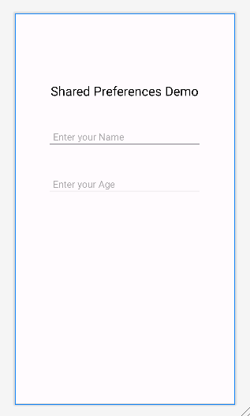

**MainActivity:-**

package com.example.sharedpreferencesmca;  
  
import androidx.appcompat.app.AppCompatActivity;  
import androidx.appcompat.app.AppCompatActivity;  
import android.content.SharedPreferences;  
import android.os.Bundle;  
import android.widget.EditText;  
  
public class MainActivity extends AppCompatActivity {  
 private EditText name, age;  
 @Override  
 protected void onCreate(Bundle savedInstanceState) {  
 super.onCreate(savedInstanceState);  
 setContentView(R.layout.*activity_main*);  
  
 name = findViewById(R.id.*edit1*);  
 age = findViewById(R.id.*edit2*);  
 }  
  
 *// Fetch the stored data in onResume() Because this is what will be called when the app opens again* @Override  
 protected void onResume() {  
 super.onResume();  
 *// Fetching the stored data from the SharedPreference* SharedPreferences sh = getSharedPreferences("MySharedPref", *MODE_PRIVATE*);  
 String s1 = sh.getString("name", "");  
 int a = sh.getInt("age", 0);  
  
 *// Setting the fetched data in the EditTexts* name.setText(s1);  
 age.setText(String.*valueOf*(a));  
 }  
  
 *// Store the data in the SharedPreference in the onPause() method  
 // When the user closes the application onPause() will be called and data will be stored* @Override  
 protected void onPause() {  
 super.onPause();  
 *// Creating a shared pref object with a file name "MySharedPref" in private mode* SharedPreferences sharedPreferences = getSharedPreferences("MySharedPref", *MODE_PRIVATE*);  
 SharedPreferences.Editor myEdit = sharedPreferences.edit();  
  
 *// write all the data entered by the user in SharedPreference and apply* myEdit.putString("name", name.getText().toString());  
 myEdit.putInt("age", Integer.*parseInt*(age.getText().toString()));  
 myEdit.apply();  
 }  
}

**OUTPUT:-**

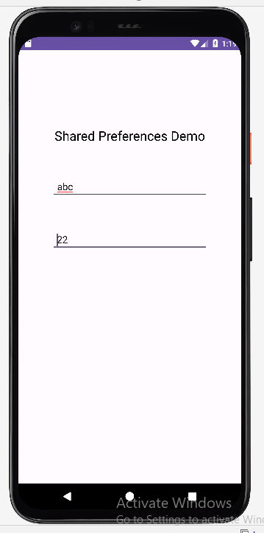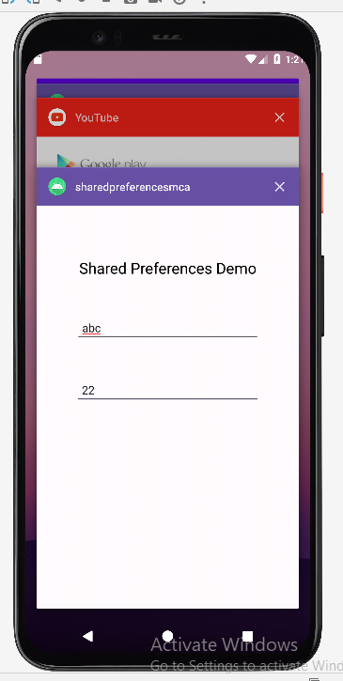

**Name:-**

**Practical No:- 16**

**Practical Name:- Develop application for database manipulation.**

**Class:- SY.MCA Roll No.:-**

**Activity_main.xml:-**

*<?*xml version="1.0" encoding="utf-8"*?>*<androidx.constraintlayout.widget.ConstraintLayout xmlns:android="http://schemas.android.com/apk/res/android"  
 xmlns:app="http://schemas.android.com/apk/res-auto"  
 xmlns:tools="http://schemas.android.com/tools"  
 android:layout_width="match_parent"  
 android:layout_height="match_parent"  
 tools:context=".MainActivity">  
  
 <TextView  
 android:id="@+id/texttitle"  
 android:layout_width="354dp"  
 android:layout_height="39dp"  
 android:text="Please enter the details below"  
 android:textSize="24dp"  
 app:layout_constraintBottom_toBottomOf="parent"  
 app:layout_constraintEnd_toEndOf="parent"  
 app:layout_constraintHorizontal_bias="0.502"  
 app:layout_constraintStart_toStartOf="parent"  
 app:layout_constraintTop_toTopOf="parent"  
 app:layout_constraintVertical_bias="0.074" />  
  
 <EditText  
 android:id="@+id/name"  
 android:layout_width="232dp"  
 android:layout_height="55dp"  
 android:layout_below="@+id/texttitle"  
 android:hint="Name"  
 android:inputType="textPersonName"  
 android:textSize="24dp"  
 app:layout_constraintBottom_toBottomOf="parent"  
 app:layout_constraintEnd_toEndOf="parent"  
 app:layout_constraintHorizontal_bias="0.525"  
 app:layout_constraintStart_toStartOf="parent"  
 app:layout_constraintTop_toTopOf="parent"  
 app:layout_constraintVertical_bias="0.199" />  
  
 <EditText  
 android:id="@+id/contact"  
 android:layout_width="236dp"  
 android:layout_height="51dp"  
 android:layout_below="@+id/name"  
 android:hint="Contact"  
 android:inputType="number"  
 android:textSize="24dp"  
 app:layout_constraintBottom_toBottomOf="parent"  
 app:layout_constraintEnd_toEndOf="parent"  
 app:layout_constraintHorizontal_bias="0.537"  
 app:layout_constraintStart_toStartOf="parent"  
 app:layout_constraintTop_toTopOf="parent"  
 app:layout_constraintVertical_bias="0.332" />  
  
 <EditText  
 android:id="@+id/dob"  
 android:layout_width="225dp"  
 android:layout_height="54dp"  
 android:layout_below="@+id/contact"  
 android:hint="Date of Birth"  
 android:inputType="number"  
 android:textSize="24dp"  
 app:layout_constraintBottom_toBottomOf="parent"  
 app:layout_constraintEnd_toEndOf="parent"  
 app:layout_constraintHorizontal_bias="0.543"  
 app:layout_constraintStart_toStartOf="parent"  
 app:layout_constraintTop_toTopOf="parent"  
 app:layout_constraintVertical_bias="0.443" />  
  
 <Button  
 android:id="@+id/btnInsert"  
 android:layout_width="265dp"  
 android:layout_height="62dp"  
 android:layout_below="@id/dob"  
 android:text="Insert New Data"  
 android:textSize="24dp"  
 app:layout_constraintBottom_toBottomOf="parent"  
 app:layout_constraintEnd_toEndOf="parent"  
 app:layout_constraintHorizontal_bias="0.534"  
 app:layout_constraintStart_toStartOf="parent"  
 app:layout_constraintTop_toTopOf="parent"  
 app:layout_constraintVertical_bias="0.675" />  
  
 <Button  
 android:id="@+id/btnUpdate"  
 android:layout_width="249dp"  
 android:layout_height="57dp"  
 android:layout_below="@id/btnInsert"  
 android:text="Update Data"  
 android:textSize="24dp"  
 app:layout_constraintBottom_toBottomOf="parent"  
 app:layout_constraintEnd_toEndOf="parent"  
 app:layout_constraintStart_toStartOf="parent"  
 app:layout_constraintTop_toTopOf="parent"  
 app:layout_constraintVertical_bias="0.804" />  
  
 <Button  
 android:id="@+id/btnDelete"  
 android:layout_width="275dp"  
 android:layout_height="59dp"  
 android:layout_below="@id/btnUpdate"  
 android:text="Delete Existing Data"  
 android:textSize="24dp"  
 app:layout_constraintBottom_toBottomOf="parent"  
 app:layout_constraintEnd_toEndOf="parent"  
 app:layout_constraintHorizontal_bias="0.573"  
 app:layout_constraintStart_toStartOf="parent"  
 app:layout_constraintTop_toTopOf="parent"  
 app:layout_constraintVertical_bias="0.556" />  
  
 <Button  
 android:id="@+id/btnView"  
 android:layout_width="239dp"  
 android:layout_height="60dp"  
 android:layout_below="@id/btnDelete"  
 android:text="View Data"  
 android:textSize="24dp"  
 app:layout_constraintBottom_toBottomOf="parent"  
 app:layout_constraintEnd_toEndOf="parent"  
 app:layout_constraintHorizontal_bias="0.505"  
 app:layout_constraintStart_toStartOf="parent"  
 app:layout_constraintTop_toTopOf="parent"  
 app:layout_constraintVertical_bias="0.921" />  
  
  
</androidx.constraintlayout.widget.ConstraintLayout>

**OUTPUT:-**

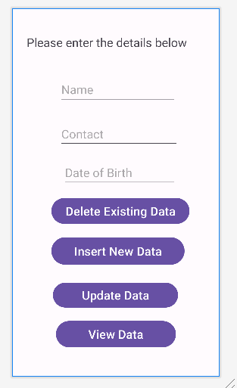

**MainActivity.java:-**

package com.example.sqllitedatabase;  
  
import androidx.appcompat.app.AlertDialog;  
import androidx.appcompat.app.AppCompatActivity;  
import android.database.Cursor;  
import android.os.Bundle;  
import android.view.View;  
import android.widget.Button;  
import android.widget.EditText;  
import android.widget.Toast;  
  
  
public class MainActivity extends AppCompatActivity {  
 EditText name, contact, dob;  
 Button insert, update, delete, view;  
 DBHelper DB;  
  
 @Override  
 protected void onCreate(Bundle savedInstanceState) {  
 super.onCreate(savedInstanceState);  
 setContentView(R.layout.*activity_main*);  
  
 name = findViewById(R.id.*name*);  
 contact = findViewById(R.id.*contact*);  
 dob = findViewById(R.id.*dob*);  
 insert = findViewById(R.id.*btnInsert*);  
 update = findViewById(R.id.*btnUpdate*);  
 delete = findViewById(R.id.*btnDelete*);  
 view = findViewById(R.id.*btnView*);  
 DB = new DBHelper(this);  
 insert.setOnClickListener(new View.OnClickListener() {  
 @Override  
 public void onClick(View view) {  
 String nameTXT = name.getText().toString();  
 String contactTXT = contact.getText().toString();  
 String dobTXT = dob.getText().toString();  
  
 Boolean checkinsertdata = DB.insertuserdata(nameTXT, contactTXT, dobTXT);  
 if(checkinsertdata==true)  
 Toast.*makeText*(MainActivity.this, "New Entry Inserted", Toast.*LENGTH_SHORT*).show();  
 else  
 Toast.*makeText*(MainActivity.this, "New Entry Not Inserted", Toast.*LENGTH_SHORT*).show();  
 } });  
 update.setOnClickListener(new View.OnClickListener() {  
 @Override  
 public void onClick(View view) {  
 String nameTXT = name.getText().toString();  
 String contactTXT = contact.getText().toString();  
 String dobTXT = dob.getText().toString();  
  
 Boolean checkupdatedata = DB.updateuserdata(nameTXT, contactTXT, dobTXT);  
 if(checkupdatedata==true)  
 Toast.*makeText*(MainActivity.this, "Entry Updated", Toast.*LENGTH_SHORT*).show();  
 else  
 Toast.*makeText*(MainActivity.this, "New Entry Not Updated", Toast.*LENGTH_SHORT*).show();  
 } });  
 delete.setOnClickListener(new View.OnClickListener() {  
 @Override  
 public void onClick(View view) {  
 String nameTXT = name.getText().toString();  
 Boolean checkudeletedata = DB.deletedata(nameTXT);  
 if(checkudeletedata==true)  
 Toast.*makeText*(MainActivity.this, "Entry Deleted", Toast.*LENGTH_SHORT*).show();  
 else  
 Toast.*makeText*(MainActivity.this, "Entry Not Deleted", Toast.*LENGTH_SHORT*).show();  
 } });  
  
 view.setOnClickListener(new View.OnClickListener() {  
 @Override  
 public void onClick(View view) {  
 Cursor res = DB.getdata();  
 if(res.getCount()==0){  
 Toast.*makeText*(MainActivity.this, "No Entry Exists", Toast.*LENGTH_SHORT*).show();  
 return;  
 }  
 StringBuffer buffer = new StringBuffer();  
 while(res.moveToNext()){  
 buffer.append("Name :"+res.getString(0)+"\n");  
 buffer.append("Contact :"+res.getString(1)+"\n");  
 buffer.append("Date of Birth :"+res.getString(2)+"\n\n");  
 }  
  
 AlertDialog.Builder builder = new AlertDialog.Builder(MainActivity.this);  
 builder.setCancelable(true);  
 builder.setTitle("User Entries");  
 builder.setMessage(buffer.toString());  
 builder.show();  
 } });  
  
 }  
}

**OUTPUT:-**

