**Write an Android Form Based Application to Perform at least two arithmetic Operations (Addition /Multiplication / Subtraction/Division) on button click. Every action should have separate button.**

**activity_main.xml**.

<?xml version="1.0" encoding="utf-8"?>

<RelativeLayout xmlns:android="http://schemas.android.com/apk/res/android"

android:layout_width="match_parent"

android:layout_height="match_parent"

android:padding="4dp">

<TextView

android:id="@+id/textResult"

android:layout_width="wrap_content"

android:layout_height="wrap_content"

android:layout_centerHorizontal="true"

android:layout_marginTop="70dp"

android:background="#008080"

android:padding="5dp"

android:text="Code4Example"

android:textColor="#fff"

android:textSize="24sp"

android:textStyle="bold" />

<EditText

android:id="@+id/editNum1"

android:inputType="number"

android:layout_width="match_parent"

android:layout_height="wrap_content"

android:layout_centerInParent="true" />

<EditText

android:id="@+id/editNum2"

android:inputType="number"

android:layout_width="match_parent"

android:layout_height="wrap_content"

android:layout_below="@+id/editNum1"

android:layout_centerInParent="true" />

<GridLayout

android:layout_centerHorizontal="true"

android:layout_centerInParent="true"

android:layout_below="@+id/editNum2"

android:columnCount="2"

android:rowCount="2"

android:layout_width="wrap_content"

android:layout_height="wrap_content">

<Button

android:layout_width="wrap_content"

android:layout_height="wrap_content"

android:layout_centerInParent="true"

android:layout_margin="1dp"

android:onClick="btnAdd"

android:text="+" />

<Button

android:layout_width="wrap_content"

android:layout_height="wrap_content"

android:layout_centerInParent="true"

android:layout_margin="1dp"

android:onClick="btnSub"

android:text="-" />

<Button

android:layout_width="wrap_content"

android:layout_height="wrap_content"

android:layout_centerInParent="true"

android:layout_margin="1dp"

android:onClick="btnMul"

android:text="*" />

<Button

android:layout_width="wrap_content"

android:layout_height="wrap_content"

android:layout_centerInParent="true"

android:layout_margin="1dp"

android:onClick="btnDiv"

android:text="/" />

</GridLayout>

</RelativeLayout>

**MainActivity.java**

import androidx.appcompat.app.AppCompatActivity;

import android.os.Bundle;

import android.view.View;

import android.widget.EditText;

import android.widget.TextView;

public class MainActivity extends AppCompatActivity {

EditText editNum1,editNum2;

TextView textResult;

@Override

protected void onCreate(Bundle savedInstanceState) {

super.onCreate(savedInstanceState);

setContentView(R.layout.activity_main);

editNum1= findViewById(R.id.editNum1);

editNum2= findViewById(R.id.editNum2);

textResult= findViewById(R.id.textResult);

}

public void btnAdd(View view){

double num1 = Double.parseDouble(editNum1.getText().toString());

double num2 = Double.parseDouble(editNum2.getText().toString());

double result = num1 + num2;

textResult.setText(Double.toString(result));

}

public void btnSub(View view){

double num1 = Double.parseDouble(editNum1.getText().toString());

double num2 = Double.parseDouble(editNum2.getText().toString());

double result = num1 - num2;

textResult.setText(Double.toString(result));

}

public void btnMul(View view){

double num1 = Double.parseDouble(editNum1.getText().toString());

double num2 = Double.parseDouble(editNum2.getText().toString());

double result = num1 * num2;

textResult.setText(Double.toString(result));

}

public void btnDiv(View view){

double num1 = Double.parseDouble(editNum1.getText().toString());

double num2 = Double.parseDouble(editNum2.getText().toString());

double result = num1 / num2;

textResult.setText(Double.toString(result));

}

}

Output:

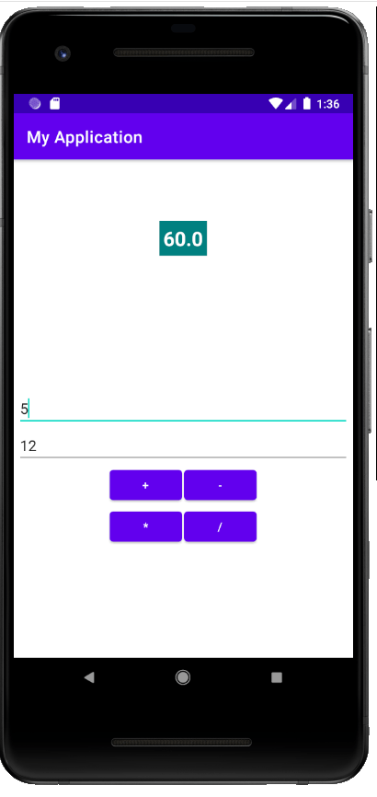

**Write an android program to Show Three Checkbox and One Button, On Button click show selected checkbox name On Toast.**

activity_main.xml

**<?xml** version="1.0" encoding="utf-8"**?>**

**<android.support.constraint.ConstraintLayout** xmlns:android="http://schemas.android.com/apk/res/android"

    xmlns:app="http://schemas.android.com/apk/res-auto"

    xmlns:tools="http://schemas.android.com/tools"

    android:layout_width="match_parent"

    android:layout_height="match_parent"

    tools:context="example.javatpoint.com.checkbox.MainActivity"**>**

**<CheckBox**

        android:id="@+id/checkBox"

        android:layout_width="wrap_content"

        android:layout_height="wrap_content"

        android:layout_marginLeft="144dp"

        android:layout_marginTop="68dp"

        android:text="gayu"

        app:layout_constraintStart_toStartOf="parent"

        app:layout_constraintTop_toTopOf="parent" **/>**

**<CheckBox**

        android:id="@+id/checkBox2"

        android:layout_width="wrap_content"

        android:layout_height="wrap_content"

        android:layout_marginLeft="144dp"

        android:layout_marginTop="28dp"

        android:text="vaishnavi"

        app:layout_constraintStart_toStartOf="parent"

        app:layout_constraintTop_toBottomOf="@+id/checkBox" **/>**

**<CheckBox**

        android:id="@+id/checkBox3"

        android:layout_width="wrap_content"

        android:layout_height="wrap_content"

        android:layout_marginLeft="144dp"

        android:layout_marginTop="28dp"

        android:text="harshal"

        app:layout_constraintStart_toStartOf="parent"

        app:layout_constraintTop_toBottomOf="@+id/checkBox2" **/>**

**<Button**

        android:id="@+id/button"

        android:layout_width="wrap_content"

        android:layout_height="wrap_content"

        android:layout_marginLeft="144dp"

        android:layout_marginTop="184dp"

        android:text="click"

        app:layout_constraintStart_toStartOf="parent"

        app:layout_constraintTop_toBottomOf="@+id/checkBox3" **/>**

**</android.support.constraint.ConstraintLayout>**

**MainActivity.java**

**package** example.javatpoint.com.checkbox;

**import** android.support.v7.app.AppCompatActivity;

**import** android.os.Bundle;

**import** android.view.View;

**import** android.widget.Button;

**import** android.widget.CheckBox;

**import** android.widget.Toast;

**public** **class** MainActivity **extends** AppCompatActivity {

    CheckBox gayu,Vaishnavi,harshal;

    Button buttonclick;

    @Override

**protected** **void** onCreate(Bundle savedInstanceState) {

**super**.onCreate(savedInstanceState);

        setContentView(R.layout.activity_main);

        addListenerOnButtonClick();

    }

**public** **void** addListenerOnButtonClick(){

        //Getting instance of CheckBoxes and Button from the activty_main.xml file

        gayu=(CheckBox)findViewById(R.id.checkBox);

        vaishnavi=(CheckBox)findViewById(R.id.checkBox2);

        harshal=(CheckBox)findViewById(R.id.checkBox3);

        buttonclick=(Button)findViewById(R.id.button);

        //Applying the Listener on the Button click

        buttonOrder.setOnClickListener(**new** View.OnClickListener(){

            @Override

**public** **void** onClick(View view) {

                StringBuilder result=**new** StringBuilder();

                result.append("Selected Items:");

**if**(gayu.isChecked()){

                    result.append("\ngayu 1st");

                }

**if**(vaishnavi.isChecked()){

                    result.append("\nvaishnavi 2nd");

                }

**if**(harshal.isChecked()){

                    result.append("\nharshal 3nd");

                }

                //Displaying the message on the toast

                Toast.makeText(getApplicationContext(), result.toString(), Toast.LENGTH_LONG).show();

            }

        });

   }

}

Output:

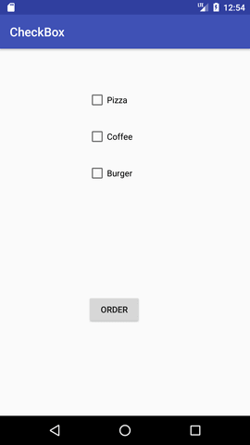 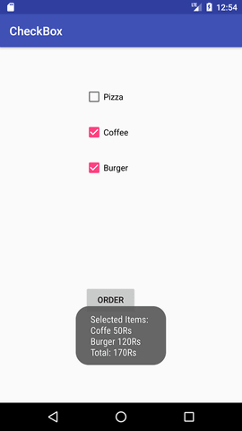

**Practical Name** :- **Write a program to populate resources (res>>value folder). Show resource on changing selection of the resources.**

**MainActivity.java:-**

package com.example.testtt;  
import androidx.appcompat.app.AppCompatActivity;  
import android.os.Bundle;  
import android.widget.TextView;  
  
public class MainActivityextends AppCompatActivity{  
TextViewt1,t2,t3;  
@Override  
protected void onCreate(Bundle savedInstanceState) {  
super.onCreate(savedInstanceState);  
setContentView(R.layout.*activity_main*);

t1=(TextView) findViewById(R.id .*textView*);  
t2=(TextView) findViewById(R.id .*textView2* );  
t3=(TextView) findViewById(R.id .*textView3* );  
t1.setText("Jalgaon");  
t2.setText("IMCA");  
t3.setText("IMR");  
 }  
}

**activity_main.xml:-**

*<?*xml version="1.0" encoding="utf-8"*?>*<LinearLayoutxmlns:android="http://schemas.android.com/apk/res/android"  
xmlns:app="http://schemas.android.com/apk/res-auto"  
xmlns:tools="http://schemas.android.com/tools"  
android:layout_width="match_parent"  
android:layout_height="match_parent"  
tools:context=".MainActivity">  
<TextView  
android:id="@+id/textView"  
android:layout_width="wrap_content"  
android:layout_height="wrap_content"  
android:layout_weight="1"  
android:text="TextView"  
android:background="@color/Lokesh" />  
<TextView  
android:id="@+id/textView3"  
android:layout_width="wrap_content"  
android:layout_height="wrap_content"  
android:layout_weight="1"  
android:text="TextView" />  
<TextView  
android:id="@+id/textView2"  
android:layout_width="wrap_content"  
android:layout_height="296dp"  
android:layout_weight="1"  
android:text="@string/Lokesh" />  
<ImageView  
android:id="@+id/imageView"  
android:layout_width="263dp"  
android:layout_height="315dp"  
android:layout_weight="1"  
app:srcCompat="@drawable/tp" />  
</LinearLayout>

**OUTPUT:-**

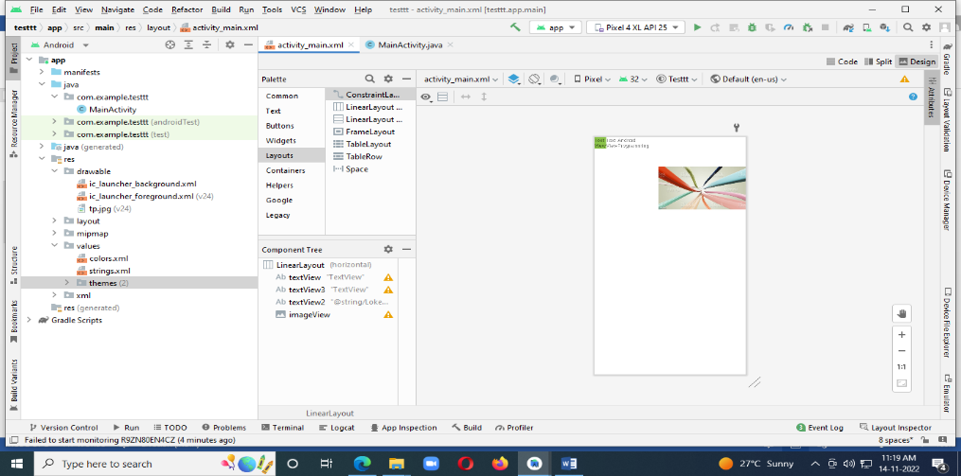

**Practical Name:- Write a program for android application to demonstrate android life cycle stages.**

**MainActivity:-**

package com.example.lifecycle;

import androidx.appcompat.app.AppCompatActivity;

import android.os.Bundle;

import android.util.Log;

public class MainActivity extends AppCompatActivity {

@Override

protected void onCreate(Bundle savedInstanceState) {

super.onCreate(savedInstanceState);

setContentView(R.layout.activity_main);

Log.d("Lifecycle","onStart invoked");

}

@Override

protected void onResume(){

super.onResume();

Log.d("Lifecycle","onResume invoked");

}

@Override

protected void onPause(){

super.onPause();

Log.d("Lifecycle","onPause invoked");

}

@Override

protected void onStop(){

super.onStop();

Log.d("Lifecycle","onStop invoked");

}

@Override

protected void onRestart(){

super.onRestart();

Log.d("Lifecycle","onRestart invoked");

}

@Override

protected void onDestroy(){

super.onDestroy();

Log.d("Lifecycle","onDestroy invoked");

}

}

**OUTPUT:-**

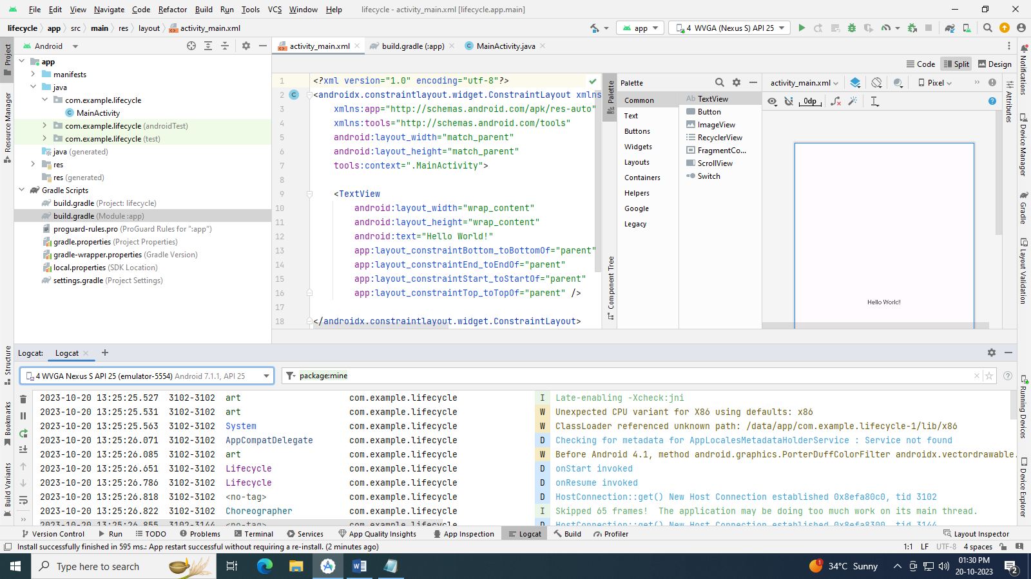

**Practical Name:- Write an android application that takes input from user and shows messages on screen.**

**Activity_main.xml:-**

*<?*xml version="1.0" encoding="utf-8"*?>*<androidx.constraintlayout.widget.ConstraintLayout xmlns:android="http://schemas.android.com/apk/res/android"  
 xmlns:app="http://schemas.android.com/apk/res-auto"  
 xmlns:tools="http://schemas.android.com/tools"  
 android:layout_width="match_parent"  
 android:layout_height="match_parent"  
 tools:context=".MainActivity">  
  
 <TextView  
 android:id="@+id/Text"  
 android:layout_width="wrap_content"  
 android:layout_height="wrap_content"  
 android:text="Hello World!"  
 app:layout_constraintBottom_toBottomOf="parent"  
 app:layout_constraintEnd_toEndOf="parent"  
 app:layout_constraintStart_toStartOf="parent"  
 app:layout_constraintTop_toTopOf="parent"  
 app:layout_constraintVertical_bias="0.139" />  
  
 <EditText  
 android:id="@+id/editTextText"  
 android:layout_width="wrap_content"  
 android:layout_height="wrap_content"  
 android:ems="10"  
 android:inputType="text"  
 android:hint="Name"  
 app:layout_constraintBottom_toBottomOf="parent"  
 app:layout_constraintEnd_toEndOf="parent"  
 app:layout_constraintHorizontal_bias="0.552"  
 app:layout_constraintStart_toStartOf="parent"  
 app:layout_constraintTop_toTopOf="parent"  
 app:layout_constraintVertical_bias="0.4" />  
  
 <Button  
 android:id="@+id/button"  
 android:layout_width="wrap_content"  
 android:layout_height="wrap_content"  
 android:text="Button"  
 android:onClick="onclick"  
 app:layout_constraintBottom_toBottomOf="parent"  
 app:layout_constraintEnd_toEndOf="parent"  
 app:layout_constraintStart_toStartOf="parent"  
 app:layout_constraintTop_toTopOf="parent"  
 app:layout_constraintVertical_bias="0.695" />  
  
</androidx.constraintlayout.widget.ConstraintLayout>

**OUTPUT:-**

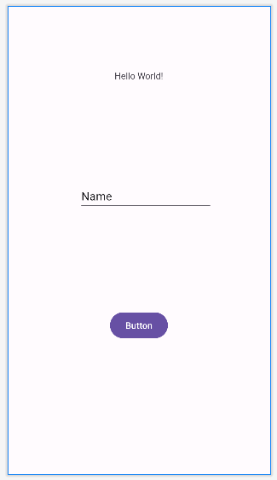

**MainActivity:-**

package com.example.inputfromuser;  
  
import androidx.appcompat.app.AppCompatActivity;  
  
import android.os.Bundle;  
import android.view.View;  
import android.widget.Button;  
import android.widget.EditText;  
import android.widget.TextView;  
import android.widget.Toast;  
  
public class MainActivity extends AppCompatActivity {  
 Button btn;  
 EditText ee;  
 TextView textView ;  
 @Override  
 protected void onCreate(Bundle savedInstanceState) {  
 super.onCreate(savedInstanceState);  
 setContentView(R.layout.*activity_main*);  
  
 btn =(Button) findViewById(R.id .*button* );  
 ee =(EditText) findViewById(R.id .*editTextText* );  
 textView =(TextView ) findViewById(R.id .*Text* );  
  
 btn .setOnClickListener(new View.OnClickListener() {  
 @Override  
 public void onClick(View v) {  
 String str=ee .getText() .toString() ;  
 textView .setText("Welcome "+str);  
 Toast.*makeText*(MainActivity.this, "Hello "+str , Toast.*LENGTH_SHORT*).show();  
 }  
 }) ;  
  
 }  
}

**OUTPUT:-**

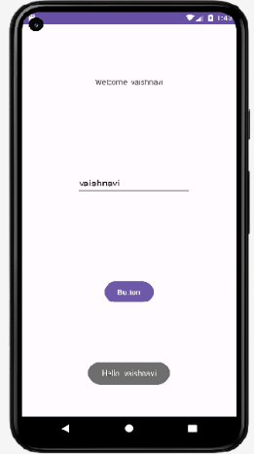

**Practical Name:- Create foreground application that will display toast (Message) on specific interval time.**

**MainActivity:-**

package com.example.toastinterval;  
  
import androidx.appcompat.app.AppCompatActivity;  
  
import android.os.Bundle;  
import android.widget.Toast;  
  
public class MainActivity extends AppCompatActivity {  
 private Toast toast;  
  
 @Override  
 protected void onCreate(Bundle savedInstanceState) {  
 super.onCreate(savedInstanceState);  
 setContentView(R.layout.*activity_main*);  
  
 toast = Toast.*makeText*(this, "This is Toast", Toast.*LENGTH_SHORT*);  
  
  
 Thread t = new Thread(new Runnable() {  
 @Override  
 public void run() {  
 for (int i = 0; i < 1000; i++) {  
 try {  
 Thread.*sleep*(1000);  
 toast.show();  
 Thread.*sleep*(1000);  
 } catch (InterruptedException e) {  
 e.printStackTrace();  
 }  
 }  
 }  
 });  
 t.start();  
 }  
}

**OUTPUT:-**

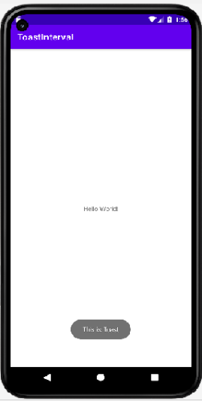

**Practical Name** **Demonstrate string manipulation by displaying at the middle of the screen in the red color with white background with change in fonts & styles of text.**

**Activity_main.xml:**

*<?*xml version="1.0" encoding="utf-8"*?>*<androidx.constraintlayout.widget.ConstraintLayout xmlns:android="http://schemas.android.com/apk/res/android"  
 xmlns:app="http://schemas.android.com/apk/res-auto"  
 xmlns:tools="http://schemas.android.com/tools"  
 android:layout_width="match_parent"  
 android:layout_height="match_parent"  
 tools:context=".MainActivity">  
  
 <TextView  
 android:layout_width="wrap_content"  
 android:layout_height="wrap_content"  
 android:text="Hello World!"  
 android:textColor="#F50057"  
 android:textSize="20sp"  
 app:layout_constraintBottom_toBottomOf="parent"  
 app:layout_constraintEnd_toEndOf="parent"  
 app:layout_constraintStart_toStartOf="parent"  
 app:layout_constraintTop_toTopOf="parent" />  
  
</androidx.constraintlayout.widget.ConstraintLayout>

**OUTPUT:-**

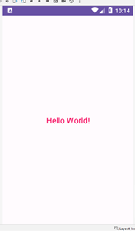

**Write an android program to use Android Explicit Intent that calls one activity from another and vice versa.**

**Activity_main.xml:-**

<?xml version="1.0" encoding="utf-8"?>

<androidx.constraintlayout.widget.ConstraintLayout

xmlns:android="http://schemas.android.com/apk/res/android"

xmlns:tools="http://schemas.android.com/tools"

xmlns:app="http://schemas.android.com/apk/res-auto"

android:layout_width="match_parent"

android:layout_height="match_parent"

tools:context=".MainActivity">

<TextView

android:id="@+id/textView"

android:layout_width="wrap_content"

android:layout_height="wrap_content"

android:text="Hello World!"

app:layout_constraintBottom_toBottomOf="parent"

app:layout_constraintEnd_toEndOf="parent"

app:layout_constraintStart_toStartOf="parent"

app:layout_constraintTop_toTopOf="parent" />

<Button

android:id="@+id/button"

android:layout_width="wrap_content"

android:layout_height="wrap_content"

android:text="Exlpicit"

app:layout_constraintBottom_toBottomOf="parent"

app:layout_constraintEnd_toEndOf="parent"

app:layout_constraintHorizontal_bias="0.179"

app:layout_constraintStart_toStartOf="parent"

app:layout_constraintTop_toTopOf="parent"

app:layout_constraintVertical_bias="0.762" />

<Button

android:id="@+id/button2"

android:layout_width="wrap_content"

android:layout_height="wrap_content"

android:text="Imlpicit"

app:layout_constraintBottom_toBottomOf="parent"

app:layout_constraintEnd_toEndOf="parent"

app:layout_constraintHorizontal_bias="0.908"

app:layout_constraintStart_toStartOf="parent"

app:layout_constraintTop_toTopOf="parent"

app:layout_constraintVertical_bias="0.762" />

</androidx.constraintlayout.widget.ConstraintLayout>

**Activity_main2.xml:-**

*<?*xml version="1.0" encoding="utf-8"*?>*<androidx.constraintlayout.widget.ConstraintLayout xmlns:android="http://schemas.android.com/apk/res/android"  
 android:layout_width="match_parent"  
 android:layout_height="match_parent">  
  
</androidx.constraintlayout.widget.ConstraintLayout>

**Activity_main.xml:- Activity_main2.xml:-**

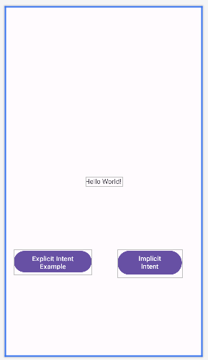 

**AndroidMenifest:-**

*<?*xml version="1.0" encoding="utf-8"*?>*<manifest xmlns:android="http://schemas.android.com/apk/res/android"  
 xmlns:tools="http://schemas.android.com/tools">  
  
 <application  
 android:allowBackup="true"  
 android:5dataExtractionRules="@xml/data_extraction_rules"  
 android:fullBackupContent="@xml/backup_rules"  
 android:icon="@mipmap/ic_launcher"  
 android:label="@string/app_name"  
 android:roundIcon="@mipmap/ic_launcher_round"  
 android:supportsRtl="true"  
 android:theme="@style/Theme.IntentsMCA"  
 tools:targetApi="31">  
 <activity  
 android:name=".MainActivity"  
 android:exported="true">  
 <intent-filter>  
 <action android:name="android.intent.action.MAIN" />  
  
 <category android:name="android.intent.category.LAUNCHER" />  
 </intent-filter>  
 </activity>  
 <activity android:name=".maiActivity2"></activity>  
 </application>  
  
</manifest>

**MainActivity:-**

package com.example.impexp;

import androidx.appcompat.app.AppCompatActivity;

import android.content.Intent;

import android.net.Uri;

import android.os.Bundle;

import android.view.View;

import android.widget.Button;

public class MainActivity extends AppCompatActivity {

Button explicit_btn,implicit_btn;

@Override

protected void onCreate(Bundle savedInstanceState) {

super.onCreate(savedInstanceState);

setContentView(R.layout.activity_main);

explicit_btn = (Button) findViewById(R.id.button);

implicit_btn = (Button) findViewById(R.id.button2);

explicit_btn.setOnClickListener(new View.OnClickListener() {

@Override

public void onClick(View view) {

Intent intent = new Intent(getBaseContext(),mainActivity2.class);

startActivity(intent);

}

});

//implicit onclick event for implicit intent

implicit_btn.setOnClickListener(new View.OnClickListener() {

@Override

public void onClick(View view) {

Intent intent = new Intent(Intent.ACTION_VIEW);

intent.setData(Uri.parse("https://www.google.com"));

startActivity(intent);

}

});

}

}

**MainActivity2.java:-**

package com.example.impexp;

import android.os.Bundle;

import android.widget.Toast;

import androidx.appcompat.app.AppCompatActivity;

public class mainActivity2 extends AppCompatActivity {

@Override

protected void onCreate(Bundle savedInstanceState) {

super.onCreate(savedInstanceState);

setContentView(R.layout.activity_main);

Toast.makeText(getApplicationContext(), "We are moved to second activity", Toast.LENGTH_LONG).show();

}

}

**OUTPUT:-**

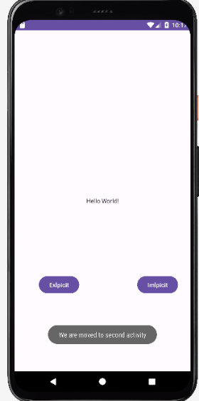 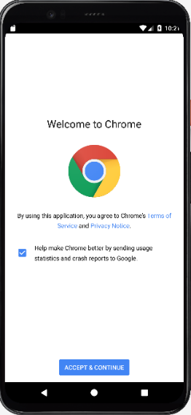

**Write an android program to Show Two Edit View (First Name and Last Name) and One Button and on button click show the entered First Name and Last Name on Text View or Toast.**

**Activity_main.xml:-**

*<?*xml version="1.0" encoding="utf-8"*?>*<androidx.constraintlayout.widget.ConstraintLayout xmlns:android="http://schemas.android.com/apk/res/android"  
 xmlns:app="http://schemas.android.com/apk/res-auto"  
 xmlns:tools="http://schemas.android.com/tools"  
 android:layout_width="match_parent"  
 android:layout_height="match_parent"  
 tools:context=".MainActivity">  
  
 <EditText  
 android:id="@+id/edit"  
 android:layout_width="wrap_content"  
 android:layout_height="wrap_content"  
 android:ems="10"  
 android:inputType="text"  
 android:hint=" Entered First Name"  
 app:layout_constraintBottom_toBottomOf="parent"  
 app:layout_constraintEnd_toEndOf="parent"  
 app:layout_constraintHorizontal_bias="0.542"  
 app:layout_constraintStart_toStartOf="parent"  
 app:layout_constraintTop_toTopOf="parent"  
 app:layout_constraintVertical_bias="0.174" />  
  
 <EditText  
 android:id="@+id/edit2"  
 android:layout_width="wrap_content"  
 android:layout_height="wrap_content"  
 android:ems="10"  
 android:inputType="textMultiLine"  
 android:hint=" Entered Last Name"  
 app:layout_constraintBottom_toBottomOf="parent"  
 app:layout_constraintEnd_toEndOf="parent"  
 app:layout_constraintHorizontal_bias="0.542"  
 app:layout_constraintStart_toStartOf="parent"  
 app:layout_constraintTop_toTopOf="parent"  
 app:layout_constraintVertical_bias="0.322" />  
  
 <Button  
 android:id="@+id/button"  
 android:layout_width="wrap_content"  
 android:layout_height="wrap_content"  
 android:text="Send SMS"  
 app:layout_constraintBottom_toBottomOf="parent"  
 app:layout_constraintEnd_toEndOf="parent"  
 app:layout_constraintStart_toStartOf="parent"  
 app:layout_constraintTop_toTopOf="parent" />  
</androidx.constraintlayout.widget.ConstraintLayout>

**OUTPUT:-**

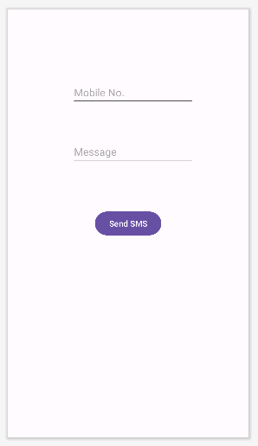

**AndroidMenifest.xml:-**

*<?*xml version="1.0" encoding="utf-8"*?>*<manifest xmlns:android="http://schemas.android.com/apk/res/android"  
 xmlns:tools="http://schemas.android.com/tools">  
  
 <uses-feature  
 android:name="android.hardware.telephony"  
 android:required="false" />  
 <uses-permission android:name="android.permission.SEND_SMS" />  
  
 <application  
 android:allowBackup="true"  
 android:dataExtractionRules="@xml/data_extraction_rules"  
 android:fullBackupContent="@xml/backup_rules"  
 android:icon="@mipmap/ic_launcher"  
 android:label="@string/app_name"  
 android:roundIcon="@mipmap/ic_launcher_round"  
 android:supportsRtl="true"  
 android:theme="@style/Theme.SMS"  
 tools:targetApi="31">  
 <activity  
 android:name=".MainActivity"  
 android:exported="true">  
 <intent-filter>  
 <action android:name="android.intent.action.MAIN" />  
  
 <category android:name="android.intent.category.LAUNCHER" />  
 </intent-filter>  
 </activity>  
 </application>  
  
</manifest>

**MainActivity:-**

package com.example.sms;  
  
import androidx.appcompat.app.AppCompatActivity;  
import androidx.core.app.ActivityCompat;  
import androidx.core.content.ContextCompat;  
  
import android.os.Bundle;  
import android.Manifest;  
import android.content.pm.PackageManager;  
import android.telephony.SmsManager;  
import android.util.Log;  
import android.view.Menu;  
import android.view.View;  
  
import android.widget.Button;  
import android.widget.EditText;  
import android.widget.Toast;  
  
public class MainActivity extends AppCompatActivity {  
 private static final int *MY_PERMISSIONS_REQUEST_SEND_SMS* =0 ;  
 Button sendBtn;  
 EditText txtphoneNo;  
 EditText txtMessage;  
 String phoneNo;  
 String message;  
 @Override  
 protected void onCreate(Bundle savedInstanceState) {  
 super.onCreate(savedInstanceState);  
 setContentView(R.layout.*activity_main*);  
  
 sendBtn = (Button) findViewById(R.id.*button* );  
 txtphoneNo = (EditText) findViewById(R.id.*edit*);  
 txtMessage = (EditText) findViewById(R.id.*edit2*);  
  
 sendBtn.setOnClickListener(new View.OnClickListener() {  
 public void onClick(View view) {  
 sendSMSMessage();  
 }  
 });  
 }  
  
 protected void sendSMSMessage() {  
 phoneNo = txtphoneNo.getText().toString();  
 message = txtMessage.getText().toString();  
  
 if (ContextCompat.*checkSelfPermission*(this,  
 Manifest.permission.*SEND_SMS*)  
 != PackageManager.*PERMISSION_GRANTED*) {  
 if (ActivityCompat.*shouldShowRequestPermissionRationale*(this,  
 Manifest.permission.*SEND_SMS*)) {  
 } else {  
 ActivityCompat.*requestPermissions*(this,  
 new String[]{Manifest.permission.*SEND_SMS*},  
 *MY_PERMISSIONS_REQUEST_SEND_SMS*);  
 }  
 }  
 }  
  
 @Override  
 public void onRequestPermissionsResult(int requestCode,String permissions[], int[] grantResults) {  
 switch (requestCode) {  
 case *MY_PERMISSIONS_REQUEST_SEND_SMS*: {  
 if (grantResults.length > 0  
 && grantResults[0] == PackageManager.*PERMISSION_GRANTED*) {  
 SmsManager smsManager = SmsManager.*getDefault*();  
 smsManager.sendTextMessage(phoneNo, null, message, null, null);  
 Toast.*makeText*(getApplicationContext(), "SMS sent.",  
 Toast.*LENGTH_LONG*).show();  
 } else {  
 Toast.*makeText*(getApplicationContext(),  
 "SMS faild, please try again.", Toast.*LENGTH_LONG*).show();  
 return;  
 }  
 }  
 }  
  
 }  
}

**OUTPUT:-**

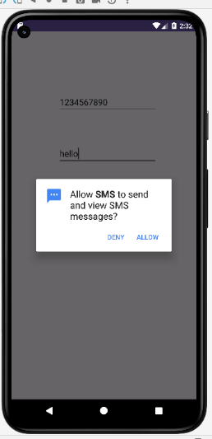 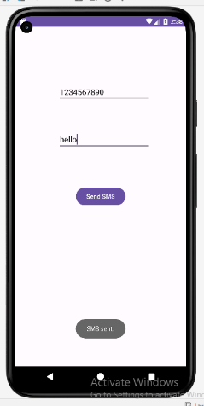

**Write an android program to Show Two Edit View(Numeric) and One Button and on button click show the multiplication of entered numbers on Text View or Toast.**

**activity_main.xml**

**<?xml** version="1.0" encoding="utf-8"**?>**

**<RelativeLayout** xmlns:android="http://schemas.android.com/apk/res/android"

    xmlns:app="http://schemas.android.com/apk/res-auto"

    xmlns:tools="http://schemas.android.com/tools"

    android:layout_width="match_parent"

    android:layout_height="match_parent"

    tools:context="example.javatpoint.com.sumoftwonumber.MainActivity"**>**

**<EditText**

        android:id="@+id/editText1"

        android:layout_width="wrap_content"

        android:layout_height="wrap_content"

        android:layout_alignParentTop="true"

        android:layout_centerHorizontal="true"

        android:layout_marginTop="61dp"

        android:ems="10"

        android:inputType="number"

        tools:layout_editor_absoluteX="84dp"

        tools:layout_editor_absoluteY="53dp" **/>**

**<EditText**

        android:id="@+id/editText2"

        android:layout_width="wrap_content"

        android:layout_height="wrap_content"

        android:layout_below="@+id/editText1"

        android:layout_centerHorizontal="true"

        android:layout_marginTop="32dp"

        android:ems="10"

        android:inputType="number"

        tools:layout_editor_absoluteX="84dp"

        tools:layout_editor_absoluteY="127dp" **/>**

**<Button**

        android:id="@+id/button"

        android:layout_width="wrap_content"

        android:layout_height="wrap_content"

        android:layout_below="@+id/editText2"

        android:layout_centerHorizontal="true"

        android:layout_marginTop="109dp"

        android:text="multiplication"

        tools:layout_editor_absoluteX="148dp"

        tools:layout_editor_absoluteY="266dp" **/>**

**</RelativeLayout>**

**MainActivity.java**

**package** example.javatpoint.com.sumoftwonumber;

**import** android.support.v7.app.AppCompatActivity;

**import** android.os.Bundle;

**import** android.view.View;

**import** android.widget.Button;

**import** android.widget.EditText;

**import** android.widget.Toast;

**public** **class** MainActivity **extends** AppCompatActivity {

**private** EditText edittext1, edittext2;

**private** Button buttonMul;

    @Override

**protected** **void** onCreate(Bundle savedInstanceState) {

**super**.onCreate(savedInstanceState);

        setContentView(R.layout.activity_main);

        addListenerOnButton();

    }

**public** **void** addListenerOnButton() {

        edittext1 = (EditText) findViewById(R.id.editText1);

        edittext2 = (EditText) findViewById(R.id.editText2);

        buttonMul = (Button) findViewById(R.id.button);

        buttonMul.setOnClickListener(**new** View.OnClickListener() {

            @Override

**public** **void** onClick(View view) {

                String value1=edittext1.getText().toString();

                String value2=edittext2.getText().toString();

**int** a=Integer.parseInt(value1);

**int** b=Integer.parseInt(value2);

**int** mul=a*b;

                Toast.makeText(getApplicationContext(),String.valueOf(mul), Toast.LENGTH_LONG).show();

            }

        });

    }

}

Output:

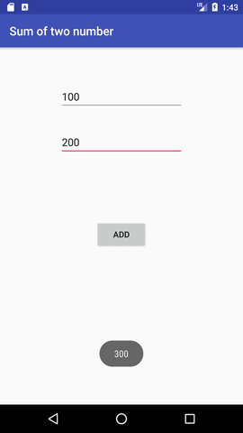

**Write an android program to Show Two Edit View(Numeric) and One Button and on button click show the addition of entered numbers on Text View or Toast.**

**activity_main.xml**

**<?xml** version="1.0" encoding="utf-8"**?>**

**<RelativeLayout** xmlns:android="http://schemas.android.com/apk/res/android"

    xmlns:app="http://schemas.android.com/apk/res-auto"

    xmlns:tools="http://schemas.android.com/tools"

    android:layout_width="match_parent"

    android:layout_height="match_parent"

    tools:context="example.javatpoint.com.sumoftwonumber.MainActivity"**>**

**<EditText**

        android:id="@+id/editText1"

        android:layout_width="wrap_content"

        android:layout_height="wrap_content"

        android:layout_alignParentTop="true"

        android:layout_centerHorizontal="true"

        android:layout_marginTop="61dp"

        android:ems="10"

        android:inputType="number"

        tools:layout_editor_absoluteX="84dp"

        tools:layout_editor_absoluteY="53dp" **/>**

**<EditText**

        android:id="@+id/editText2"

        android:layout_width="wrap_content"

        android:layout_height="wrap_content"

        android:layout_below="@+id/editText1"

        android:layout_centerHorizontal="true"

        android:layout_marginTop="32dp"

        android:ems="10"

        android:inputType="number"

        tools:layout_editor_absoluteX="84dp"

        tools:layout_editor_absoluteY="127dp" **/>**

**<Button**

        android:id="@+id/button"

        android:layout_width="wrap_content"

        android:layout_height="wrap_content"

        android:layout_below="@+id/editText2"

        android:layout_centerHorizontal="true"

        android:layout_marginTop="109dp"

        android:text="ADD"

        tools:layout_editor_absoluteX="148dp"

        tools:layout_editor_absoluteY="266dp" **/>**

**</RelativeLayout>**

**MainActivity.java**

**package** example.javatpoint.com.sumoftwonumber;

**import** android.support.v7.app.AppCompatActivity;

**import** android.os.Bundle;

**import** android.view.View;

**import** android.widget.Button;

**import** android.widget.EditText;

**import** android.widget.Toast;

**public** **class** MainActivity **extends** AppCompatActivity {

**private** EditText edittext1, edittext2;

**private** Button buttonSum;

    @Override

**protected** **void** onCreate(Bundle savedInstanceState) {

**super**.onCreate(savedInstanceState);

        setContentView(R.layout.activity_main);

        addListenerOnButton();

    }

**public** **void** addListenerOnButton() {

        edittext1 = (EditText) findViewById(R.id.editText1);

        edittext2 = (EditText) findViewById(R.id.editText2);

        buttonSum = (Button) findViewById(R.id.button);

        buttonSum.setOnClickListener(**new** View.OnClickListener() {

            @Override

**public** **void** onClick(View view) {

                String value1=edittext1.getText().toString();

                String value2=edittext2.getText().toString();

**int** a=Integer.parseInt(value1);

**int** b=Integer.parseInt(value2);

**int** sum=a+b;

                Toast.makeText(getApplicationContext(),String.valueOf(sum), Toast.LENGTH_LONG).show();

            }

        });

    }

}

Output:



**Write an android program to Show Two Edit View(Numeric) and One Button and on button click show the subtraction of entered numbers on Text View or Toast.**

**activity_main.xml**

**<?xml** version="1.0" encoding="utf-8"**?>**

**<RelativeLayout** xmlns:android="http://schemas.android.com/apk/res/android"

    xmlns:app="http://schemas.android.com/apk/res-auto"

    xmlns:tools="http://schemas.android.com/tools"

    android:layout_width="match_parent"

    android:layout_height="match_parent"

    tools:context="example.javatpoint.com.sumoftwonumber.MainActivity"**>**

**<EditText**

        android:id="@+id/editText1"

        android:layout_width="wrap_content"

        android:layout_height="wrap_content"

        android:layout_alignParentTop="true"

        android:layout_centerHorizontal="true"

        android:layout_marginTop="61dp"

        android:ems="10"

        android:inputType="number"

        tools:layout_editor_absoluteX="84dp"

        tools:layout_editor_absoluteY="53dp" **/>**

**<EditText**

        android:id="@+id/editText2"

        android:layout_width="wrap_content"

        android:layout_height="wrap_content"

        android:layout_below="@+id/editText1"

        android:layout_centerHorizontal="true"

        android:layout_marginTop="32dp"

        android:ems="10"

        android:inputType="number"

        tools:layout_editor_absoluteX="84dp"

        tools:layout_editor_absoluteY="127dp" **/>**

**<Button**

        android:id="@+id/button"

        android:layout_width="wrap_content"

        android:layout_height="wrap_content"

        android:layout_below="@+id/editText2"

        android:layout_centerHorizontal="true"

        android:layout_marginTop="109dp"

        android:text="Subtraction"

        tools:layout_editor_absoluteX="148dp"

        tools:layout_editor_absoluteY="266dp" **/>**

**</RelativeLayout>**

**MainActivity.java**

**package** example.javatpoint.com.sumoftwonumber;

**import** android.support.v7.app.AppCompatActivity;

**import** android.os.Bundle;

**import** android.view.View;

**import** android.widget.Button;

**import** android.widget.EditText;

**import** android.widget.Toast;

**public** **class** MainActivity **extends** AppCompatActivity {

**private** EditText edittext1, edittext2;

**private** Button buttonSub;

    @Override

**protected** **void** onCreate(Bundle savedInstanceState) {

**super**.onCreate(savedInstanceState);

        setContentView(R.layout.activity_main);

        addListenerOnButton();

    }

**public** **void** addListenerOnButton() {

        edittext1 = (EditText) findViewById(R.id.editText1);

        edittext2 = (EditText) findViewById(R.id.editText2);

        buttonSub = (Button) findViewById(R.id.button);

        buttonSub.setOnClickListener(**new** View.OnClickListener() {

            @Override

**public** **void** onClick(View view) {

                String value1=edittext1.getText().toString();

                String value2=edittext2.getText().toString();

**int** a=Integer.parseInt(value1);

**int** b=Integer.parseInt(value2);

**int** sub=a-b;

                Toast.makeText(getApplicationContext(),String.valueOf(sub), Toast.LENGTH_LONG).show();

            }

        });

    }

}

#### Output:



**Write an android program to Show Two Edit View(Numeric) and One Button and on button click show the division of entered numbers on Text View or Toast.**

**activity_main.xml**

**<?xml** version="1.0" encoding="utf-8"**?>**

**<RelativeLayout** xmlns:android="http://schemas.android.com/apk/res/android"

    xmlns:app="http://schemas.android.com/apk/res-auto"

    xmlns:tools="http://schemas.android.com/tools"

    android:layout_width="match_parent"

    android:layout_height="match_parent"

    tools:context="example.javatpoint.com.sumoftwonumber.MainActivity"**>**

**<EditText**

        android:id="@+id/editText1"

        android:layout_width="wrap_content"

        android:layout_height="wrap_content"

        android:layout_alignParentTop="true"

        android:layout_centerHorizontal="true"

        android:layout_marginTop="61dp"

        android:ems="10"

        android:inputType="number"

        tools:layout_editor_absoluteX="84dp"

        tools:layout_editor_absoluteY="53dp" **/>**

**<EditText**

        android:id="@+id/editText2"

        android:layout_width="wrap_content"

        android:layout_height="wrap_content"

        android:layout_below="@+id/editText1"

        android:layout_centerHorizontal="true"

        android:layout_marginTop="32dp"

        android:ems="10"

        android:inputType="number"

        tools:layout_editor_absoluteX="84dp"

        tools:layout_editor_absoluteY="127dp" **/>**

**<Button**

        android:id="@+id/button"

        android:layout_width="wrap_content"

        android:layout_height="wrap_content"

        android:layout_below="@+id/editText2"

        android:layout_centerHorizontal="true"

        android:layout_marginTop="109dp"

        android:text="Division"

        tools:layout_editor_absoluteX="148dp"

        tools:layout_editor_absoluteY="266dp" **/>**

**</RelativeLayout>**

**MainActivity.java**

**package** example.javatpoint.com.sumoftwonumber;

**import** android.support.v7.app.AppCompatActivity;

**import** android.os.Bundle;

**import** android.view.View;

**import** android.widget.Button;

**import** android.widget.EditText;

**import** android.widget.Toast;

**public** **class** MainActivity **extends** AppCompatActivity {

**private** EditText edittext1, edittext2;

**private** Button buttonDivision;

    @Override

**protected** **void** onCreate(Bundle savedInstanceState) {

**super**.onCreate(savedInstanceState);

        setContentView(R.layout.activity_main);

        addListenerOnButton();

    }

**public** **void** addListenerOnButton() {

        edittext1 = (EditText) findViewById(R.id.editText1);

        edittext2 = (EditText) findViewById(R.id.editText2);

        buttonDivision = (Button) findViewById(R.id.button);

        buttonDivision.setOnClickListener(**new** View.OnClickListener() {

            @Override

**public** **void** onClick(View view) {

                String value1=edittext1.getText().toString();

                String value2=edittext2.getText().toString();

**int** a=Integer.parseInt(value1);

**int** b=Integer.parseInt(value2);

**int** division=a/b;

                Toast.makeText(getApplicationContext(),String.valueOf(division), Toast.LENGTH_LONG).show();

            }

        });

    }

}

#### Output:



**Write an android program to Show three Checkbox with Student Hobbies (Playing, Reading and Listening) on the selection of Checkbox all the selected hobbies are displayed on Text View.**

**activity_main.xml**

**<?xml** version="1.0" encoding="utf-8"**?>**

**<android.support.constraint.ConstraintLayout** xmlns:android="http://schemas.android.com/apk/res/android"

    xmlns:app="http://schemas.android.com/apk/res-auto"

    xmlns:tools="http://schemas.android.com/tools"

    android:layout_width="match_parent"

    android:layout_height="match_parent"

    tools:context="example.javatpoint.com.checkbox.MainActivity"**>**

**<CheckBox**

        android:id="@+id/checkBox"

        android:layout_width="wrap_content"

        android:layout_height="wrap_content"

        android:layout_marginLeft="144dp"

        android:layout_marginTop="68dp"

        android:text="Pizza"

        app:layout_constraintStart_toStartOf="parent"

        app:layout_constraintTop_toTopOf="parent" **/>**

**<CheckBox**

        android:id="@+id/checkBox2"

        android:layout_width="wrap_content"

        android:layout_height="wrap_content"

        android:layout_marginLeft="144dp"

        android:layout_marginTop="28dp"

        android:text="Coffee"

        app:layout_constraintStart_toStartOf="parent"

        app:layout_constraintTop_toBottomOf="@+id/checkBox" **/>**

**<CheckBox**

        android:id="@+id/checkBox3"

        android:layout_width="wrap_content"

        android:layout_height="wrap_content"

        android:layout_marginLeft="144dp"

        android:layout_marginTop="28dp"

        android:text="Burger"

        app:layout_constraintStart_toStartOf="parent"

        app:layout_constraintTop_toBottomOf="@+id/checkBox2" **/>**

**<Button**

        android:id="@+id/button"

        android:layout_width="wrap_content"

        android:layout_height="wrap_content"

        android:layout_marginLeft="144dp"

        android:layout_marginTop="184dp"

        android:text="Order"

        app:layout_constraintStart_toStartOf="parent"

        app:layout_constraintTop_toBottomOf="@+id/checkBox3" **/>**

**</android.support.constraint.ConstraintLayout>**

**MainActivity.java**

**package** example.javatpoint.com.checkbox;

**import** android.support.v7.app.AppCompatActivity;

**import** android.os.Bundle;

**import** android.view.View;

**import** android.widget.Button;

**import** android.widget.CheckBox;

**import** android.widget.Toast;

**public** **class** MainActivity **extends** AppCompatActivity {

    CheckBox pizza,coffe,burger;

    Button buttonOrder;

    @Override

**protected** **void** onCreate(Bundle savedInstanceState) {

**super**.onCreate(savedInstanceState);

        setContentView(R.layout.activity_main);

        addListenerOnButtonClick();

    }

**public** **void** addListenerOnButtonClick(){

        //Getting instance of CheckBoxes and Button from the activty_main.xml file

        pizza=(CheckBox)findViewById(R.id.checkBox);

        coffe=(CheckBox)findViewById(R.id.checkBox2);

        burger=(CheckBox)findViewById(R.id.checkBox3);

        buttonOrder=(Button)findViewById(R.id.button);

        //Applying the Listener on the Button click

        buttonOrder.setOnClickListener(**new** View.OnClickListener(){

            @Override

**public** **void** onClick(View view) {

**int** totalamount=0;

                StringBuilder result=**new** StringBuilder();

                result.append("Selected Items:");

**if**(pizza.isChecked()){

                    result.append("\nPizza 100Rs");

                    totalamount+=100;

                }

**if**(coffe.isChecked()){

                    result.append("\nCoffe 50Rs");

                    totalamount+=50;

                }

**if**(burger.isChecked()){

                    result.append("\nBurger 120Rs");

                    totalamount+=120;

                }

                result.append("\nTotal: "+totalamount+"Rs");

                //Displaying the message on the toast

                Toast.makeText(getApplicationContext(), result.toString(), Toast.LENGTH_LONG).show();

            }

        });

    }

}

Output:

 

**Write an android program to Show Edit View and One Button and on button click show the weather entered string is palindrome string or not on Text View or Toast.**

**activity_main.xml**

<?xml version="1.0" encoding="utf-8"?>

<androidx.constraintlayout.widget.ConstraintLayout

xmlns:android="http://schemas.android.com/apk/res/android"

xmlns:app="http://schemas.android.com/apk/res-auto"

xmlns:tools="http://schemas.android.com/tools"

android:layout_width="match_parent"

android:layout_height="match_parent"

android:background="@drawable/background"

android:orientation="vertical"

tools:context=".MainActivity">

<TextView

android:id="@+id/textView"

android:layout_width="wrap_content"

android:layout_height="wrap_content"

android:text="GFG Palindrome Checker"

android:textColor="@color/white"

android:textSize="35sp"

app:layout_constraintEnd_toEndOf="parent"

app:layout_constraintHorizontal_bias="0.548"

app:layout_constraintStart_toStartOf="parent"

app:layout_constraintTop_toTopOf="parent" />

<EditText

android:id="@+id/editText"

android:layout_width="wrap_content"

android:layout_height="wrap_content"

android:layout_gravity="center_horizontal"

android:layout_marginTop="128dp"

android:gravity="center_vertical"

android:hint="Enter the Word"

android:textColor="@color/white"

android:textColorHint="@color/white"

android:textSize="40sp"

app:layout_constraintEnd_toEndOf="parent"

app:layout_constraintHorizontal_bias="0.659"

app:layout_constraintStart_toStartOf="parent"

app:layout_constraintTop_toBottomOf="@+id/textView" />

<Button

android:id="@+id/ButtonCheck"

android:layout_width="128dp"

android:layout_height="58dp"

android:background="#fff"

android:text="Check"

android:textColor="@color/white"

android:textSize="25dp"

app:layout_constraintBottom_toBottomOf="parent"

app:layout_constraintEnd_toEndOf="parent"

app:layout_constraintHorizontal_bias="0.498"

app:layout_constraintStart_toStartOf="parent"

app:layout_constraintTop_toBottomOf="@+id/editText"

app:layout_constraintVertical_bias="0.095" />

</androidx.constraintlayout.widget.ConstraintLayout>

**MainActivity.java**

import android.os.Bundle

import android.widget.Toast

import androidx.appcompat.app.AppCompatActivity

import kotlinx.android.synthetic.main.activity_main.*

class MainActivity : AppCompatActivity() {

override fun onCreate(savedInstanceState: Bundle?) {

super.onCreate(savedInstanceState)

setContentView(R.layout.activity_main)

ButtonCheck.setOnClickListener {

val text = editText.text.toString()

if (ispalindrome(text)) {

Toast.makeText(this, "Entered word is palindrome ", Toast.LENGTH_SHORT).show()

} else {

Toast.makeText(this, "Entered word is not a Palindrome", Toast.LENGTH_SHORT).show()

}

}

}

private fun ispalindrome(text: String): Boolean {

val reverseString = text.reversed().toString()

return text.equals(reverseString, ignoreCase = true)

}

}

**Write an android program to check which toggle button is ON/OFF.**

**activity_main.xml**

**<?xml** version="1.0" encoding="utf-8"**?>**

**<android.support.constraint.ConstraintLayout** xmlns:android="http://schemas.android.com/apk/res/android"

    xmlns:app="http://schemas.android.com/apk/res-auto"

    xmlns:tools="http://schemas.android.com/tools"

    android:layout_width="match_parent"

    android:layout_height="match_parent"

    tools:context="example.javatpoint.com.togglebutton.MainActivity"**>**

**<ToggleButton**

        android:id="@+id/toggleButton"

        android:layout_width="wrap_content"

        android:layout_height="wrap_content"

        android:layout_marginLeft="8dp"

        android:layout_marginTop="80dp"

        android:text="ToggleButton"

        android:textOff="Off"

        android:textOn="On"

        app:layout_constraintEnd_toStartOf="@+id/toggleButton2"

        app:layout_constraintStart_toStartOf="parent"

        app:layout_constraintTop_toTopOf="parent" **/>**

**<ToggleButton**

        android:id="@+id/toggleButton2"

        android:layout_width="wrap_content"

        android:layout_height="wrap_content"

        android:layout_marginRight="60dp"

        android:layout_marginTop="80dp"

        android:text="ToggleButton"

        android:textOff="Off"

        android:textOn="On"

        app:layout_constraintEnd_toEndOf="parent"

        app:layout_constraintTop_toTopOf="parent" **/>**

**<Button**

        android:id="@+id/button"

        android:layout_width="wrap_content"

        android:layout_height="wrap_content"

        android:layout_marginBottom="144dp"

        android:layout_marginLeft="148dp"

        android:text="Submit"

        app:layout_constraintBottom_toBottomOf="parent"

        app:layout_constraintStart_toStartOf="parent" **/>**

**</android.support.constraint.ConstraintLayout>**

**MainActivity.java**

**package** example.javatpoint.com.togglebutton;

**import** android.support.v7.app.AppCompatActivity;

**import** android.os.Bundle;

**import** android.view.View;

**import** android.widget.Button;

**import** android.widget.Toast;

**import** android.widget.ToggleButton;

**public** **class** MainActivity **extends** AppCompatActivity {

**private** ToggleButton toggleButton1, toggleButton2;

**private** Button buttonSubmit;

    @Override

**protected** **void** onCreate(Bundle savedInstanceState) {

**super**.onCreate(savedInstanceState);

        setContentView(R.layout.activity_main);

        addListenerOnButtonClick();

    }

**public** **void** addListenerOnButtonClick(){

        //Getting the ToggleButton and Button instance from the layout xml file

        toggleButton1=(ToggleButton)findViewById(R.id.toggleButton);

        toggleButton2=(ToggleButton)findViewById(R.id.toggleButton2);

        buttonSubmit=(Button)findViewById(R.id.button);

        //Performing action on button click

        buttonSubmit.setOnClickListener(**new** View.OnClickListener(){

            @Override

**public** **void** onClick(View view) {

                StringBuilder result = **new** StringBuilder();

                result.append("ToggleButton1 : ").append(toggleButton1.getText());

                result.append("\nToggleButton2 : ").append(toggleButton2.getText());

                //Displaying the message in toast

                Toast.makeText(getApplicationContext(), result.toString(),Toast.LENGTH_LONG).show();

            }

        });

    }

}

Output:

