Architecture Documentation
AI-Assisted OPD Claims Adjudication System

This document describes the target system architecture for the assignment solution. The design keeps document understanding flexible while making policy enforcement deterministic and auditable.

1. Architecture Overview
The platform is designed as a two-layer decision system. The first layer handles messy, real-world medical documents using OCR and optional LLM assistance. The second layer applies deterministic policy rules for final adjudication.
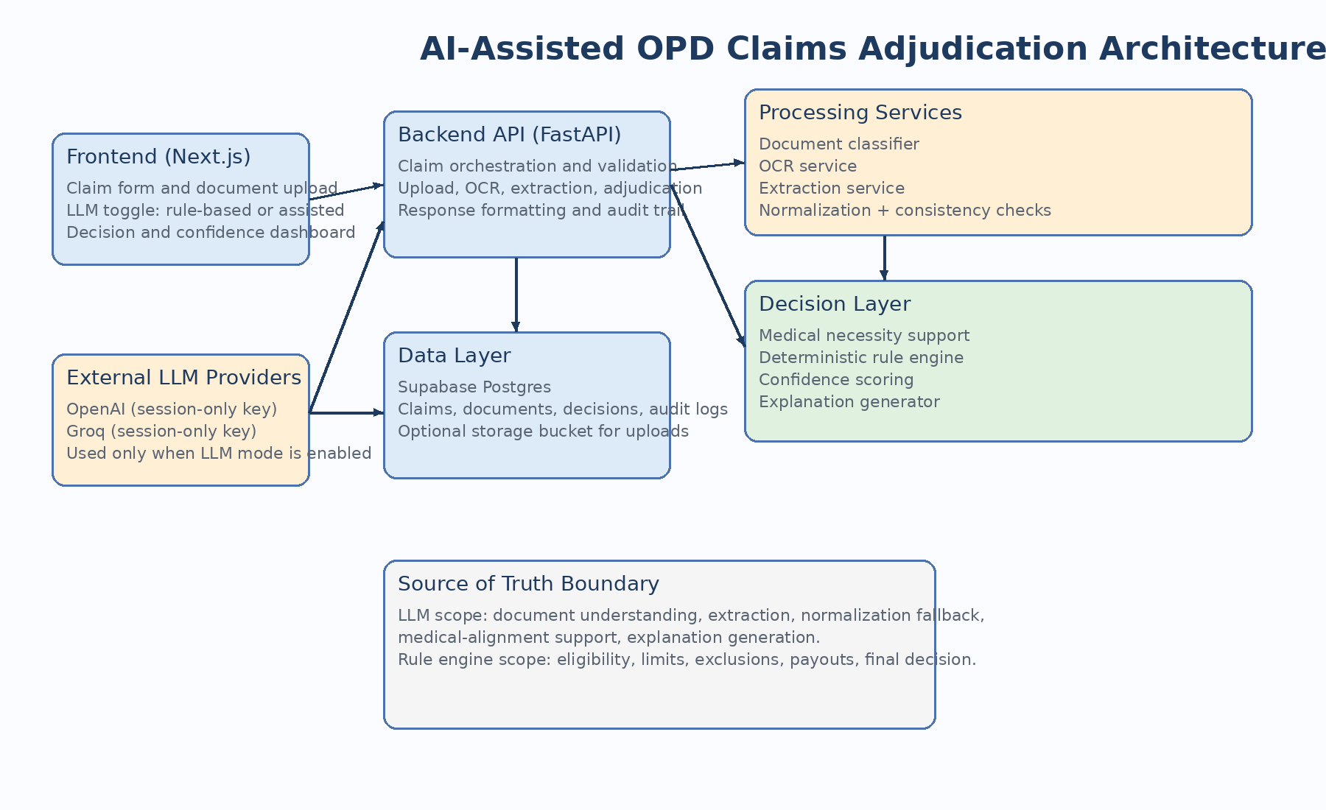
Figure 1. High-level architecture and system boundaries.

2. Core Components
Component | Responsibility | Notes
Frontend (Next.js) | Claim intake, file upload, mode selection, result view | Supports rule-based and LLM-assisted processing modes
Backend API (FastAPI) | Workflow orchestration, validation, response generation | Single entry point for the processing pipeline
OCR Service | Extract text from uploaded PDFs/images | Used in both modes
Extraction Service | Create structured fields from OCR text | Rule-based heuristics or LLM structured extraction
Normalization Service | Map text to canonical categories | Deterministic first, LLM fallback only when enabled
Rule Engine | Eligibility, coverage, limits, payout logic | Source of truth for the final decision
Confidence Service | Quantify certainty and review routing | Consumes OCR, extraction, consistency, rule, and medical signals
Database (Supabase Postgres) | Persist claims, documents, extractions, decisions, audit trail | Cloud-ready and deployment-friendly

3. Processing Modes
- Rule-based mode: classification, extraction, normalization, and medical-support logic rely on heuristics and lookup rules only.
- LLM-assisted mode: the system may use OpenAI or Groq for classification fallback, structured extraction, semantic normalization fallback, and medical-alignment support.
- In both modes, the final adjudication remains deterministic and is calculated by code.

4. Data Flow
- Receive claim metadata, uploaded files, and runtime processing mode.
- Perform OCR and detect document types.
- Extract structured fields such as diagnosis, doctor registration number, dates, medicines, tests, and bill amounts.
- Normalize extracted fields into canonical policy categories.
- Evaluate consistency across documents and compute supporting confidence signals.
- Apply deterministic policy logic for eligibility, coverage, limits, exclusions, fraud checks, and outcome generation.
- Persist decisions, deductions, flags, and audit metadata.

5. Recommended Deployment Topology
The recommended deployment is a separated web stack: the frontend on Vercel, the backend on Render or Railway, and Supabase as the managed Postgres layer. Session-only API keys are passed at runtime when LLM mode is enabled and are never stored in the database.

