Decision Logic Flow
Deterministic Adjudication Sequence

This document explains the decision path used by the claims adjudication engine. The final outcome is always produced by deterministic policy rules, even when LLM assistance is enabled.
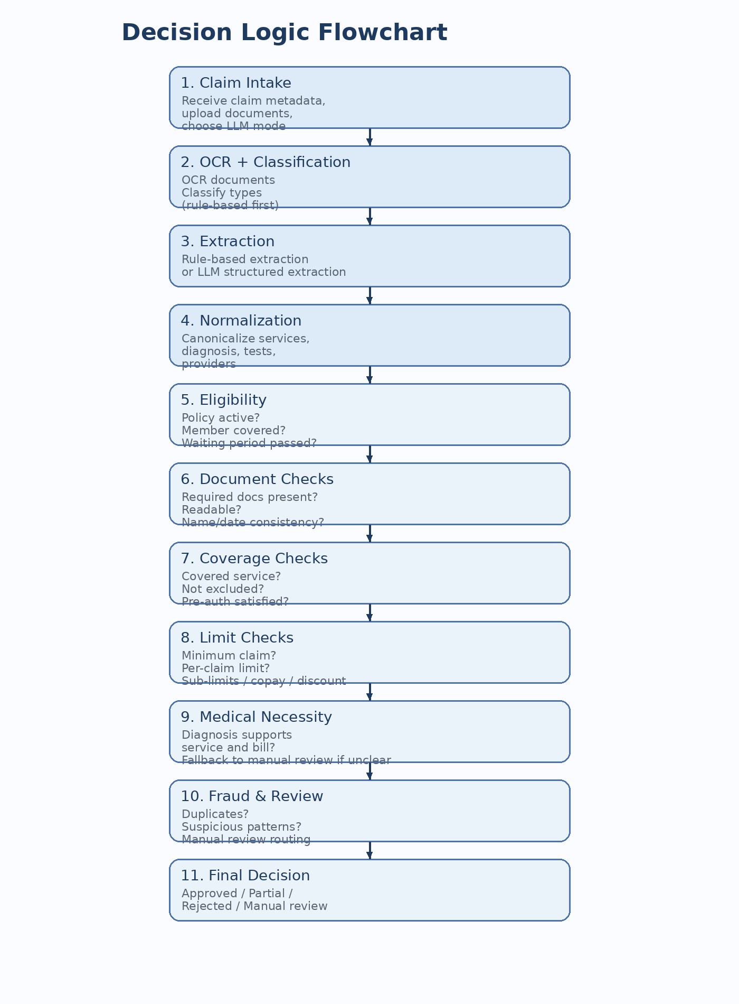
Figure 2. Decision logic flowchart.

1. Ordered Decision Sequence
Step | Decision Question | Possible Outcome
1 | Is the claim payload complete enough to begin processing? | Continue or reject for invalid input
2 | Are OCR, classification, and extraction sufficient to build claim context? | Continue or manual review
3 | Is the policy active and the member covered? | Continue or reject
4 | Has the waiting period been satisfied? | Continue or reject
5 | Are required documents present and internally consistent? | Continue, reject, or manual review
6 | Is the service covered and not excluded? | Continue or reject
7 | Are pre-auth and process conditions met? | Continue or reject
8 | Do minimum amount, per-claim limit, sub-limits, co-pay, and discounts apply? | Continue, reject, or partial
9 | Does diagnosis support the treatment, tests, or medicines? | Continue, reject, or manual review
10 | Do fraud or anomaly checks require escalation? | Continue or manual review
11 | What is the final decision state? | APPROVED, PARTIAL, REJECTED, or MANUAL_REVIEW

2. Decision Principles
- Hard policy rules override soft semantic interpretation.
- LLM outputs may inform extraction, normalization, and medical-alignment support, but they cannot override coverage or payout logic.
- Manual review is preferred when the system is uncertain, contradictory, or suspicious rather than forcing an unsafe automated decision.
- Confidence score affects automation routing, not the underlying policy truth.

