# GourmetGo - Food Delivery System –

# Project Documentation

1. **Introduction**

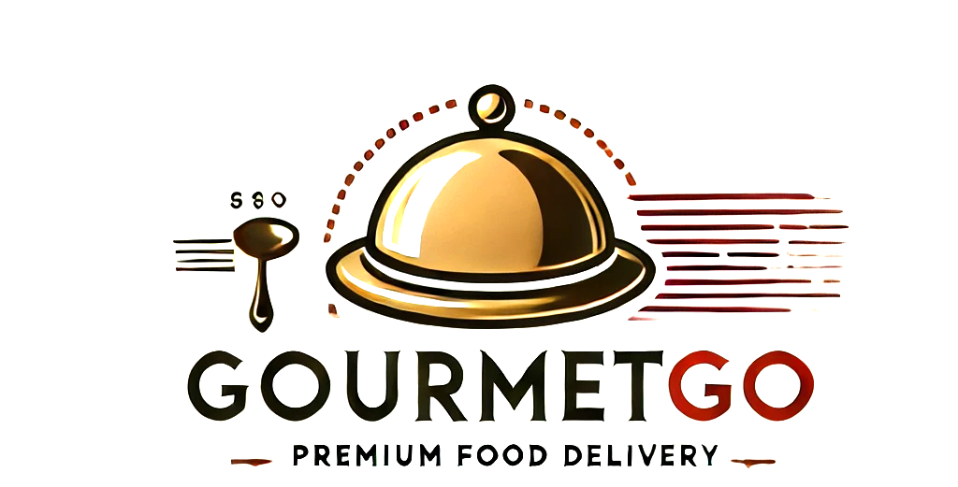

This document provides an in-depth explanation of the GourmetGo food delivery system project, detailing its technologies, architecture, and workflow. It includes insights into the frontend, backend, and administrative functionalities.

**2. Technologies Used**

**Frontend:**

* **Framework:** React.js
* **Styling:** CSS, Tailwind
* **State Management:** React Context API
* **Routing:** React Router
* **Package Manager:** npm/yarn

**Backend:**

* **Framework:** Node.js (Express.js)
* **Database:** MongoDB / MySQL (to be confirmed)
* **Authentication:** JWT (JSON Web Tokens)
* **API:** REST API for communication with frontend

**Admin Panel:**

* **Framework:** React.js / Angular (if separate)
* **Backend Integration:** Fetching analytics, managing orders and users
* **Dashboard:** Tracks sales, user activities, and order status

**3. Project Structure**

**Frontend Structure (React.js)**

* **Components:** UI elements such as Navbar, Food Display, Cart, Order Summary
* **Pages:** Home, Cart, Order History, Checkout
* **Context API:** Handles user authentication, cart, and order states
* **API Calls:** Communicates with backend endpoints for data retrieval and updates

**Backend Structure (Node.js/Express.js)**

* **Authentication Module:** Handles user login/signup using JWT
* **Order Management:** Processes food orders, stores in database
* **Cart Management:** Adds/removes items, calculates total
* **Payment Processing:** Integrates with payment gateway for transactions
* **Admin API:** Provides access to admin dashboard data

**Admin Panel Features**

* **User Management:** Add/remove users, view details
* **Order Monitoring:** Track real-time orders, statuses
* **Restaurant Menu Management:** Modify available food items
* **Revenue Analytics:** View reports on sales and transactions

**4. Workflow Overview**

1. **User visits the GourmetGo website** -> Browses food menu
2. **User adds items to the cart** -> Cart updates in real-time
3. **User proceeds to checkout** -> Selects payment method
4. **Backend processes the order** -> Stores data in database
5. **Payment is verified** -> Transaction completed
6. **Admin monitors orders** -> Ensures timely delivery

**5. Summary**

GourmetGo enables users to browse and order meals via a user-friendly interface. The backend manages orders, authentication, and payments, while the admin panel provides business insights and control over transactions. The project follows a scalable approach, allowing for future enhancements and integrations.