**ASSIGNMENT 1:-**

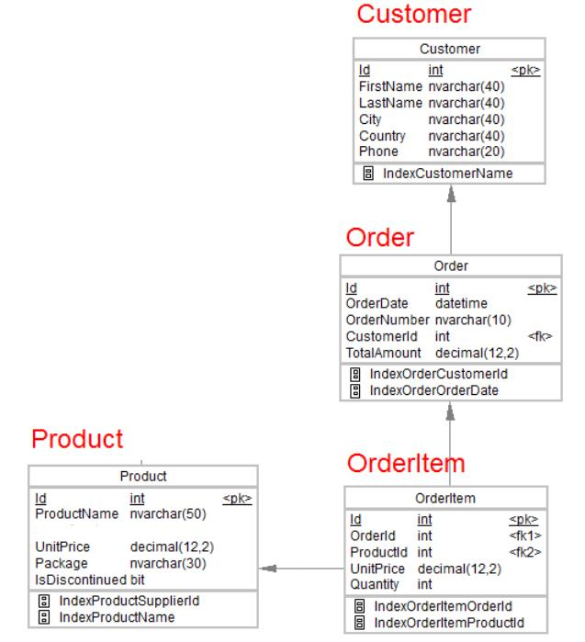

**Desgin the above database with following table by applying Primary key and Foreign key**

CREATE TABLE Customer

(Id int NOT NULL PRIMARY KEY,

FirstName nvarchar(40) NOT NULL,

LastName nvarchar(40),

City nvarchar(40),

Country nvarchar(40),

Phone nvarchar(20));

ALTER TABLE Customer ADD FAX INTEGER;

CREATE TABLE Orders(

Id int NOT NULL PRIMARY KEY,

OrderDate datetime NOT NULL,

OrderNumber nvarchar(10),

CustomerId int FOREIGN KEY REFERENCES Customer(Id) ,

TotalAmount decimal(12,2));

ALTER TABLE Orders ADD ShipName varchar(50);

**PRODUCT:-**

CREATE TABLE Product(

Id int NOT NULL PRIMARY KEY,

ProductName nvarchar(50),

UnitPrice decimal(12,2),

Package nvarchar(30),

IsDiscontinued bit);

alter table Product ADD supplier varchar(50);

alter table Product ADD CategoryName varchar(50);

**ORDER_ITEM:-**

CREATE TABLE OrderItem(

Id int PRIMARY KEY,

OrderID int FOREIGN KEY REFERENCES Orders(Id),

ProductId int FOREIGN KEY REFERENCES Product(Id),

UnitPrice decimal(12,2),

Quantity int);

**Insert Records in all tables :-**

INSERT INTO Customer(Id, FirstName, LastName, City, Country, Phone) VALUES ('1', '', 'Harshal', 'Chalke',’Kolhapur’, 'India', '87968778'),

('2', 'Sri', 'Sharma', 'Berlin', 'Germany', '1234567'), ('2', 'Abhi', 'Russel', 'pune', 'India', '4298745');

INSERT INTO Orders(Id, OrderDate, OrderNumber, CustomerId, TotalAmount) VALUES ('2001', '2018-10-27 12:36:10', '102', '2', '1500'),

('2002', '2020-05-15 09:07:47', '102', '3', '3130'), ('2003', '2015-08-27 18:12:33', '3', '1001', '7360');

INSERT INTO Orders(Id, OrderDate, OrderNumber, CustomerId, TotalAmount,ShippingDate) VALUES ('2004', '2018-11-27 12:36:10', '4', '1002', '3000','2022-05-25');

INSERT INTO Orders(Id, OrderDate, OrderNumber, CustomerId, TotalAmount,ShippingDate) VALUES ('2005', '2018-02-25 16:36:10', '5', '1001', '300','2022-05-17');

INSERT INTO Product(Id, ProductName, UnitPrice, Package, IsDiscontinued) VALUES ('3001', 'shampoo', '250.00', '500000', '0'),

('3002', 'cookies', '140.00', '150000', '0'), ('3003', 'cooking oil', '300.00', '683000', '1');

INSERT INTO OrderItem(Id, OrderID, ProductId, UnitPrice, Quantity) VALUES ('4001', '2001', '3001', '250', '200'),

('4002', '2002', '3002', '200', '300'), ('4003', '2003', '3003', '350', '100'),('4004', '2004', '3002', '10', '90'),('4005', '2005', '3001', '17', '80');

insert into Shipping(ShipName,ShipCompany,IsOperational) values ('La corned abondance','AA',1);

insert into Shipping(ShipName,ShipCompany,IsOperational) values ('Titanic','BB',0);

INSERT INTO Employee(EmpID,EmpRole,EmpName,EmpLName) VALUES (101,'Manager','Akshay','Kumar'),(102,'Manager','RUSHI','PATIL'),(103,'Employer','SANAVI','Khan');

**In Customer table FirstName Attribute should not accept null value**

**In Order table OrderDate should not accept null value**

**Display all customer details**

SELECT * FROM Customer;

**write a query to display Country whose name starts with A or I**

Select Country FROM Customer WHERE Country like 'A%'or Country like'I%';

**write a query to display whose name of customer whose third character is i**

Select FirstName FROM Customer WHERE FirstName like '__I%';

**ASSIGNMENT 2:-**

**Display the details from Customer table who is from country Germany**

Select * FROM Customer WHERE Country='Germany';

**Display the full name of the employee**

Select FirstName,LastName FROM Customer;

**Display the customer details who has Fax number**

SELECT * FROM Customer WHERE FAX IS NOT NULL

**display the customer details whose name holds second letter as U**

Select FirstName,LastName FROM Customer where FirstName like '_u%';

**select order Details where unit price is greater than 10 and less than 20**

select * from OrderItem where UnitPrice Between 10 and 20;

**Display order details which contains shipping date and arrange the order by date**

select * from [Order] WHERE SHIPPING_DATE IS NOT NULL Order By OrderDate;

**Print the orders shipped by ship name 'La corned'abondance' between 2 dates(Choose dates of your choice)**

SELECT * FROM Order WHERE ShipName=’La corned'abondance’ and ShippingDate BETWEEN ‘2022-01-23’ AND ‘2022-05-02’

**Print the products supplied by 'Exotic Liquids'**

Select * from Product where Supplier=’Exotic Liquids’

**print the average quantity ordered for every product**

select avg(Quantity) from OrderItem;

**Print all the Shipping company name and the ship names if they are operational**

Select * from Shipping WHERE IsOperational=1;

**Print all Employees with Manager Name**

Select Employees,Manager_Name from emp;

**Print the bill for a given order id .bill should contain Productname, Categoryname,price after discount**

Select Productname,Categoryname,price-(price*(discount/100)) as BILL from ORDER;

**Print the Total price of orders which have the products supplied by 'Exotic Liquids' if the price is > 50 and also print it by Shipping company's Name**

--Select sum(unitprice) from product group by unitprice having unitprice>50

**ASSIGNMENT 3**

**write a query to display the orders placed by customer with phone number 030-00743212.**

SELECT * FROM [Order] where CustomerId in (SELECT Id from customer where Phone=9112982369)

**fetching all the products which are available under Category Seafood.**

Select * from products where category=seafood;

**Display the orders placed by customers not in London**

select * from [order] where CustomerId in (select id from customer where City='pune');

**selects all the order which are placed for the product Chai.**

select * from OrderItem where ProductId in (select id from Product where ProductName='chai');

**Write a query to display the name , department name and rating  of any given employee**

SELECT Name,Dept_name,rating FROM emp WHERE Emp_id=’101’;

**ASSIGNMENT 4**

**Print the Total price of orders which have the products supplied by 'Exotic Liquids' if the price is > 50 and also print it by Shipping company's Name**

SELECT SUM(PRICE) FROM PRODUCT GROUP BY PRICE HAVING PRICE>50;

**Display the employee details whose joined at first**

Select TOP 1 * from employee order by doj desc

**Display the employee details whose joined at recently**

Select TOP 1 * from employee order by doj asc

**Write a query to get most expense and least expensive Product list (name and unit price)**.

Select productname,min(unitprice),max(unitprice)from product group by productname

**Display the list of products that are out of stock**

SELECT ProductName From Products where stock=0;

**Display the list of products whose unitinstock is less than unitonorder**

SELECT ProductName, UnitsONOrder,UnitsInStock

From Products

WHERE (((Discontinued)=NO) AND ((Unitsinstock)<unitsonorder)

**Display list of categories and suppliers who supply products within those categories**

SELECT Category_Name,ProductSupplier FROM Product GROUP BY Category_Name

**Display complete list of customers, the OrderID and date of any orders they have made**

SELECT c.*,o.Id,o.OrderDate from [Order] o, customer c where o.CustomerId=c.id

**Write query that determines the customer who has placed the maximum number of orders**

Select Customerid,count(id) AS Order_count FROM order GROUP BY Customer_id ORDER BY Order_count DESC;

**Display the customerid whose name has substring ‘RA’**

Select customerid from customer where FirstName like ‘%RA%’

**Display the first word of all the company name**

Select substring_index(companyName,’ ’,1) as firstword from company