horizontal line

Cook @ Home

# PROJECT MEMBERS

1. Harshal Patil (111803160)
2. Kanhaiya Madaswar (111803162)

# PROBLEM STATEMENT / INTRODUCTION

In today's busy world we get a lot of options to order food at home but it cannot satisfy our passion for cooking, In the proposed project we will define a new way for passionate people to cook any food at home without going through the hassle of finding and ordering all the ingredients.

# FUNCTIONAL REQUIREMENTS

* Users should be able to create and manage their account.
* Provide an easy way for enthusiastic home cooks to order required ingredients for the recipe.
* Remove all the hassle of going through a painful ordering process.
* Users should be capable of searching through a huge library of recipes.
* Review system to help users to choose a better option among all the available recipes.
* Admin interface to keep track of stock of all the items in the inventory.
* Administrator should be able to manage deliveries.
* Administrators must be able to control the access rights by each user as per requirement.
* Generate daily reports for the admin.

# TECHNOLOGIES

1. **Database:** MySQL
2. **Front-end:** ReactJS
3. **Back-end:** NodeJS, ExpressJS

# 

# 

# E-R DIAGRAM

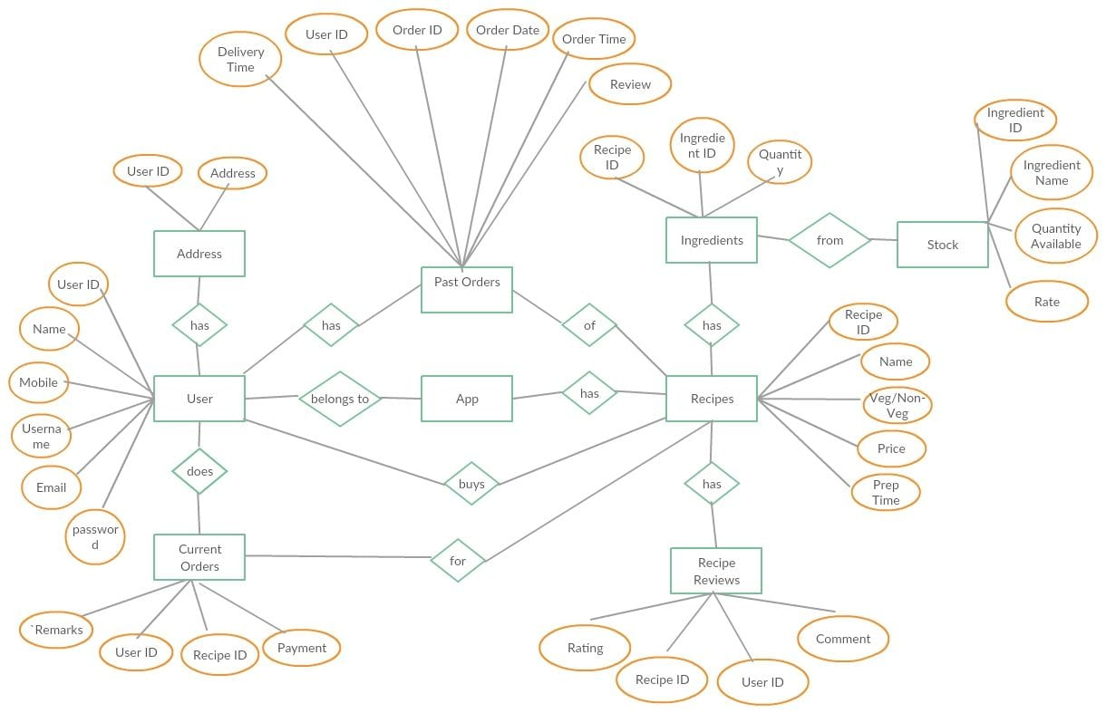

# FUTURE DEVELOPMENTS

* Allowing users to add various recipes and share them with the community.
* Allow users to add videos of their own recipe.
* Making the platform scalable and deploying it into the production.

# 

# TABLES

## USER

|  |  |
| --- | --- |
| **Attribute** | **Data Type** |
| User_ID (Primary Key) | Int |
| Name | Varchar (100) |
| Mobile | Char (10) |
| Email | Varchar (50) |
| Password | Varchar (50) |

## ADDRESS

|  |  |
| --- | --- |
| **Attribute** | **Data Type** |
| User_ID (Foreign Key ref = User) | Int |
| Address | Varchar (100) |

## STOCK

|  |  |
| --- | --- |
| **Attribute** | **Data Type** |
| Ingredient_ID (Primary Key) | Int |
| Ingredient_Name | Varchar (100) |
| Quantity_Available | Int |
| Rate | Int |

## 

## 

## RECIPE

|  |  |
| --- | --- |
| **Attribute** | **Data Type** |
| Recipe_ID (Primary Key) | Int |
| Name | Varchar (100) |
| Price | Int |
| Prep_Time | Time |

## INGREDIENTS

|  |  |
| --- | --- |
| **Attribute** | **Data Type** |
| Recipe_ID (Primary Key)  (Foreign Key ref = Recipe) | Int |
| Ingredient_ID  (Foreign Key ref =stock) | Int |
| Quantity | Int |

## ##CURRENT ORDERS

|  |  |
| --- | --- |
| **Attribute** | **Data Type** |
| Order_ID (Primary Key) | Int |
| User_ID (Foreign Key ref = User) | Int |
| Recipe_ID (Foreign Key ref = Recipe) | Int |
| Payment | Int |
| Remarks | Varchar (200) |

## ORDERS

|  |  |
| --- | --- |
| **Attribute** | **Data Type** |
| Order_ID (Primary Key) | Int |
| User_ID (Foreign Key ref = User) | Int |
| Order_Date | Date |
| Order_Time | Time |
| Delivery_Time | Time(if null current order) |
| Remarks | Varchar (200) |
| Bill | Int |

## RECIPE ORDERS

|  |  |
| --- | --- |
| **Attribute** | **Data Type** |
| Order_ID (Primary Key)  (Foreign Key ref = Orders) | Int |
| Recipe_ID (Foreign Key ref = Recipe) | Int |

## REVIEWS

|  |  |
| --- | --- |
| **Attribute** | **Data Type** |
| Recipe_ID (Primary Key)  (Foreign Key ref = Recipe) | Int |
| User_ID (Primary Key)  (Foreign Key ref = User) | Int |
| Rating | Int |
| Comment | Varchar (200) |