*System* *Engineering* *Course* *Project.*

***Topic- Simulation Modeling of Hospital Management.***

***Current System.(Model 1)***

The current health care system consist of any other normal hospital system where there are various activities going on simultaneously. Patients are coming through the source, registration for the respective treatment, taking the treatment, billing and exiting the hospital. Details of the current system are as follows-

Types of patients(Entities)-

1.Walk in patients.

2.Lab patients.

3.Xray patients.

4.MRI patients.

5.EKG patients.

6. Emergency patients.

Types of working stations(servers)-

1.Registration Counter.

2.Emergency

3.Pathalogy.

4.MRI Room.

5.Treatment.

6.Xray Room.

7.EKG Room.

8.Billing Counter.

9.Triage

Number of entrances and exits.(sources and sink)

1. There are 6 entrances for 6 types of patients.

2. There is one and only one exit for all kind of patients.

Since we had to assign different entities i.e. patients to different servers i.e. rooms we had to define a certain path for the patients so we resolved this issue using a sequence table in SIMIO. Different paths for different patients are as below-

For Walk-in patients-

**Registration Triage Treatment Billing Sink.**

For Pathology patients-

**Pathology Lab  Billing  Sink.**

For X-RAY patients-

**RegistrationXRAY LabBillingSink.**

For MRI patients-

**RegistrationMRI Lab  BillingSink.**

For ECG patients-

**RegistrationECG LabBillingSink.**

For Emergency patients-

**Emergency RegistrationBillingSink.**

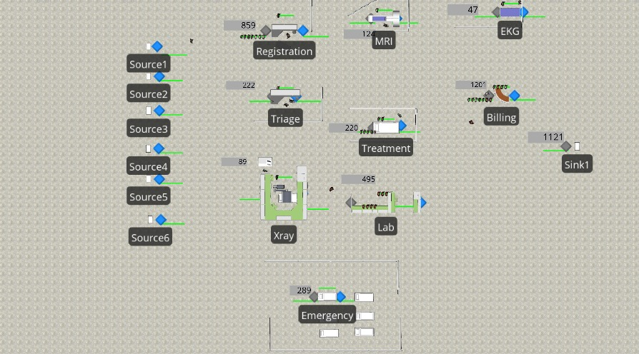

So this is the current management system on which the hospital will run efficiently.

Now hospital has decided to vaccinate people in the emergency room as the number of people entering are low and grouping can be done here. But by doing that, we can observe huge crowding on registration counter due to increase in number of people.

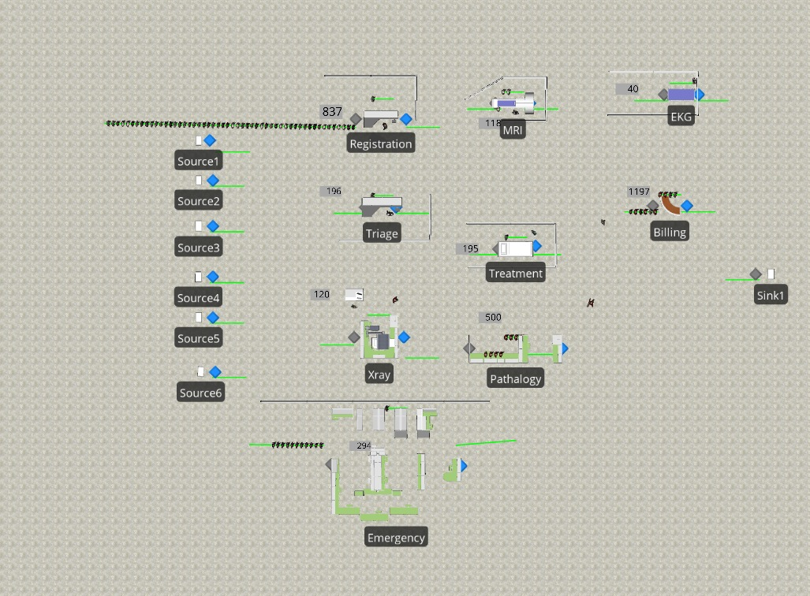

***Proposed System. (Model 2)***

Now since we observed overcrowding at registration counter and billing, we thought of a new system where we can introduce one dedicated billing counter specifically for emergency and vaccine takers so that crowding is reduced in main counter and we can have streamlined flow of patients in the hospital.

Types of patients (Entities)-

1.Walk in patients.

2.Lab patients.

3.Xray patients.

4.MRI patients.

5.EKG patients.

6. Emergency patients& covid vaccine patients

Types of working stations(servers)-

1.Registration Counter

2.Emergency.

3.Pathalogy.

4.MRI .

5.Treatment.

6.Xray Room.

7.EKG

8.Billing Counter

9. Billing and registration

10. Triage

So now there are total 10 servers. As of for the sequence table we made some slight changes in the paths of patients so that emergency and vaccine takers go to their dedicated billings table.

For walk-in patients-

**Registration Triage  TreatmentBilling  Sink.**

For Pathology patients-

**Pathology LabBillingSink.**

For XRAY patients-

**RegistrationXray LabBillingSink.**

For MRI patients-

**RegistrationMRI Lab BillingSink.**

For EKG patients-

**RegistrationEKG BillingSink.**

For Emergency patients & covid vaccine patients-

**Emergency  Billing & Registration  Sink.**

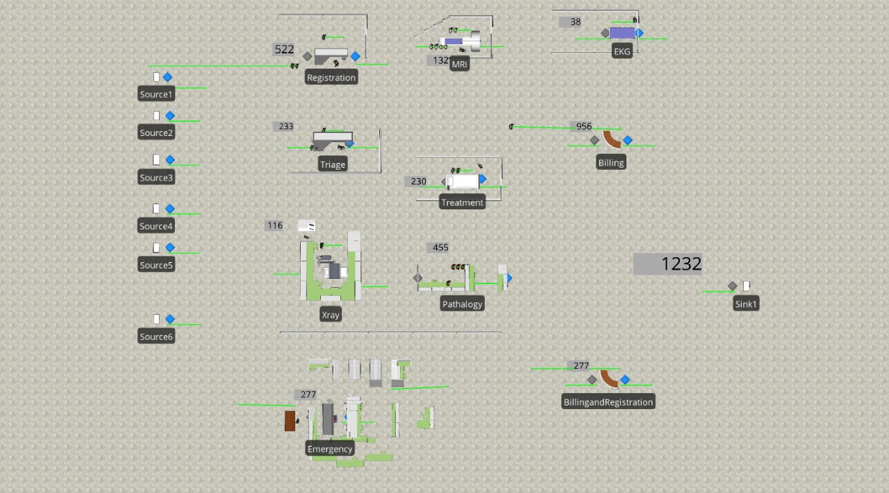

**Observations-**

1.By implementing model 2, we can substantially decrease the crowding on registration counter.

2.People who are coming in for vaccination do not have to stay for a long time as we have created a dedicated billing counter for them

Model1-



Model2-



**Conclusion-**

Apparently, we observed that the improved system is more efficient and safer as we are reducing the contact of COVID patients with the general patients and were successfully able to reduce the que at billing and registration also were able to bill more patients than before.

*THANK-YOU*