AI takes Autonomous Navigation to Mars and Beyond

# **Workshop Pre-work Instructions**

# Hardware and Software Requirements

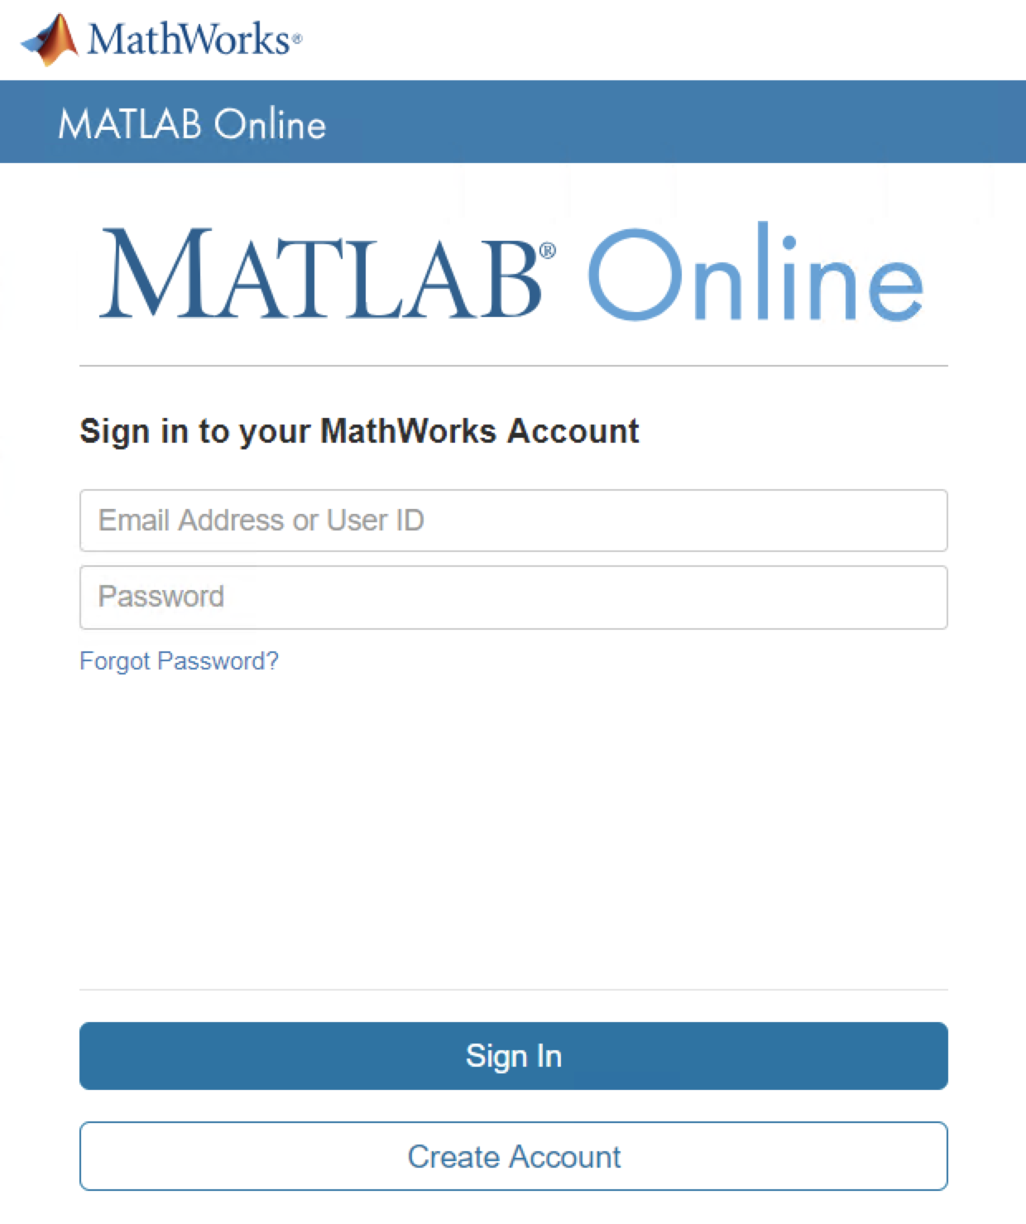To participate in the workshop, you need:

1. A laptop
2. Google Chrome browser recommended
3. A MathWorks account to access MATLAB Online

You will be provided with a temporary workshop license that will give you access to all products used in the workshop.

# Setup Required for this workshop

For the workshop, you need to ensure you have a MathWorks Account, activate the temporary workshop license and access the workshop files using MATLAB Online.

## Step I. Set Up Your MathWorks Account

If you don’t have a MathWorks account, you need to create one to get access to MATLAB Online and the material for this event. You will need access to your email on the machine you are using to create the account.

1. 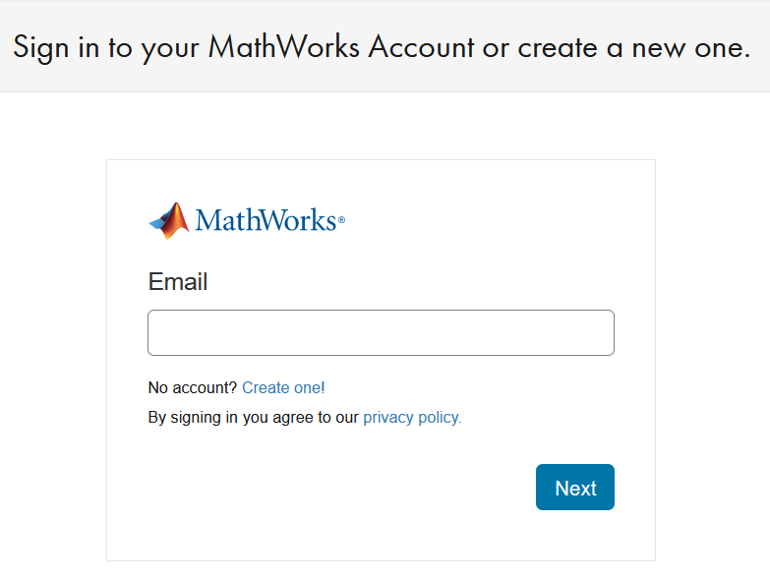In Google Chrome, go to: <https://www.mathworks.com/mwaccount/> and click **Create one!** next to No Account?:
2. Fill out the form and click **Create**. Follow   
   the directions for verifying your email address.
3. To complete your registration, click the link in the verification email and fill out the form.

**You must check the Online Services Agreement box.**   
You may leave these fields blank: Activation Key or License Number, Sales rep contact, Associate with a license, Trial

## Step II. Activate the Workshop License

The workshop uses MATLAB Online. You must activate this license to participate.

1. Navigate to this address in Google Chrome:  <https://tinyurl.com/mw-ghc-mars-rover>

Click **Access MATLAB Online***.*

1. Log in to MATLAB Online using your MathWorks account. After you log in, you see the MATLAB Online interface.

## Step III. Access Exercise Files

MATLAB Online will try to port your workshop files from GitHub. You will see a dialog pop-up for saving and opening the repository of files.

* Click on the checkbox to accept outside source code.
* To access the files, hit “Save and Open”.

## Contact Information If you have any questions about the content, please reach to **Kritika Ramani** ([kramani@mathworks.com](mailto:kramani@mathworks.com))