**Test case 1**

**If we entered the same answer multiple times it will show the same result as that of entered one time**

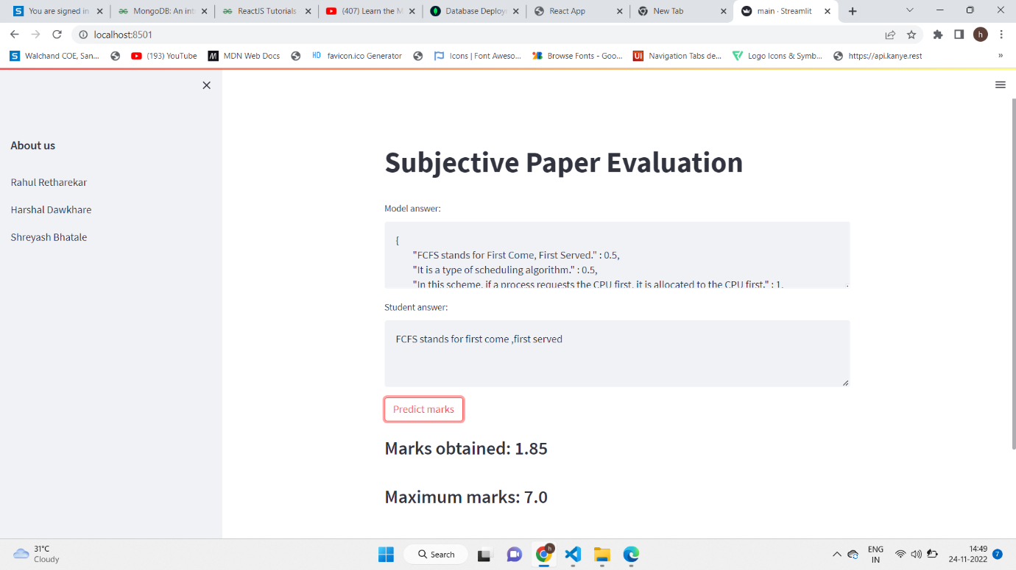

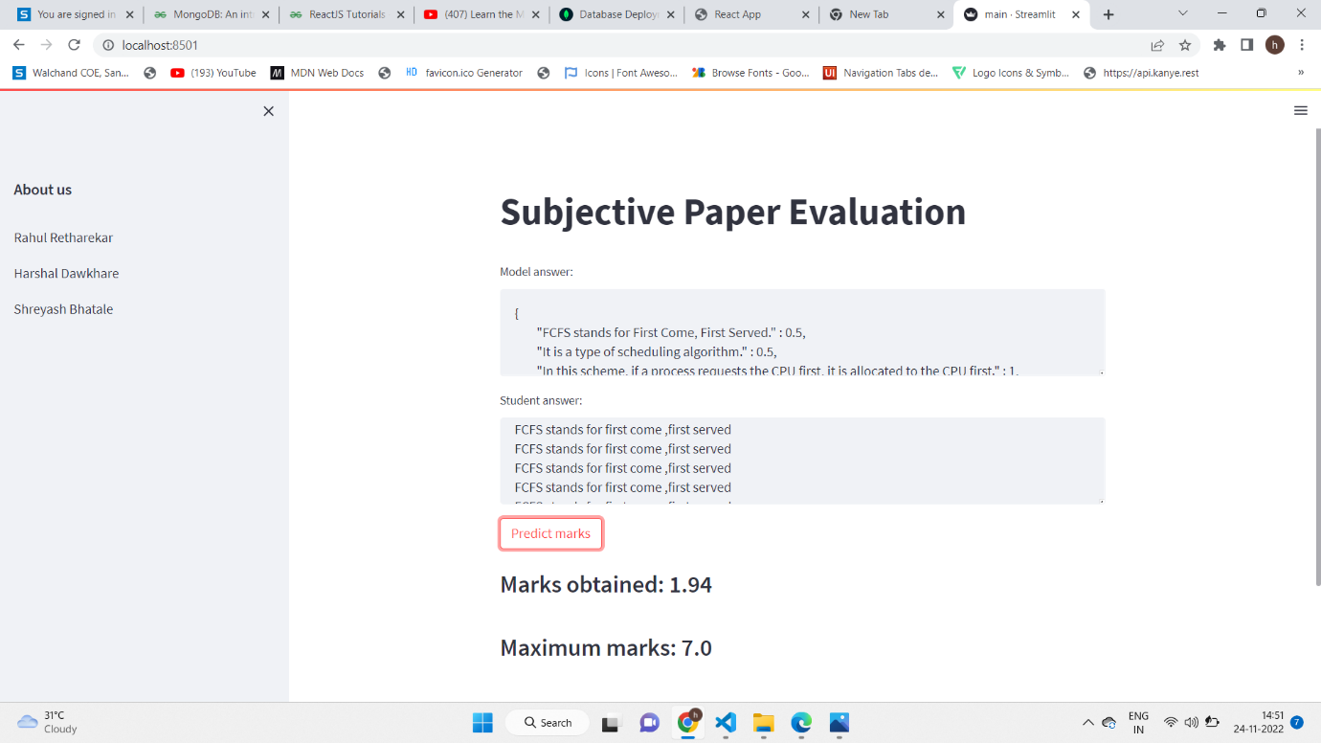

**Test case 2 When we entered the first 6 lines of answer which have 5 marks It will give marks as 4.94**

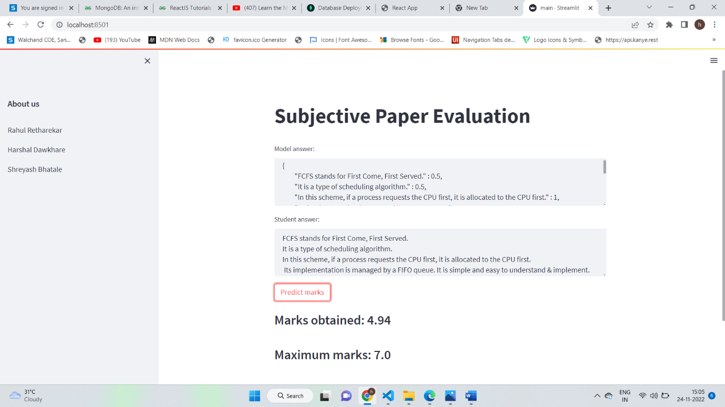

**Test case 3 when we write only keywords then it will only give marks such as 3.97 out of 7**

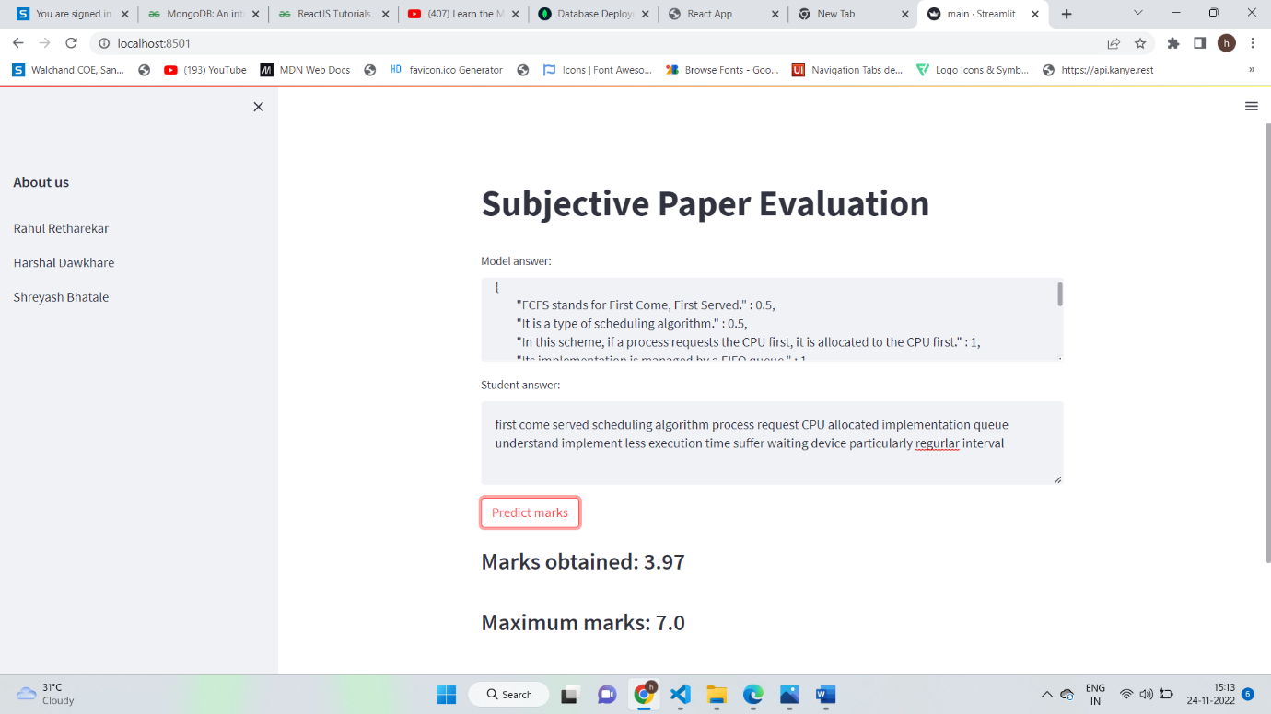

**Test case 4 When we write sentences with grammatical error present in it then it will give 0 marks for that answer**

