**ESCROW ONLINE TRANSACTION (CONSTRUCTION FINANCE)**

Escrow bank account is a special bank account wherein lender & borrower appoint the bank as the escrow agent to manage the funds as per the agreement.

Process Flow at Glance-



1. CPU team will receive an Escrow Fund Transfer instruction details on **Email** as per standard pre-defined format attached herewith. All mails related to Escrow Transaction will be marked to “ABFL Escrow Tran” group ID.

*Note-There could be scenario, where email may contain sometime one beneficiary A/c or multiple beneficiary A/cs.*

**Sample Email where there is single Beneficiary code**

We have asked concern teams to send the mails with attached file for seamless processing.



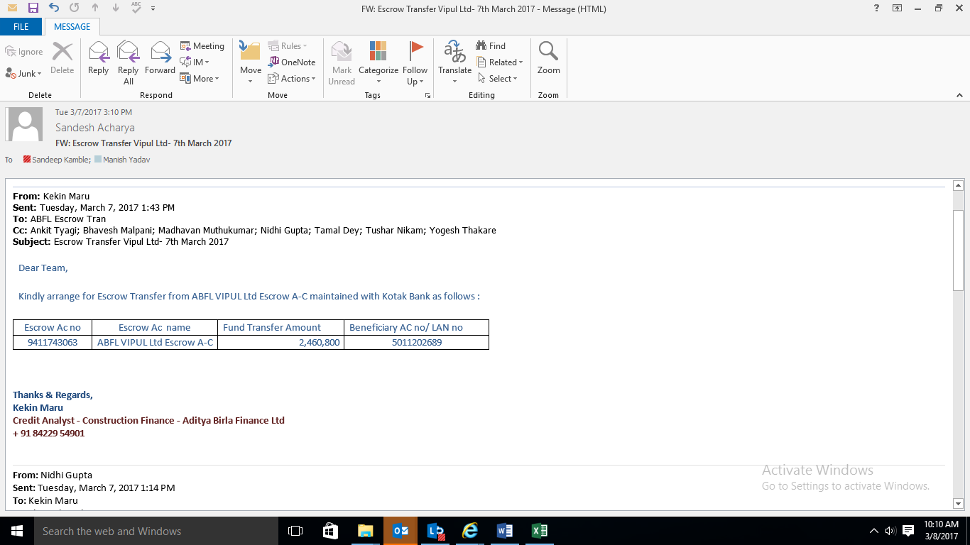

**Sample Email where there are Multiple Beneficiary codes**

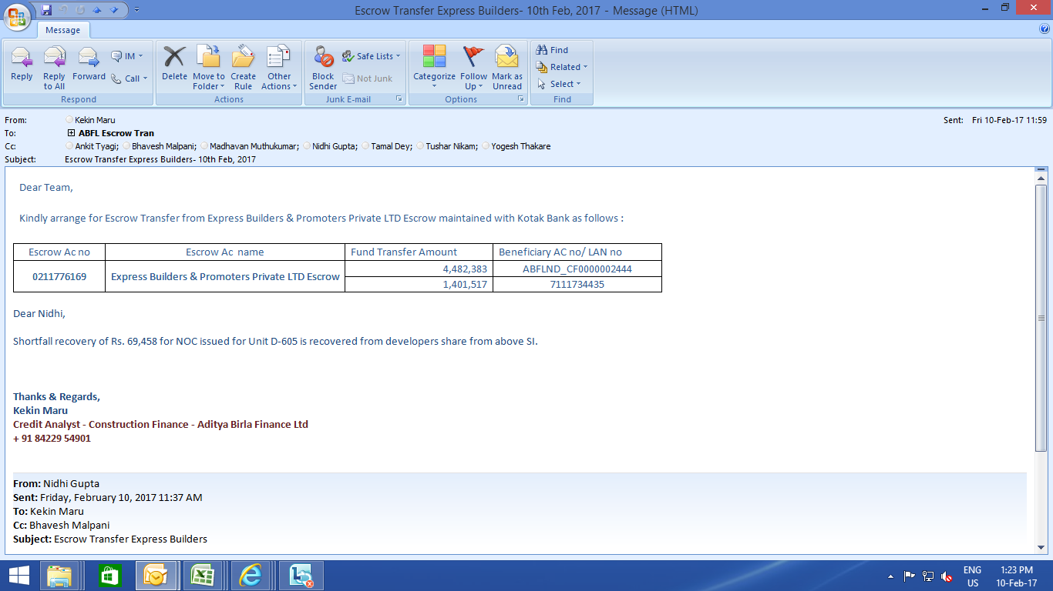

1. CPU user will check an Escrow Account Number availability for online transaction in **Escrow Account Excel Master**.

Refer “MASTER ESCROW DATA” sheet.



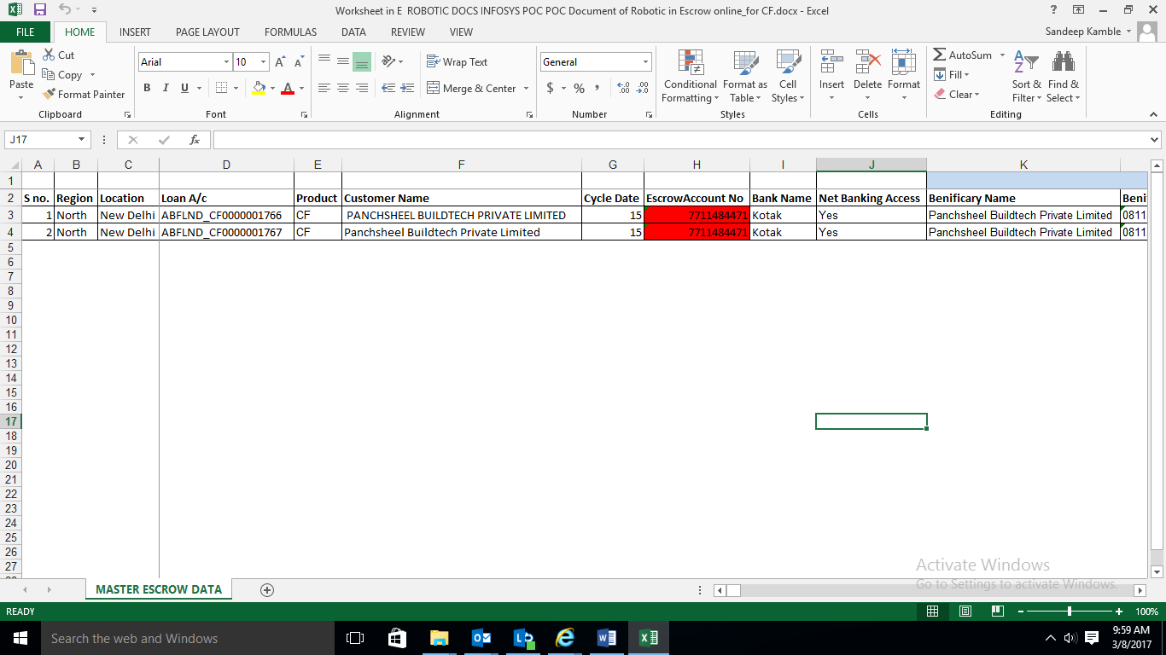

1. If Escorw Account Number exists in **ESCROW EXCEL MASTER**, than CPU user will also check if Beneficary code of customer’s bank account exists in **Beneficiary Excel Master**. User will have to search Beneiciary A/c Number (from Email) in the Beneficiary Excel Master File. Once record searched, take corresponding value against Beneificary_code (i.e. abbivation code) column and paste it in Beneficiary_Code column in an upload file.

The same exercise has to be done, in case if there are multiple beneficairy a/c numbers.

Sample File-



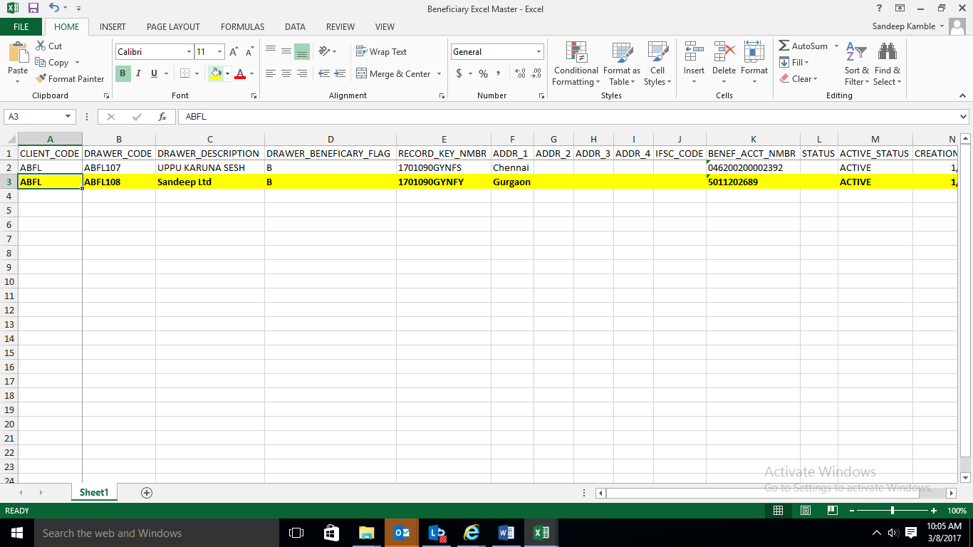

1. CPU user will prepare an upload file as per attached format herewith.

*Note-There could be scenario, where email may contain sometime one beneficiary A/c or multiple beneficiary A/cs. User will have to create the multiple entries basis the count of beneficiary a/cs.*

*Only mandatory fields have to be filled-up. Refer instructions given in the attached file.*



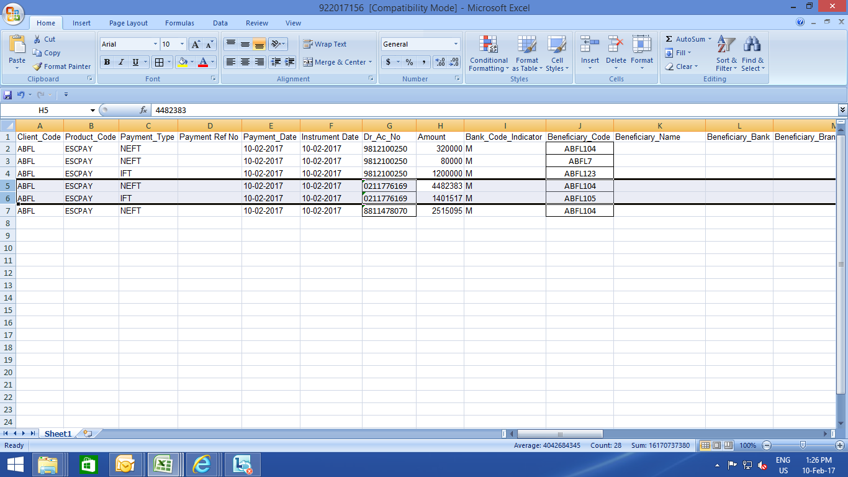

1. CPU User will have to convert the excel file as per Bank’s uploadable format. Kotak has provided Macro (password protected) file for conversion.

User need to select **BROWSE** button to select and upload the appropriate file.

On submittion, system will pop-up successful / Error message.

Once uploaded, close the file without save.

Converter File-



File Post conversion-



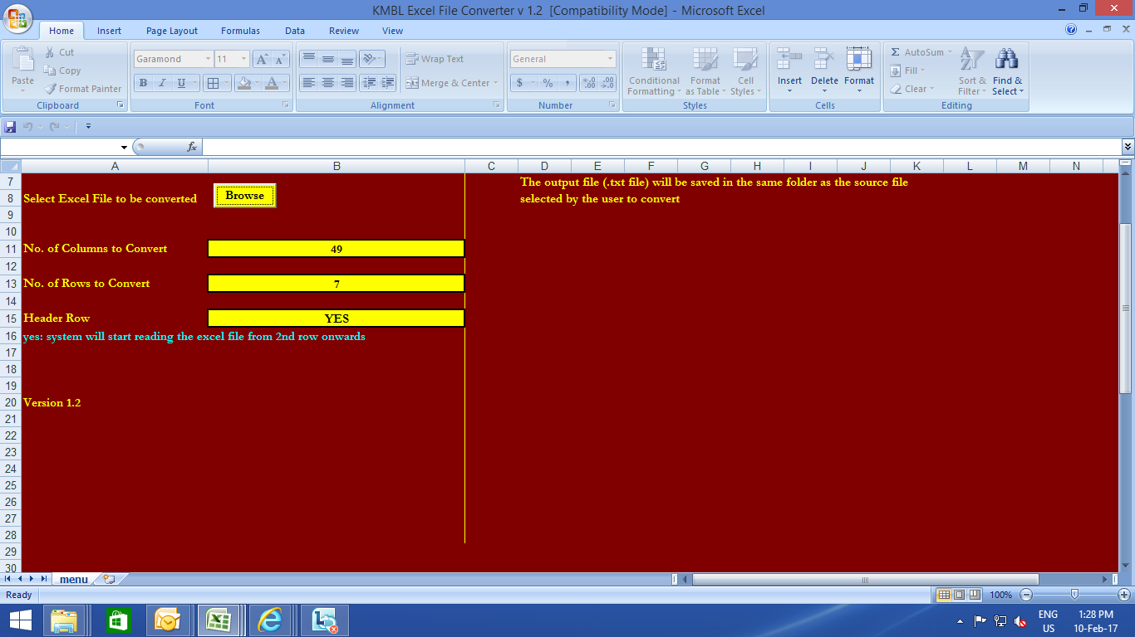

1. CPU user will login into the Kotak (respective Bank portal) with his/her credentials.

Url- [www.kotakbank.com/](http://www.kotakbank.com/)

Login ID – 193420962

Password – Tushar@123

On clicking on Login, below page will be displayed

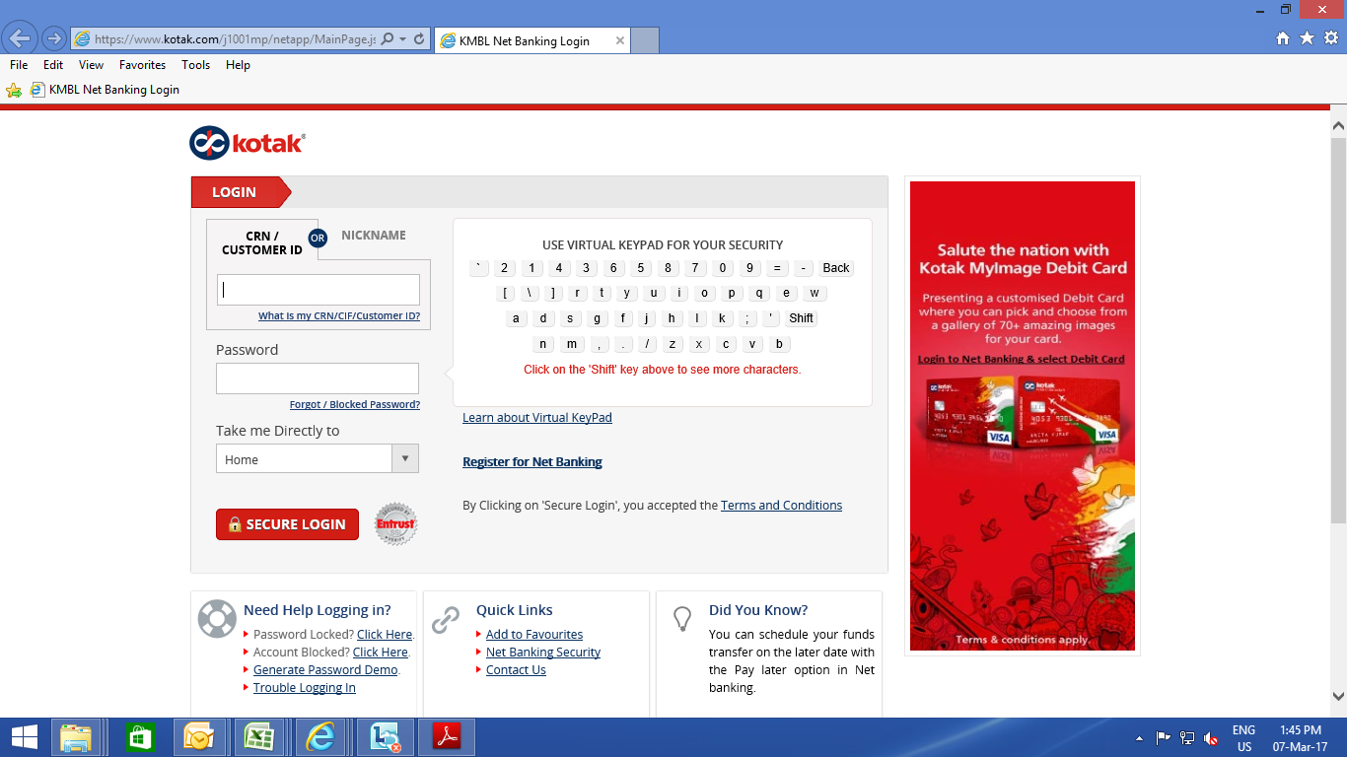

Go to CMS netIT 🡪 File Upload 🡪 Import instruction

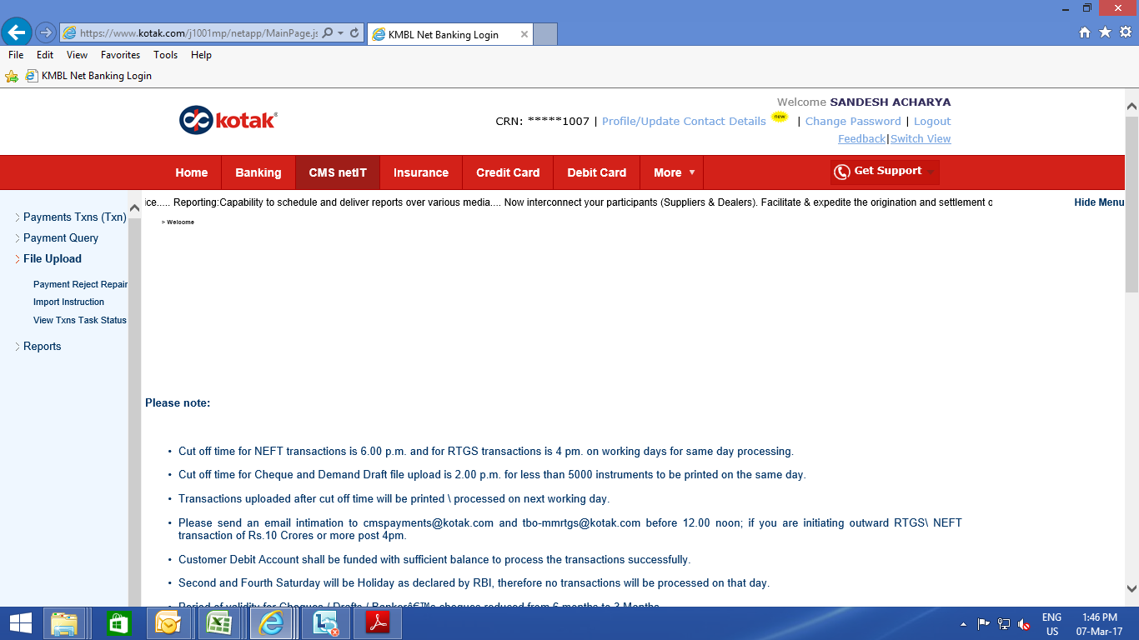

Select file from Browse option and on selection file click on F11 button

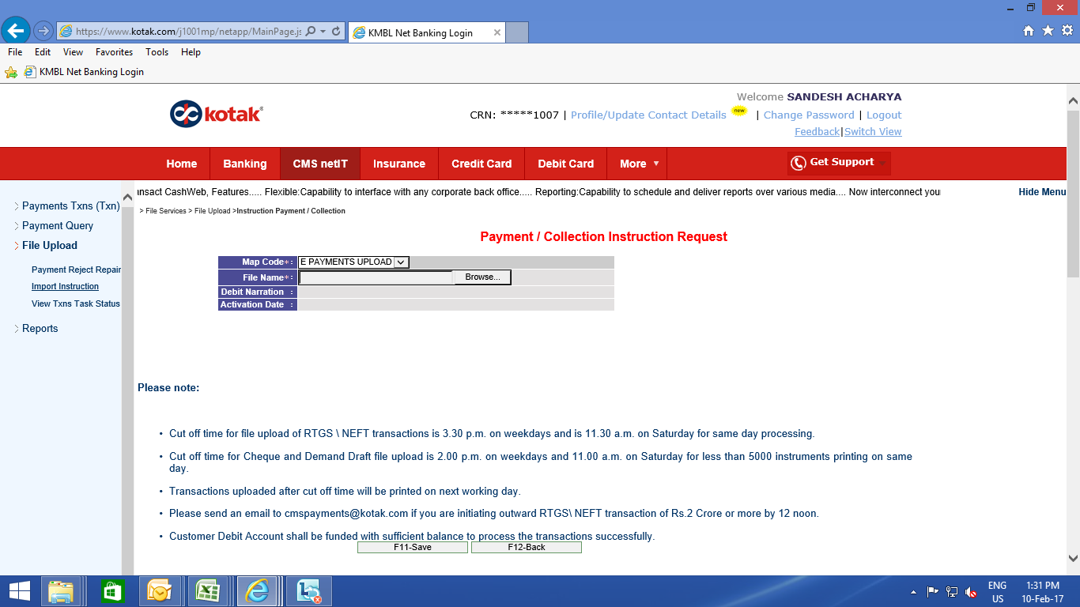

1. CPU user will have to click F3 Button (mentioned as per screen shot given below) till the STAUS & REMARK columns gets updated as “Completed” and Data uploaded successfully” respectively.

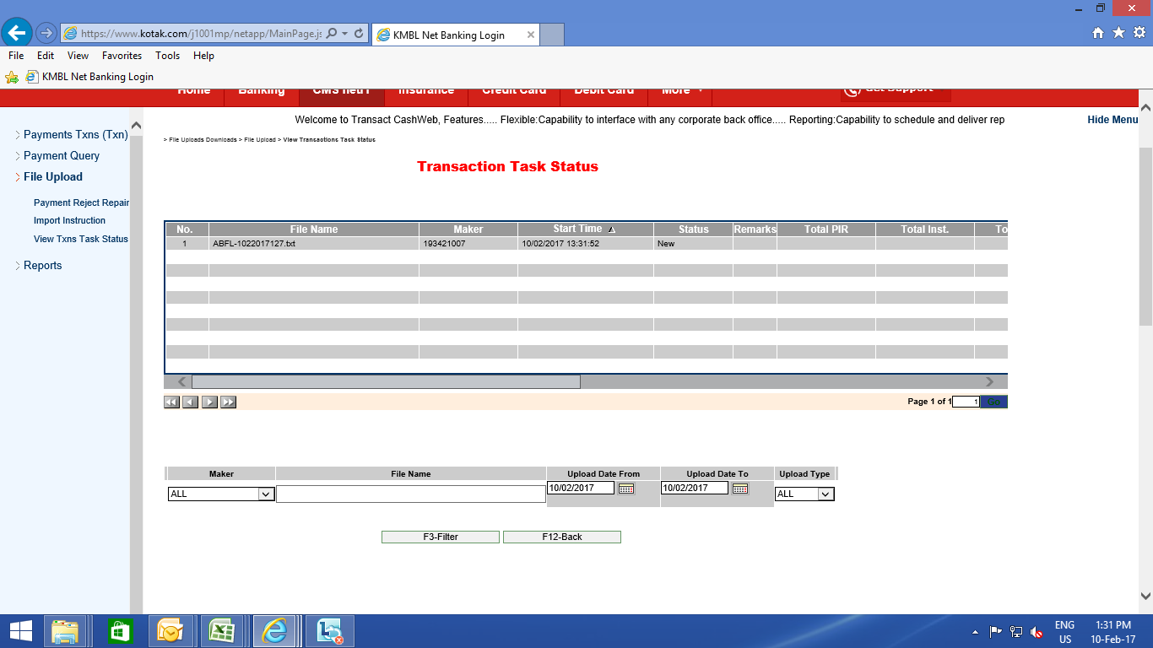

1. Once the remark column show the status “Data uploaded successfully” CPU user will initimate to authozied signtory for authrization of instruction on bank portal.

