<http://www.kotak.com/>

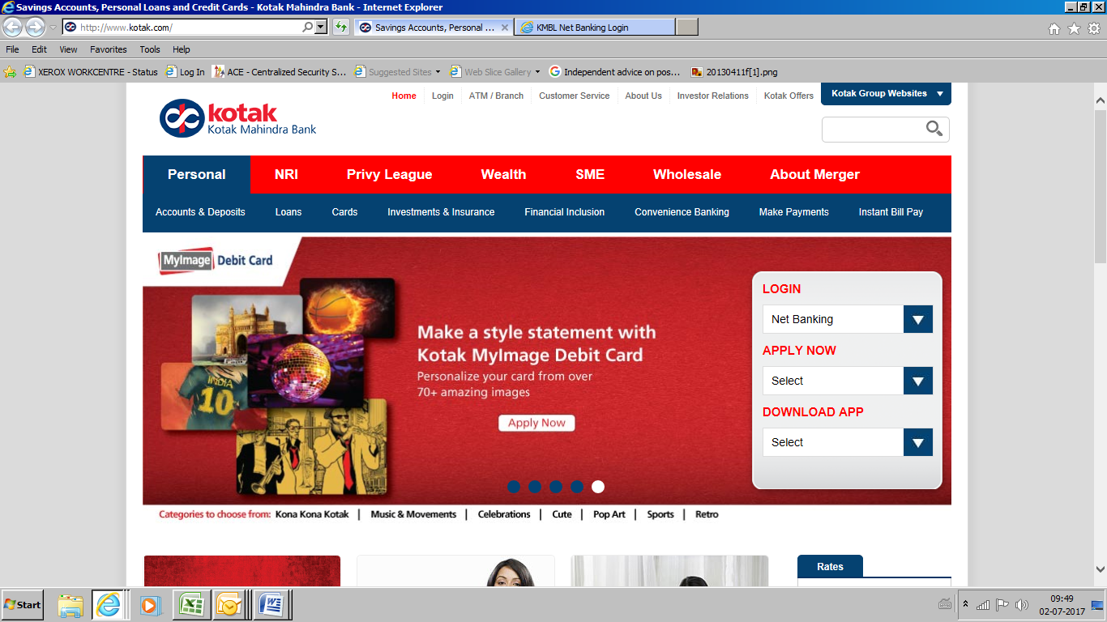

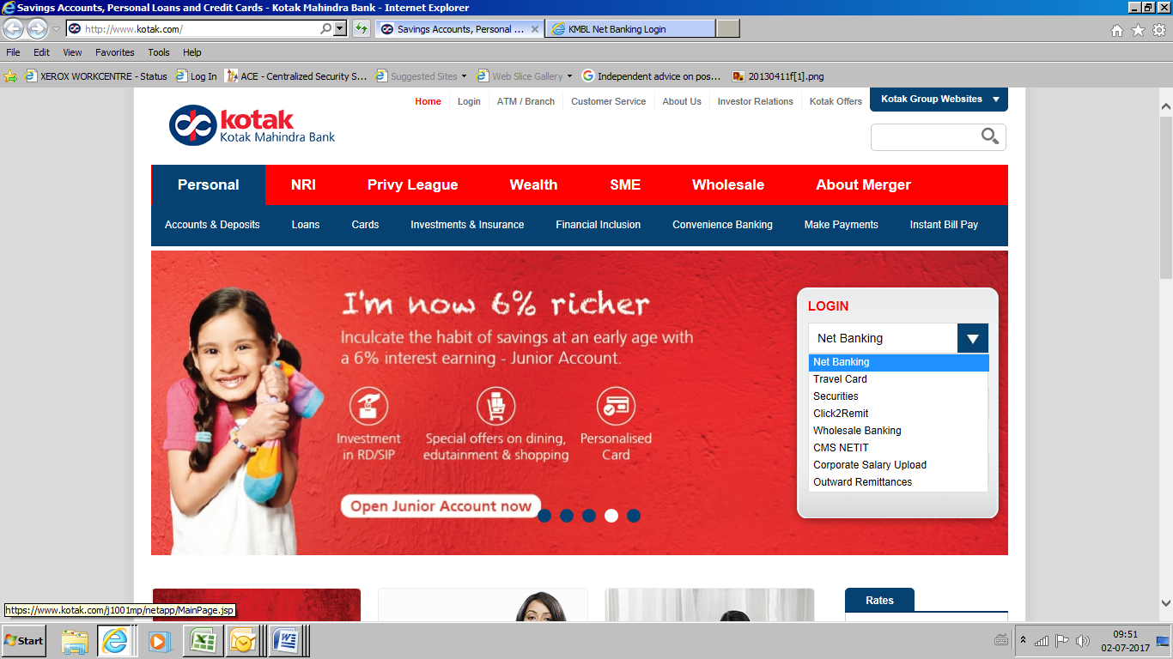

Url- [www.kotak.com](http://www.kotak.com)

Login ID – 193420962

Password – tushar@123

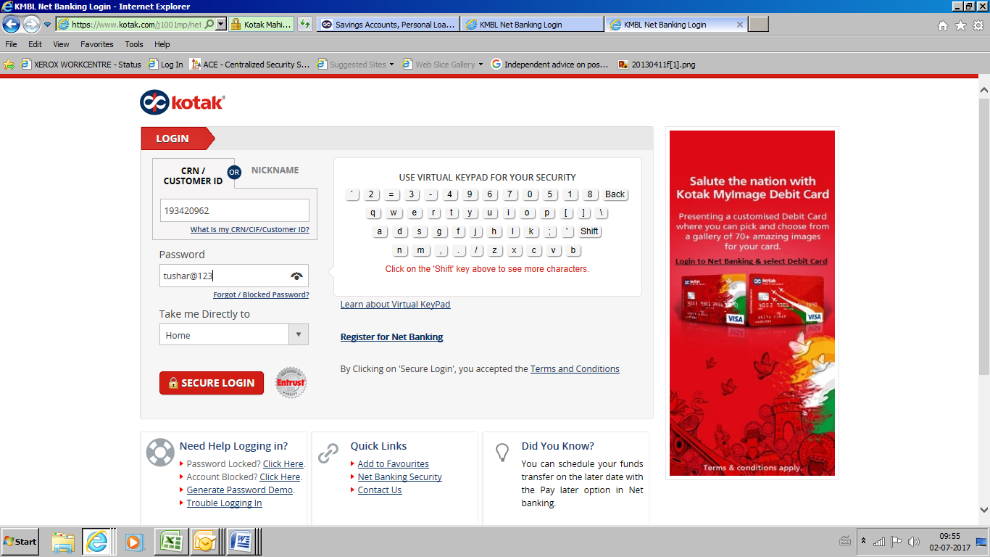

Go to CMS netIT 🡪 File Upload 🡪 Import instruction

