Regular Expressions in Linux

- https://www.youtube.com/watch?v=KJG1dETacLI

- A regular expression is a string that can be used to describe several sequences of characters.

- Regular expressions are used by several different Unix commands, including ed, sed, awk, grep, and to a more limited extent, vi.

- SED stands for stream editor. This stream-oriented editor was created exclusively for executing scripts.

For example,

harshal.gunda@harshal:/$ grep cat /usr/share/dict/american-english

The above command will give the list of words which contains ‘cat’ in the file located in /usr/share/dict/american-english

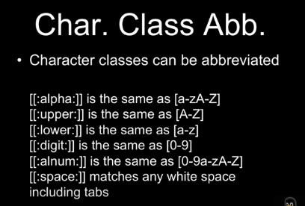

For example, if we want to find a regular expression in /etc/passwd file like

grep “[0-9]” /etc/passwd
then this pattern will find the numbers in the file.

- We can use the above character classes abbreviation in regular expression as –
grep "c[[:lower:]]t" /usr/share/dict/american-english
- This command wil find the word which contains ‘c’(some lower character letters)‘t’
like cat, cft, cot, cit, etc.

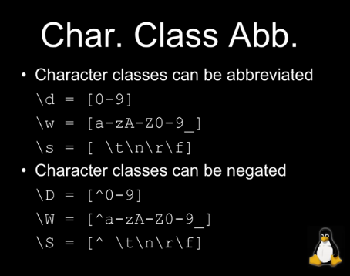

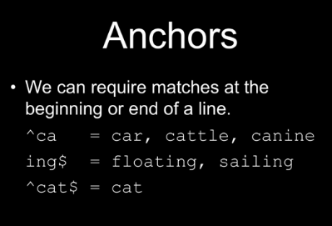

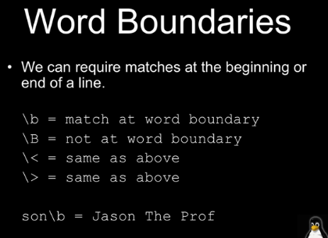

1) Find the word which starts with ‘s’ in /etc/passwd file by using “^s”

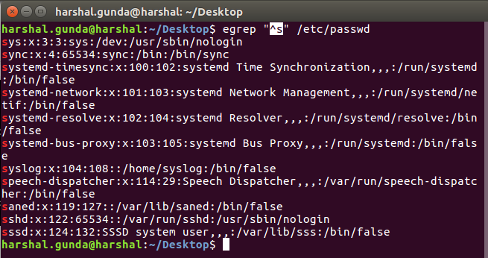

2) Find the word which ends with ‘n’ in /etc/passwd file using “h$”

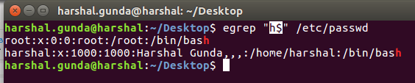

3) Find the word “Jason”
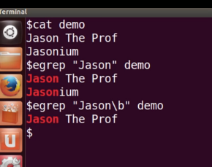

Here, we will find the word “Jasonium” which is not true, so we have used “\b” i.e. word boundary
to find the perfect word.

We use egrep(extended get regular expression) command to execute the following examples, because plain grep(get regular expression) does not work with quantifiers.

1. egrep "bo?t" /usr/share/dict/american-english

This will find the words which contains 0 or 1 letter ‘o’.

2. egrep "bo*t" /usr/share/dict/american-english

This will find the words which contains 0 or more letter ‘o’

3. egrep "bo+t" /usr/share/dict/american-english

This will find the words which contains 1 or more letter ‘o’
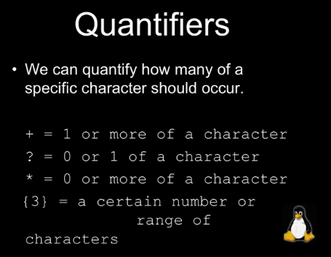

Regex using sed command:
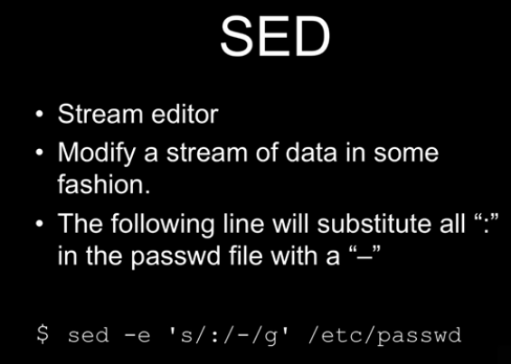

Using this command, we can replace the string from ‘bin’ to ‘harshal’ in the /etc/passwd file.

harshal.gunda@harshal:~/Desktop$ sed -e 's/bin/harshal/g' /etc/passwd

where,
-e expression
g global
s substitute

